Restoration of in situ fiber degradation and the role of fibrolytic microbes and ruminal pH in cows fed concentrate-rich diets transiently or continuously
P. Pourazad^{1,3,a}, R. Khiaosa-ard^{1,3,a}, B. U. Metzler-Zebeli^{2,3}, F. Klevenhusen^{1,3} and Q. Zebeli^{1,3}

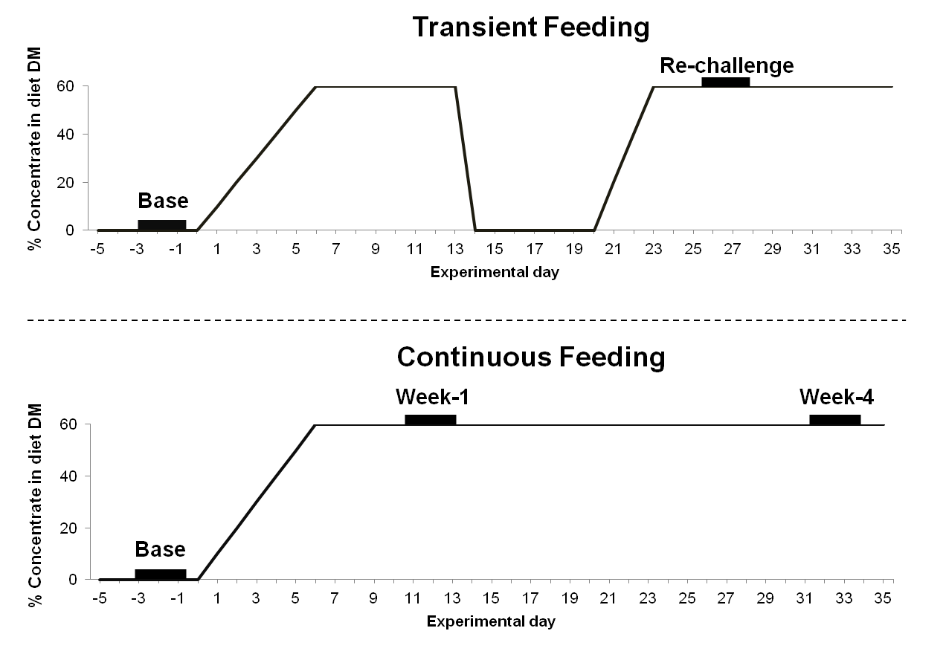
Supplementary Figure S1 Schematic plans of the transient and continuous concentrate-rich feeding models. Thick short bars represent in situ trials in each feeding model (Transient feeding: baseline (Base) and during the first week of the re-challenge with concentrate (Re-challenge); Continuous feeding: baseline (Base) and after 1 week and 4 weeks of concentrate feeding)
Supplementary Material S1 Diets and feeding management
Grass silage and second-cut meadow hay (1:1 DM basis) were the sole diet fed to animals during baseline and concentrate break periods. This forage-only diet contained on diet DM basis 91.6% organic matter (OM), 12.8% CP, 51.7% NDF, 25.6% NFC and 1.5% ether extract. The DM content of the forage-only diet was 54.4%. The 60% concentrate challenge diet was composed of (DM basis) 20.0% grass silage, 20.0% second-cut meadow hay, 19.8% ground barley grain, 18.0% ground wheat, 10.2% ground rapeseed meal, 9.0% ground corn, 1.9% ground dried beet pulp, 0.6% mineral-vitamin premix, 0.3% calcium carbonate, and 0.2% sodium chloride. As intended, the challenge diet was low in NDF (31.2%) and ADF (19.9%) content but high in NFC (45.2%) content. The content of OM, CP and ether extract of the challenge diet was 94.1%, 15.4% and 1.71%, respectively (DM basis) and the DM content was 74.5%.
During the baseline, the concentrate break, and until d 4 of the diet transition, the diet was offered at 1.5% of BW, whereas on the last 2 d of diet transition and during the concentrate challenge the diet was offered at 2.0% of BW, in all cases meeting the voluntary feed intake of the cows. Daily intakes of forage, concentrate and water were recorded for the individual cows. In order to keep constant forage to concentrate ratio, the dietary intake was checked twice daily. At each time point, depending on the ingested amount of forage, the unconsumed concentrate portion was administered through the cannula, accounting approximately for 30% of daily total concentrate intake.

Supplementary Material S2 Quantitative PCR protocol
Primer sets used for quantitative PCR have been described previously and their currently known specificities were checked in silico by BLAST search in Genbank (Metzler-Zebeli et al., 2015). For primer sets for species amplification that showed not to be completely monospecific, the assemblage identified by these primer sets will be referred to as bacterial group (i.e. Butyrivibrio fibrisolvens group and Ruminococcus flavefaciens group). The quantitative PCR analysis was performed on a Stratagene Mx3000P QPCR System (Agilent Technologies, Santa Clara, CA) using the Fast-Plus EvaGreen Master Mix with Low ROX (Biotium, Hayward, CA, USA Technologies) in 20 µl reaction mixtures. Each standard and sample reaction contained 10 µl of master mix, forward and reverse primers (62.5 pmol) and 2 ng of DNA template. The amplification program included an initial denaturation step at 95°C for 10 min, followed by 40 cycles of 95°C for 15 s, primer annealing at 60°C for 30 s, and elongation at 72°C for 30 s. Fluorescence was measured at the last step of each cycle. A melting curve analysis was performed to determine the specificity of the amplification. The dissociation of PCR products were monitored by slow heating with an increment of 0.1°C/s from 55 to 95°C, with fluorescence measurement at 0.1°C intervals. Correct PCR product length was additionally verified by horizontal gel electrophoresis. Amplification efficiency was calculated as the negative reciprocal of the slope of the line of the standard curve: E = -1 + 10^{-1/slope}. Standard curves for each primer set were generated using 10-fold serial dilutions (10⁷ to 10³ molecules/µl) of the purified and quantified PCR products generated by standard PCR using DNA from ruminal fluid and digesta of the present experiment and the corresponding primer sets (Metzler-Zebeli et al., 2015). To minimize errors of DNA quantification from ruminal fluid and solid samples, relative quantification method for fibrolytic bacteria was used by expressing the amplification of target bacterial groups and species relative to the amplification of total bacteria and by utilizing experimentally derived amplification efficiency.

Reference
Metzler-Zebeli BU, Khol-Parisini A, Gruber L and Zebeli Q 2015. Microbial populations and fermentation profiles in rumen liquid and solids of Holstein cows respond differently to dietary barley processing. Journal of Applied Microbiology 119, 1502–1514.

Supplementary Table S1 Primers used for quantification of total bacteria, fibrolytic bacteria and fungi
Target | Forward (top) and reverse (bottom) primer (5’-3’) | Amplicon size (bp) | A_{T} (°C) | Efficiency (%) | Reference
Universal bacteria | CCTACGGGAGGCAGCAG | 189 | 55 | 94.6 | Muyzer et al. (1993)
 | ATTACCGCGGCTGCTGG
Butyrivibrio fibrisolvens group | ACCGCATAAGCGCACGGA | 65 | 60 | 98.3 | Stevenson and Weimer (2007)
 | CGGGTCCATCTTGTACCGATAAAT
Ruminococcus albus | TGTTAACAGAGGGAAGCAAAGCA | 75 | 60 | 94.0 | Stevenson and Weimer (2007)
 | TGCAGCCTACAATCCGAACTAA
Ruminococcus flavefaciens group | CGAACGGAGATAATTTGAGTTTACTTAGG | 132 | 60 | 94.0 | Denman and McSweeney (2006)
 | CGGTCTCTGTATGTTATGAGGTATTACC
Fibrobacter succinogenes | GGTATGGGATGAGCTTGC | 446 | 62 | 91.5 | Tajima et al. (2001)
 | GCCTGCCCCTGAACTATC
General anaerobic fungi | GAGGAAGTAAAAGTCGTAACAAGGTTTC | 110-115 | 60 | 93.1 | Denman and McSweeney (2006)
 | CAAATTCACAAAGGGTAGGATGATT
A_{T}, annealing temperature

References
Denman SE and McSweeney CS 2006. Development of a real-time PCR assay for monitoring anaerobic fungal and cellulolytic bacterial populations within the rumen. FEMS Microbiology Ecology 58, 572–582.
Muyzer G, de Waal EC and Uitterlinden AG 1993. Profiling of complex microbial populations by denaturing gradient gel electrophoresis analysis of polymerase chain reaction-amplified genes coding for 16S rRNA. Applied and Environmental Microbiology 59, 695–700.
Stevenson DM and Weimer PJ 2007. Dominance of Prevotella and low abundance of classical ruminal bacterial species in the bovine rumen revealed by relative quantification real-time PCR. Applied Microbiology and Biotechnology 75, 165–174
Tajima K, Aminov RI, Nagamine T, Matsui H, Nakamura M and Benno Y 2001. Diet-dependent shifts in the bacterial population of the rumen revealed with real-time PCR. Applied and Environmental Microbiology 67, 2766–2774.

Supplementary Table S2 Ruminal pH and temperature profile relative to in situ incubation time as affected by transient or continuous concentrate-rich feeding and incubation time (n = 4 cows/treatment)
Item | Transient feeding¹ |  | SEM | P-value³ |  | Continuous feeding² |  |  | SEM | P-value³
 | Base | Re-challenge |  | Feeding × Time |  | Base | Week-1 | Week-4 |  | Feeding × Time
Mean pH |  |  | 0.09 | 0.085 |  |  |  |  | 0.11 | 0.484
0 h (before incubation) | 6.66ª | 6.28^{b} |  |  |  | 6.55 | 6.56 | 6.51
0-4 h | 6.54ª | 6.32^{b} |  |  |  | 6.55 | 6.48 | 6.58
4-8 h | 6.45ª | 6.15^{b} |  |  |  | 6.45^{x} | 6.19^{y} | 6.25^{xy}
8-24 h | 6.51ª | 6.00^{b} |  |  |  | 6.48ª | 6.12^{b} | 6.10^{b}
24-48 h | 6.56ª | 5.99^{b} |  |  |  | 6.48^{x} | 6.18^{y} | 6.25^{xy}
Minimum pH |  |  | 0.12 | 0.011 |  |  |  |  | 0.17 | 0.399
0-4 h | 6.36 | 6.10 |  |  |  | 6.41 | 6.25 | 6.33
4-8 h | 6.34ª | 5.95^{b} |  |  |  | 6.27ª | 5.90^{ab} | 5.75^{b}
8-24 h | 6.28ª | 5.50^{b} |  |  |  | 6.16ª | 5.52^{b} | 5.41^{b}
24-48 h | 6.30ª | 5.33^{b} |  |  |  | 6.21ª | 5.69^{b} | 5.54^{b}
Maximum pH |  |  | 0.09 | 0.270 |  |  |  |  | 0.10 | 0.614
0-4 h | 6.72ª | 6.54^{b} |  |  |  | 6.69 | 6.72 | 6.79
4-8 h | 6.56ª | 6.34^{b} |  |  |  | 6.61^{ab} | 6.41^{b} | 6.63ª
8-24 h | 6.73ª | 6.32^{b} |  |  |  | 6.75^{x} | 6.55^{y} | 6.62^{xy}
24-48 h | 6.75ª | 6.47^{b} |  |  |  | 6.77 | 6.65 | 6.77
Time pH < 5.8, min |  |  | 76.86 | 0.099 |  |  |  |  | 95.98 | 0.769
0-4 h | 0 | 10 |  |  |  | 0 | 0 | 0
4-8 h | 0 | 0 |  |  |  | 0 | 20 | 53
8-24 h | 0^{b} | 223ª |  |  |  | 0^{y} | 195^{xy} | 255^{x}
24-48 h | 0^{b} | 310ª |  |  |  | 0 | 188 | 228
Time pH < 5.5, min |  |  | 34.37 | 0.071 |  |  |  |  | 42.83 | 0.615
0-4 h | 0 | 0 |  |  |  | 0 | 0 | 0
4-8 h | 0 | 0 |  |  |  | 0 | 3 | 20
8-24 h | 0 | 23 |  |  |  | 0^{b} | 60^{ab} | 155ª
24-48 h | 0^{b} | 158ª |  |  |  | 0 | 53 | 83
Mean temperature, °C |  |  | 0.14 | 0.030 |  |  |  |  | 0.15 | 0.087
0-4 h | 38.21^{b} | 38.92ª |  |  |  | 38.75 | 38.81 | 39.08
4-8 h | 38.43 | 38.23 |  |  |  | 38.26^{b} | 38.94ª | 38.97ª
8-24 h | 38.82 | 38.88 |  |  |  | 38.77 | 38.85 | 38.78
24-48 h | 38.72 | 38.75 |  |  |  | 38.83 | 38.73 | 38.82
Time temperature > 39.5 °C, min |  |  | 30.89 | 0.738 |  |  |  |  | 56.63 | 0.862
0-4 h | 0 | 0 |  |  |  | 0 | 5 | 30
4-8 h | 0 | 18 |  |  |  | 0 | 73 | 70
8-24 h | 3 | 55 |  |  |  | 8 | 83 | 108
24-48 h | 23 | 83 |  |  |  | 28^{b} | 50^{ab} | 175ª
¹Forage-only feeding (Baseline) followed by 1-week challenge using a 60% concentrate diet, 1-week break, and then re-challenge for 2 weeks. The in situ measurement was conducted during baseline (Base) and during week-1 of the re-challenge (re-challenge).
² Forage-only feeding (Baseline) followed by 60% concentrate challenge for a continuous 4 weeks. The in situ measurement was conducted during baseline (Base), in the first week (Week-1) and the last week (Week-4) of concentrate challenge.
³For both feeding models, a time effect (P < 0.05) was found for all parameters, except Mean temperature in the continuous feeding model, Time pH < 5.5, Time pH < 5.8, and Time temperature > 39.5 °C in both models.
^{a,b}Means within each feeding model and incubation time differ at P ≤ 0.05 based on paired t-tests.
^{x,y}Means within each feeding model and incubation time tend to differ at 0.05 < P ≤ 0.10 based on paired t-tests.

