Validation of a mathematical model of the bovine estrous cycle for cows with different estrous cycle characteristics

H. M. T. Boer, S.T. Butler, C. Stötzel, M.F.W. te Pas, R. F. Veerkamp, H. Woelders

Supplementary Figure S5

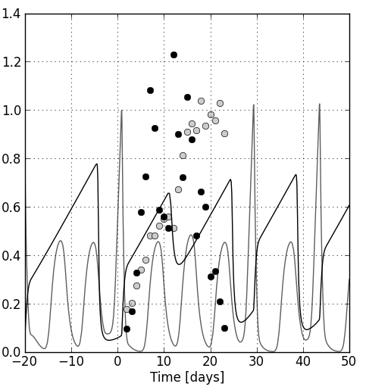
Example of model predictions and data points for CL (black line, black bullets) and follicle (grey line, grey bullets) after estimating the parameters mentioned in Table 3. Parameter values were fitted to a cow with two follicular waves, resulting in a 2-wave simulation for the cycle following the cycle in which the data points were overlaid. Because P4 concentrations are still high after the second wave of the cycle in which the data points were overlaid, there is yet no ovulation. After two more waves P4 concentrations are at a nadir and therefore ovulation takes place. No dimension is given at the y-axis because the equations are expressed on a relative scale.

