Validation of a mathematical model of the bovine estrous cycle for cows with different estrous cycle characteristics

H. M. T. Boer, S.T. Butler, C. Stötzel, M.F.W. te Pas, R. F. Veerkamp, H. Woelders

Supplementary Figure S4

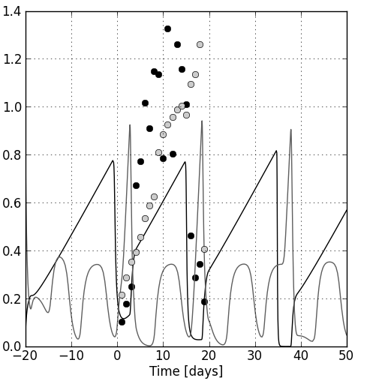

Example of model predictions and data points for CL (black line, black bullets) and follicle (grey line, grey bullets) after estimating the parameters mentioned in Table 3. Parameter values were fitted to one of the cows with two follicular waves, resulting in a 2-wave simulation for the cycle in which the data points were overlaid. No dimension is given at the y-axis because the equations are expressed on a relative scale.

