Validation of a mathematical model of the bovine estrous cycle for cows with different estrous cycle characteristics

H. M. T. Boer, S.T. Butler, C. Stötzel, M.F.W. te Pas, R. F. Veerkamp, H. Woelders

Supplementary Figure S2

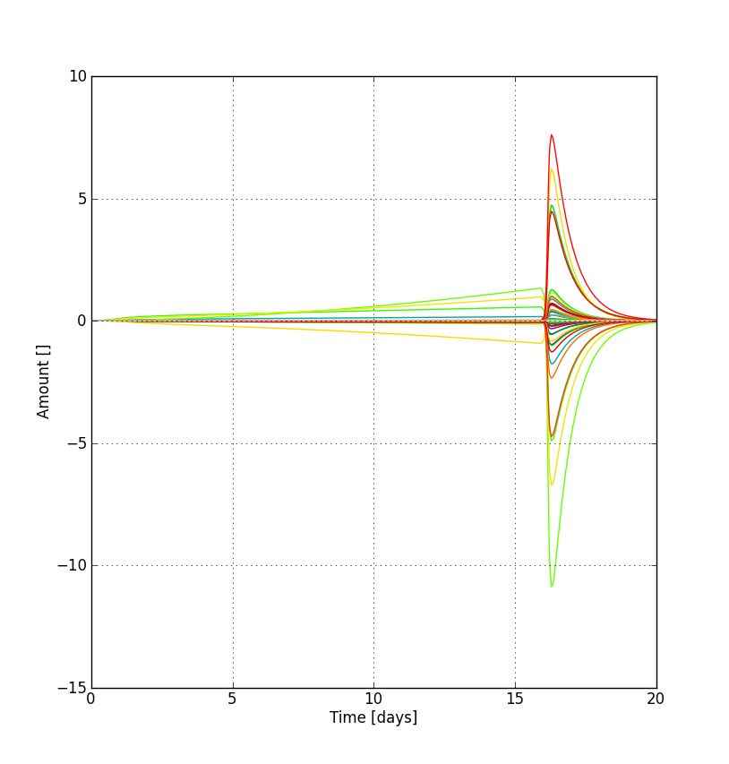
Sensitivities of P4 to the 60 model parameters as a function of time of cycle. Each line represents the absolute sensitivity of P4 to one parameter. Sensitivities are highest immediately after the onset of luteolysis on day 16.3.

