Gait and posture discrimination in sheep using a tri-axial accelerometer
M. Radeski and V. Ilieski

Supplementary Table S1. Discriminant function and canonical correlation analysis for the significant acceleration categories (AC) and discriminant functions (roots) for gait discrimination – supplementary data of Table 3
 | Vertical axis |  |  |  |  | Horizontal axis |  |  |  |  |  | Total acceleration
Discriminant function analysis
AC | (0, 1] | (1, 2] |  | (2, 3] | (-3, -2] | (3, 4] | (-4, -3] | (2, 3] |  | (-2, -1] | (1, 2] | (0, 1] | (1,2] | (2, 3] | (5, 6] | (3,4]
Wilks’ λ | 0.32 | 0.18 |  | 0.12 | 0.11 | 0.26 | 0.11 | 0.12 |  | 0.10 | 0.10 | 0.10 | 0.10 | 0.10 | 0.10 | 0.09
Partial Wilks’ λ | 0.33 | 0.60 |  | 0.90 | 0.96 | 0.33 | 0.82 | 0.75 |  | 0.89 | 0.89 | 0.86 | 0.94 | 0.87 | 0.93 | 0.96
F-remove (2.70) | 71.40 | 23.85 |  | 4.13 | 1.36 | 70.97 | 7.84 | 11.84 |  | 4.50 | 4.40 | 5.60 | 2.10 | 5.35 | 2.73 | 1.41
P | <0.001 | <0.001 |  | <0.05 | 0.26 | <0.001 | <0.001 | <0.001 |  | <0.05 | <0.05 | <0.01 | 0.13 | <0.01 | 0.07 | 0.25
Tolerance  (1-R²) | 0.46 | 0.36 |  | 0.19 | 0.35 | 0.13 | 0.09 | 0.27 |  | 0.03 | 0.19 | 0.54 | 0.61 | 0.35 | 0.28 | 0.69
Canonical correlation analysis
Root | 1 |  | 2 |  |  | 1 |  |  | 2 |  |  | 1 |  |  | 2
Eigenvalue | 5.08 |  | 0.57 |  |  | 6.56 |  |  | 0.52 |  |  | 5.64 |  |  | 0.68
Canonical correlation | 0.91 |  | 0.60 |  |  | 0.93 |  |  | 0.59 |  |  | 0.92 |  |  | 0.64
Wilks’ λ | 0.11 |  | 0.64 |  |  | 0.09 |  |  | 0.66 |  |  | 0.09 |  |  | 0.60
χ² | 163.32 |  | 32.50 |  |  | 175.96 |  |  | 30.31 |  |  | 173.58 |  |  | 37.32
Df | 8 |  | 3 |  |  | 10 |  |  | 4 |  |  | 10 |  |  | 4
P | <0.001 |  | <0.001 |  |  | <0.001 |  |  | <0.001 |  |  | <0.001 |  |  | <0.001

Supplementary Table S2. Squared Mahalanobis Distances (SMD) of misclassified cases in the classification matrix on the vertical and horizontal axes and the total acceleration
 |  | Misclassified cases¹
 | Gait | Walking p=0.34 | SMD |  | Trotting p=0.31 | SMD |  | Galloping p=0.35 | SMD
 |  |  | False | True |  | False | True |  | False | True
Vertical Axis | Trotting | 1 | 4.67 | 4.93 |  |  |  | 3 | 3.36 | 7.86
 |  |  |  |  |  |  |  |  | 26.14 | 26.69
 |  |  |  |  |  |  |  |  | 4.96 | 5.67
 | Galloping |  |  |  | 4 | 0.78 | 8.19
 |  |  |  |  |  | 4.34 | 6.55
 |  |  |  |  |  | 4.81 | 9.37
 |  |  |  |  |  | 2.33 | 7.08
Horizontal Axis | Trotting | 4 | 3.43 | 5.04 |  |  |  | 1 | 6.76 | 10.67
 |  |  | 6.58 | 7.05
 |  |  | 3.93^{b} | 3.81
 |  |  | 3.58 | 4.44
 | Galloping |  |  |  | 2 | 0.48 | 11.63ª
 |  |  |  |  |  | 6.50 | 7.20
Total Acceleration | Walking |  |  |  | 1 | 2.83 | 5.32
 | Trotting | 2 | 9.33 | 10.07 |  |  |  | 3 | 4.01 | 5.74
 |  |  |  |  |  |  |  |  | 4.87 | 10.00
 |  |  | 4.81 | 5.10 |  |  |  |  | 3.25 | 6.84
 | Galloping |  |  |  | 4 | 0.86 | 5.93
 |  |  |  |  |  | 9.22 | 10.76
 |  |  |  |  |  | 4.83 | 13.19ª
 |  |  |  |  |  | 3.28 | 9.46
p = a priori group probability set up (proportional to the group size);
¹ The misclassified cases (epochs) are presented with their distances (SMD) from the centroid of the False gait classification, followed by the SMD of the correct (True) gait classification.
ª Gait misclassifications where the true gait is the third (last) choice in the post hoc predictions.
^{b} Misclassification due to a priori probability set up (p)

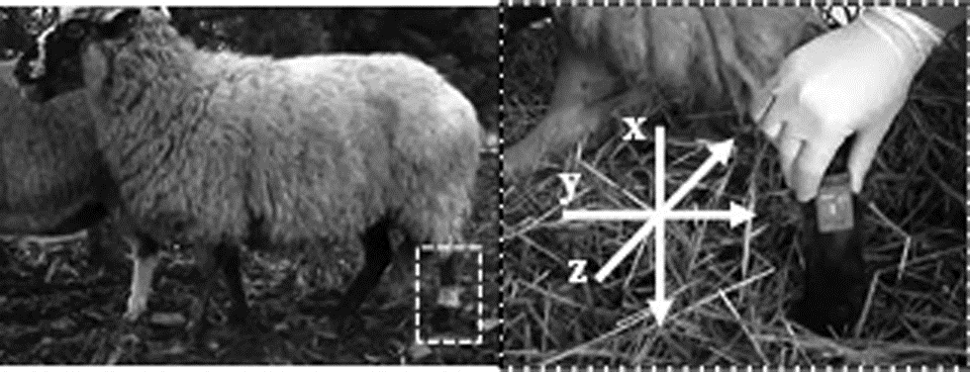
Supplementary Figure S1. Location and positioning of the accelerometer on sheep. The accelerometer is mounted on the left hind leg in lateral metatarsal region (picture left). The accelerometer is positioned with x as vertical axis and y as horizontal axis and z axis is directed from lateral to medial side (picture right).

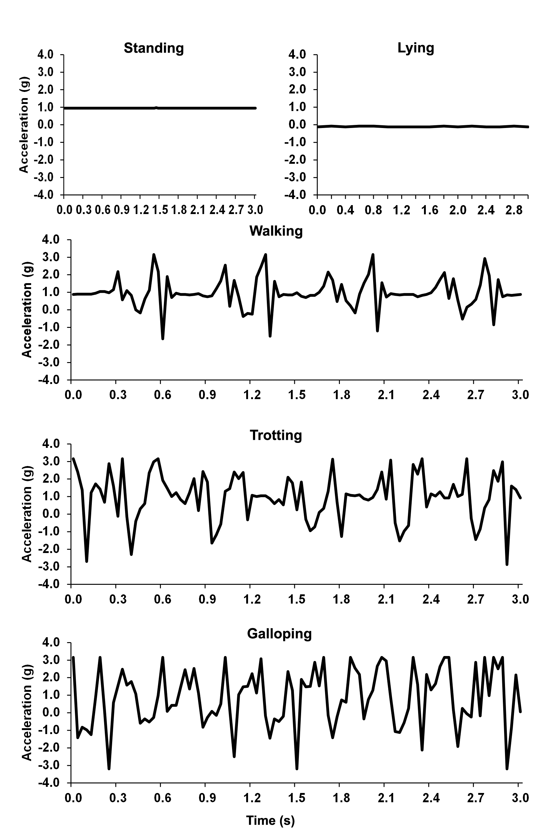
Supplementary Figure S2. Graphs showing the acceleration values on the vertical (x) axis of tri-axial accelerometer while sheep is standing, lying, walking, trotting and galloping in a period of 3 s (one epoch).

