Effect of a ceiling fan ventilation system on finishing young bulls’ health, behaviour, and growth performance

Magrin et al.

Supplementary Figure S1 Schematic representation of the barn (left) and picture taken from the feeding alley at entrance level (right).

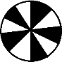
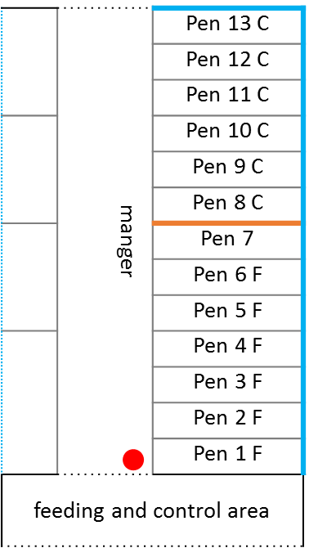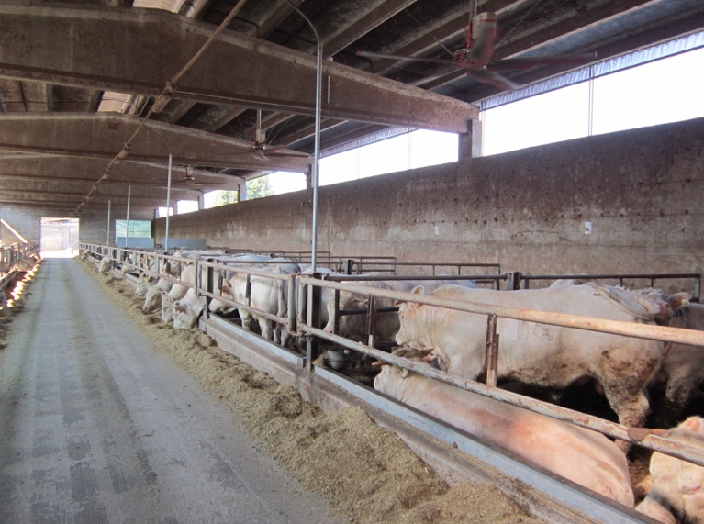
Blue line = wall + opening with sheer green shadow curtain with possibility to roll it up or scroll it down.
Grey line = metal horizontal bars between experimental pens and between pens and manger
Black line = full wall
Orange line = full metal barrier between F and C pens
Dotted blue line = metal horizontal bars + opening with sheer green shadow curtain with possibility to roll it up or scroll it down.
Dotted black line = opening with no barriers
Red dot = position where the picture was taken from
Pinwheel = ceiling fans positioned in the center above two pens

