Ultra-low density genotype panels for breed assignment of Angus and Hereford cattle
M.M Judge, M.M. Kelleher, J.F. Kearney, R. D. Sleator, D.P. Berry

Supplementary Material

Supplementary Table S1 Number of SNPs chosen per autosome (BTA) for each of the ultra-low density i.e. 100, 200, 300, 400, 500, 600, 700, 800, 900 and 1 000 SNP genotype panels
 | Single nucleotide polymorphism density
BTA | 100 | 200 | 300 | 400 | 500 | 600 | 700 | 800 | 900 | 1 000
1 | 6 | 12 | 18 | 24 | 30 | 36 | 42 | 48 | 54 | 61
2 | 5 | 10 | 15 | 20 | 25 | 30 | 35 | 40 | 45 | 50
3 | 5 | 10 | 15 | 20 | 26 | 31 | 36 | 41 | 46 | 51
4 | 5 | 10 | 14 | 19 | 24 | 29 | 34 | 38 | 43 | 48
5 | 4 | 8 | 12 | 16 | 21 | 25 | 29 | 33 | 37 | 41
6 | 4 | 9 | 13 | 17 | 22 | 26 | 30 | 34 | 39 | 43
7 | 5 | 9 | 14 | 18 | 23 | 27 | 32 | 36 | 41 | 45
8 | 5 | 10 | 15 | 19 | 24 | 29 | 34 | 39 | 44 | 49
9 | 4 | 8 | 12 | 16 | 20 | 24 | 28 | 32 | 36 | 40
10 | 4 | 9 | 13 | 17 | 22 | 26 | 30 | 34 | 39 | 43
11 | 4 | 9 | 13 | 17 | 22 | 26 | 30 | 35 | 39 | 44
12 | 3 | 6 | 9 | 13 | 16 | 19 | 22 | 25 | 28 | 32
13 | 4 | 7 | 11 | 14 | 18 | 22 | 25 | 29 | 32 | 36
14 | 3 | 7 | 10 | 13 | 17 | 20 | 23 | 27 | 30 | 34
15 | 3 | 7 | 10 | 14 | 17 | 21 | 24 | 28 | 31 | 35
16 | 3 | 6 | 10 | 13 | 16 | 19 | 22 | 26 | 29 | 32
17 | 3 | 7 | 10 | 13 | 17 | 20 | 23 | 26 | 30 | 33
18 | 3 | 6 | 8 | 11 | 14 | 17 | 19 | 22 | 25 | 28
19 | 3 | 6 | 9 | 11 | 14 | 17 | 20 | 23 | 26 | 29
20 | 3 | 6 | 9 | 12 | 15 | 19 | 22 | 25 | 28 | 31
21 | 3 | 5 | 8 | 11 | 14 | 16 | 19 | 22 | 24 | 26
22 | 3 | 5 | 8 | 10 | 13 | 15 | 18 | 20 | 23 | 25
23 | 2 | 4 | 6 | 9 | 11 | 13 | 15 | 17 | 19 | 22
24 | 3 | 4 | 8 | 10 | 11 | 15 | 18 | 20 | 23 | 25
25 | 2 | 4 | 6 | 9 | 10 | 12 | 14 | 16 | 18 | 20
26 | 2 | 4 | 7 | 9 | 11 | 13 | 15 | 18 | 20 | 21
27 | 2 | 4 | 5 | 8 | 9 | 11 | 13 | 14 | 16 | 18
28 | 2 | 4 | 6 | 8 | 9 | 11 | 13 | 15 | 17 | 19
29 | 2 | 4 | 6 | 9 | 9 | 11 | 15 | 17 | 18 | 19

Supplementary Table S2 Correlations of the predicted breed proportion in the Angus (n=5 470; below diagonal) and Hereford (n=5 187; above diagonal) populations among the different density genotype panels including the gold-standard (gold) panel. Single nucleotide polymorphisms were selected using the Global Index statistic
Panel Density | 100 | 200 | 300 | 400 | 500 | 600 | 700 | 800 | 900 | 1,000 | Gold
100 |  | 0.995 | 0.993 | 0.992 | 0.992 | 0.991 | 0.991 | 0.991 | 0.991 | 0.991 | 0.989
200 | 0.993 |  | 0.997 | 0.997 | 0.996 | 0.996 | 0.996 | 0.996 | 0.996 | 0.995 | 0.994
300 | 0.991 | 0.996 |  | 0.998 | 0.998 | 0.998 | 0.998 | 0.998 | 0.997 | 0.997 | 0.995
400 | 0.990 | 0.996 | 0.997 |  | 0.999 | 0.998 | 0.998 | 0.998 | 0.999 | 0.998 | 0.996
500 | 0.989 | 0.995 | 0.997 | 0.998 |  | 0.999 | 0.999 | 0.999 | 0.999 | 0.999 | 0.997
600 | 0.989 | 0.995 | 0.997 | 0.998 | 0.998 |  | 0.999 | 0.999 | 0.999 | 0.999 | 0.997
700 | 0.988 | 0.994 | 0.997 | 0.998 | 0.998 | 0.999 |  | 0.999 | 0.999 | 0.999 | 0.998
800 | 0.988 | 0.994 | 0.997 | 0.998 | 0.998 | 0.999 | 0.999 |  | 0.999 | 0.999 | 0.998
900 | 0.988 | 0.994 | 0.997 | 0.997 | 0.998 | 0.998 | 0.999 | 0.999 |  | 0.999 | 0.998
1 000 | 0.988 | 0.994 | 0.996 | 0.997 | 0.998 | 0.998 | 0.999 | 0.999 | 0.999 |  | 0.998
Gold | 0.983 | 0.990 | 0.993 | 0.994 | 0.995 | 0.995 | 0.996 | 0.996 | 0.996 | 0.997

Supplementary Table S3 The number of common single nucleotide polymorphsims (selected using the Global Index selection method) between each genotype panel density in the Angus population (n=5 470; below diagonal), the Hereford population (n=5 187; above diagonal) as well as between the Angus and Hereford populations for the same density (on the diagonal)
 | Panel Density
Panel Density | 100 | 200 | 300 | 400 | 500 | 600 | 700 | 800 | 900 | 1 000
100 | 2 | 100 | 99 | 96 | 98 | 98 | 99 | 99 | 99 | 99
200 | 99 | 2 | 183 | 190 | 191 | 192 | 196 | 196 | 197 | 196
300 | 99 | 177 | 4 | 257 | 274 | 289 | 282 | 289 | 294 | 289
400 | 98 | 188 | 255 | 12 | 347 | 354 | 362 | 385 | 381 | 380
500 | 98 | 188 | 261 | 337 | 18 | 418 | 429 | 450 | 455 | 480
600 | 98 | 193 | 293 | 360 | 410 | 24 | 491 | 517 | 543 | 550
700 | 98 | 192 | 274 | 369 | 436 | 484 | 33 | 563 | 592 | 609
800 | 99 | 197 | 284 | 388 | 456 | 514 | 588 | 39 | 644 | 677
900 | 100 | 197 | 398 | 374 | 455 | 529 | 590 | 636 | 50 | 730
1 000 | 100 | 197 | 290 | 382 | 478 | 530 | 603 | 679 | 723 | 63

Supplementary Figure S1 Allele frequencies for each of the 300 SNPs selected using in Pairwise F_{st} method in Angus population versus the Hereford (♦), Holstein (▪), Belgian Blue (▲), Limousin (×), Simmental (–) and Charolais (•) populations

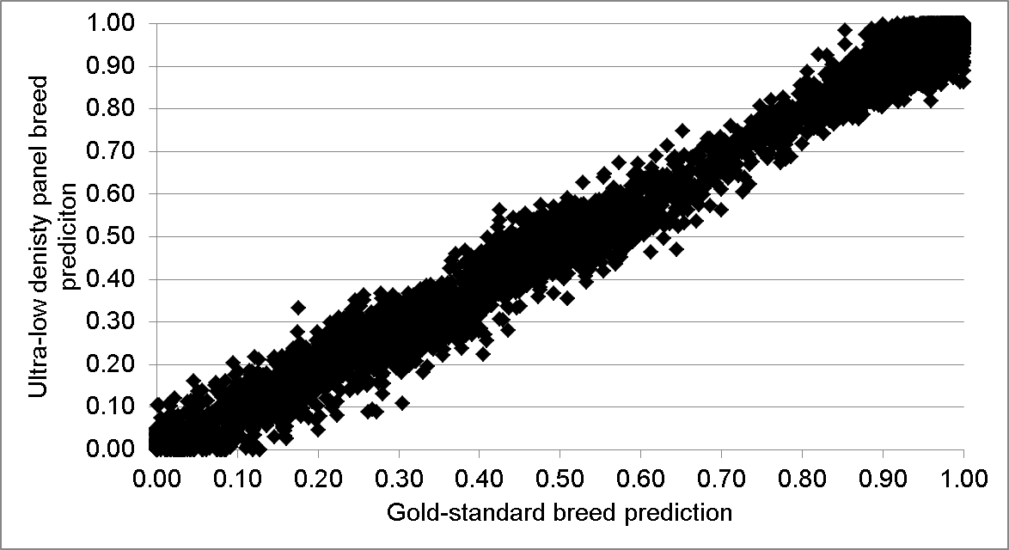
Supplementary Figure S2 The Angus breed proportion of all Angus animals (n=5 740) using the gold-standard genotype panel (x-axis) and the 300 single nucleotide polymorphism genotype panel (y-axis) (SNPs selected using the Global Index method)

