Supplementary material

Perches and elevated platforms in commercial broiler farms – use and effect on walking ability, incidence of tibial dyschondroplasia and bone mineral content

E. Kaukonen 1, M. Norring 1 and A. Valros 1

1 Research centre for animal welfare, Department of Production Animal Medicine, University of Helsinki, 00014 Helsinki, Finland

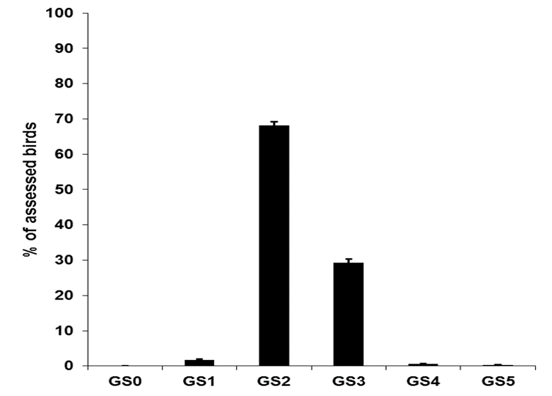
Supplementary Figure S1 Overall distribution of gait scores in broiler flocks (N = 49). Scoring was performed using the method described in the Welfare Quality® Assessment protocol, with scoring scale from 0 = normal gait to score 5 = incapable to walk. Error bars indicate SE.

Supplementary Table S1 Mean bone ash and mineral contents in the femur of broilers with gait score 3 at younger and older scoring age
 | Bone ash |  |  | Calcium |  | Phosphorus |  | N
Age | % | SD |  | g/kg | SD | g/kg | SD
29-31 days | 15.6 |  | 1.2 | 54.4 | 3.8 | 29.8 | 2.2 | 12
34-36 days | 16.1 |  | 1.2 | 55.8 | 4.3 | 30.4 | 2.4 | 24

