Supplementary Material S1

The experimental farm is characterized by very heterogeneous and unusual management conditions. Consequently, recorded cow performances are not routinely included in the national data base and no national EBV are available for these cows. Furthermore, genomic evaluations were not available for the oldest cows of this study. Therefore, specific EBV had to be computed. This was performed combining within herd information with national sire and maternal grand sire estimated breeding values (EBV). Based on these results, cows were classified within breeds into 2 groups according to their customized estimated breeding value (EBV) for milk yield (MY), fat and protein contents(respectively FC and PC) as 2 groups capable of producing similar milk solids (MS) quantity in different ways. Here, we present these customized EBV.

Estimation of customized Breeding values

The EBV for each trait was evaluated combining within herd information analysed with a BLUP animal model with national EBV of the sires and grandsires. The model of analysis of cow performances over three lactations included usual fixed environmental effects (year, lactation number, calving age, calving month, drying off period length, and permanent environment effect) and the feeding system (H. Larroque, INRA UMR 1388 GenPhySE, Toulouse, France, personal communication). Within breed and experimental year, nulliparous cows with EBV for milk yield higher than average and EBV for fat and protein contents lower than average constituted a “Milk-Group”. Nulliparous cows with EBV for milk yield lower than average and EBV for fat and protein contents higher than average constituted a “Content-Group”. The others nulliparous cows (with high EBV for milk yield and high EBV for fat and protein contents or low EBV for milk yield and low EBV for fat and protein contents) did not enter the experiment. EBV were expressed in deviation from a base population, whose average EBV were set to 0.

Average EBV for production traits

Table 1 Distribution of the customized Estimated Breeding Values for production traits (milk yield, fat content, protein content and milk solids yield) for Holstein and Normande cows, in the Milk- or the Content-Group.
 | Holstein |  | Normande
 | Milk-Group | Content-Group | Milk-Group | Content-Group
Centred within breed
EBV(MY) | +308 | -303 | +290 | -264
EBV(FC) | -1.7 | +1.9 | -1.9 | +1.5
EBV(PC) | -0.5 | +0.5 | -0.9 | +0.8
EBV(MS) | +4.4 | -4.4 | +5.9 | -6.8

Regression of production performance on EBV for production traits

In order to further understand the link between genetic merit for production traits and the actual performance, regression of adjusted production performances (predicted outcomes of the model used in the study) on EBV are presented here.
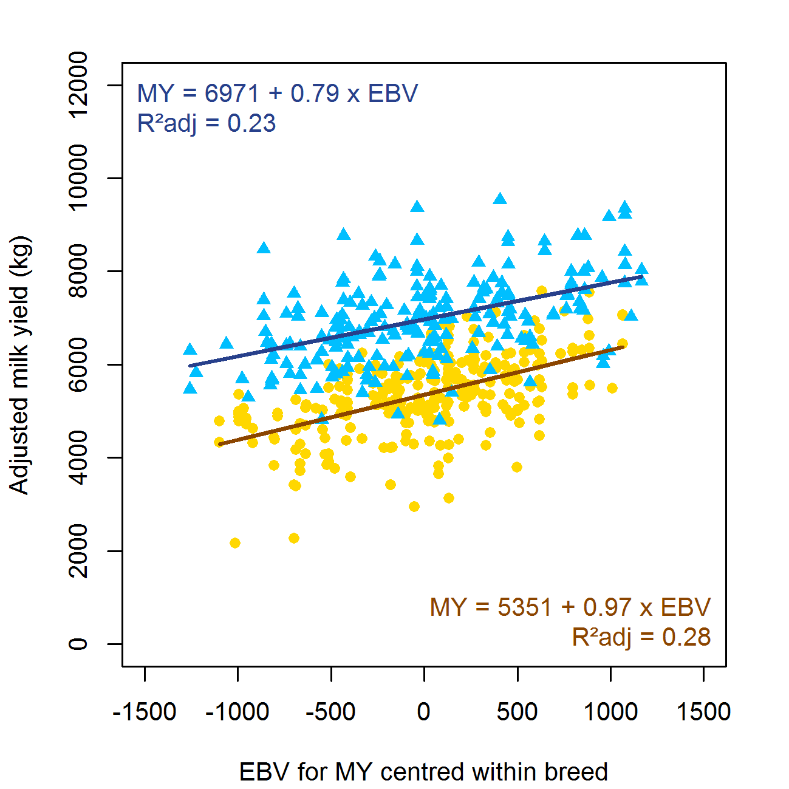
Figure 1 Total milk yield over the 44 weeks of lactation, adjusted from the effect of year, parity, age at first calving, feeding system and lactation length, for Holstein in blue (each filled triangle represents a cow/year) and for Normande in orange (each filled circle represents a cow/year), and regression line of prediction on customized EBV for milk yield for the 217 Holstein and 283 Normande lactations recorded.

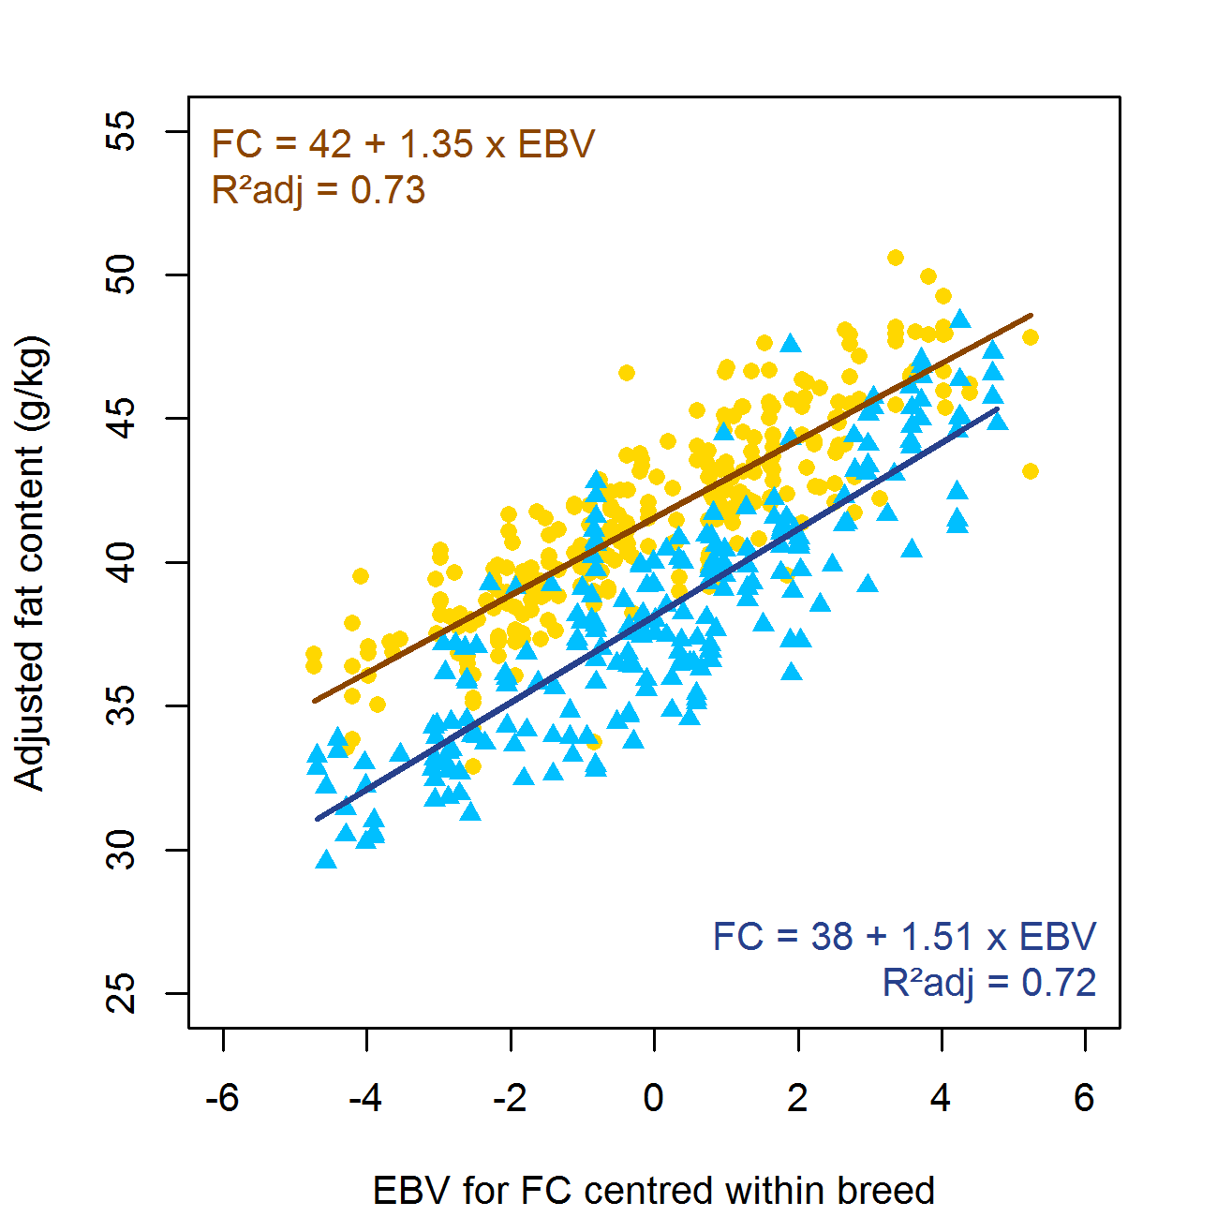
Figure 3 Average milk fat content over the 44 weeks of lactation, adjusted from the effect of year, parity, age at first calving, and feeding system, for Holstein in blue (each filled triangle represent sa cow/year) and for Normande in orange (each filled circle represents a cow/year), and regression line of prediction on customized EBV for fat content for the 217 Holstein and 283 Normande lactations recorded.

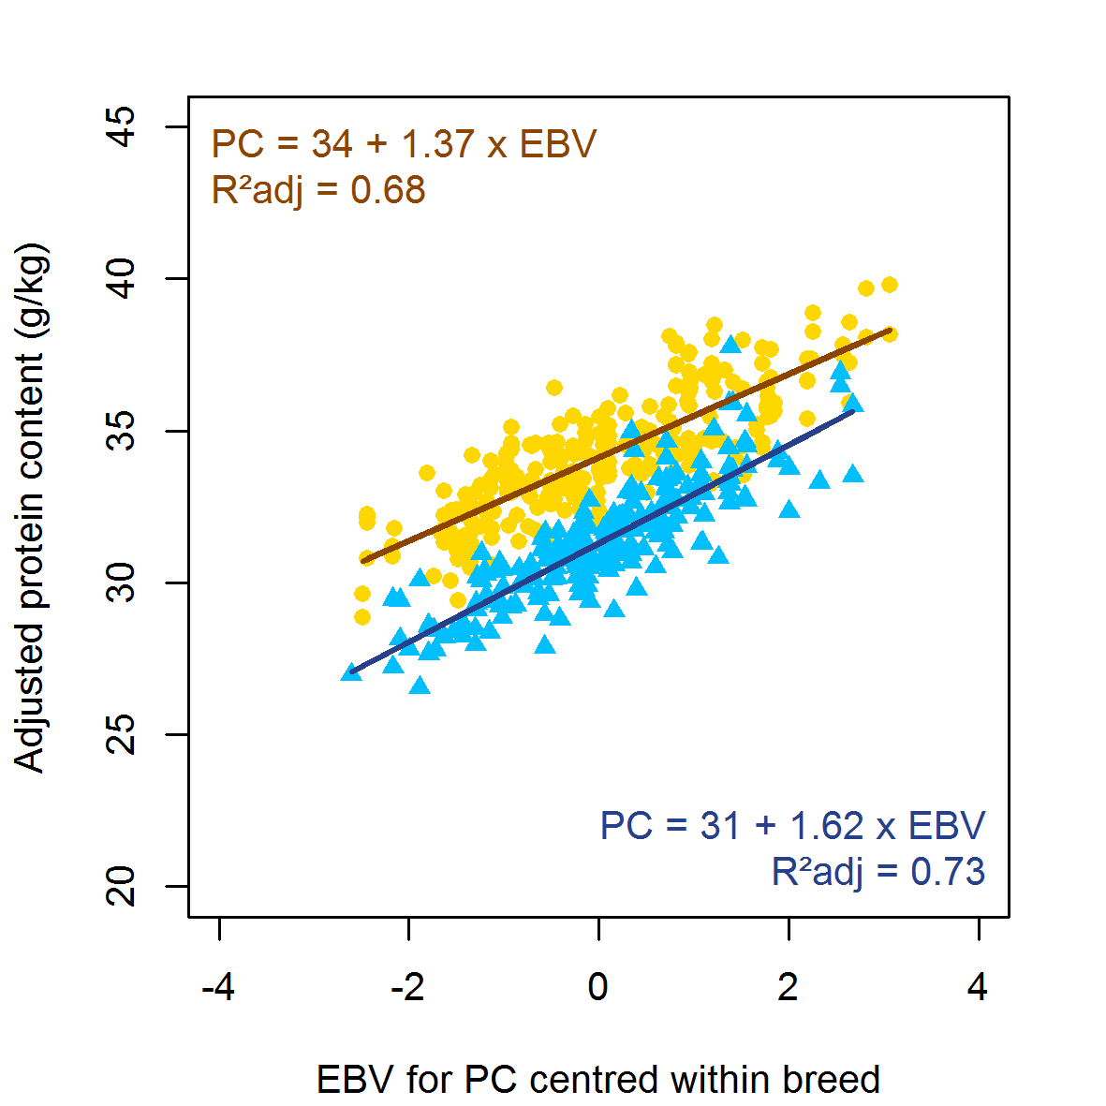
Figure 4 Average milk protein content over the 44 weeks of lactation, adjusted from the effect of year, parity, age at first calving, and feeding system, for Holstein in blue (each filled triangle represents a cow/year) and for Normande in orange (each filled circle represents a cow/year), and regression line of prediction on customized EBV for protein content for the 217 Holstein and 283 Normande lactations recorded.

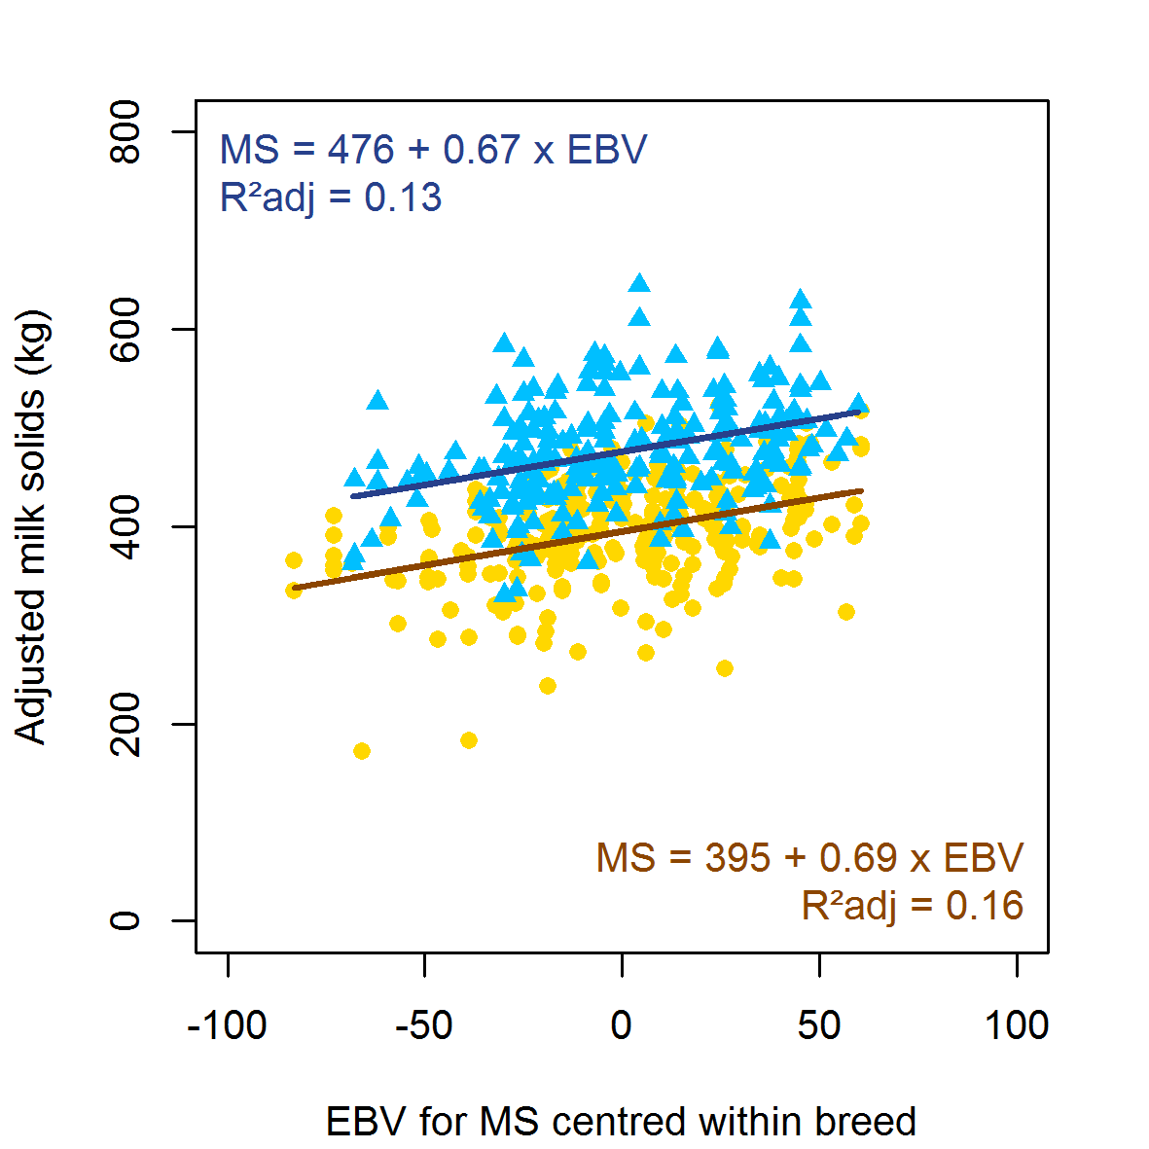
Figure 5 Total milk solids yield over the 44 weeks of lactation, adjusted from the effect of year, parity, age at first calving, feeding system, and lactation length, for Holstein in blue (each filled triangle represents a cow/year) and for Normande in orange (each filled circle represents a cow/year), and regression line of prediction on customized EBV for milk solids for the 217 Holstein and 283 Normande lactations recorded.

