Earlier hatching time predisposes Cobb broiler chickens to tibial dyschondroplasia.
P.J. Groves and W.I. Muir.

Supplementary Materials

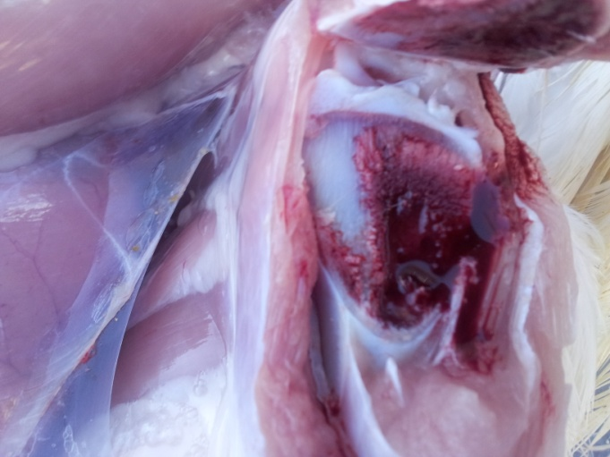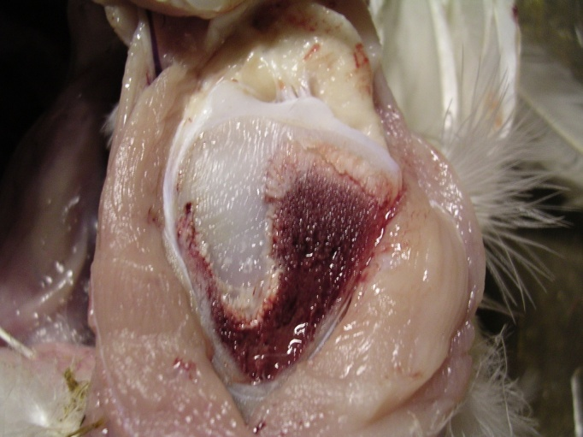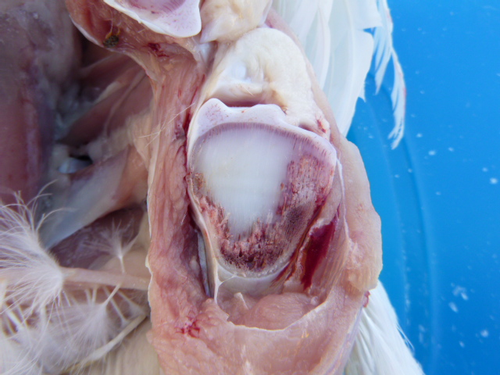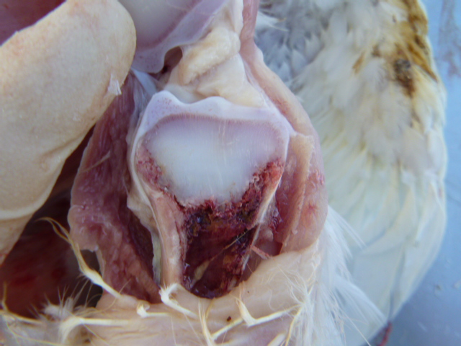
Supplementary Figure S1. Lesions of Tibial Dyschondroplasia shown on a coronal section of the right proximal tibiotarsus. Typical appearance for each lesion score.

Score 4
Score 1
Score 3
Score 2

Supplementary Figure S2. Survival Analysis for Latency-To-Lie for male chicks from each incubator at day 34. Variables: LTL d34 sec by Incubator.
(Censored cases are marked with +). Chi² = 1.83000 df = 4 p = 0.61.

