Supplementary Material S2.
New spline function for criterion 1: absence of hunger
Data as shown in table 1.2 in Botreau et al. (2009) do not match with Figure 1.1. in Botreau et al. (2009). The first four index scores in table 1.2 (Botreau et al., 2009) were placed incorrectly in figure 1.1 in Botreau et al. (2009). Therefore, the data in Botreau et al. (2009) were used to calculate a new and correct spline function as presented below.
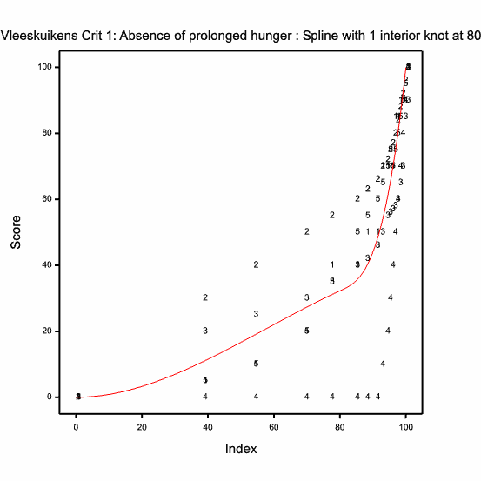
Figure 1 Spline function for criterion 1, absence of hunger, based on data in Botreau et al. (2009).
Table 1 Coefficients and values of spline function for criterion 1 according to the expert consultation in Botreau et al. (2009) and as shown in Figure 1 in this Supplementary Material S2.
Coefficients | Value
a1 | 0.0000000000
b1 | 0.0000000000
c1 | 0.0093729150
d1 | -0.0000541267
a2 | -3865.4448840019
b2 | 144.9541766846
c2 | -1.8025542202
d2 | 0.0074955694

The index is transformed into a score with l-spline functions (Figure 1) as follows:
Index = I
When I≤80 then Score = 0.0093729 x I² - 0.0000541267 x I³
When I≥80 then Score = -3865.445 + (144.95418 x I) – (1.8025542 x I²) + (0.0074955694 x I³)
The index as presented above replaces the index as presented in chapter 5.2.1.1. in Welfare Quality (2009).

References
Botreau R, Buist W, Butterworth A, Perny P and Veissier I 2009. Reports on the construction of welfare criteria for different livestock species. Part 3 – Subcriteria construction for Broilers on farm. Deliverable 2.8c, subtask 2.3.1.2, Welfare Quality® (EU Food-CT-2004-506508), Lelystad, The Netherlands.
Welfare Quality 2009. The Welfare Quality® assessment protocol for poultry (broilers, laying hens). The Welfare Quality® Consortium, Lelystad, The Netherlands.

