Supplementary Material S1
Here we present the modified calculation for criterion 7 (absence of disease) and for the measures of rejections and total mortality of a flock, to replace the calculations as presented in chapter 5.2.1.7 of Welfare Quality (2009).
An expert consultation was performed and spline functions were created for rejection figures and total mortality of a flock. Subsequently, a Choquet integral was calculated for criterion 7 according to Botreau et al. (2009).
Percentage total rejections
Table 1 Results of expert consultation: scores of four experts for different values of imaginary % of rejections for a flock and the average score for all experts.
% Rejections | Expert 1 score | Expert 2 score | Expert 3 score | Expert 4 score | Average  score
0 | 100 | 100 | 100 | 100 | 100
0.5 | 70 | 60 | 75 | 100 | 76.25
1 | 50 | 35 | 41 | 100 | 56.25
1.5 | 20 | 25 | 30 | 90 | 41.25
3 | 15 | 15 | 15 | 70 | 28.75
5 | 10 | 9 | 10 | 50 | 19.75
8 | 8 | 7 | 5 | 30 | 12.5
15 | 0 | 5 | 0 | 10 | 3.75
40 | 0 | 3 | 0 | 0 | 0.75
80 | 0 | 1 | 0 | 0 | 0.25
100 | 0 | 0 | 0 | 0 | 0

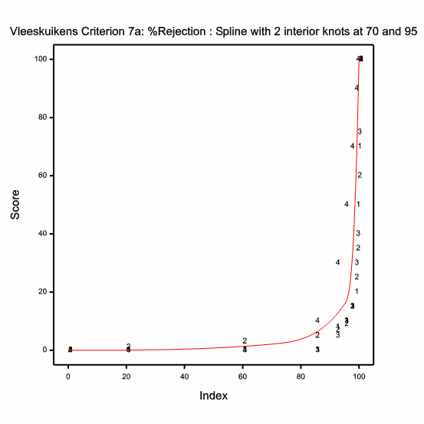
Figure 1 Spline function for criterion 7, measure % rejection, according to the expert consultation as presented in Table 1. Index = 100 - % rejections.
Table 2 Coefficients and values of spline function for criterion 7, measure % rejection, according to the expert consultation presented in Table 1.
Coefficients | Value
a1 | 0.0000000000
b1 | 0.0000000000
c1 | 0.0000000000
d1 | 0.0000061018
a2 | -231.6675631157
b2 | 9.9286098477
c2 | -0.1418372835
d2 | 0.0006815174
a3 | -519197.8596370568
b3 | 16398.3343341204
c3 | -172.6513677013
d3 | 0.6059781032

The index score for % rejections is transformed into a score with l-spline functions (Figure 2) as follows:
Index = I
When I≤70 then Score = 0.0000061018 x I³
When I≥70 and I≤95 then Score = -231.668 + (9.9286 x I) – (0.14183728 x I²) + (0.0006815174 x I³)
When I≥95 then Score = -519197.86 + (16398.334 x I) – (172.651368 x I²) + (0.6059781032 x I³)

Total flock mortality

Table 3 Result of expert consultation: scores of three experts for different values of imaginary % of mortality in a flock and the average expert score.
% Mortality | Expert 1 score | Expert 2 score | Expert 3 score | Average score
0 | 100 | 100 | 100 | 100
1 | 85 | 90 | 100 | 91.67
2 | 50 | 80 | 100 | 76.67
3 | 42 | 50 | 90 | 60.67
4 | 35 | 20 | 80 | 45
5 | 23 | 15 | 60 | 32.67
8 | 16 | 5 | 30 | 17
15 | 10 | 0 | 0 | 3.33
40 | 5 | 0 | 0 | 1.67
80 | 2 | 0 | 0 | 0.67
100 | 0 | 0 | 0 | 0

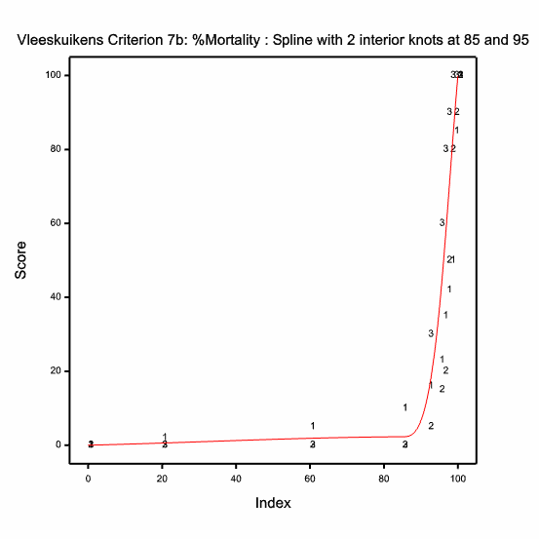
Figure 2 Spline function for criterion 7, measure % mortality, according to the expert consultation as presented in Table 3. Index = 100 - % mortality.

Table 4 Coefficients and values of spline function for criterion 7, measure % rejection, according to the expert consultation presented in Table 3.
Coefficients | Value
a1 | 0.0000000000
b1 | 0.0241473135
c1 | 0.0003195893
d1 | -0.0000033715
a2 | -21268.8183841396
b2 | 750.6883257716
c2 | -8.8310236888
d2 | 0.0346293473
a3 | 109906.7696641756
b3 | -3391.6987003969
c3 | 34.7730506336
d3 | -0.1183674060

The index is transformed into a score with l-spline functions (Figure 2) as follows:
Index = I
When I≤85 then Score = (0.024147 x I) + (0.0003195893 x I²) - (0.0000033715 x I³)
When I≥85 and I≤95 then Score = -21268.82 + (750.6883 x I) – (8.83102368 x I²) + (0.0346293473 x I³)
When I≥95 then Score = 109906.77 - (3391.6987 x I) + (34.77305 x I²) - (0.1183674060 x I³)

Criterion 7 score
The modified calculation for the score of criterion 7 (absence of disease) as presented below replaces the score as presented in Welfare Quality (2009), chapter 5.2.1.7.
The two partial scores for rejections and total mortality are combined using a Choquet integral with the following parameters:
Rejections: µ_{a} = 0.12
Mortality: µ_{b} = 0.71
Sum of capacities = 0.83

References
Botreau R, Buist W, Butterworth A, Perny P and Veissier I 2009. Reports on the construction of welfare criteria for different livestock species. Part 3 – Subcriteria construction for Broilers on farm. Deliverable 2.8c, subtask 2.3.1.2, Welfare Quality® (EU Food-CT-2004-506508), Lelystad, The Netherlands.
Welfare Quality 2009. The Welfare Quality® assessment protocol for poultry (broilers, laying hens). The Welfare Quality® Consortium, Lelystad, The Netherlands.

