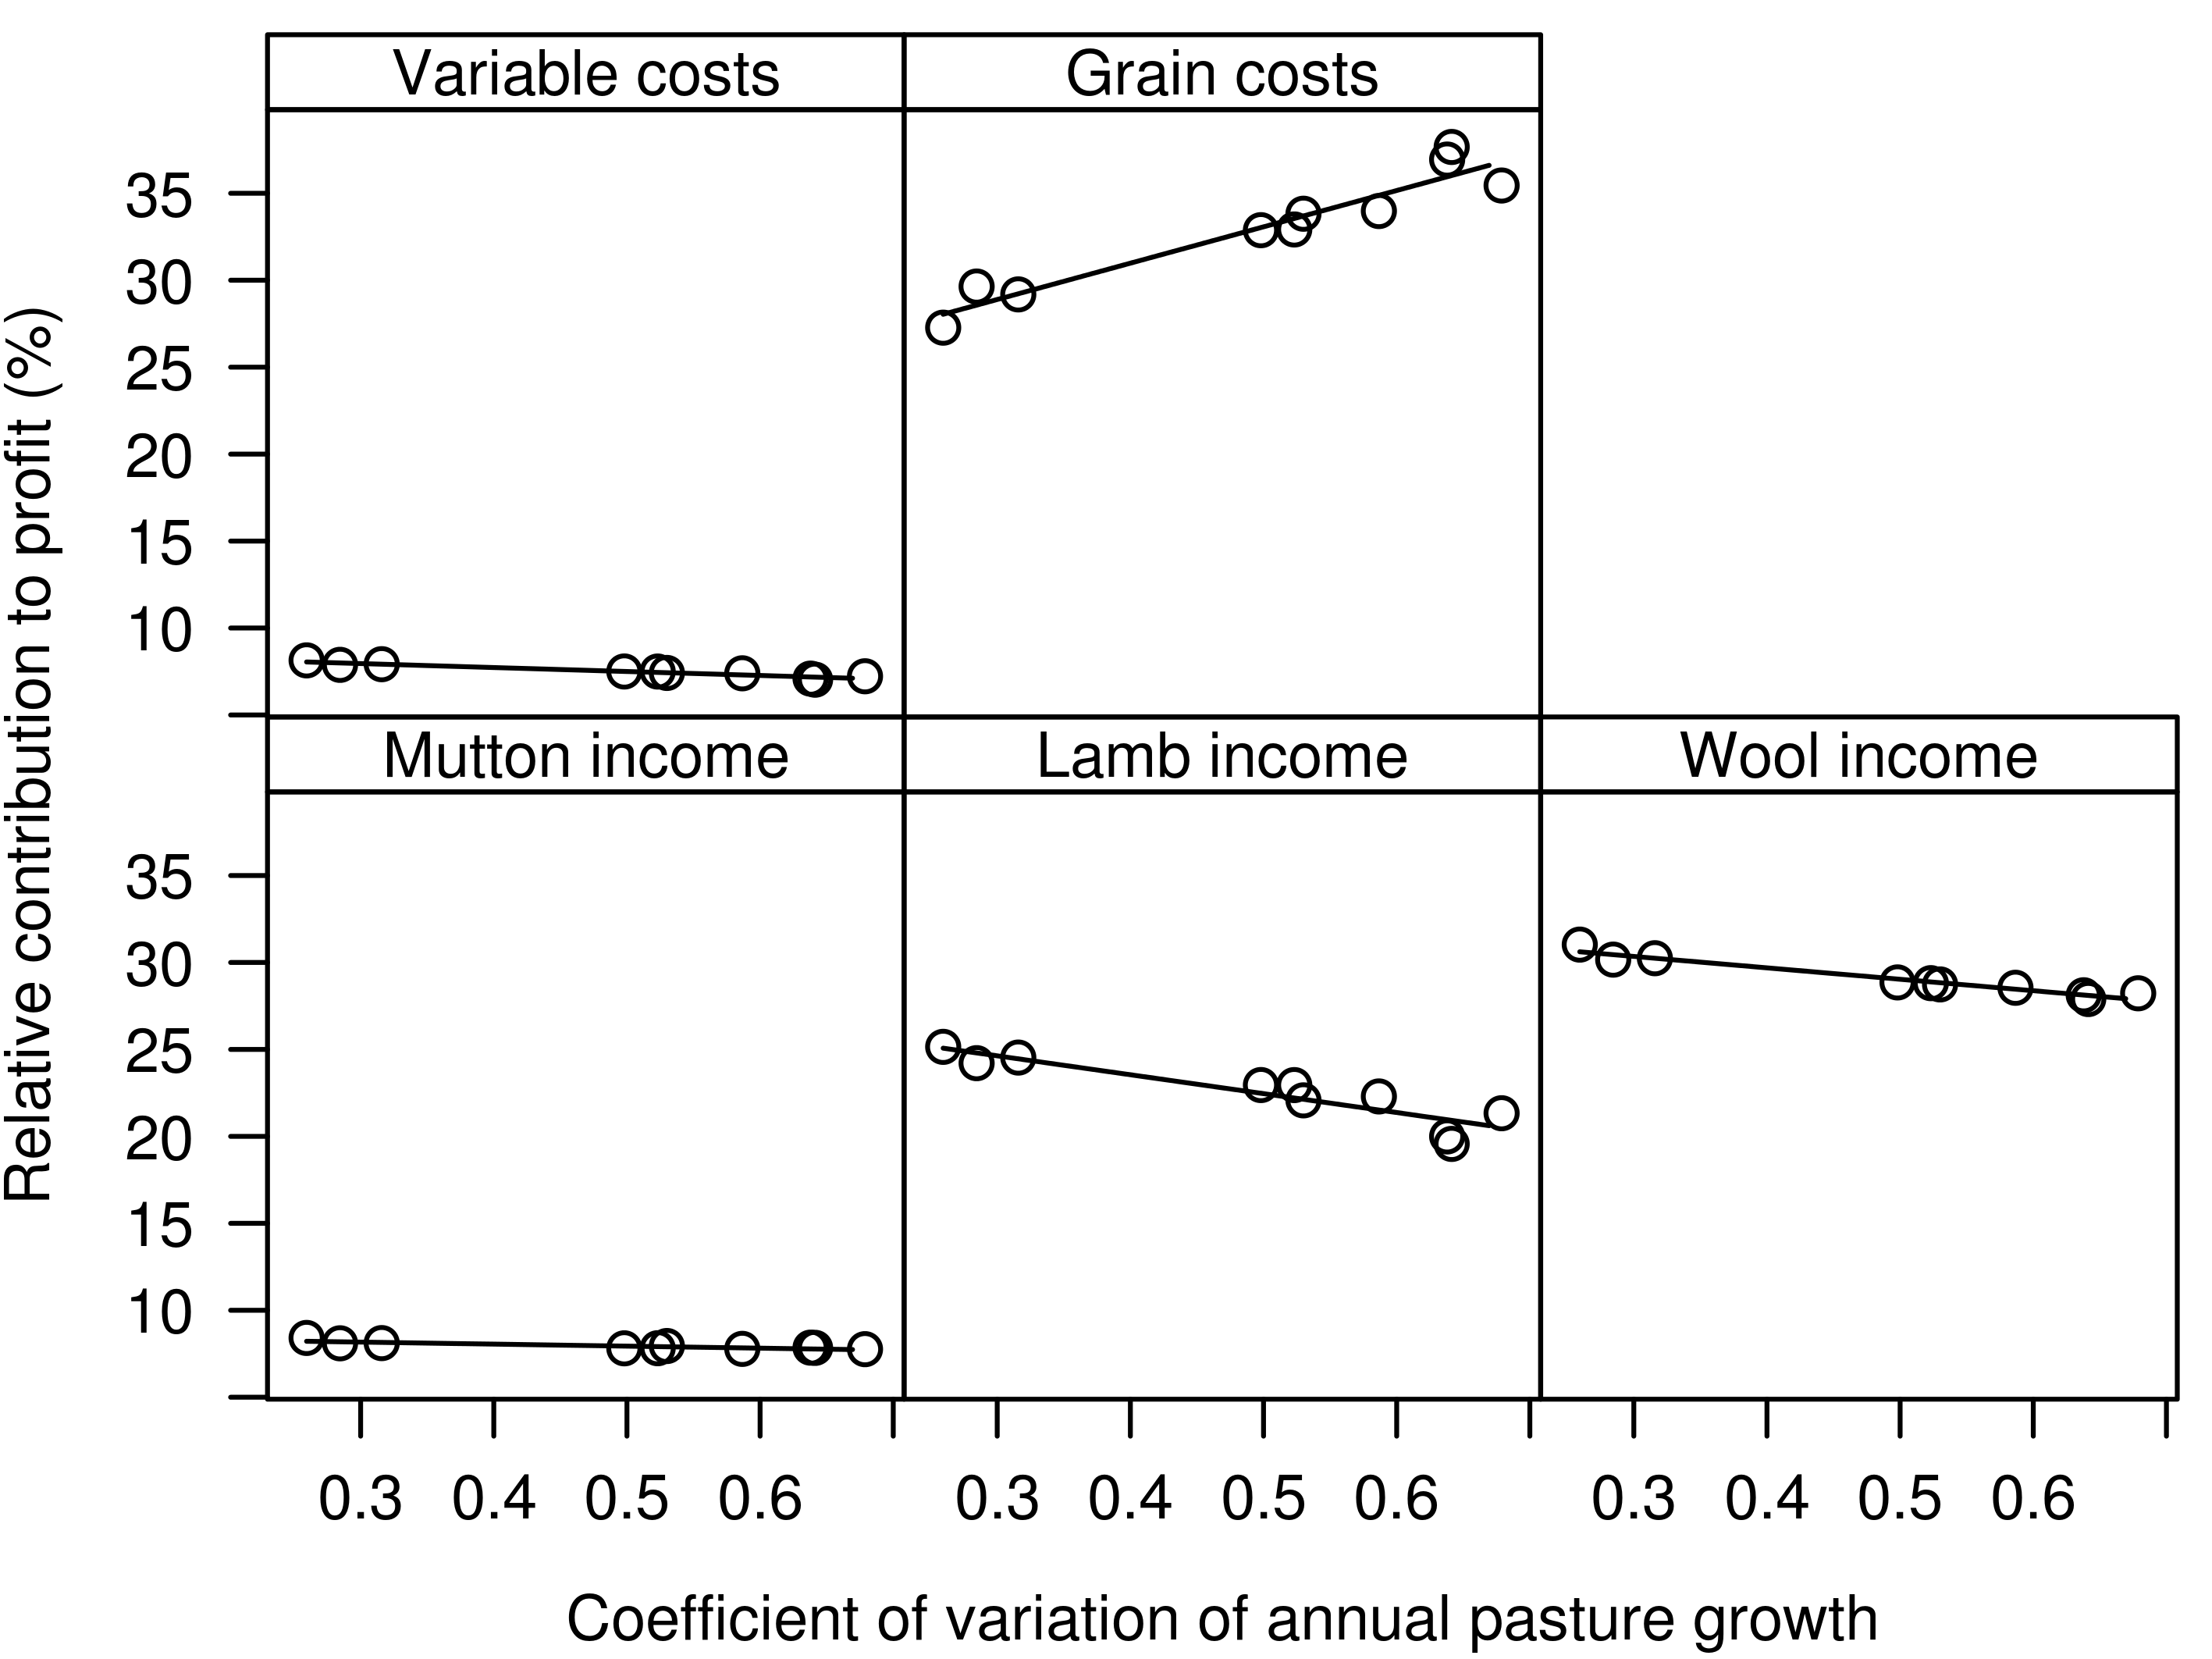
Supplementary Figure S8 Relative contribution of each costs and incomes to overall profit. Calculated by dividing the absolute value of each cost and income by the sum of the absolute costs and incomes.

