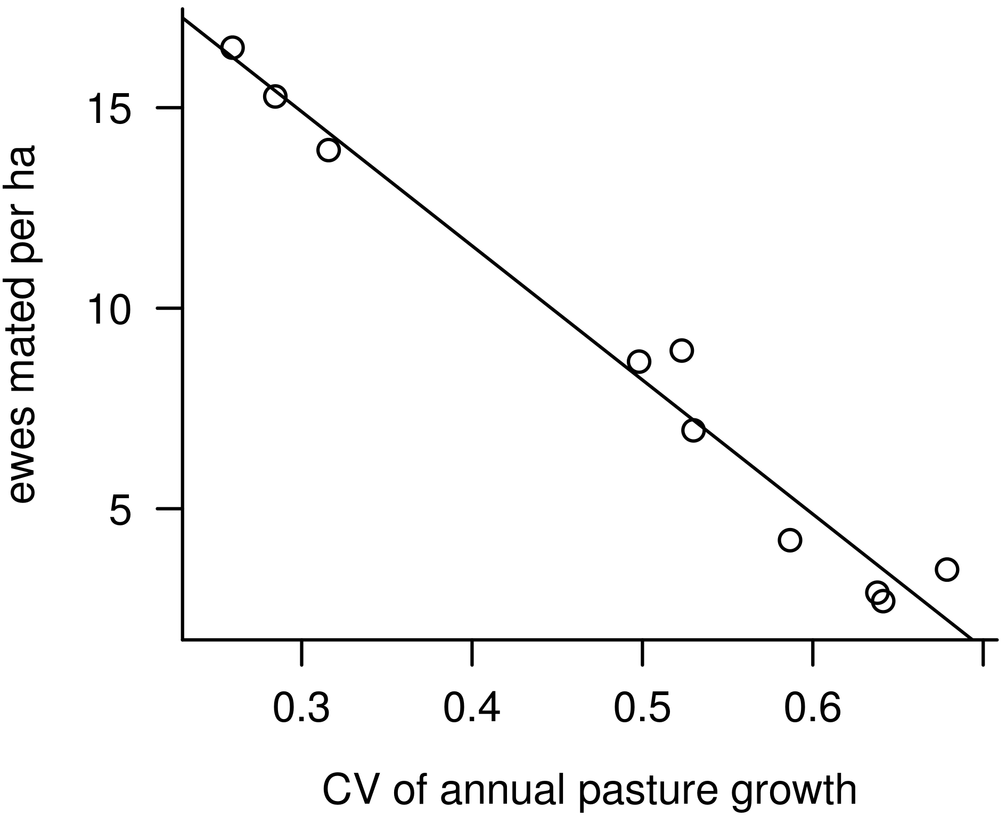
Supplementary Figure S7 Number of ewes mated per ha plotted against coefficient of variation of annual pasture growth for each region.

