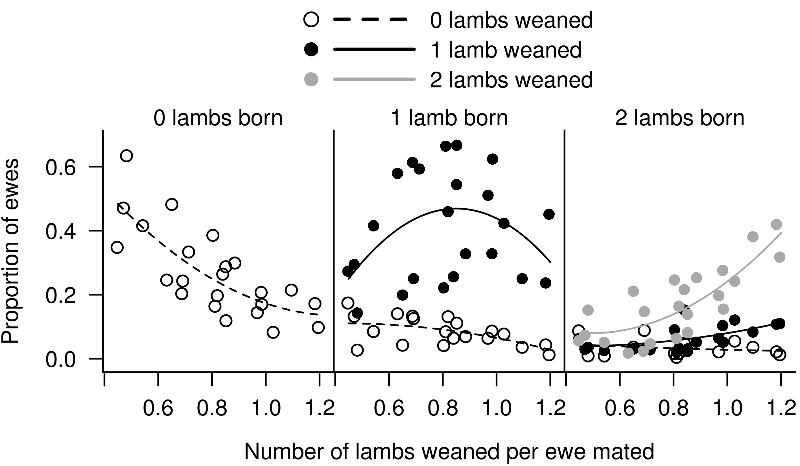
Supplementary Figure S6 The number of ewes in each of the 6 birth and wean categories based on number of weaned per ewe mated estimated from 8 information nucleus flocks (Sheep CRC) from Australia over 3 years. We fitted curves to these points and estimated the number of sheep in the 6 litter size at birth and litter size at weaning category.

