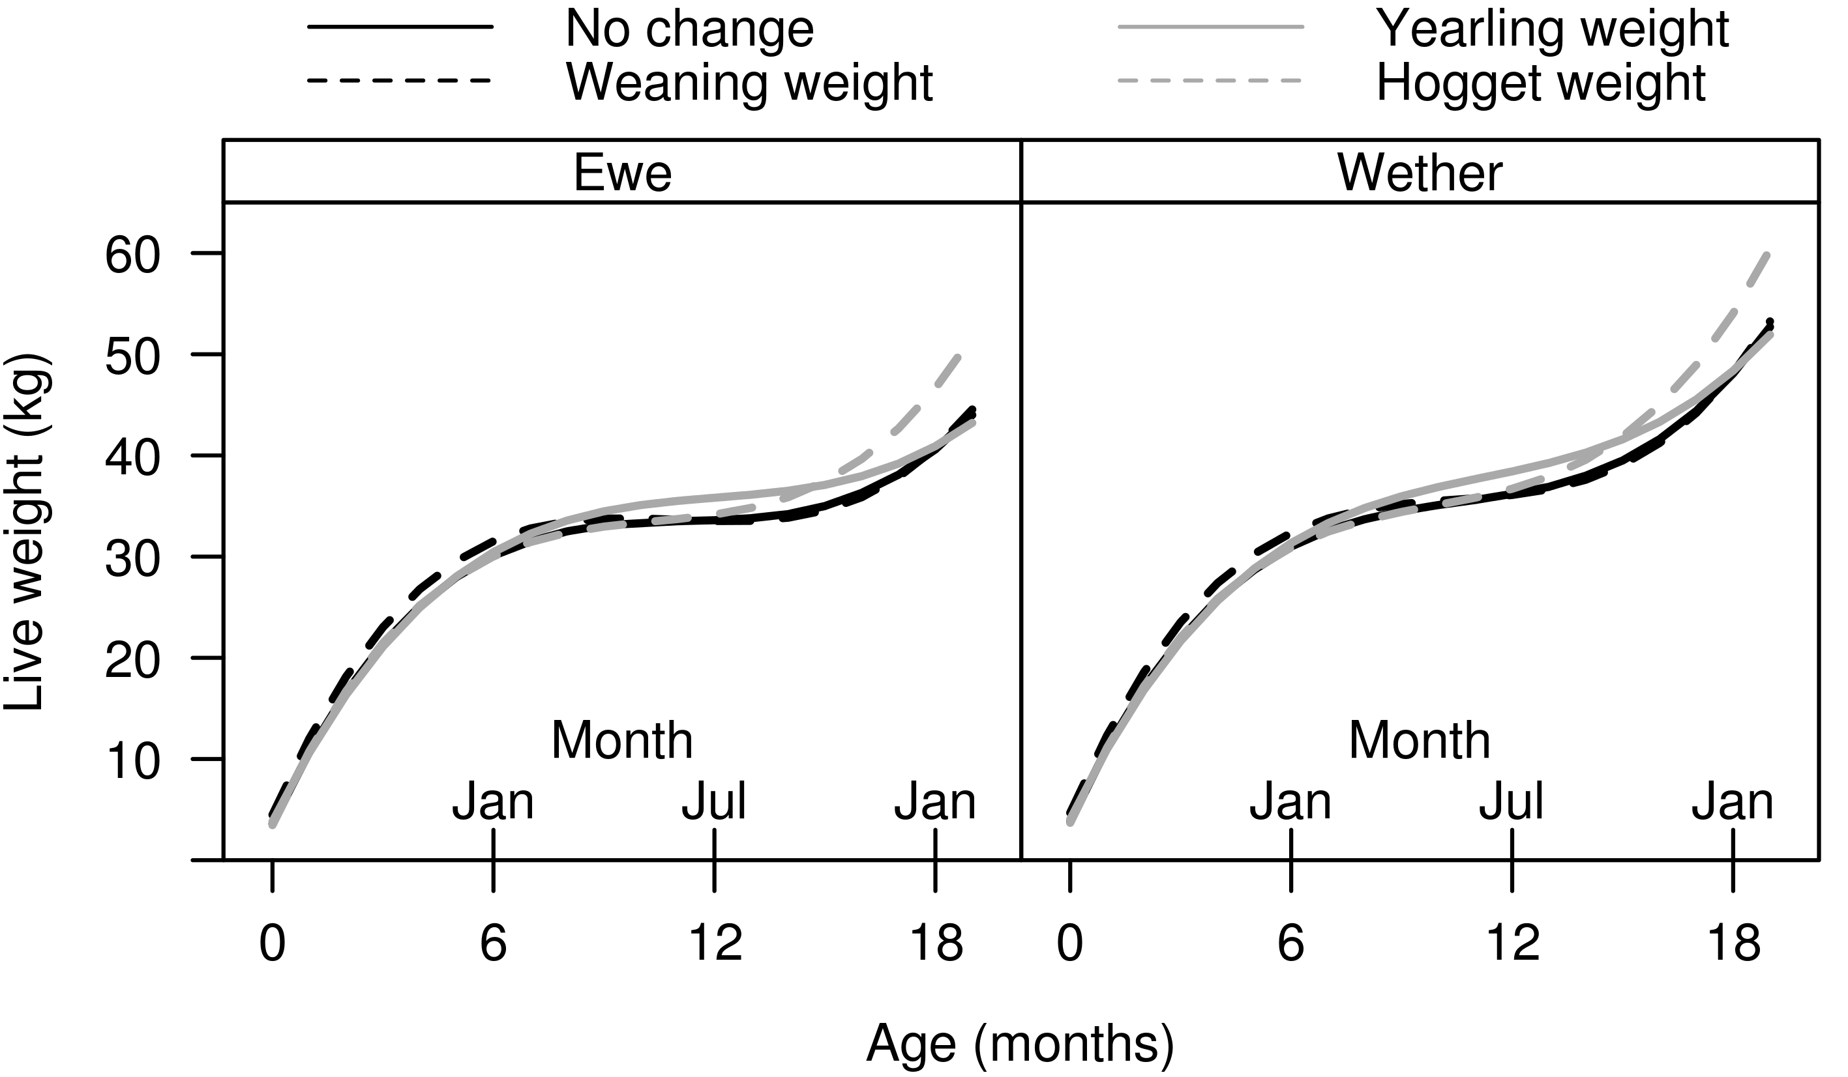
Supplementary Figure S5 alterations of live weight for growing sheep used to calculate economic values of weaning, yearling and hogget live weight. Only lambs that were born and reared as one lamb are shown.

