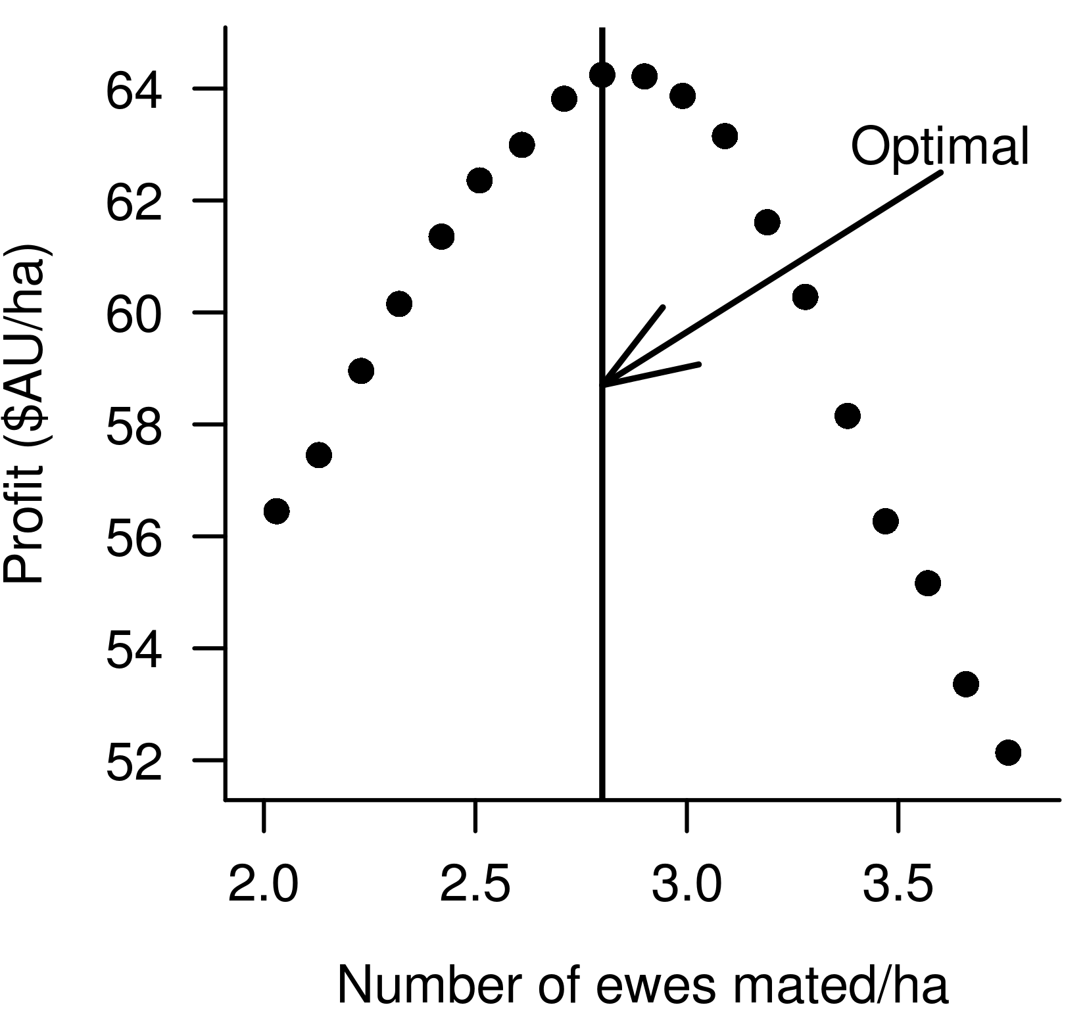
Supplementary Figure S4 Example of how optimal stocking rate was found to maximise profit by increasing number of ewes mated by a small increment. Profit was calculated at each stocking rate until a maximum profit was found.

