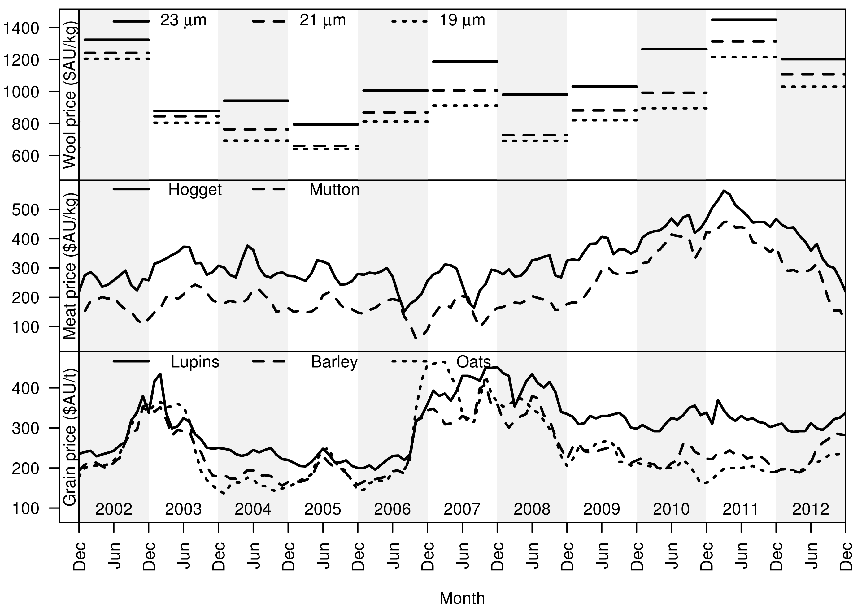Supplementary Figure S3 Wool, meat and grain prices from 2002 to 2012. Used to model profit and economic values for each region.

