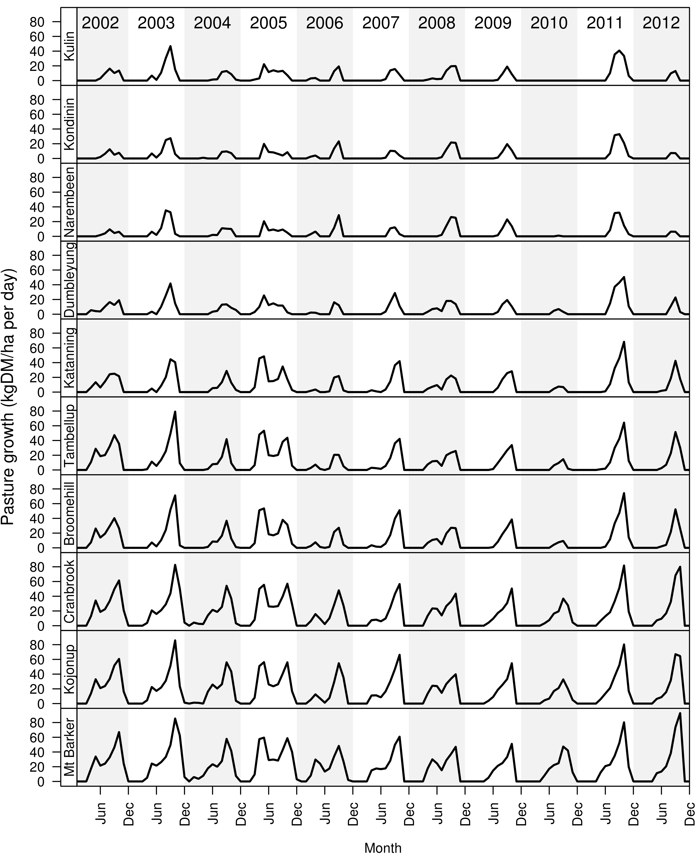
Supplementary Figure S2 Pasture growth rate of 10 climatic regions from 2002-2012. Used to model profit and economic values for each region.

