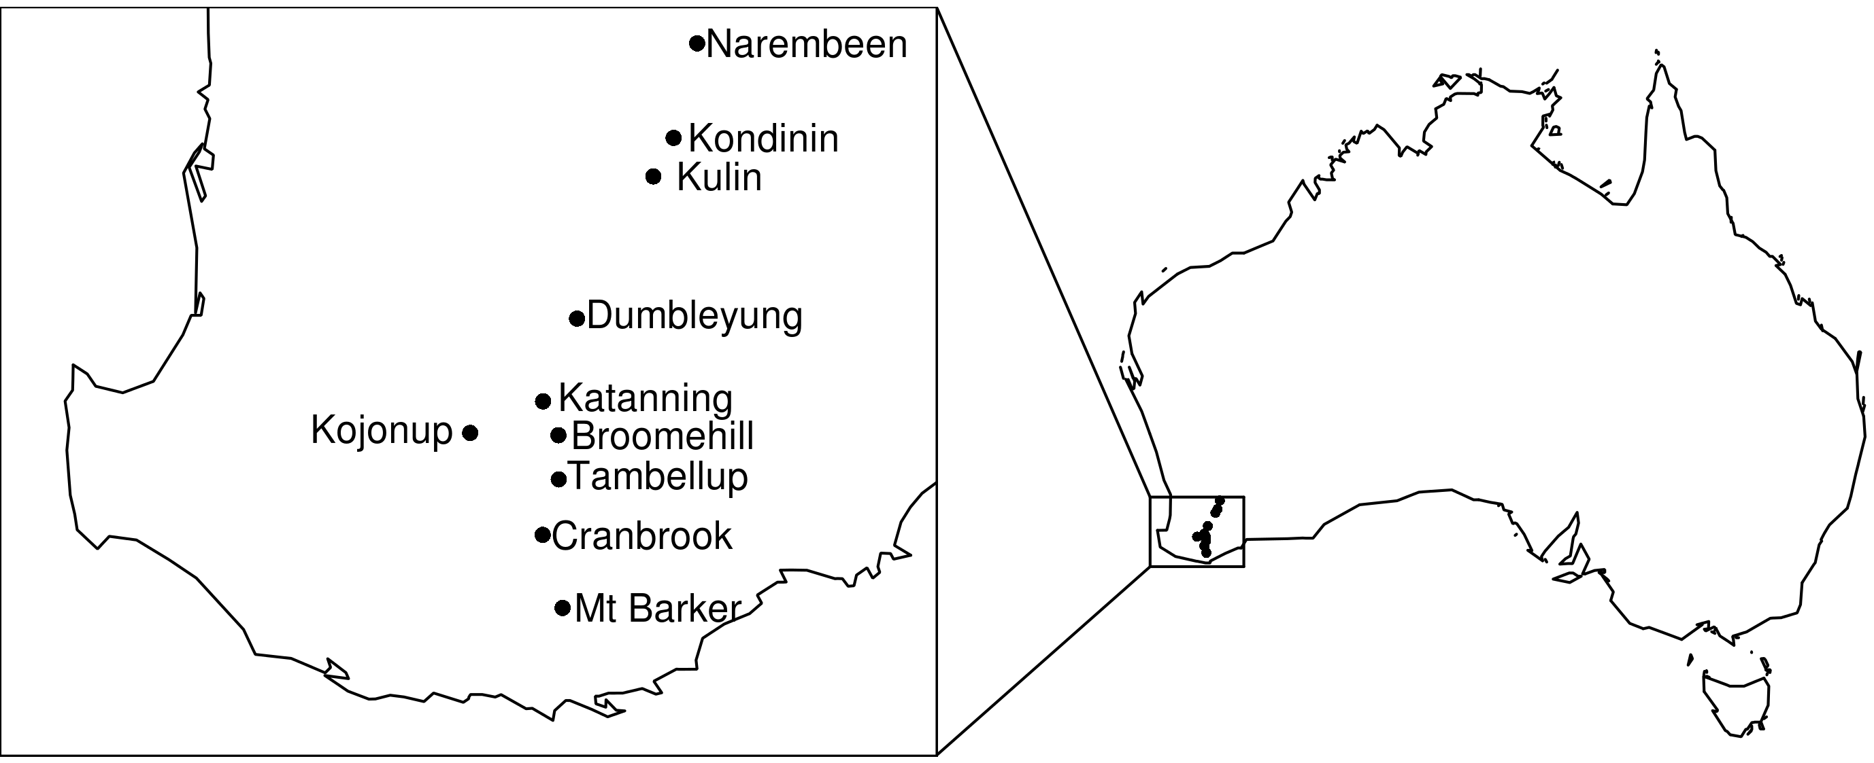
Supplementary Figure S1 location of sheep regions of Western Australia used in this study.

