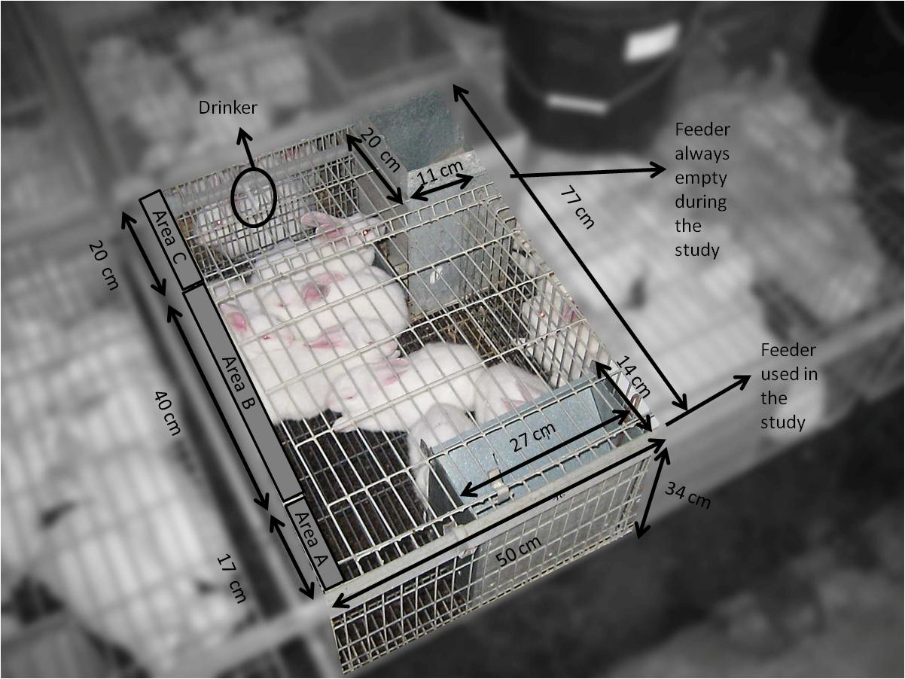
Supplementary Figure S1. Dimensions and conditions of the cages used during the study.

