**Supplementary Material S1: Model parameterisation and test**

*Introduction*

This supplementary material explains the parameterisation and testing of the LIVSIM model for the Méré breed. The model results presented in the paper were obtained with the parameters as explained below. The LIVSIM model and further explanation on its use can be found on [http://models.pps.wur.nl/cofntent/livsim-mere-cattle-mali](http://models.pps.wur.nl/content/livsim-mere-cattle-mali).

*Parameterisation*

The model was parameterised for the Méré breed. Minimum and maximum bodyweight curves by age were fitted using weights and growth rates from the literature (Supplementary Figure S1A). We also used data from the literature (Supplementary Figure S1B) to estimate when heifers achieve reproductive maturity. The earliest age to reach reproduction maturity was set at 4 years with an average body weight of 230 kg. The conception rate is a function of body condition and age of the cow. Calf birth weight is a breed-dependent parameter of the model which is varied according to the feeding system and condition of cows. Milk yields are simulated deterministically in LIVSIM using a breed-dependent potential milk yield curve, which is a function of the length of lactation (Supplementary Figure S2; Coulibaly and Nialibouly, 1998) and is affected by age and body condition. Potential milk yield was set at 6 l/d during the first two months. After two months, potential yields decrease linearly to 0.25 l/d at 18 months when lactation stops. Most *Bos indicus* cows do not let down milk if the calf is not first allowed to suckle. This is also the case with the Méré breed and is the reason to keep calves with their dams for extended periods. Weaning age of calves was set at 1.5 years (Wagenaar *et al.*, 1986).

Fat and crude protein content of milk were set at 46 and 23.6 g/kg, respectively (Bonfoh *et al.*, 2005). Energy needs for lactating cows were set at 1.2 times the need of dry cows and intake was adjusted accordingly (Hunter and Siebert, 1986). Energy use for walking was set at 1.0 KJ/km per kg BW (Dijkman and Lawrence, 1997; Lambourne *et al.*, 1983).

*Model testing*

In the paper we present model tests of body weight development of cows and calves and milk and manure production. We compare the data obtained in farmer participatory feed experiments (Table 1) which belonged to the farm types as shown in Supplementary Table S1. Feed availability per Tropical Livestock Unit (TLU, equivalent to an animal of 250 kg) expressed in kg dry matter (DM) during the experimentation period March-June is presented in Supplementary Table S2. Estimation of fodder availability from pastures and crop residue on cropland is taken from Sanogo (2011) (Supplementary Tables S2 and S3). Quality of the different feed stuffs is similar to that used for the lifetime analysis (Supplementary Table S4). Although the simulated bodyweight was underestimated slightly at larger weights and overestimated at the lower end (Supplementary Figure S3), we conclude that body weight development of cows and calves and milk and manure production are simulated satisfactorily. The discrepancy between simulated body weights at the upper and lower ends of the range can possibly be explained by the intake function used. Discrepancies between model simulations and observed values could be reduced by calibrating the intake function for the local breed.

Simulation of reproduction is important for lifetime productivity analysis. Reproduction determines the total number of calves born per cow, the number of lactations and the amount of milk produced. Condition and BW of the animal throughout its life cycle influence reproduction rates, which in turn depend on the feed supply. In addition, the distribution of calf births throughout the year is influenced by the variability in feed availability. We compared the distribution of simulated calving throughout the year with values reported in the literature. Simulations differed only slightly from observations, which support the robustness of the model for use in lifetime analysis.

The impact of up to plus or minus 20% changes in fraction milked in the different feeding regimes on BW at the end of the lifetime cycle of cows are presented in Supplementary Figure S4A. In particular up to 20% higher fraction milked in the control treatment has a large impact on BW. The impact of fraction of milk allocated to the calves for the different feeding regimes is presented in Supplementary Figure S4B. Baseline for comparison is a fraction of 0.175 of milk taken for human consumption, which is close to what farmers currently milk from their cows. Increasing the fraction of milk taken for human consumption strongly increased calf mortality, with the majority of mortality occurring before offspring reaches the age of three years. The mortality was calculated as the average of 1000 runs (each time one cow) of the offspring during the entire life cycle of that offspring up to the end of the simulation. The fraction of milk given to suckling calves had a large impact on mortality not only up to weaning at 1.5 years, but also at older ages. Weaned calves need to be in good body condition to survive the first harsh period that they experience without milk from the dam, i.e. the next dry and hot season with little fodder of good quality. Management decisions concerning the fraction of milk given to the calf thus have a strong impact on the survival rate after weaning. Thus changes in feeding of lactating cows should consider not only the feeding of dams but also that of the offspring up to the age of three. Additional feeding of the offspring up to three years during harsh periods is important; otherwise the benefits of improved feeding of lactating cows to produce more milk are offset by mortality of the offspring.

Changes in the frequency distribution of birth of the offspring were minor when feeding of lactating cows was improved during the dry and hot season (Supplementary Figure S5a). However, when the diet of lactating cow was improved, calf mortality rates are reduced but timing changed from June-July to February-May) (Supplementary Figure S5b). Timing of the supplementary feeding has to be targeted to the period of greatest need in order to keep the offspring alive.

*Sensitivity analysis*

A sensitivity analysis was conducted to evaluate the impact of parameter values on outcomes of the simulations. Parameter values tested were: walking distance (in km) during grazing and the energy spent per km walked; feed amounts and quality and the lower boundary of the growth curve (see Supplementary Figure S1a). Parameters were changed to ±10 and 20% of the current values.

Increasing the quantity of feed available by 20% increased simulated BW by 6, 14 and 25% for the treatments Control, Supplemented and Stall-fed, respectively. The increase was 28, 34 and 61% for milk production. Lowering the quantity of feed available by 20% resulted in the death of the animals at young age in all treatments and no milk production. Similar trends but with somewhat higher percentages in increase of BW (plus 10, 15 and 27) and of milk production (35, 39 and 61) were found in the respective treatments when the quality of the feed was increased by 20%. When the quality of the feed was decreased by 20%, decreases of BW in the respective treatments were -36, -48% and death of the animal and decreases of milk production were -49, -89 and 100%. The model is thus sensitive to the feed input data, with particularly large impacts on the Control animals in poor condition. Changes in the parameter values for walking distance during grazing (km) and the energy used per km walked had a large impact on the performance of animals in the Control treatment, but less on the animals that were Supplemented and Stall-fed. Based on the model evaluations (fit between the simulated and observed performance of the cows in the participatory experiment), we can use the model confidently to simulate the effect of feeding strategies on productivity.

*References*

*Supplementary Material S1*

Bengaly K, Meurs CBH and Berckmoes WML 1993. La productivité des bovins et des ovins dans les exploitations agricoles de Fonsebougou. Rapport Annuel de Recherche 1993, ESPGRN-Sikasso, Mali.

Bonfoh B, Zinsstag J, Farah Z, Simbé CF, Alfaroukh IO, Aebi R, Badertscher R, Collomb M, Meyer J and Rehberger B 2005. Raw milk composition of Malian Zebu cows (*Bos indicus*) raised under traditional system. Journal of Food Composition and Analysis 18, 29-38.

Coulibaly M and Nialibouly O 1998. Effect of suckling regime on calf growth, milk production and off take of Zebu cattle in Mali. Tropical Animal Health and Production 30, 179-189.

Coulomb J 1972. Opération de développement de l’élevage dans la région de Mopti (République du Mali). Etude du troupeau. IEMVT, Maisons-Alfort, France.

Diallo A 1978. Transhumance: comportement, nutrition et productivité d’un troupeau de zébus de Diafarabé. Thèse CPS, Bamako, Mali.

Dijkman JT and Lawrence PR 1997. The energy expenditure of cattle and buffaloes walking and working in different soil conditions. Journal of Agricultural Science 128, 95-103.

Hunter RA and Siebert BD, 1986. The effects of genotype, age, pregnancy, lactation and rumen characteristics on voluntary intake of roughage diets by cattle. Australian Journal of Agricultural Research 37, 547-560.

Lacrouts M, Sarniguet J and Tyc J 1965. Exploitation du cheptel bovin au Mali. Ministère du Développement, Bamako, République du Mali.

Lambourne LJ, Dicko MS, Sweeney P and Butterworth M 1983. Pastoral systems research in Sub-Saharan Africa: Animal nutrition. International Livestock Center for Africa (ILCA), Addis Ababa, Ethiopia

Sanogo OM, de Ridder N and van Keulen H 2010. Diversité et dynamique des exploitations agricoles mixtes agriculture-élevage au sud du Mali. Cahiers Agricultures 19 (3), 185-193.

Sanogo OM 2010. Évaluation participative des technologies de supplémentation des vaches laitières en milieu paysan au Mali (Koutiala). Revue Canadienne d'études du Développement 31 (1-2), 91-106.

Sanogo OM 2011. Le lait de l’or blanc? Amélioration de la productivité des exploitations mixtes culture-élevage à travers une meilleure gestion et alimentation des vaches laitières dans la zone de Koutiala, Mali. PhD thesis, Wageningen University, Wageningen, the Netherlands.

Wagenaar KT, Diallo A and Sayers AR 1986. Productivity of transhumant Fulani cattle in the inner Niger Delta of Mali. ILCA Research Report No 13, International Livestock Center for Africa (ILCA), Addis Ababa, Ethiopia.

Wilson RT 1986. Livestock production in central Mali: Long-term studies on cattle and small ruminants in the agro-pastoral system. ILCA Research Report No. 14, International Livestock Center for Africa (ILCA), Addis Ababa, Ethiopia.

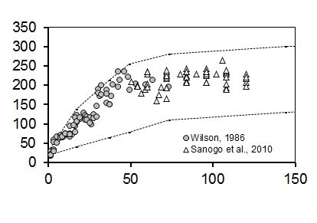

A

Bodyweight (kg)

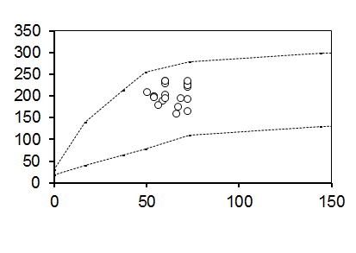

Age (months)

B

*Supplementary Figure S1. A) Fitted potential growth curve and minimum body weight curve (Wilson, 1986; Sanogo, 2010), and B) the feasible age–bodyweight set when heifers achieve reproductive maturity (Lacrouts et al., 1965; Coulomb, 1972; Diallo, 1978; Wagenaar et al., 1986; Bengaly et al., 1993) for Méré cattle.*

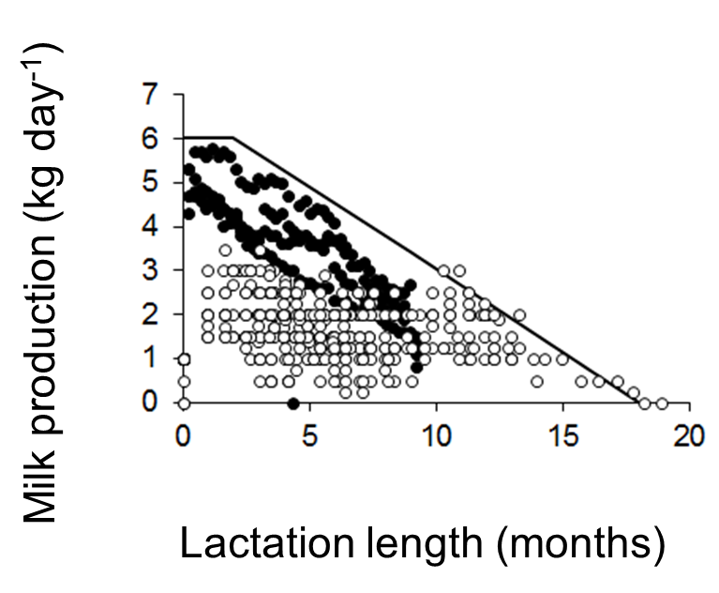

*Supplementary Figure S2. Literature data on daily milk production in relation to length of the lactation period. Data are from Hunter and Siebert (1986) (closed symbols) and Sanogo (2010) (open symbols).*

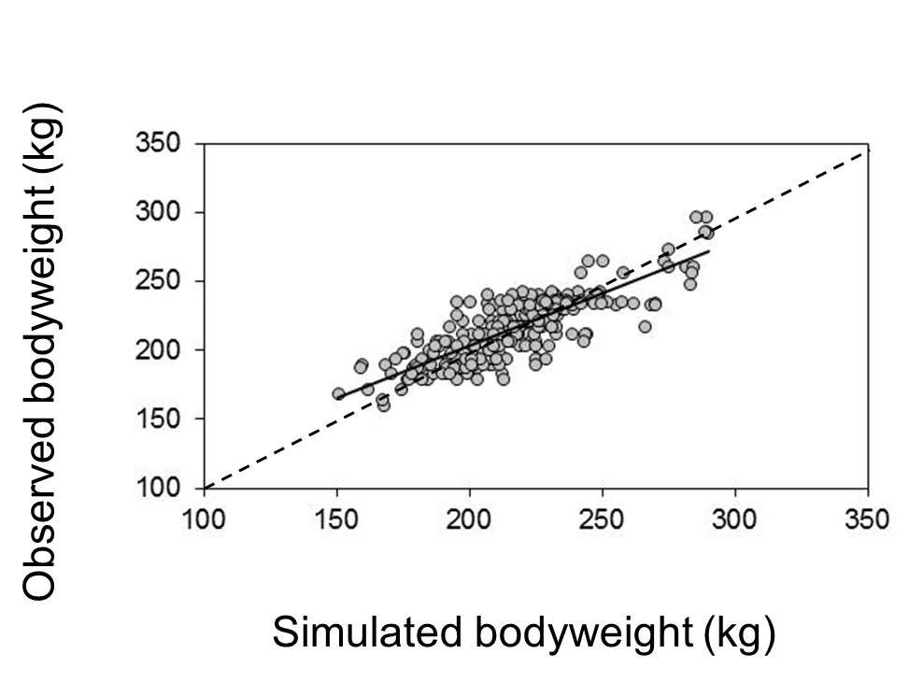

*Supplementary Figure S3. Observed body weight of cows in a farmer participatory feeding trial compared with values simulated using LIVSIM. The dotted line represents the 1:1 line. The trend line (y = 0.77x + 50; R2 = 0.68) shows a good fit but at low weights observed weights are larger than simulated and at high weights observed are less than simulated.*



*Supplementary Figure S4.* *Sensitivity of changes in fraction milked for different feeding regimes on BW of lactating dams (A); and of fraction milked on mortality of their offspring (B). Mortality is calculated including all animals belonging to the offspring of a cow that die during the time span of the lifetime analysis of this cow. The given mortality rate is the average of 1000 runs. Mortality of offspring is particularly heavy up to the second year in the months March, April, May and June.*

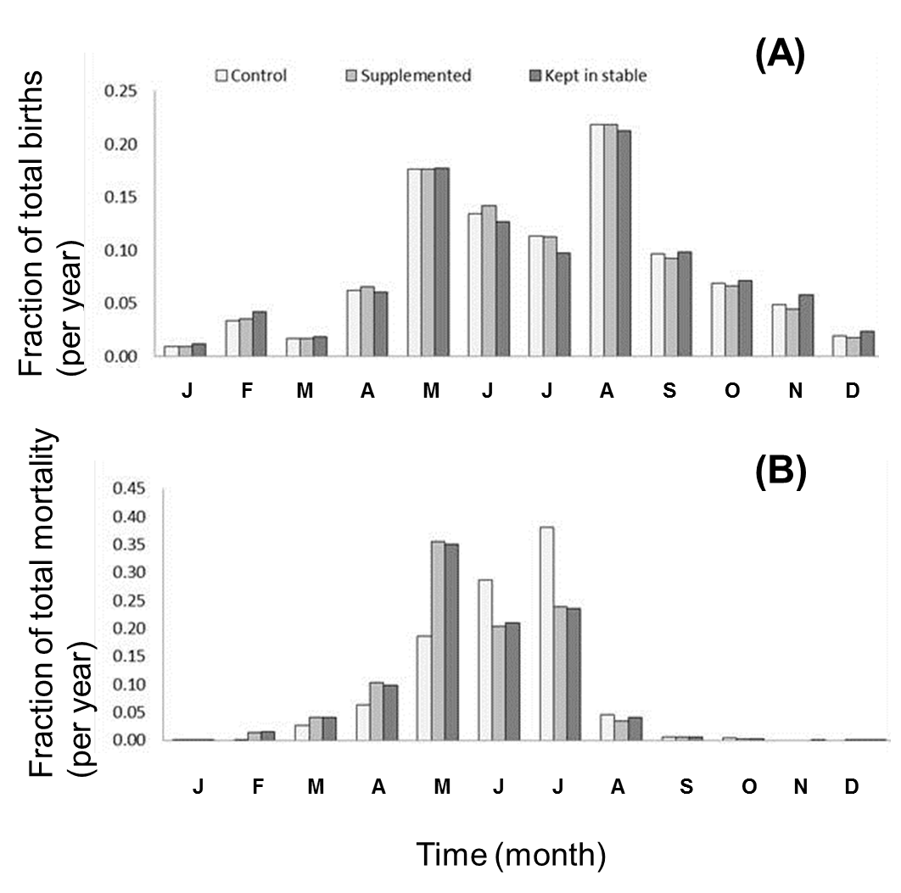

*Supplementary Figure S5.* *Impact of changing feeding regime in the hot and dry season on (a) the frequency distribution of birth events through the year; and (b) impact on mortality of offspring until the second year.*

*Supplementary Table S1. Characteristics of farm types in the Koutiala region, Mali 2008 average values (+ standard deviation).*

|  |  |  |  |  |  |  |  |  |  |  |  |  |  |
| --- | --- | --- | --- | --- | --- | --- | --- | --- | --- | --- | --- | --- | --- |
| Farm typea | TLUb | Oxen | | Equipment | Family labour | Family labour per  unit of land | | Area allocated to different crops | | | | | Food self  sufficient |
| cotton | | maize | | cereals |
|  | (#) | (#) | | (#) | (#) | (# per ha) | | (%) | | (%) | | (%) |  |
| 1 | 56.9 (16.7) | 8.0 (2.8) | | 8.3 (1.7) | 20.8 (5.7) | 1.0 (0.1) | | 41.3 (7.9) | | 12.6 (2.4) | | 53.7 (8.7) | yes |
| 2 | 14.9 (8.1) | 3.8 (1.3) | | 5.3 (1.6) | 11.3 (4.9) | 0.9 (0.3) | | 38.1 (9.4) | | 9.1 (4.6) | | 55.9 (9.2) | yes |
| 3 | 4.4 (1.8) | 1.3 (1.2) | | 2.3 (2.5) | 4.0 (0.9) | 0.6 (0.2) | | 36.4 (12.0) | | 5.6 (4.9) | | 59.5 (8.3) | yes |
| 4 | 1.1 (0.2) | 0.0 (0.0) | | 1.0 (0.0) | 2.8 (1.4) | 1.7 (1.5) | | 0.0 (0.0) | | 0.0 (0.0) | | 84.2 (27.3) | no |
| after Sanogo *et al*., 2010 | | |  | |  | |  | |  | |  |  |  |
| a Farm types 1, 2 and 3 are large, medium and small mixed farms practicing arable farming and keeping cattle. Farm type 4 represents small farms with no cattle. | | | | | | | | | | | | | |
| b TLU: Tropical Livestock Unit equivalent to an animal of 250 kg | | | | | | |  | |  | |  |  |  |

*Supplementary Table S2. Feed availability from pastures differing in quantity and quality (Pasture type 1 is on bottomland and Pasture type 2 on crests), crop residues (grazed or fed from stock) and supplements on offer expressed in kg DM/TLU per month for the villages of Try and N’Goukan for three feeding strategies implemented in the participatory trial.*

|  |  |  |  |  |  |  |
| --- | --- | --- | --- | --- | --- | --- |
| Village | Treatment | Feed | March | April | May | June |
|  |  |  | (kg DM/TLU per month) | | | |
| Try | Control | Pasture type 1 | 44 | 38 | 33 | 115 |
|  |  | Pasture type 2 | 29 | 25 | 22 | 77 |
|  |  | Grazing of residues | 71 | 62 | 55 | 0 |
|  |  | Cereals bran | 30 | 30 | 30 | 30 |
|  |  | Crop residues | 20 | 20 | 20 | 20 |
|  | Supplemented | Pasture type 1 | 44 | 38 | 33 | 115 |
|  |  | Pasture type 2 | 29 | 25 | 22 | 77 |
|  |  | Grazing of residues | 71 | 62 | 55 | 0 |
|  |  | Cotton seed cake | 60 | 60 | 60 | 60 |
|  |  | Cowpea hay | 30 | 30 | 30 | 30 |
|  | Stall-fed | Cotton seed cake | 60 | 60 | 60 | 60 |
|  | (dry season only) | Cowpea hay | 75 | 75 | 75 | 75 |
|  |  | Crop residues | 80 | 80 | 80 | 80 |
| N'Goukan | Control | Pasture type 1 | 31 | 27 | 23 | 118 |
|  |  | Pasture type 2 | 6 | 5 | 4 | 39 |
|  |  | Grazing of residues | 87 | 77 | 67 | 0 |
|  |  | Cereals bran | 30 | 30 | 30 | 30 |
|  |  | Crop residues | 20 | 20 | 20 | 20 |
|  | Supplemented | Pasture type 1 | 31 | 27 | 23 | 118 |
|  |  | Pasture type 2 | 6 | 5 | 4 | 39 |
|  |  | Grazing of residues | 87 | 77 | 67 | 0 |
|  |  | Cotton seed cake | 60 | 60 | 60 | 60 |
|  |  | Cowpea hay | 30 | 30 | 30 | 30 |
|  | Stall-fed | Cotton seed cake | 60 | 60 | 60 | 60 |
|  | (dry season only) | Cowpea hay | 75 | 75 | 75 | 75 |
|  |  | Crop residues | 80 | 80 | 80 | 80 |

*Supplementary Table S3. Feed availability from pastures (Pasture type 1 is on bottomland and Pasture type 2 on crests), crop residues (grazed or fed from stock) and supplements (kg DM/TLU per month) for four feeding strategies used in the lifetime analysis.*

|  |  |  |  |  |  |  |  |  |  |  |  |  |  |  |  |  |  |  |  |  |  |  |  |  |  |
| --- | --- | --- | --- | --- | --- | --- | --- | --- | --- | --- | --- | --- | --- | --- | --- | --- | --- | --- | --- | --- | --- | --- | --- | --- | --- |
|  |  | Mar | Apr | May | Jun |  | | Jul | | August | | Sep | | Oct | |  | | Nov | | Dec | | Jan | | Feb | |
|  |  | (kg DM/TLU per month) | | | | | | | | | | | | | | | | | | | | | | | |
| Control | Pasture type 1 | 44 | 38 | 33 | 115 | |  | | 303 | | 303 | | 303 | | 182 | |  | | 75 | | 65 | | 57 | | 50 | |
|  | Pasture type 2 | 29 | 25 | 22 | 77 | |  | | 199 | | 199 | | 199 | | 90 | |  | | 49 | | 43 | | 38 | | 33 | |
|  | Residues grazed | 71 | 62 | 55 | 0 | |  | | 0 | | 0 | | 0 | | 139 | |  | | 122 | | 106 | | 93 | | 82 | |
|  | Husk of cereals | 30 | 30 | 30 | 30 | |  | | 0 | | 0 | | 0 | | 0 | |  | | 0 | | 0 | | 0 | | 0 | |
|  | Crop residues | 20 | 20 | 20 | 20 | |  | | 0 | | 0 | | 0 | | 0 | |  | | 0 | | 0 | | 0 | | 0 | |
| Supplemented | Pasture type 1 | 44 | 38 | 33 | 115 | |  | | 303 | | 303 | | 303 | | 182 | |  | | 75 | | 65 | | 57 | | 50 | |
|  | Pasture type 2 | 29 | 25 | 22 | 77 | |  | | 199 | | 199 | | 199 | | 90 | |  | | 49 | | 43 | | 38 | | 33 | |
|  | Residues grazed | 71 | 62 | 55 | 0 | |  | | 0 | | 0 | | 0 | | 139 | |  | | 122 | | 106 | | 93 | | 82 | |
|  | Cotton seed cake | 60 | 60 | 60 | 60 | |  | | 0 | | 0 | | 0 | | 0 | |  | | 0 | | 0 | | 0 | | 0 | |
|  | Cow pea hay | 30 | 30 | 30 | 30 | |  | | 0 | | 0 | | 0 | | 0 | |  | | 0 | | 0 | | 0 | | 0 | |
| Stall-fed | Pasture type 1 | 0 | 0 | 0 | 0 | |  | | 303 | | 303 | | 303 | | 182 | |  | | 75 | | 65 | | 57 | | 50 | |
| (dry season only) | Pasture type 2 | 0 | 0 | 0 | 0 | |  | | 199 | | 199 | | 199 | | 90 | |  | | 49 | | 43 | | 38 | | 33 | |
|  | Residues grazed | 0 | 0 | 0 | 0 | |  | | 0 | | 0 | | 0 | | 139 | |  | | 122 | | 106 | | 93 | | 82 | |
|  | Cotton seed cake | 60 | 60 | 60 | 60 | |  | | 0 | | 0 | | 0 | | 0 | |  | | 0 | | 0 | | 0 | | 0 | |
|  | Cow pea hay | 75 | 75 | 75 | 75 | |  | | 0 | | 0 | | 0 | | 0 | |  | | 0 | | 0 | | 0 | | 0 | |
|  | Crop residues | 80 | 80 | 80 | 80 | |  | | 0 | | 0 | | 0 | | 0 | |  | | 0 | | 0 | | 0 | | 0 | |
| Stall-fed | Cotton seed cake | 90 | 90 | 90 | 90 | |  | | 90 | | 90 | | 90 | | 90 | |  | | 90 | | 90 | | 90 | | 90 | |
| (year round) | Cow pea hay | 60 | 60 | 60 | 60 | |  | | 60 | | 60 | | 60 | | 60 | |  | | 60 | | 60 | | 60 | | 60 | |
|  | Crop residues | 120 | 120 | 120 | 120 | |  | | 120 | | 120 | | 120 | | 120 | |  | | 120 | | 120 | | 120 | | 120 | |

*Supplementary Table S4. Feed quality from pastures (Pasture type 1 on bottomlands and Pasture type 2 on crests), residues grazed or fed from stock, and supplements for four feeding strategies used in the lifetime analysis.*

|  |  |  |  |  |  |  |  |  |  |  |  |  |  |  |
| --- | --- | --- | --- | --- | --- | --- | --- | --- | --- | --- | --- | --- | --- | --- |
|  | Dry and hot season (March-June) | | | | Rainy season (July-October) | | | | Dry and cool season (November-February) | | | | | |
|  | DM | ME | CP | DDM | DM | ME | CP | DDM | | DM | ME | CP | DDM |
|  | (g/kg) | (MJ/kg DM) | (g/kg DM) | (g/kg DM) | (g/kg) | (MJ/kg DM) | (g/kg DM) | (g/kg DM) | | (g/kg) | (MJ/kg DM) | (g/kg DM) | (g/kg DM) |
| Pasture type 1 | 864 | 7.1 | 71.2 | 559 | 317 | 9.5 | 97.8 | 748 | | 675 | 7.9 | 77.5 | 624 |
| Pasture type 2 | 807 | 6.8 | 69.0 | 533 | 385 | 9.4 | 96.0 | 737 | | 620 | 7.6 | 74.9 | 600 |
| Crop residues | 863 | 6.7 | 64.3 | 500 |  |  |  |  | | 863 | 7.0 | 64.3 | 550 |
| Cow pea hay | 940 | 9.4 | 137.5 | 730 |  |  |  |  | |  |  |  |  |
| *Stylosanthes* hay | 940 | 9.6 | 105.2 | 650 |  |  |  |  | |  |  |  |  |
| Cotton seed cake | 916 | 12.3 | 276.0 | 710 |  |  |  |  | |  |  |  |  |
| Cotton seed | 863 | 7.0 | 64.3 | 550 |  |  |  |  | |  |  |  |  |
| Cereal bran | 898 | 9.0 | 124.7 | 690 |  |  |  |  | |  |  |  |  |