Supplementary Material

BCS Class | Description | Example
1 (cachectic) | Full visibility of ribs, exposed iliac and ischial bones and pronounced muscle atrophy (“skin and bones” appearance)
2 (thin) | Very prominent bones and visibility of the dorsal, iliac and ischial processes
3 (optimal) | Slight muscle coverage and no fat layers
4 (fat) | Good muscle coverage and some fat deposition in the tail insertion;
5 (obese) | All body angles covered, including the protruding parts of the skeleton, and a round appearance of the animal.
Supplementary Figure S1. Descriptions about body condition score measurement, detailing what points should be observed in body cows. Pictures from Nellore Jandaia herd, by author of this paper.

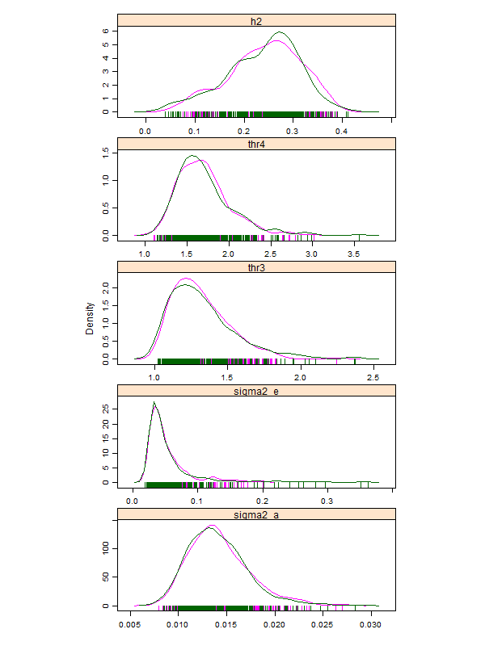
Supplementary Figure S2. Posterior distributions of all parameters estimated in the genetic analysis of the body condition score of Nellore cows, where h2, thr3, thr4, sigma2_e and sigma2_a, represent the marginal posterior densities of the estimates of heritability, third threshold, fourth threshold, residual variance and additive variance, respectively.

