Supplementary material
Supplementary Figure S1. Dot plots corresponding to the sperm head size obtained from the computerised morphometric analysis (dimensional parameters area and perimeter) under capacitating and non capacitating in vitro incubation conditions in bovine spermatozoa. Each dot plot was represented to follow the progressive evolution of the different sperm population groups among incubation media (TBM: Tyrode's basal medium; TCM: Tyrode's complete medium heparin-free; TCMH: Tyrode's complete medium with heparin) and incubation periods (0 h, 3 h, and 6 h). Units: Area (µm²) and Perimeter (µm). Each event represents one individual spermatozoon.
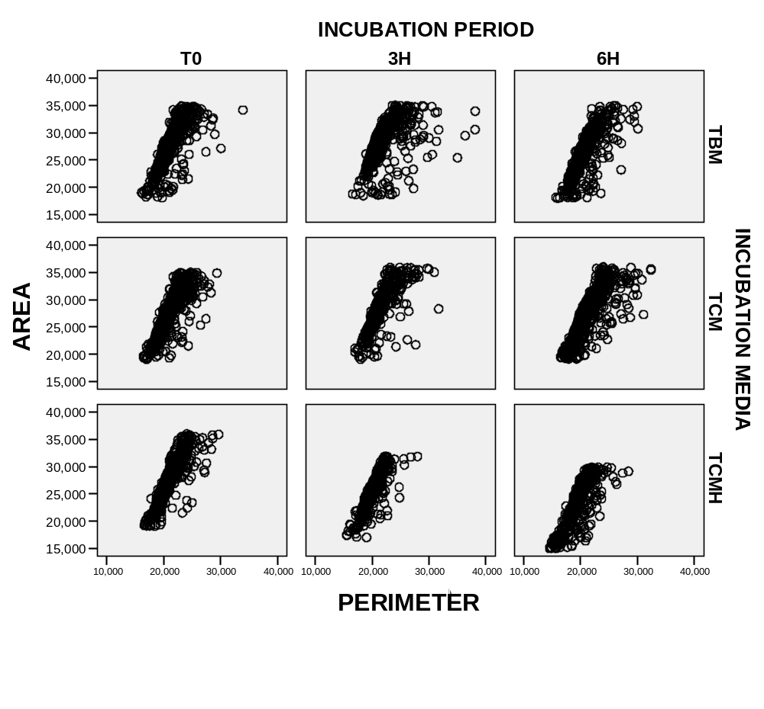

Supplementary Figure S2. Dot plots corresponding to separated sperm head dimensional and shape parameters obtained from the computerised morphometric analysis under capacitating and non capacitating in vitro incubation conditions in bovine spermatozoa. To follow the progressive evolution of the different sperm populational clusters, each original dot plot was descomposed into two, showing both clusters (black cluster, dimensional parameters; grey cluster, shape parameters) among incubation media (TBM: Tyrode's basal medium; TCM: Tyrode's complete medium heparin-free; TCMH: Tyrode's complete medium with heparin) and incubation periods (0 h, 3 h, and 6 h). Units: Dimensional parameters (µm² for area and µm for perimeter, length and width). Shape parameters (no units). Each event represents one individual spermatozoon.


