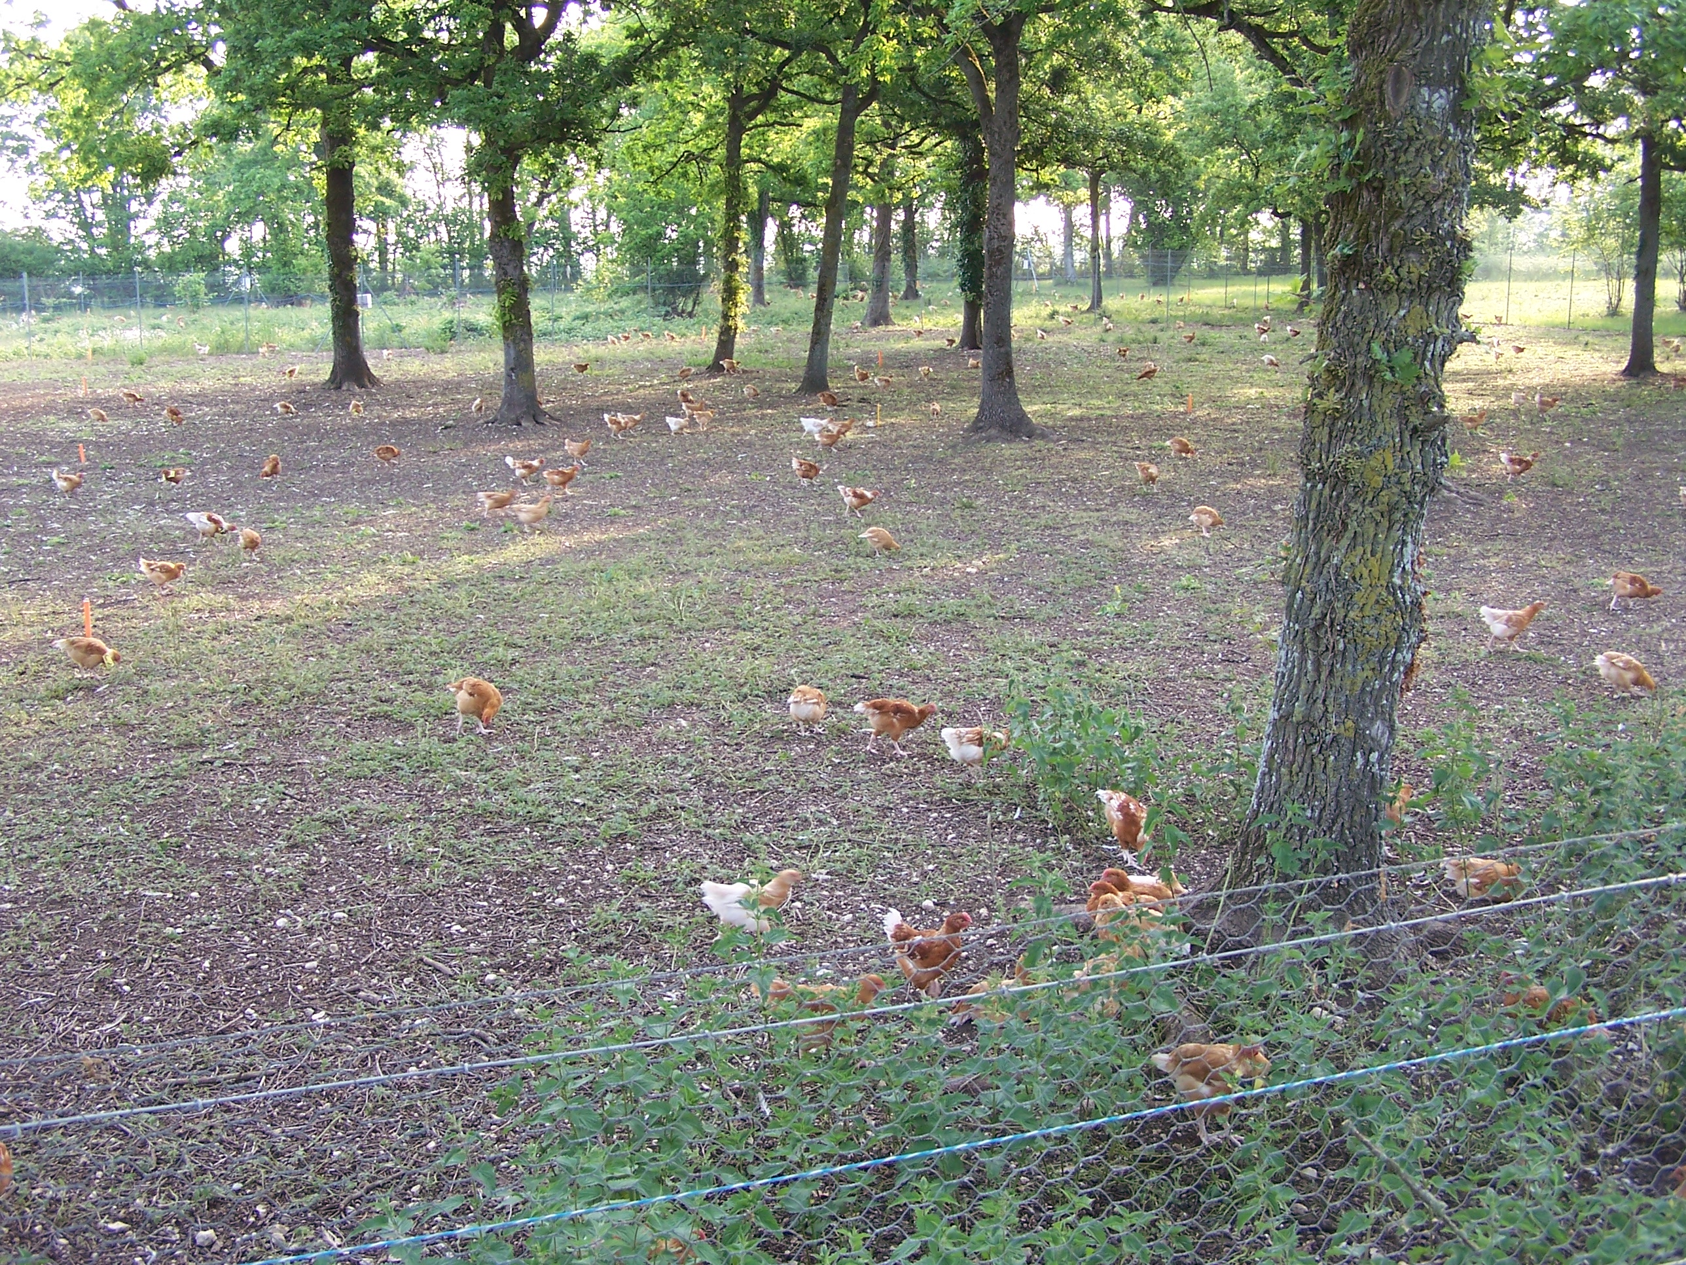

Supplementary Material S2: nearly no vegetation on the yards under trees in winter (flock 3).

