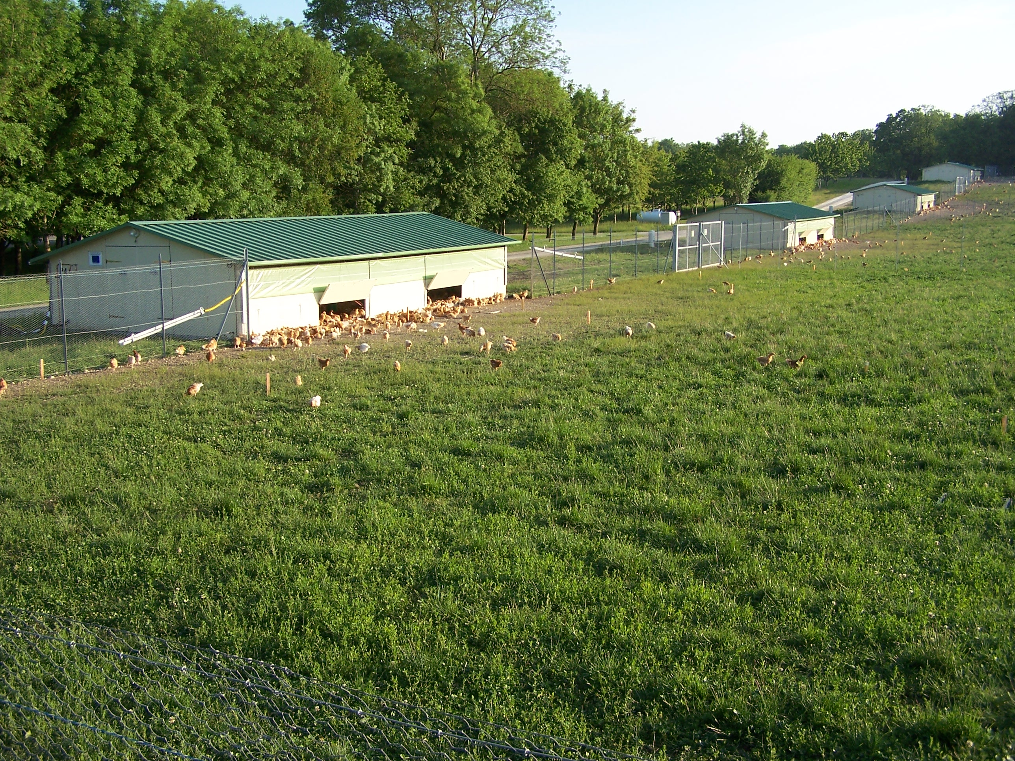

Supplementary Material S1: dense vegetation on grass covered yards in spring (flock 2) where deterioration up from the pop-holes can be observed.

