Supplementary Material S2. Model calibration

Calibration
Grazed grass sub-model. Calibration of the grass dynamics at the field level was performed in three steps. First, the grass dynamics were calibrated by minimizing the mean squared error obtained from data from 74 ungrazed fields monitored in spring 2004 in the Marais Poitevin (France), which was our study area (46°22’ N, 1°25’ W). Second, the relationship between biomass and grass height was calibrated using data from 240 quadrats collected in 15 fields during the same period. Third, a monthly survey of cattle densities and grass heights in 12 fields that was performed in 2002 was used to calibrate q. Full details about this calibration have been published in Sabatier et al. (2010). After calibration, a mean squared error of 27 cm² was obtained, which corresponds to a 5.2 cm root mean squared error.
At the farm level, the model was calibrated to compare two contrasting types of farms (intensive vs. extensive). The intensive farm model was parameterized to represent the 10% of the most intensive farms in a data set of 67 farms from the Marais Poitevin (Tichit et al., 2006). The extensive farm model represented the 10% most extensive farms from the same data set. In the model, differences between intensive and extensive farms were represented in u_{tot} and .
Bird sub-model. The model was calibrated for two bird species in our study area, the northern lapwing and the common redshank. Key elements of the birds’ life cycles are summarized in Figure S.2.1. Wader demographic parameters were based on data from the literature. Due to the lack of accurate data about the relationship between chick survival and grass height, we used a threshold approach that was similar to Tichit et al. (2007) and Sabatier et al. (2010). Mean chick survival published in the literature was used for the survival within the range of viable grass height and survival was assumed to be 25% of this value outside the viable height range. Population size was initialized at 100 individuals.
The values of all parameters are summarized in Table S2.1. and Table S2.2.
Table S2.1. Parameters used in the model. Differences in calibration between lapwing and redshank are indicated by L and R, respectively. Differences in calibration between intensive and extensive farms are indicated by int and ext, respectively.
Parameter | Description | Value | Reference
α ₂ | Number of eggs per sub-adult | 1.39 | Ottvall, 2004
α ₁ | Number of eggs per adult | 1.52 | Ottvall, 2004
η | Daily nest survival for 1 LU.ha-1 | 0.99 | Beintema & Muskens, 1987
σ | Incubation time (days) | 26 | Kooiker, 1993
m | Egg destruction due to mowing | 0.5 | Labisky,1957
 |  |  | Berg et al., 1992
s₁ | Sub-adult survival | L: 0.6 | Peach et al., 1994
 |  | R: 0.7 | Insley et al. 1997
s₂ | Adult survival | L: 0.7 | Peach et al., 1994
 |  | R: 0.8 | Insley et al. 1997
h⁽⁻⁾ | Minimal viable grass height (cm) | L: 0 | Durant et al. 2008
 |  | R: 10 | Durant et al. 2008
h⁽⁺⁾ | Maximal viable grass height (cm) | L: 14 | Durant et al. 2008
 |  | R: 20 | Durant et al. 2008
s₀(suitable hab) | Juvenile survival in viable grass height | L: 0.45 | Peach et al., 1994
 |  | R: 0.35 | Insley et al. 1997
s₀(unsuitable hab) | Juvenile survival in non-viable grass height | L: 0.011 | Tichit, 2007
 |  | R: 0.0087 | Tichit, 2007
c | Intra-specific competition coefficient | L: 0.001 | Tichit, 2007
 |  | R: 0.0007 | Tichit, 2007
d | Juvenile mortality due to movement | 0.2 | Blomqvist and Johansson, 1995
t* | Incubation month | L: April | Durant et al, 2008
 |  | R: May | Durant et al, 2008
t*+1 | Chick rearing month | L: May | Durant et al, 2008
 |  | R: June | Durant et al, 2008
t_{C} | Mowing month | May | -
u⁽⁺⁾ | trampling constraint | 0,5 | -
p⁽⁻⁾ | Land use proportion constraint | 0 - 40% | -
u_{tot} | Farm level stocking rate | Ext: 0.84 | Tichit et al., (2006)
 |  | Int: 2.06 | Tichit et al., (2006)
u^{farm type} | Maximum stocking rate in POG | Ext: 1.5 | Tichit et al., (2006)
 |  | Int: 4.5 | Tichit et al., (2006)
Br | Residual biomass | 62.5 g.m⁻² | Tichit, 2007
q | Daily feed requirement | 3,8 10⁵ g.LU⁻¹ | -
a | Biomass-height coeff. | 0.08 | -
β | Growth rate attenuation coefficient | 0.01 | Tichit, 2007

Table S2.2. Values of the grass growth related vectors.
Parameter | Description | Value
γ(t) | Grass growth rate | (0.009,0.009,0.126,0.137,0.486,0.450,0.450,0.450,0.450,0.450,0.0,0.0)
r2(t) | Senesence rates | (0.0,0.0,0.0,0.773,0.669,0.727,0.858,0.478,0.478,0.478,0.0,0.0)
r3(t) | Decay rates | (1.0,1.0,1.0,0.538,0.472,0.368,0.607,0.607,0.368,0.368,0.607,0.607)

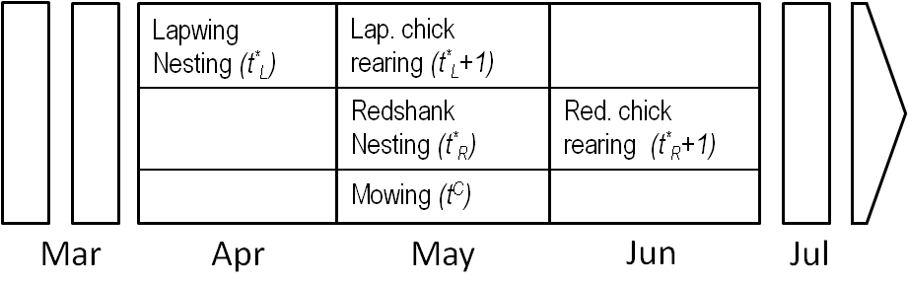
Figure S2.1. Timeline of the bird life cycles and farming activities.

References

Beintema AJ 1987. Nesting success of birds breeding in Dutch agricultural grassland. Journal of Applied Ecology 24, 743–758.
Berg A, Lindberg T and Kallebrink KG 1992. Hatching success of lapwings on farmland - differences between habitats and colonies of different sizes. Journal of Animal Ecology 61, 469–476.
Durant D, Tichit M and Kerneis E, Fritz H 2008. Management of agricultural wet grasslands for breeding waders: integrating ecological and livestock system perspectives - a review. Biodiversity and Conservation. 17, 2275–2295.
Insley H, Peach W, Swann B and Etheridge B 1997. Survival rates of Redshank Tringa totanus wintering on the Moray Firth. Bird Study 44, 277–289.
Kooiker G 1993. Phenology and breeding biology of lapwing (Vanellus vanellus) - Results of a 17 year study in NW Germany. Journal Fur Ornithologie 134, 43–58.
Labisky RF 1957. Relation of hay harvesting to duck nesting under a refuge-perimettee system. The Journal of Wildlife Management 21, 194–200.
Ottvall R 2004. Population ecology and management of waders breeding on coastal meadows. PhD Thesis, Lund University, Lund, Sweeden.
Peach WJ, Thompson PS and Coulson JC 1994. Annual and Long-Term Variation in the Survival Rates of British Lapwings Vanellus-Vanellus. Journal of Animal Ecology 63, 60–70.
Sabatier R, Doyen L and Tichit M 2010. Modelling trade-offs between livestock grazing and wader conservation in a grassland agroecosystem. Ecological Modelling 221, 1292–1300.
Tichit M, Grené P and Léger F 2006. Management intensity and biodiversity : is farm size the key?, 57th meeting of the European Animal Production Association, 17-20 September 2006, Antalya, Turkey, pp 97 L15-5.
Tichit M, Doyen L, Lemel JY, Renault O and Durant D 2007. A co-viability model of grazing and bird community management in farmland. Ecological Modelling 206, 277–293.

