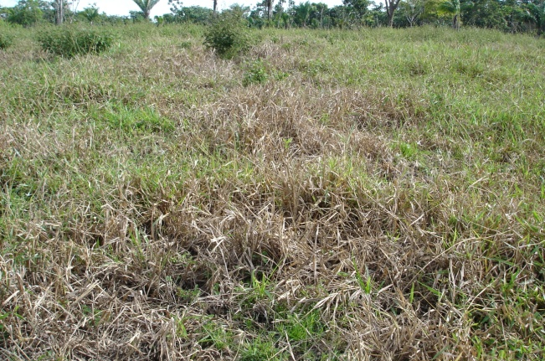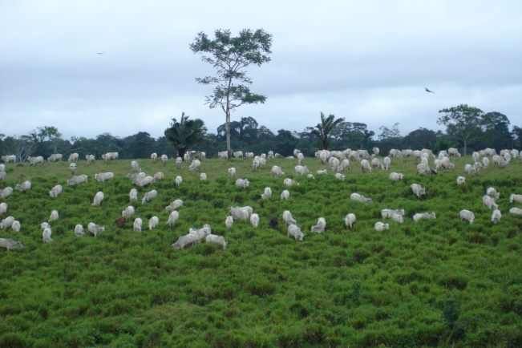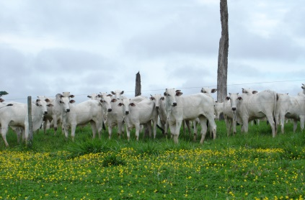
A
B
C

Supplementary Figure S1. Degraded pasture affected by sudden death of Brachiaria brizahnta cv. Marandu (síndrome da morte do braquiarão in Portugese) (A), sustainably intensified pasture (B) and grass-legume pastures (C). (B) and (C) represent improved management and carrying capacity managed under rotational grazing in the Brazilian Amazon. Photos courtesy of Judson Valentim / Embrapa.

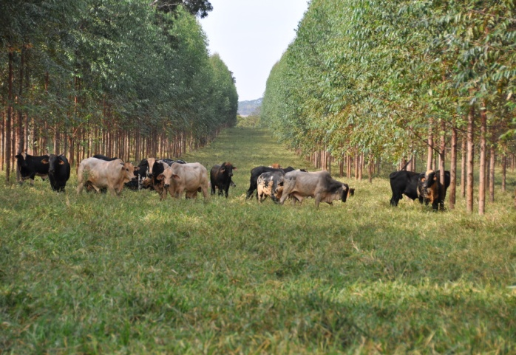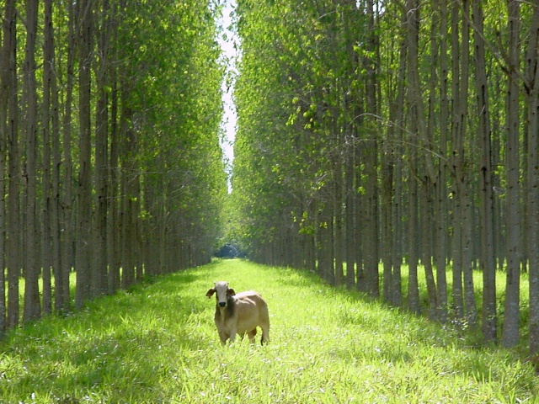
Supplementary Figure S2. Integrated crop-livestock-forestry system during forestry-cattle phase with seven year old eucalyptus trees and Brachiaria brizantha pastures under rotational grazing in the Brazilian Cerrado (left panel, photo: Lourival Vilela).
Right panel: Integrated crop-livestock-forestry system during forestry-cattle phase with four year old eucalyptus trees and Brachiaria brizantha pastures under rotational grazing in the Brazilian Cerrado (Photo: Allan Kardec).

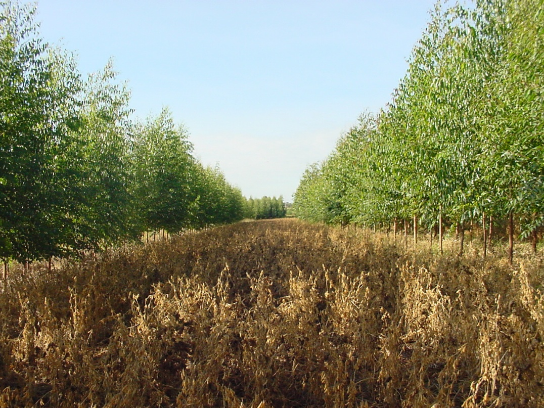
Integrated crop-livestock-forestry system in second year of the crop—forestry phase with two year old eucalyptus trees and mature soybean crop in the Brazilian Cerrado (Photo: Lourival Vilela).

