The use of banquettes of Posidonia oceanica as a source of fibre and minerals in ruminant nutrition. An observational study.
C. Castillo¹, A. R. Mantecón², J. Sotillo³, J.L. Benedito¹, A. Abuelo¹, C. Gutiérrez³, and J. Hernández¹.

¹Departamento de Patología Animal, Facultad de Veterinaria, Universidad de Santiago de Compostela, 27002-Lugo. Spain.
²Instituto de Ganadería de Montaña. CSIC-ULE. Finca Marzanas. 24346 Grulleros-León. Spain.
³Departamento de Medicina y Cirugía Animal, Facultad de Veterinaria, Campus de Espinardo, 30100-Murcia. Spain.
Corresponding author at: Departamento de Patología Animal, Facultad de Veterinaria, Universidad de Santiago de Compostela, 27002-Lugo. Spain. Tel. +34 600 94 23 21. E-mail address: cristina.castillo@usc.es
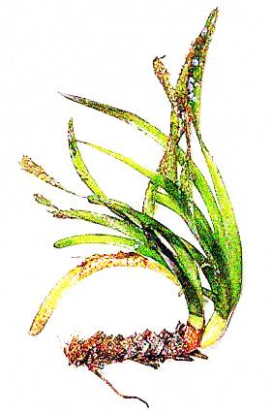
Leaves
Rhizome
Roots
Flowers

Supplementary figure S1. Morphology of P. oceanica (adapted from Dkimages, London)

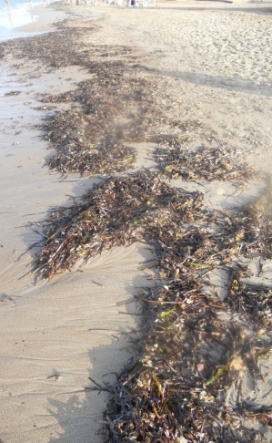

Supplementary figure S2. Leaves of P. oceanica beached at Cartagena beaches (Murcia, S.E. Spain).

Supplementary figure S3. Map of the study area. Dots in the third photo indicate the sampling places.

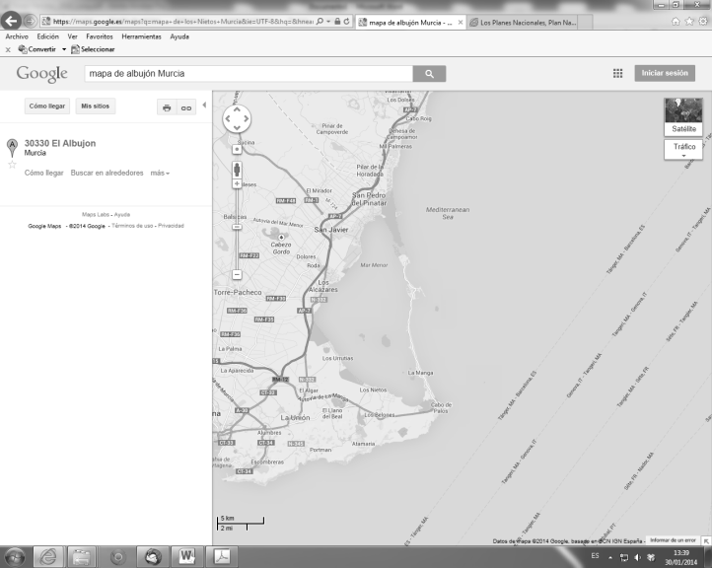
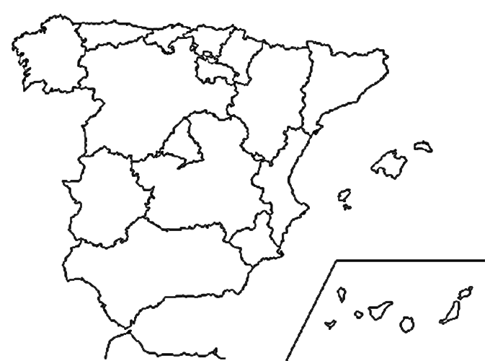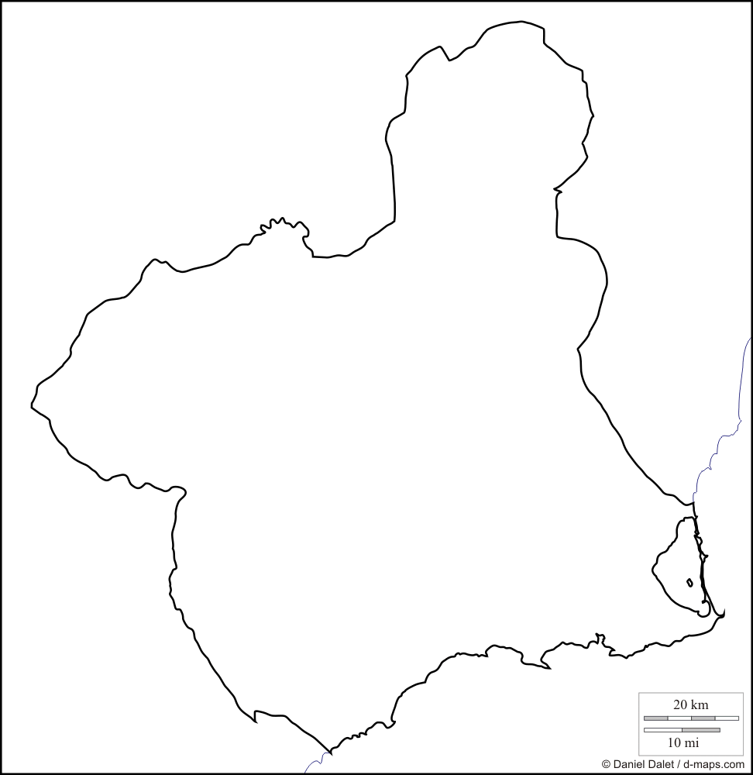

More detailed images below.


