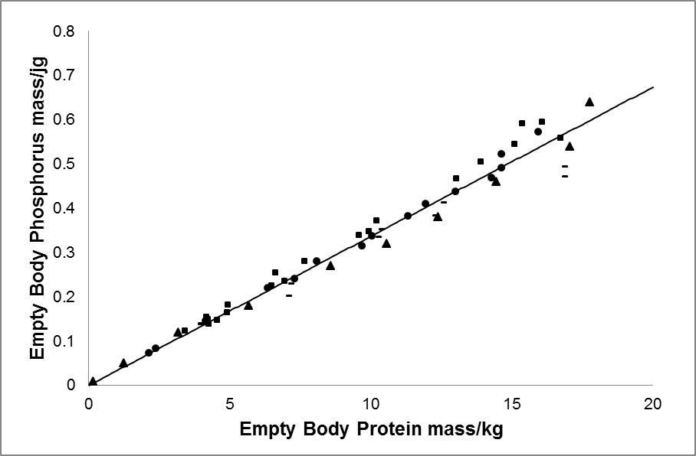

**Supplementary Figure S4**: The isometric relationship between protein (kg) and phosphorus (kg) in the empty body of pigs. Data was derived from different experiments: Jongbloed, (1987) used gilts (n=22) of a Landrace x Large White breed (■); Rymarz *et al*., (1982) used gilts (n=65) of a Norwegian Landrace x (Large White x Hampshire) hybrid (●); Hendriks and Moughan, (1993) used gilts (n=36) of a Landrace x Large White breed (▬); and Mahan and Shields, (1998) used gilts and boars (n=81) of a Hampshire x (Large White x Duroc) hybrid (▲).