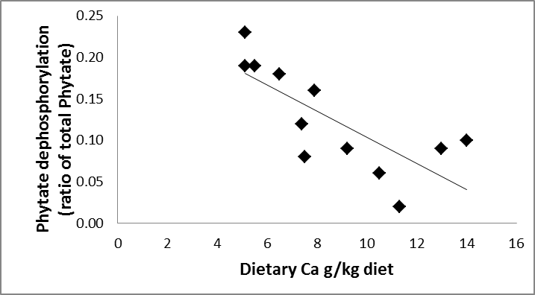

**Supplementary Figure S3**: The relationship between dietary Calcium (g/kg) and proportion of phytate dephosphorylation in the small intestine, based on the in *vivo* ileum cannulated experiment of Plumstead *et al.*, (2008). The line fitted assumes a linear relationship between the two variables: 0.261–(0.0158 *(Ca g/kg diet) R2 = 0.834; RMSE= 0.0531 kg/kg oP.