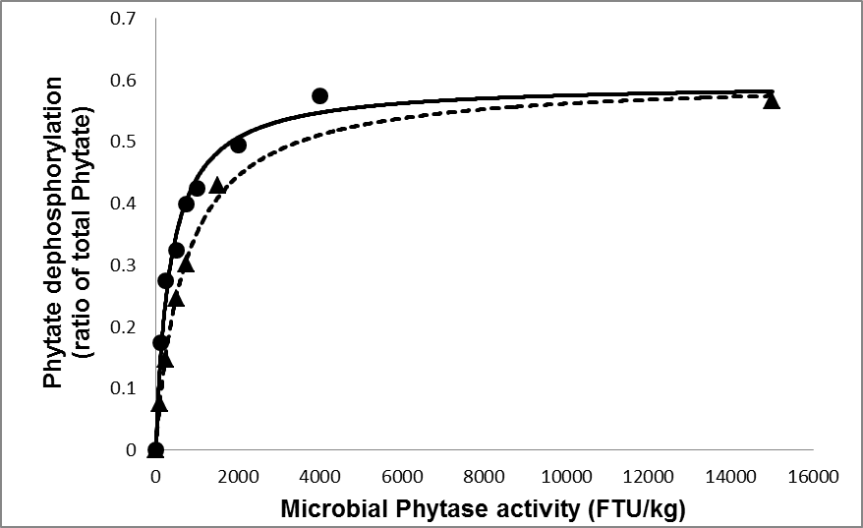

**Supplementary Figure S2**: The relationship between E. coli (▬) and A. niger ( ) microbial phytase activity and phytate dephosphorylation. The equations were: 0.532 × (1 – exp(-0.00187 × FTU); R2=0.93; RMSE= 0.0221 kg/kg oP and 0.562 × (1 – exp(-0.00104 × FTU); R2 = 0.920; RMSE= 0.0324 kg/kg oP, for *E.coli* and *A. niger*, respectively.The values were derived from the *in vitro* study of Adeola *et al*., (2004) (●) and the in the *in vivo* study of Kies *et al.*, (2006) (▲) for *E.coli* and *A. niger* phytase activity, respectively.