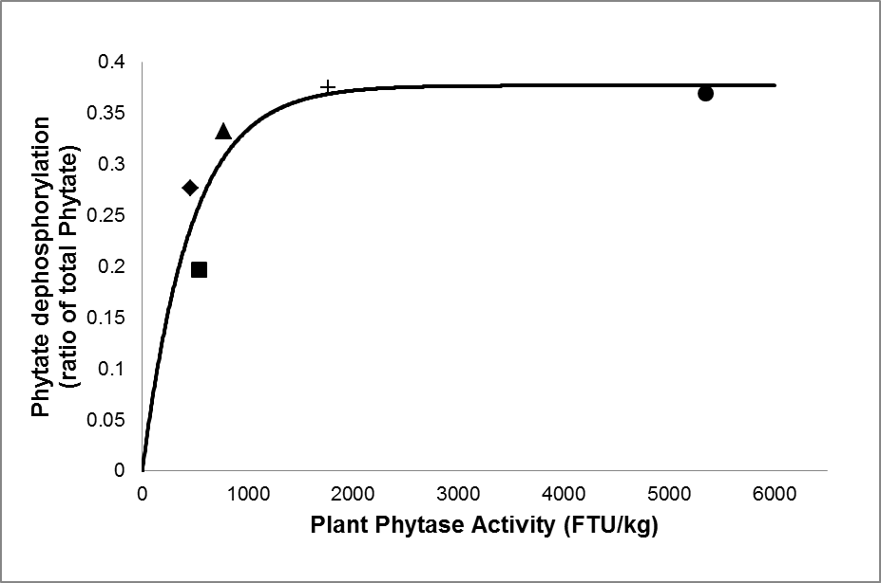

**Supplementary Figure S1**: The relationship between plant phytase activity and proportion of phytate dephosphorylation, for: (■) barley; (♦) wheat; (▲) triticale; (+) wheat bran; and (●) rye. The fitted relationship was 0.337 × (1 – exp(-0.00217 × FTU); R2 = 0.854; RMSE= 0.0391 kg/kg oP. The values were derived from Sauvant *et al.*, (2004).