Measure/criterion | missing information | data handling | based on consideration
cleanliness of water points | in some cases, drinkers not visible (569 drinkers in 27°farms) | set to the score of the most prevalent state on farm | inspection/ cleaning of water points mostly done routinely
expression of other behaviours | partly unknown; access to pasture before fattening (e.g. < 200°kg)  not included in protocol at time of assessment (all farms) | all farms were treated as if they had no access to pasture | most likely there was no pasturing before fattening period
mild integument alterations | hairless patches due to soiling of animals (55°farms) | soiled animals were assumed to have no hairless patches | no correlation known for soiling and prevalence of hairless spots
mutilations such as disbudding or tail docking | management routines on farms of origin unknown by the farmer (19°farms) | hornless animals with unknown history were treated as they were not disbudded/dehorned | any assumption would have been speculative (eg genetic hornless)
ease of movement | estimation of live weight in 100°kg intervals  not included in protocol at time of assessment (all farms) | set to 275°kg or to 525°kg | midpoint of the two weight classes (200-350°kg and 350-700°kg)
Supplementary Table S1: Approach used in case of missing data.

Supplementary Table S2: Results of the WQ assessment for the initial and final assessment (mean and range across all three assessments) regarding the criterion: ‘Absence of pain induced by management procedures’
Criteria |  |  |  | mean |  |  |  | min-max
absence of pain induced by management procedures |  |  |  | initial Ass. | interim Ass. |  | final  Ass. | Ø all ass.
practice of procedures of disbudding/  dehorning animals |  | % of farms with less than 15% of hornless animals |  | 43 |  |  | 44
 |  | % of farms dehorning/disbudding animals on-farm |  | 29 |  |  | 27
 |  | average % of animals dehorned/disbudded on these farms |  | 87 |  |  | 95 | 40-100
 |  | % farms where animals are disbudded |  | 100 |  |  | 100
 |  | % farms using thermo-cautering for disbudding |  | 100 |  |  | 100
 |  | % farms using no anaesthesia for disbudding |  | 44 |  |  | 41
 |  | % farms using no analgesia for disbudding |  | 94 |  |  | 88
practice of procedures of tail-docking animals |  | % of farms tail-docking animals |  | 6 |  |  | 5
 |  | average % of animals tail-docked on these farms |  | 11 |  |  | 12 | 1-33
 |  | % farms using no anaesthesia for tail-docking |  | 75 |  |  | 100
 |  | % farms using no analgesia for tail-docking |  | 100 |  |  | 100
practice of procedures of castrating animals |  | did not occur in this dataset |  | - |  | - | - | -

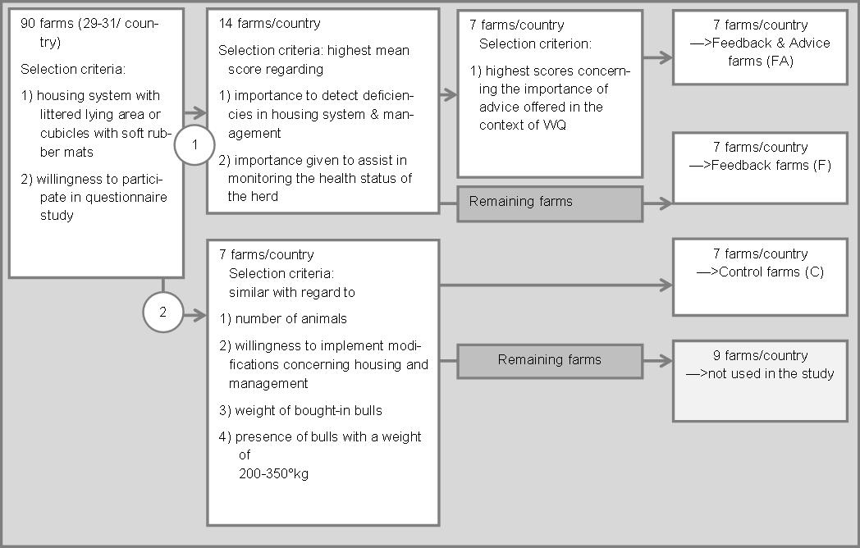

Supplementary Figure S1: Scheme of the stepwise selection of farms included in the
study and selection criteria for their allocation to the treatment groups: feedback and
advice (FA), feedback (F) and control (C)

