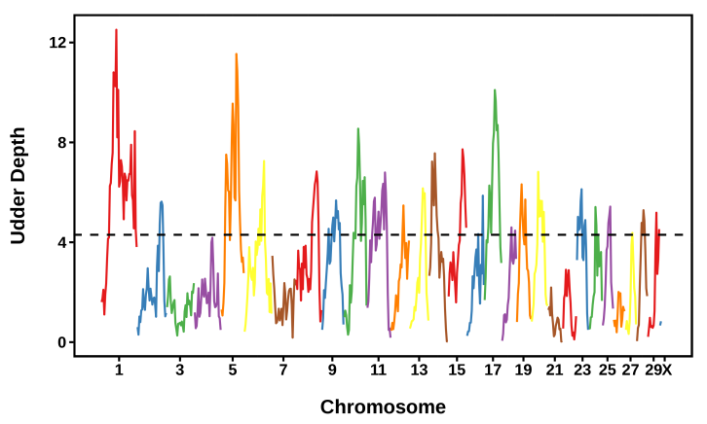
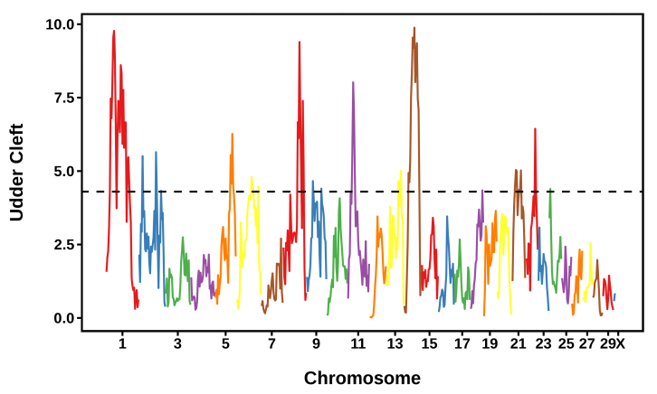

Supplementary Figure S4: Manhattan plots of the a posteriori granddaughter design for two conformation traits. The dotted line at P = 4.3 corresponds to genomewide P = 0.05. Each chromosome is plotted in a different color.

