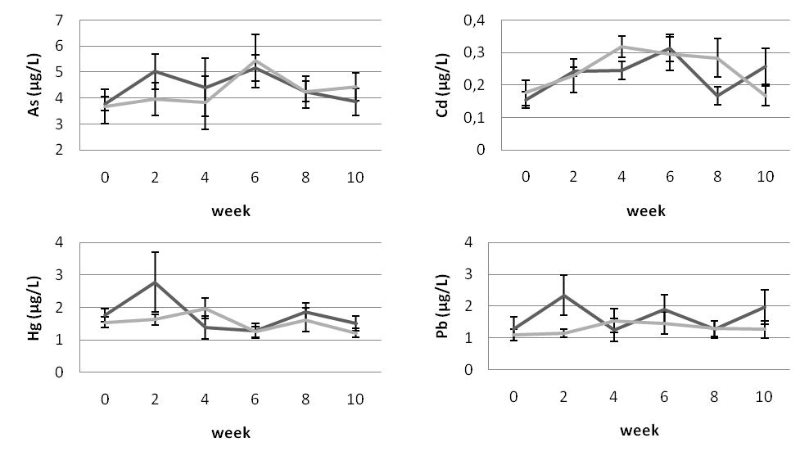
Supplementary Figure S1. Scatterplots showing toxic element concentrations in plasma of the algae-supplemented (dark line, n=8) and control (light line, n=8) groups during the experiment.

