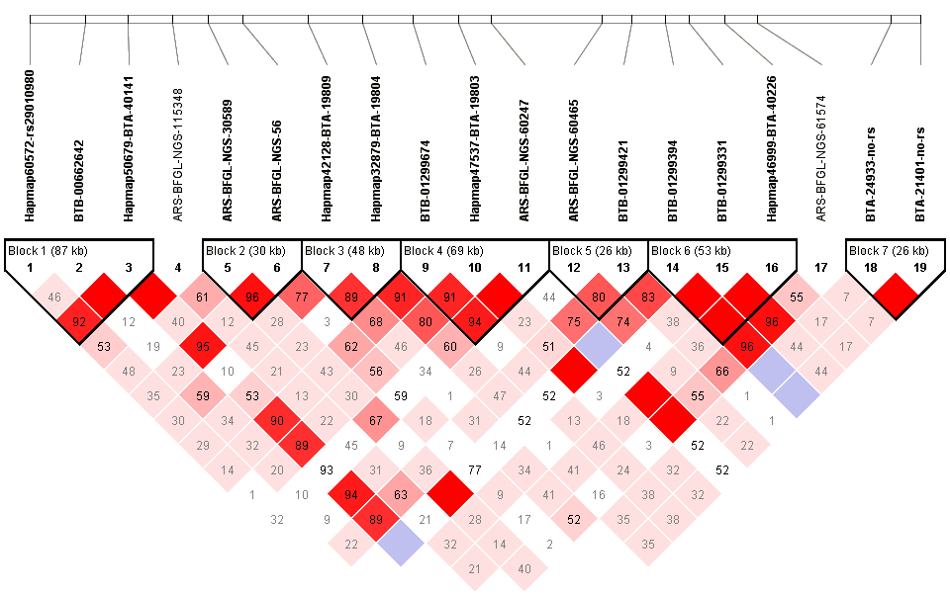 | 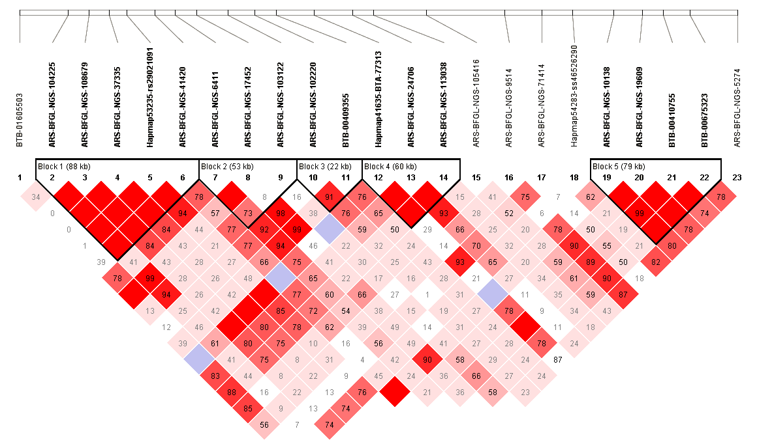
C) | D)
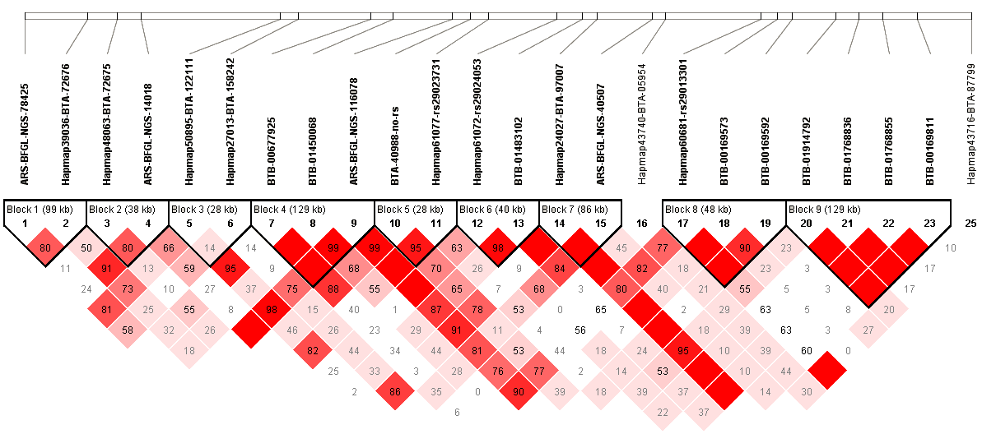 | 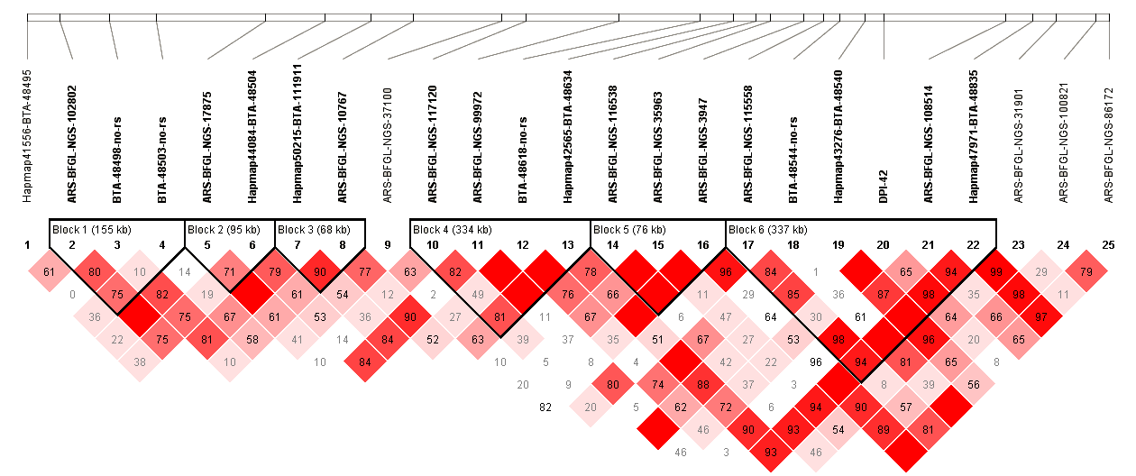
E) | F)
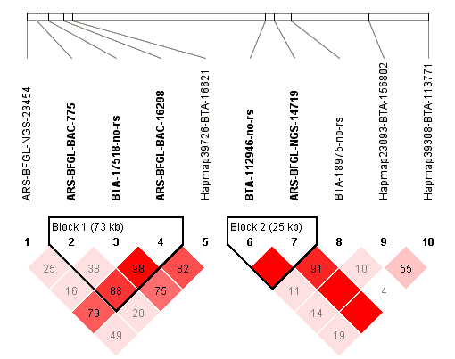 | 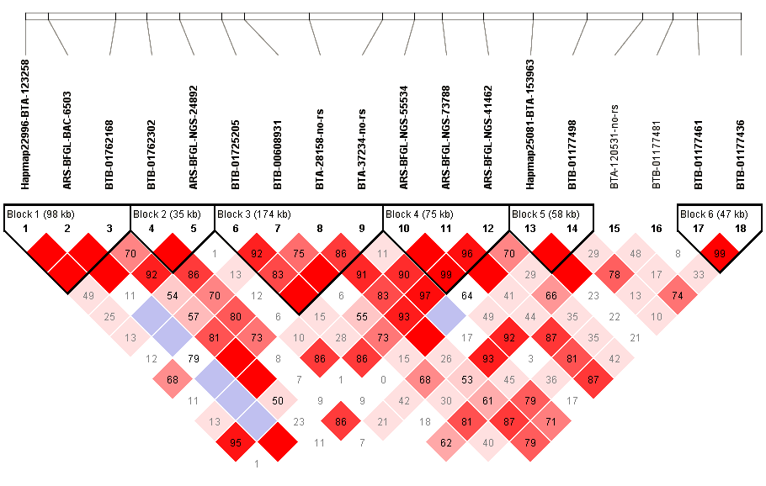
G) | H)
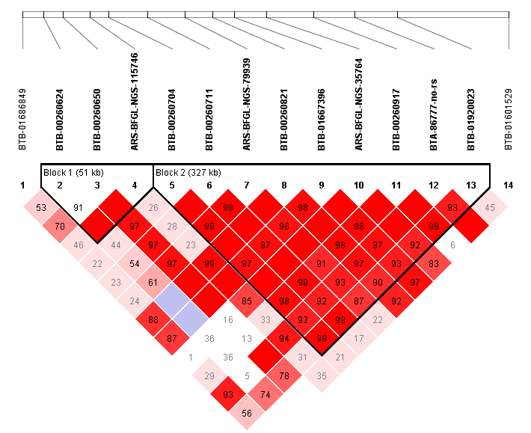 | 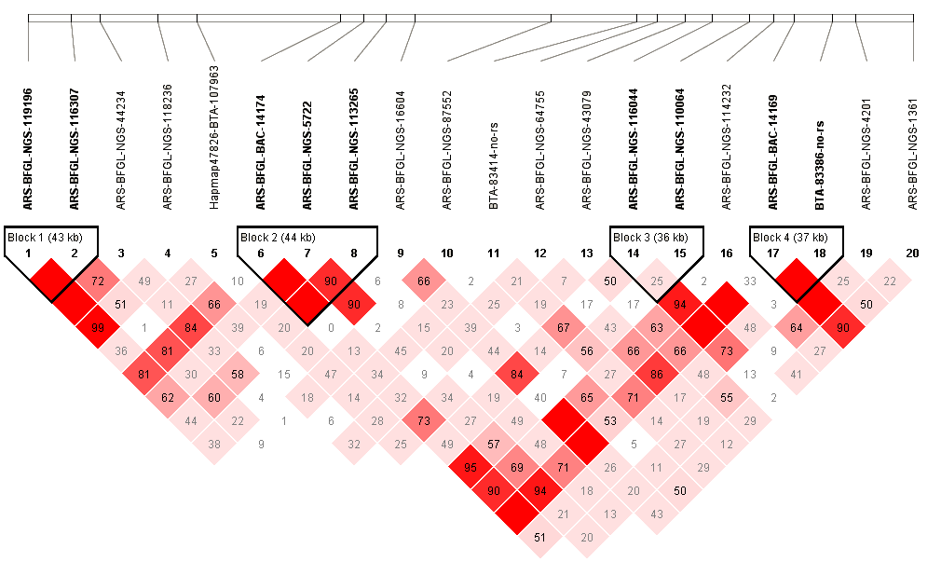
Supplementary Figure S3: Haplotype analysis of 500kb up and downstream of remaining nine most associated SNPs for perinatal mortality. The SNP of interest is outlined in red. A) haploview plot for rs41627212 on BTA 16,B) haploview plot for rs43616983 on BTA 10, C) haploview plot for ss86316303 on BTA 4D) haploview plot for ss86303585 on BTA 2, E) haploview plot for rs416117236 on BTA 12, F) haploview plot for ss86315311 on BTA 15, G) haploview plot for rs43469091 on BTA 16, H) haploview plot for ss86299461 on BTA 10. The SNP ss86324977 on BTA 18 is detailed on Figure 2.

