Liberal egalitarian justice in the distribution of a common output. Experimental evidence and implications for effective institution design

SUPPLEMENTARY ONLINE MATERIAL (SOM)

SOM includes:

- Variable legend and descriptive statistics
- Full estimates results
- Subjects’ beliefs across treatments
- Instructions
- Main zTree screens

I Variable legend and descriptive statistics
 | Legend | Obs. | Mean | St. dev. | Min. | Max.
Bargaining | DV=1 if subjects took part in the Bargaining treatment | 236 | 0.339 | 0.474 | 0 | 1
Chat | DV=1 if subjects took part in the Chat treatment | 236 | 0.322 | 0.468 | 0 | 1
No_veil | DV=1 if subjects took part in the Noveil treatment | 236 | 0.339 | 0.474 | 0 | 1
Belief_aligned_compliance | DV=1 if Belief_first=agr=1 and Belief_second=agr=1 | 156 | 0.571 | 0.497 | 0 | 1
Compliance | DV=1 if subjects comply with the rule they agreed on in the ex-ante agreement | 156 | 0.596 | 0.492 | 0 | 1
Payment_agreement | the payoff – in experimental tokens -associated with the rule agreed in the ex-ante agreement | 156 | 43.291 | 12.985 | 16.47 | 87
Rule_agr_1 | Dummy variables equal to 1 if subjects involved in the Chat or in the Bargaining treatment opt for one of the five different rules in the ex-ante agreement | 156 | 0.141 | 0.349 | 0 | 1
Rule_agr_2 |  | 156 | 0.013 | 0.113 | 0 | 1
Rule_agr_3 |  | 156 | 0.103 | 0.304 | 0 | 1
Rule_agr_4 |  | 156 | 0.577 | 0.496 | 0 | 1
Rule_agr_5 |  | 156 | 0.167 | 0.374 | 0 | 1
Rule_4_ex-post | DV=1 if a division consistent with Rule 4 is selected in the ex-post choice | 236 | 0.318 | 0.467 | 0 | 1
Control variables included in all the estimates
Age | Subject’s age in years | 236 | 20.682 | 2.488 | 18 | 33
Experiment | DV=1 if the subject has already taken part in Lab experiment | 236 | 0.242 | 0.429 | 0 | 1
Female | DV=1 if the subject is a female | 236 | 0.521 | 0.501 | 0 | 1
Income | Income level of the subject’s household, on a 5-level scale between 1 (less than 17,000€) and 5 (more than 120,000€) | 236 | 1.911 | 0.925 | 1 | 5
No_religious | DV=1 if the subject is not a believer | 236 | 0.487 | 0.501 | 0 | 1
Productivity | Encrypted words per minute | 236 | 4.586 | 0.958 | 1.33 | 6.83
Risk | Risk aversion measure based on the following question: “Are you generally a person who is fully prepared to take risks or do you try to avoid taking risks? Please tick a box on the scale, where the value 0 means: ‘unwilling to take risks’ and 10: ‘fully prepared to take risk”(see Dohmen et al., 2011). | 236 | 6.458 | 1.846 | 0 | 10
Trust | DV=1 if the subject declares that, generally speaking, most people can be trusted | 236 | 0.233 | 0.424 | 0 | 1
Words | Number of words encrypted in the task | 236 | 36.788 | 12.451 | 8 | 64

II Full estimates results
Table A1. The determinants of the choice of the rule
 | (1) | (2)
 | Logit | Logit
Dependent variable: | Rule_4_ex-post - DV=1 if a division consistent with Rule 4 is selected in the ex-post choice
Chat | 1.231*** | -0.344
 | (0.408) | (0.545)
Bargaining | 1.201*** | -0.326
 | (0.417) | (0.553)
Rule_agr_4 |  | 2.485***
 |  | (0.448)
Female | 0.469 | 0.347
 | (0.319) | (0.356)
Age | -1.365** | -1.552*
 | (0.650) | (0.792)
Age2 | 0.0295** | 0.0345*
 | (0.0146) | (0.0180)
Income | 0.114 | 0.124
 | (0.170) | (0.189)
No_religious | -0.0833 | -0.0747
 | (0.304) | (0.338)
Trust | 0.581 | 0.696*
 | (0.360) | (0.402)
Risk | 0.0333 | 0.0383
 | (0.0843) | (0.0962)
Experiment | -0.234 | -0.115
 | (0.407) | (0.446)
Words | -0.0169 | -0.0172
 | (0.0161) | (0.0180)
Productivity | 0.122 | 0.106
 | (0.213) | (0.239)
Constant | 13.12* | 14.80*
 | (7.184) | (8.684)
Observations | 236 | 236
Pseudo R² | 0.0904 | 0.2262
Chat-Bargaining | 0.030  (0.352) | -0.018  (0.405)
Standard errors in parentheses *** p<0.01, ** p<0.05, * p<0.1

Table A2. The determinants of compliance
 | (1) | (2) | (3) | (4)
 | Logit | Logit | Logit | Logit
 | Whole sample | Whole sample | Sub-sample of subjects involved in the Chat | Sub-sample of subjects involved in the Bargaining
Dependent variable: Compliance
Chat | 0.973** | 0.635
 | (0.407) | (0.454)
Payment_agreement | 0.0648* | 0.0729* | 0.208 | 0.0334
 | (0.0354) | (0.0374) | (0.195) | (0.0500)
Belief_aligned_compliance |  | 1.993*** | 6.255*** | 1.162*
 |  | (0.456) | (2.001) | (0.605)
Rule_agr_1 | 1.720** | 1.894** | 9.913 | 1.209
 | (0.731) | (0.771) | (15.76) | (1.003)
Rule_agr_2 | -2.393 | -1.565 |  | -0.892
 | (2.045) | (2.143) |  | (2.383)
Rule_agr_3 | 0.280 | 0.0735 | 5.037* | -0.221
 | (0.670) | (0.705) | (2.769) | (0.842)
Rule_agr_5 | 0.0659 | 0.0243 | 3.028 | -1.094
 | (0.638) | (0.690) | (4.038) | (1.198)
Female | 0.471 | 0.894* | 1.539 | 1.135*
 | (0.411) | (0.464) | (1.130) | (0.668)
Age | -0.245 | -0.874 | -0.403 | -2.356
 | (1.367) | (1.530) | (4.118) | (2.766)
Age2 | 0.00347 | 0.0188 | 0.0161 | 0.0514
 | (0.0317) | (0.0355) | (0.0957) | (0.0648)
Income | 0.350 | 0.487* | 2.328** | 0.00117
 | (0.241) | (0.273) | (0.922) | (0.411)
No_religious | -0.706* | -1.082** | -1.076 | -1.007*
 | (0.389) | (0.446) | (1.085) | (0.591)
Trust | 0.840* | 0.643 | 0.427 | 0.650
 | (0.491) | (0.530) | (1.236) | (0.823)
Risk | -0.0644 | 0.00199 | 0.878** | -0.327*
 | (0.109) | (0.123) | (0.391) | (0.189)
Experiment | -0.773 | -0.676 | -3.449** | -0.369
 | (0.514) | (0.570) | (1.641) | (0.800)
Words | -0.0725** | -0.0768** | -0.195 | -0.0606
 | (0.0329) | (0.0345) | (0.186) | (0.0522)
Productivity | 0.411 | 0.324 | -0.542 | 0.646
 | (0.288) | (0.308) | (1.077) | (0.416)
Constant | 1.145 | 6.104 | -11.22 | 25.52
 | (14.66) | (16.43) | (44.47) | (29.58)
Observations | 156 | 156 | 76 | 80
Pseudo R² | 0.159 | 0.264 | 0.603 | 0.236
Standard errors in parentheses *** p<0.01, ** p<0.05, * p<0.1

III. Subjects’ beliefs across treatments

In the two treatments with agreement, 70.51% of subjects believed that the other player in the pair was going to comply. The percentage increases to 78.95% when we consider the Chat treatment and decreases to 62.50% in the Bargaining treatment. This difference is statistically significant (Pearson chi2(1), Pr=0.024). When we consider second-order beliefs, we find that 73.72% of subjects believed that the other player in their pair believed that they would comply. The percentage is 86.84% in the Chat treatment, and 61.25% in the Bargaining treatment. This difference is statistically significant (Pearson chi2(1), Pr=0.000).
Among those who complied, 77.42% believed their counterpart would comply too. This percentage increases in Chat (87.04%) and decreases in Bargaining (64.10%), generating a statistically significant difference between the two treatments (Pearson chi2 (1), Pr=0.009). As for second-order beliefs, 90.31% of subjects who complied believed that their counterpart believed that they would comply. In this case as well, the percentage is significantly larger (Fisher's exact=0.032) in Chat (96.30%) than in Bargaining (82.05%).
Finally, 73.12% of subjects who complied had aligned first-order and second-order beliefs: that is, they believed that their counterpart would comply and believed that the counterpart believed that they would too. In this case as well, the percentage is significantly larger (Pearson chi2(1), Pr=0.000) in the Chat (87.04%) than in Bargaining (53.85%).

IV. Instructions

INSTRUCTIONS

NO VEIL TREATMENT

Good morning, thank you for participating in this activity. You are taking part into a study on economic decisions. During the activity, you can, depending on your decisions and on other participants’ decisions, earn an amount of money in addition to the 3 euros you will receive anyway.
The answers you give and the choices you make will be totally anonymous. The researchers will not be able neither is their intention to associate your choices and your answers to your name.

Only in session in which the questionnaire was administered at the beginning of the experiment:
Before starting the activity, we ask you to fill a short questionnaire.

[Subjects fill in the questionnaire]

[NOTE: in each treatment, in two sessions the questionnaire was administered at the beginning of the experiment, and in two sessions it was administered at the very end of the experiment, just before the payment - our main empirical results are virtually unchanged when we consider this distinction]

During the activity you cannot communicate with other participants and you should be very careful in reading the instruction that will appear on your screen and will be read out by one of the experimenters. You can find a copy of the instruction on your desk. You can check them in any moment during the activity. If you have any questions, please ask the researchers.
Your earnings will be calculated in tokens; each token will be converted in euros at the following ratio: 1 token = 0,15 euros.

[Only in session in which the questionnaire was administered at the end of the experiment:]

At the end of the activity, you will be asked to fill a short questionnaire; afterwards, we will proceed with the payment, that will occur in cash and privately.
This experiment is financed by the I+D+I Program of the DGICYT (Ministry of Economy) through the Research Project FFI2011-29005.

During the activity you are paired with another participant. You will not be informed of other’s identity, and the other will not be informed about your identity.

The activity consists of two Stages.

STAGE 1

In the first stage you will be asked to perform a task. The task is the same for all the participants and it determines the earnings of Stage 1.
You will be presented a series words and you will be asked to produce words by substituting the letters of alphabet with numbers, using the Table 1. For example, if the word that appears on your screen is “HOLA” you must enter the numbers 24 for “H”, 21 for “O”, 25 for “L” and 6 for “A”.
For each word produced through a correct encoding you will receive 1 token. The words are the same for all the participants.
You will be given a time limit and within this limit you can produce as many words as you can.
You and the other participant are given two different time limits. One of you will have 10 minutes at his/her disposal, while the other will have 6 minutes. The assignment of time limits is random and it is made by the software without any intervention by the experimenter. Thus you have a probability of 50% of getting 10 minutes and 50% of getting 6 minutes.

If you are the participant with the 6 minute limits you will be asked, at the end of the task, to answer a few general questions, not related with the activity, for the remaining 4 minutes. This activity does not produce any earnings, and it is introduced only with the aim of not allowing the identification of people with lower limits.

At the end of the task you and the other participant will be informed about the number of words you produced and the total products generated by your pair, corresponding to the sum of your products:

total product = your product in the task + other participant’s product in the task
(Remember that each word produced through the encoding activity corresponds to 1 token)

STAGE 2.

At this point you both will be asked to decide how to divide the total product (and the corresponding earning) generated through the activity of both of you by choosing: a rule which define a division of the product between you and the other participant (the five rules which can be chosen are reported on the last page of the instruction) or by indicating any combination of percentages (only integers are admitted) indicating a division of the product between you and the other participant.
The software will extract at random you or the other participant and the division decision made by the extracted person will be used for the final division of the product. The probability of being extracted is 50%.

SUMMARY OF THE STAGES
Stage 1: The task. Both you and the other participant are informed about your time limits, perform the task and are informed about the number of words produced through the task by your pair.
Stage 2: The division. Both you and the other participant choose how to divide the total product. You or the other participant is extracted and the decision of the extracted person is implemented. Final earnings are computed by associating 1 tokens to each word and you are paid.

In a few minutes, we will ask you to answer a few control questions. They will help you to verify whether the instructions are clear to you. Before the control questions, you have the opportunity to practice with the five rules that can be chosen (along with any combination of percentage) to divide the product (as previously explained).

CONTROL QUESTIONS.
[Control questions, Table 1 – below - and the rules – below - are the same in all treatments]

1)You produce a total of 21 words, the other participant produces a total of 20 words.
Your earning from the task is of ……….. tokens
The other participant’s earning is of . …….tokens.

2)The total product of your pair is 70 words.
You have chosen the first rule to divide it. The other participant has chosen the second rule.
a)If you are extracted:
you obtain a part of the total product of ……. and your earning is of ………. tokens;
the other participant obtains a part of the total product of …. and his/her earning is of …..tokens
b)if the other participant is selected and the second rule is used to divide the total products:
if you are extracted, according to the procedure of the second rule, you obtain a part of the total product of .... and your earning is of ………. tokens;
if the other participant is extracted, according to the procedure of the second rule, s/he obtains a part of the total product of .... and his/her earning is of ………. tokens;

3)You produced 40 words and the other participant produced 30 words

Both you and the other participant have chosen the third rule to divide it:
you obtain a part of the total product of …. and your earning is of ………. tokens;
the other participant obtains a part of the total product of …. and his/her earning is of …..tokens

4)You had 10 minutes to perform the task and the other participant 6 minutes. You produced 30 words in the first 6 minutes and 20 words in the remaining 4 minutes. The other participant produced 40 words in his/her 6 minutes.
According to the rule number 4:
you obtain a part of the total product of …. and your earning is of ………. tokens;
the other participant obtains a part of the total product of …. and his/her earning is of …..tokens

5)The total product of your pair is 70 words.
Both you and the other participant have chosen rule 5 to divide it.
if you are the more productive during the first 6 minutes you obtain a part of the total product of …. and your earning is of ………. tokens;
if the other participant is the more productive during the first 6 minutes s/he obtains a part of the total product of …. and his/her earning is of …..tokens.

TABLE 1
Letter Number
A 6
B 26
C 13
D 3
E 14
F 19
G 10
H 24
I 2
J 20
K 5
L 25
M 9
N 17
O 21
P 1
Q 11
R 8
S 4
T 18
U 22
V 12
W 16
X 7
Y 23
Z 15

THE RULES

RULE 1 – Pure Equal Split
Each participant obtains exactly the half of the total product generated through the activity performed by the two participants.

Example: participant A produces X in 10 minutes; participant B produces Y in 6 minutes. Both participant A and participant B obtain: (X+Y)/2

RULE 2 – One gets all
One participant obtains all the total product generated through the activity performed by the two participants. A random draw selects the participant who gets the 100% of the total product. Both participants have the 50% of probability to be selected.

Example: participant A produces X in 10 minutes; participant B produces Y in 6 minutes. The participant who is randomly selected (50% of probability to be selected) obtains X+Y, the other participant obtains 0.

RULE 3 – One gets what s/he has produced
Each participant obtains exactly what s/he has produced through his/her activity.
Example: participant A produces X in 10 minutes; participant B produces Y in 6 minutes. Participant A obtains X, participant B obtains Y.

RULE 4 – Time independent division
Each participant obtains what s/he has produced through his/her activity during the first 6 minutes; what is produced by the participant who has 10 minutes of time in the last 4 minutes is divided at 50% among the two participants.

Example: participant A produces X in 10 minutes, with X = Z + K and Z=what A produces in the first 6 minutes and K= what A produces in the last 4 minutes; participant B produces Y in 6 minutes. Participant A obtains Z+K/2, participant B obtains Y+K/2

RULE 5 – Divide according to productivity (words/minute)

If the ratio between the productivity (words/minutes) of A and B is R, then the ratio between the payment of A and the payment of B will be R, under the condition that the sum of the two payment is equal to the total product.

Example: participant A has 10 minutes and participant B has 6 minutes. If the productivity (words/minute) of A is twice the productivity of B, then B obtains half of the payment of A

INSTRUCTIONS
BARGAINING TREATMENT

Good morning, thank you for participating in this activity. You are taking part into a study on economic decisions. During the activity, you can, depending on your decisions and on other participants’ decisions, earn an amount of money in addition to the 3 euros you will receive anyway.
The answers you give and the choices you make will be totally anonymous. The researchers will not be able neither is their intention to associate your choices and your answers to your name.

Only in session in which the questionnaire was administered at the beginning of the experiment:
Before starting the activity, we ask you to fill a short questionnaire.

[Participants fill in the questionnaire]

[NOTE: in each treatment, in two sessions the questionnaire was administered at the beginning of the experiment, and in two sessions it was administered at the very end of the experiment, just before the payment - our main empirical results are virtually unchanged when we consider this distinction]

During the activity you cannot communicate with other participants and you should be very careful in reading the instruction that will appear on your screen and will be read out by one of the experimenters. You can find a copy of the instruction on your desk. You can check them in any moment during the activity. If you have any questions, please ask the researchers.
Your earnings will be calculated in tokens; each token will be converted in euros at the following ratio: 1 token = 0,15 euros.

[Only in session in which the questionnaire was administered at the end of the experiment:]

At the end of the activity, you will be asked to fill a short questionnaire; afterwards, we will proceed with the payment, that will occur in cash and privately.
This experiment is financed by the I+D+I Program of the DGICYT (Ministry of Economy) through the Research Project FFI2011-29005.

During the activity you are paired with another participant. You will not be informed of other’s identity, and the other will not be informed about your identity.

The activity consists of different stages. We will tell you about Stage 1 in a minute, but we begin by presenting first Stage 2 because your choices in Stage 1 depend on the knowledge of Stage 2 procedure.

STAGE 2

In the Stage 2 you will be asked to perform a task. The task is the same for all the participants and it determines the earnings of Stage 2.
You will be presented a series words and you will be asked to produce words by substituting the letters of alphabet with numbers, using the Table 1. For example, if the word that appears on your screen is “HOLA” you must enter the numbers 24 for “H”, 21 for “O”, 25 for “L” and 6 for “A”.
For each word produced through a correct encoding you will receive 1 token. The words are the same for all the participants.
You will be given a time limit and within this limit you can produce as many words as you can.
You and the other participant are given two different time limits. One of you will have 10 minutes at his/her disposal, while the other will have 6 minutes. The assignment of time limits is random and it is made by the software without any intervention by the experimenter. Thus you have a probability of 50% of getting 10 minutes and 50% of getting 6 minutes.
If you are the participant with the 6 minute limits at the end of the task, if you wish, you could play a simple video game that will appear on your computer screen This activity does not produce any earnings, and it is introduced only with the aim of not allowing the identification of people with lower limits.

At the end of the task you and the other participant will be informed about the number of words you produced and the total products generated by your pair, corresponding to the sum of your products:

total product = your product in the task + other participant’s product in the task
(Remember that each word produced through the encoding activity corresponds to 1 token)

STAGE 1.

In Stage 1 you and the other participant will be asked to bargain over the criterion that should be adopted to divide the total product (and the corresponding earning) that your couple will get in the task of Stage 2 (as described above). The bargaining procedure consists of a series of offers and counter-offers. The offers concern one of the five rules reported on the last page of the instruction which define a division of the product between you and the other participant or any combination of percentages (only integers are admitted) indicating a division of the product between you and the other participant.

The bargaining procedure
The bargaining procedure consists of thirteen rounds, as described below:
First you will start with six rounds of simultaneous choice. In these six rounds the two persons forming a pair choose a rule at the same time, without knowing the rule chosen by the other. If both choose the same rule in one of these six rounds, they will have agreed on the rule, the bargaining ends, and they proceed to stage 2. If they do not choose the same rule in any of these six rounds, they continue bargaining in the following four rounds.
At this moment four rounds of sequential choice will begin. They are as follows:
One member of the pair will be randomly selected.
If the selected person is A and the other one is B, A will propose a rule to B; B can either accept or reject the rule.
If B accepts the rule, they will have agreed on the rule, the bargaining ends and the pair proceed to stage 2.
If B rejects the rule, s/he will be asked to make a counter-offer by proposing a different rule to A.
The sequence is iterated so that A has two opportunities to make an offer and B also has two opportunities to make an offer; and each has equally two opportunities to accept or reject the other person’s offer.
If there is a fourth round, in which B makes her/his second counter-offer, and A accepts the proposed rule, then they will have agreed on the proposed rule, the bargaining ends and the pair proceeds to stage 2.
If A rejects the offer at this point, the sequential rounds end, and the pair proceeds to the last three rounds of simultaneous choice.
These last three rounds work like the six first rounds.
If no agreement over a rule is reached in these three last rounds, then the persons forming the pair are excluded from the next stages of the experiment.
Persons thus excluded from the next stages of the experiment will be requested to fill in a questionnaire that the experimenters will hand out, and wait until the end of the session to receive their payment.

[NOTE: The first sequence of simultaneous proposals was introduced to capture the simultaneous nature of the bargaining. The second sequential bargaining phase was introduced to help break possible non-coordination cycles in the simultaneous choices. The last simultaneous choices phase was intended to prevent agreements reached in the sequential bargaining phase from suffering the typical hold-up problem that characterizes finite sequential bargaining, in which the second to last mover has an advantage over the last mover. Note that only two pairs failed to reach an agreement within the first sequence of simultaneous choices.]

STAGE 3

After having performed the task (according to the previous description of Stage 2) both you and the other person will be asked to choose how to divide the total product generated by you and the other participant in the task. You can confirm the criterion identified through the bargaining procedure (Stage 1) or choose a different criterion (one of the five rules reported on the last page of the instruction or a combination of percentages).
Once you have chosen, the software will extract at random you or the other participant (the probability of being extracted is 50%), and the division chosen by the extracted person will be implemented and your final payment will be computed according to that division.

SUMMARY OF THE STAGES

Stage 1: The bargaining procedure to agree on a division criterion. You can offer a rule among the five rules which are reported on the last page of the instruction or any combination of percentages (only integers are admitted). Only pairs who reach an agreement within 10 attempts access to Stage 2.
Stage 2: The task. Both you and the other participant are informed about your time limits, perform the task and are informed about the number of tokens obtained with the task by your pair.
Stage 3: The division. You and the other participant will be asked to choose a criterion to divide the total product. One of the two is extracted and his/her decision is implemented. Final earnings are computed by associating 1 tokens to each word and you are paid.

In a few minutes, we will ask you to answer a few control questions. They will help you to verify whether the instructions are clear to you. Before the control questions, you have the opportunity to practice with the five rules that can be chosen (along with any combination of percentage) to divide the product (as previously explained).

[Control questions, Table 1 and the division rules are as described in the No veil instructions – see above.]

INSTRUCTIONS
CHAT TREATMENT

Good morning, thank you for participating in this activity. You are taking part into a study on economic decisions. During the activity, you can, depending on your decisions and on other participants’ decisions, earn an amount of money in addition to the 3 euros you will receive anyway.
The answers you give and the choices you make will be totally anonymous. The researchers will not be able neither is their intention to associate your choices and your answers to your name.

Only in session in which the questionnaire was administered at the beginning of the experiment:
Before starting the activity, we ask you to fill a short questionnaire.
[Participants fill in the questionnaire]
[NOTE: in each treatment, in two sessions the questionnaire was administered at the beginning of the experiment, and in two sessions it was administered at the very end of the experiment, just before the payment- our main empirical results are virtually unchanged when we consider this distinction]

During the activity you cannot communicate with other participants and you should be very careful in reading the instruction that will appear on your screen and will be read out by one of the experimenters. You can find a copy of the instruction on your desk. You can check them in any moment during the activity. If you have any questions, please ask the researchers.
Your earnings will be calculated in tokens; each token will be converted in euros at the following ratio: 1 token = 0,15 euros.

[Only in session in which the questionnaire was administered at the end of the experiment:]

At the end of the activity, you will be asked to fill a short questionnaire; afterwards, we will proceed with the payment, that will occur in cash and privately.
This experiment is financed by the I+D+I Program of the DGICYT (Ministry of Economy) through the Research Project FFI2011-29005.

During the activity you are paired with another participant. You will not be informed of other’s identity, and the other will not be informed about your identity.

The activity consists of different stages. We will tell you about Stage 1 in a minute, but we begin by presenting first Stage 2 because your choices in Stage 1 depend on the knowledge of Stage 2 procedure.

STAGE 2

In the Stage 2 you will be asked to perform a task. The task is the same for all the participants and it determines the earnings of Stage 2.
You will be presented a series words and you will be asked to produce words by substituting the letters of alphabet with numbers, using the Table 1. For example, if the word that appears on your screen is “HOLA” you must enter the numbers 24 for “H”, 21 for “O”, 25 for “L” and 6 for “A”.
For each word produced through a correct encoding you will receive 1 token. The words are the same for all the participants.
You will be given a time limit and within this limit you can produce as many words as you can.
You and the other participant are given two different time limits. One of you will have 10 minutes at his/her disposal, while the other will have 6 minutes. The assignment of time limits is random and it is made by the software without any intervention by the experimenter. Thus you have a probability of 50% of getting 10 minutes and 50% of getting 6 minutes.
If you are the participant with the 6 minute limits at the end of the task, if you wish, you could play a simple video game that will appear on your computer screen This activity do not produce any earnings, and it is introduced only with the aim of not allowing the identification of people with lower limits.

At the end of the task you and the other participant will be informed about the number of words you produced and the total products generated by your pair, corresponding to the sum of your products:

total product = your product in the task + other participant’s product in the task
(Remember that each word produced through the encoding activity corresponds to 1 token)

STAGE 1.

In Stage 1 you and the other participant will be asked to discuss over the criterion that should be adopted to divide the total product (and the corresponding earning) that your couple will get in the task of Stage 2 (as described above). The procedure for this discussion consists of a chat. When the chat opens, you and the other person will be able to chat about the division rule to be applied, among the five division rules defining a division of the total product between you and the other person. The division rules are available in the last page of the instruction set.

The discussion procedure
You and the other person will be put in contact through a chat. You will be able to send messages to each other. The chat will be anonymous; you will be randomly assigned names A and B. It is forbidden to reveal any information that may identify you, such as your name, ID number, seat you occupy, or physical looks; it is also forbidden to threat, to promise side payments, and to use offensive language.
The chat will last for a maximum of ten minutes. Every two minutes, an experimenter will inform you of the remaining time.
By the side of the chat window, a grey window will show. There you will select the criterion to divide the total product, by clicking one of the five rules (the same that you’ll find in the last page of this instruction set).

Once you agree on a rule, you and the other person will click on the agreed rule.
If you do not reach an agreement, you will not go to Stage 2. In this case, you will be asked to answer a few general questions, not related with the activity, until the other pairs of participants have finished their activity. In this case, your earning is equal to the initial 3 euros.

STAGE 3

After having performed the task (according to the previous description of Stage 2) both you and the other person will be asked to choose how to divide the total product generated by you and the other participant in the task. You can confirm the criterion identified through the bargaining procedure (Stage 1) or choose a different criterion (one of the five rules reported on the last page of the instruction or a combination of percentages).
Once you have chosen, the software will extract at random you or the other participant (the probability of being extracted is 50%), and the division chosen by the extracted person will be implemented and your final payment will be computed according to that division.

SUMMARY OF THE STAGES

Stage 1: Discussion procedure to agree on a division criterion. A chat opens where you can discuss over the division rules. Only pairs that agree before ten minutes and both click on the same rule, go to stage 2.
Stage 2: The task. Both you and the other participant are informed about your time limits, perform the task and are informed about the number of tokens obtained with the task by your pair.
Stage 3: The division. You and the other participant will be asked to choose a criterion to divide the total product. One of the two is extracted and his/her decision is implemented. Final earnings are computed by associating 1 tokens to each word and you are paid.

In a few minutes, we will ask you to answer a few control questions. They will help you to verify whether the instructions are clear to you. Before the control questions, you have the opportunity to practice with the five rules that can be chosen (along with any combination of percentage) to divide the product (as previously explained).

[Control questions, Table 1 and the division rules are as described in the No veil instructions – see above.]

Questionnaire (administered in Spanish)

1. Birth Date |__||__| |__||__| |__||__||__||__|

2. Sex M F

3. Place of birth (country, region/province, city) ______________________________________

4. In general you would say you are:
Completely Completely
unhappy happy

1 2 3 4 5 6 7 8 9 10

5. You are:

Catholic
Ateist
Agnóstic
Other (specify) ___________________

6. a) Major: _________________________________________________
b) year |__|
c) number of participants already passed |__||__|
d) average score |__||__|

7. Have you participated in the Erasmus program? Yes No

8. Are you in general a person ready to take risks, oro u try to avoid taking risks? Please tick a number in the following scale where 0 means “reluctant to take risks” and 10 means “totally ready to take risks”.

Reluctant to take risks totally ready to take risks

0 1 2 3 4 5 6 7 8 9 10

9.Please consider the following levels of income. Can you indicate which level your family belongs to, considering wages, pensions and all income of all the members of your family? Please choose the level of net income, that is after taxes.

Less than 17.000,01- 33.000,01 - 53.000,01- above
17.000 euros 33.000 euros 53.000 euros 120.000 euros 120.000 euros

10. How would you describe your finantial situation now?

I make a comfortable living
I make an aceptable living
Enough to go by
I am doing really bad

11 Would you say that most people is trustworthy Yes No

Thanks!

Main zTree screens (translated from Spanish)

- Practice phase
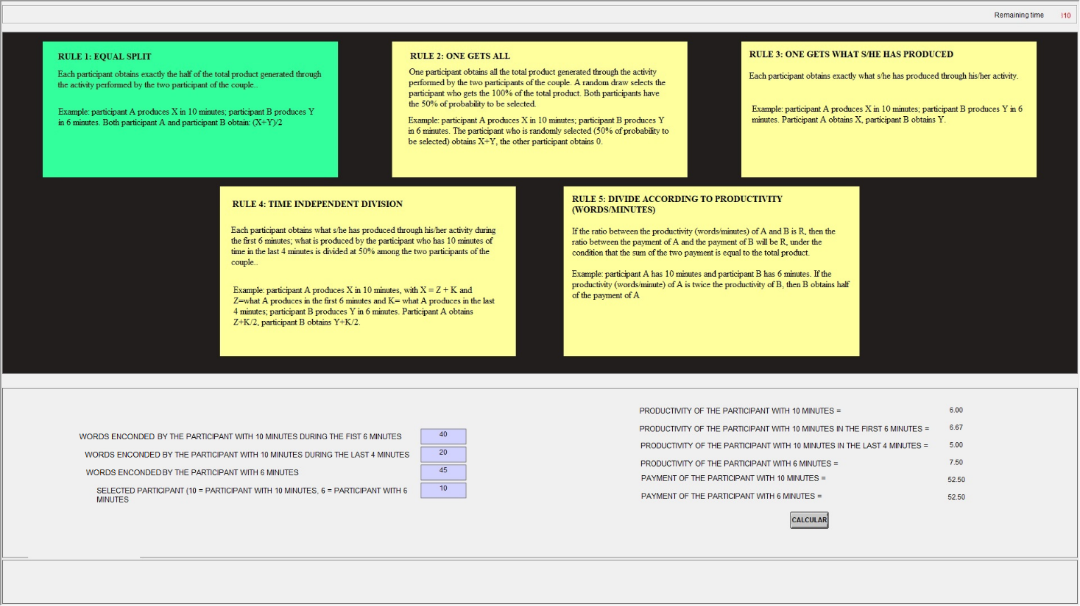
Participants enter the data.

The software automatically completes this part

The rule chosen is colored in green

Participants enter the data here

2. Ex-ante rule choice (Chat treatment - after the chat- and simultaneous choices of the Bargaining treatment)
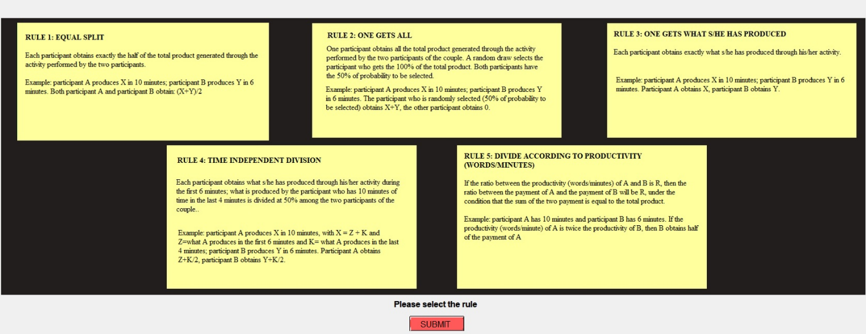
Participants choose the rule by selecting one of the 5 boxes

In the Chat treatment, participants communicated using an external software and moved to the choice screen after the chat time expired. They selected the rule, and received immediate feedback on the choice of their counterpart.
3. Ex-ante rule choice (sequential choices of the Bargaining treatment)
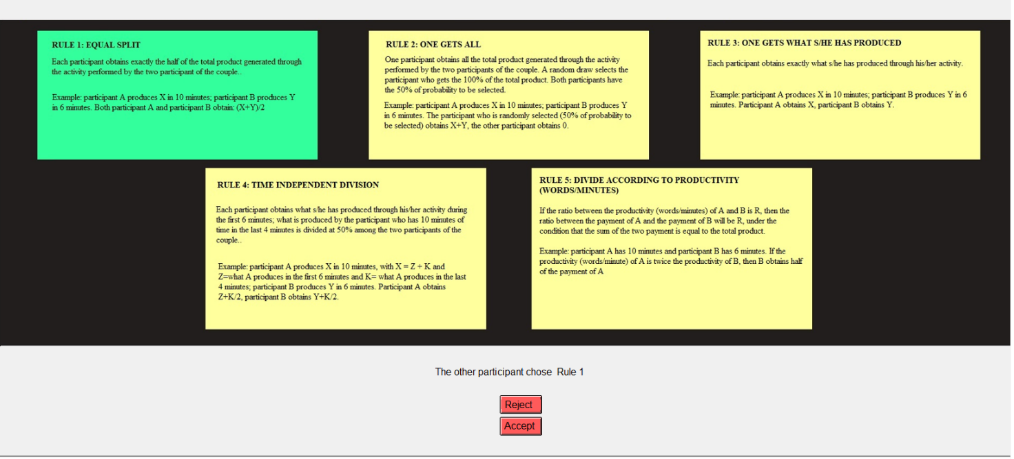
After six rounds of simultaneous choices, participants who did not reach the agreement proceeded with four rounds of sequential choices and, in case of no agreement, with two last rounds of simultaneous choices.

4. Ex-post choice of the rule (treatments Chat and Bargaining)
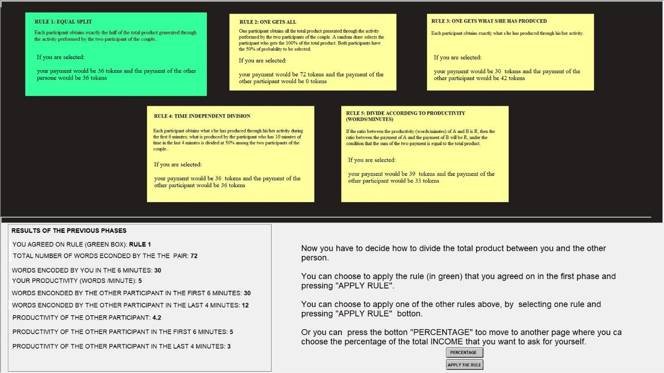
For each rule, participants know their payoffs if they are selected and the rule is applied.

5. Ex-post choice: participants choosing the percentage.
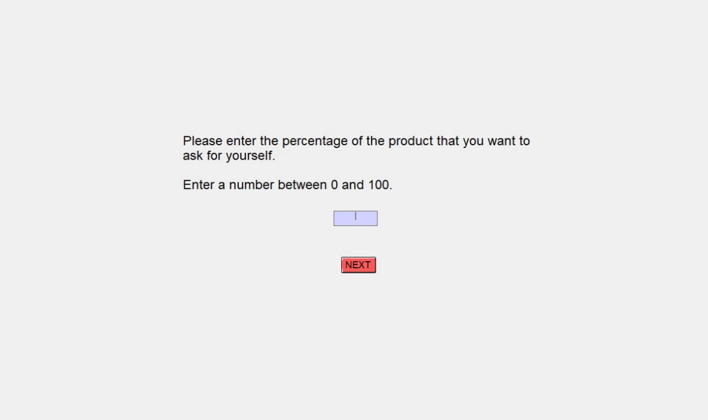

6. Ex-post choice (treatment Noveil)
