Individual trust: does quality of local institutions matter?
ONLINE APPENDIX
SILVIA CAMUSSI*
Economic Research Unit, Turin Branch, Bank of Italy
ANNA LAURA MANCINI**
Economic Research Unit, Turin Branch, Bank of Italy

* Email: silviaannamaria.camussi@bancaditalia.it
** Email: annalaura.mancini@bancaditalia.it

Figure a1 Quality of local services and trust: raw correlation
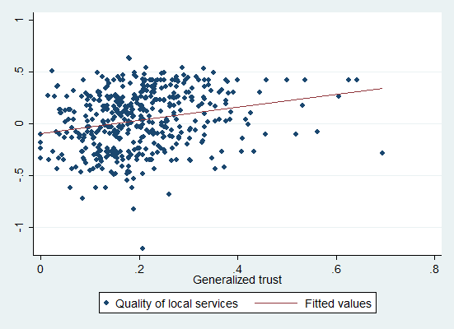 | 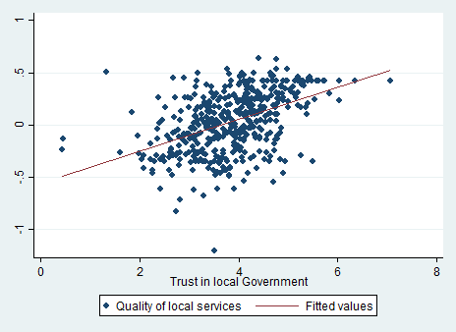

Table a1 Ranking of the service quality indicators at regional level
 |  | Charron et al. (2014) | Giordano and Tommasino (2013) | Giacomelli and Tonello (2015) |  |  | Golden and Picci (2005)
 | Quality of local services indicator | Quality of government index^{(a)} | Public sector efficiency indicator^{(b)} | LGP1^{(c)} | LGP2^{(c)} | Corruption indicator
Piedmont | 10 | 5 | 4 | 7 | 13 | 2
Valle d'Aosta | 3 | 2 | 14 | 1 | 1 | 12
Lombardy | 6 | 12 | 3 | 8 | 6 | 9
Bolzano | 2 | 1 | 10 | 4 | 7 | 6
Trento | 1 | 3 | 11 | 5 | 8 | 7
Veneto | 5 | 9 | 8 | 14 | 14 | 8
Friuli-Venezia Giulia | 4 | 4 | 7 | 9 | 5 | 10
Liguria | 13 | 10 | 5 | 19 | 21 | 16
Emilia-Romagna | 7 | 7 | 1 | 13 | 11 | 4
Tuscany | 11 | 11 | 2 | 2 | 3 | 3
Umbria | 8 | 6 | 12 | 11 | 4 | 1
Marche | 9 | 8 | 9 | 3 | 2 | 5
Lazio | 19 | 17 | 6 | 16 | 15 | 14
Abruzzo | 15 | 14 | 15 | 6 | 10 | 11
Molise | 12 | 15 | 21 | 12 | 16 | 18
Campania | 16 | 21 | 19 | 17 | 17 | 21
Puglia | 17 | 18 | 13 | 21 | 20 | 15
Basilicata | 18 | 16 | 20 | 10 | 9 | 19
Calabria | 20 | 20 | 18 | 18 | 19 | 20
Sicily | 21 | 19 | 16 | 20 | 18 | 17
Sardinia | 14 | 13 | 17 | 15 | 12 | 13
Spearman  coefficient^{(d)} |  | 0.905 | 0.441 | -0.665 | -0.650 | 0.662
p-value |  | (0.000) | (0.045) | (0.001) | (0.001) | (0.001)
(a) The quality of government index is constructed by Charron et al. (2014) for the European NUTS 2 regions focusing on three public services that are often managed by sub-national authorities: education, healthcare and law enforcement. Each public service is rated with respect to quality, impartiality and level of corruption. Indicators are then constructed using factor analysis. (b) The efficiency indicator is an average of provincial level data and is calculated as the average of the efficiency indicator in different areas: health, education, judicial system, day-care and waste management. (c) LGP1 and LGP2 are two measures of Local Government Performance. The first one is the number of days needed to conclude the mystery call, the second one is the number of telephone contacts needed to conclude the mystery call. (d)The Spearman coefficient compares the quality of local services indicator to each of the other quality indicators.

Table a2 Descriptive statistics
 | Obs | Mean | Sd
Dependent variables
Generalized trust | 66,589 | 0.211 | 0.408
Trust in local government | 65,595 | 3.910 | 2.387
Quality indicators
Structural quality | 67,731 | 0.005 | 0.578
General accessibility | 67,731 | 0.007 | 0.600
Waiting times | 67,731 | 0.011 | 0.549
Quality of local services | 67,731 | 0.011 | 0.291
Quality of local services (without waiting times) | 67,731 | 0.005 | 0.496
Number of municipalities with a train station | 67,731 | 0.450 | 0.409
Individual controls
Employed | 67,731 | 0.457 | 0.498
Unemployed | 67,731 | 0.095 | 0.294
Age | 67,731 | 53.183 | 15.675
Female | 67,731 | 0.521 | 0.500
Sickness | 67,731 | 0.192 | 0.394
Divorced | 67,731 | 0.084 | 0.277
B.A. | 67,731 | 0.134 | 0.341
High school diploma | 67,731 | 0.277 | 0.447
Number of children | 67,731 | 0.961 | 0.971
Sufficient family income | 67,342 | 2.541 | 0.637
Job in a social sector | 67,731 | 0.107 | 0.309
Local controls
Main city in the province | 67,731 | 0.147 | 0.355
Mountainous surface (%, LMA) | 67,731 | 0.346 | 0.368
Seismic municipality (%, LMA) | 67,731 | 0.423 | 0.443
Population (Log, LMA) | 67,731 | 12.003 | 1.460
Unemployed to total population (%, LMA) | 67,731 | 0.058 | 0.027
B.A. rate (%, LMA) | 67,731 | 0.106 | 0.029
General government workers in 1971 (%, LMA) | 67,731 | 0.068 | 0.039
Population density in 1971 (LMA) | 67,731 | 4.644 | 7.081
North-West | 67,731 | 0.213 | 0.410
North-East | 67,731 | 0.208 | 0.406
Centre | 67,731 | 0.182 | 0.386
South | 67,731 | 0.288 | 0.453
Islands | 67,731 | 0.107 | 0.309

Table a3 Two stage least squares results
 |  | (1) | (2)
 | b/se  generalized trust |  | b/se  trust in local government
Quality of local services | 0.132 |  | -0.282
 | [0.106] |  | [0.657]
Provincial dummies | YES |  | YES
Local controls | YES |  | YES
Endogeneity test: Robust F statistic | 1.022 |  | 0.738
Robust F p-value | [0.312] |  | [0.390]
Weak instruments test: F-test | 174.838 |  | 169.902
F-test p-value | [0.000] |  | [0.000]
Obs. | 66,239 |  | 65,255
Note: * p<0.10, ** p<0.05, *** p<0.01. Standard errors are clustered at the family level.

Table a4 GMM estimation: full results
 | Generalized trust |  | Trust in local government
 | First step  b/se | Main eq  b/se | First step  b/se | Main eq  b/se
Quality of local services |  | 0.132 |  | -0.291
 |  | [0.106] |  | [0.657]
Employed | -0.001 | 0.014*** | -0.001 | -0.161***
 | [0.001] | [0.005] | [0.001] | [0.027]
Unemployed | -0.000 | -0.003 | 0.000 | -0.146***
 | [0.002] | [0.006] | [0.002] | [0.039]
Age | 0.000 | 0.006*** | 0.000 | -0.012***
 | [0.000] | [0.001] | [0.000] | [0.004]
Age squared | 0.000 | -0.000*** | 0.000 | 0.000***
 | [0.000] | [0.000] | [0.000] | [0.000]
Sickness | 0.001 | -0.048*** | -0.000 | -0.404***
 | [0.001] | [0.004] | [0.001] | [0.027]
Female | 0.000 | -0.019*** | 0.000 | 0.010
 | [0.001] | [0.003] | [0.001] | [0.015]
Divorced | 0.002 | 0.001 | 0.002 | 0.030
 | [0.002] | [0.006] | [0.002] | [0.035]
B.A. | 0.003 | 0.137*** | 0.002 | 0.002
 | [0.002] | [0.006] | [0.002] | [0.033]
Diploma | 0.001 | 0.070*** | 0.001 | -0.022
 | [0.001] | [0.004] | [0.002] | [0.025]
Number of children | 0.000 | 0.003 | 0.000 | -0.004
 | [0.000] | [0.002] | [0.000] | [0.014]
Job in a social sector | -0.001 | 0.032*** | -0.001 | 0.096***
 | [0.002] | [0.006] | [0.002] | [0.031]
Family income enough | -0.001 | -0.044*** | -0.002 | -0.418***
 | [0.002] | [0.003] | [0.001] | [0.020]
Population density in 1971 | -0.009*** |  | -0.009***
 | [0.001] |  | [0.001]
P.A: workers in 1971 (%) | 0.600*** |  | 0.598***
 | [0.043] |  | [0.043]
Provincial dummies | YES | YES | YES | YES
Local controls | YES | YES | YES | YES
R² | 0.85 | 0.052 | 0.85 | 0.087
Obs. | 66,239 | 66,239 | 65,255 | 65,255
Note: * p<0.10, ** p<0.05, *** p<0.01. Standard errors are clustered at the family level.

Alternative quality measures
To disentangle the effect of the infrastructural components from that of the day-to-day supply and to test its relevance on both types of trust, we built five alternative measures of our quality index. Infrastructural quality should be less exposed to reverse causality due to individual behaviours and therefore could be considered as a further robustness check to the possible bias linked to a specific channel of reverse causality.
We start by constructing a specific indicator for each of the three sets of questions used to build the original indicator. We label these three indicators as: structural quality, general services accessibility and waiting time. We also build an overall indicator that does not include the block of questions relating to waiting times. All alternatives are statistically significant and positively affect trust in local government: the effect is basically unchanged in the case of the overall indicator with respect to our original variable, smaller in the case of each specific subset. None of our alternatives, conversely, have an effect that is statistically different from zero on generalized trust.
We then test the relation between our trust variables and a measure of the number of municipalities in each LMA that have at least one train station. This measure should capture the potential infrastructural endowment and is close in spirit to the one devised by Messina (2007), which provides a measure of the local endowment of transport infrastructure at the provincial level. Also our train station variable is positive and significant for trust in local government and not statistically different from zero for generalized trust.
Table a5
 | (2) | (3)
 | Generalized trust | Trust in local government
 | b/se | b/se
N° of municipalities with train station | 0.004 | 0.166***
 | [0.008] | [0.051]
Quality of local services (without waiting times) | 0.001 | 0.366***
 | [0.007] | [0.044]
Structure quality | 0.004 | 0.271***
 | [0.006] | [0.037]
General service quality | -0.004 | 0.152***
 | [0.005] | [0.030]
Waiting times | 0.003 | 0.126**
 | [0.008] | [0.048]
Individual controls | YES | YES
Provincial dummies | YES | YES
Local controls | YES | YES
R2 | 0.053 | 0.087
Obs. | 65,255 | 66,239
Note: * p<0.10, ** p<0.05, *** p<0.01. Standard errors are clustered at the family level.

