Appendix A: Survey instruction
Section | Web-page | Text
Introduction | Introduction | This research is about the costs of healthcare. In the Netherlands, healthcare costs 5,500 euros on average per inhabitant per year. These costs are still rising every year. The government is asking citizens to think along about cutbacks in health care. What could be removed from the basic benefit package, in your opinion? And which care would you definitely want to keep included? We are going to show you 8 different treatments. Your task is to remove one or more treatments from the basic benefit package.  Is it really necessary to make cuts? For this exercise, it is. Some treatments will have to be removed from the basic benefit package because many new treatments are going to be added to the basic benefit package. New medicines, for example, or new ways to diagnose and treat diseases. To prevent health insurance premiums rising much more, it is also necessary to remove treatments from the basic benefit package from time to time. Please be assured that acute care, for example, infectious disease control such as Covid-19 control or care for people with a heart attack, will always be reimbursed.
Instruction | Attributes and levels | Each treatment on the list is described using a number of characteristics. These characteristics are explained on this page.  Number of patients in the Netherlands  Some diseases only occur in very few patients. Other diseases are very common. Here you can see how many people are currently receiving the treatment in the Netherlands. At the moment, all these patients are reimbursed for this treatment.  Cost per patient  This is the cost of the treatment per patient. When we talk about costs, we mean all the costs of care taken together, such as the costs of medicines, GPs and hospital costs. Some treatments are cheap, for example, 100 euros per patient. Other treatments are very expensive. Some treatments may cost as much as 50,000 or 90,000 euros per patient.  Quality of life when the treatment is reimbursed  This is the quality of life of patients when the treatment is reimbursed. Here you can see patients' average quality of life with the treatment. We indicate quality of life with a number between 0% and 100%. 100% represents the best quality of life you can imagine. 0% represents the worst quality of life you can imagine.  Quality of life if reimbursement for the treatment is discontinued.  This is the quality of life of patients if reimbursement of the treatment is discontinued. We indicate quality of life with a number between 0% and 100%. 100% represents the best quality of life you can imagine. 0% represents the worst quality of life you can imagine.  If reimbursement for treatment is discontinued, there are three options:  - No other treatment is available. The number represents the quality of life without the treatment.  - The only treatment available is to alleviate symptoms of the disease. This treatment is still reimbursed. The number represents the quality of life with this other treatment.  - A different treatment is available. This treatment is still reimbursed. The number represents the quality of life with this other treatment.  Loss of quality of life due to discontinuation of reimbursement  Here you can see the loss of quality of life of patients due to discontinuation of the reimbursement of the treatment. Sometimes, discontinuing reimbursement for treatment will not change the quality of life. For example, because a suitable alternative treatment is available or because the treatment has no effect on the quality of life. If this is the case, you will see the value 0%.  Remaining life expectancy when reimbursed for the treatment  This is the remaining life expectancy of patients when the treatment is reimbursed. Here you can read how many years on average patients stay alive with the treatment.  Remaining life expectancy in case of discontinuation of the treatment  This is the remaining life expectancy of patients when reimbursement of the treatment is discontinued. Here you can see how many years on average patients will live when the reimbursement of the treatment is discontinued.  If reimbursement for treatment is discontinued, there are three options:  - No other treatment is available. The number represents the remaining life expectancy without the treatment.  - The only treatment available is to alleviate symptoms of the disease. This treatment is still reimbursed. The number represents the remaining life expectancy of patients with this other treatment.  - A different treatment is available. This treatment is still reimbursed. The number represents the remaining life expectancy of patients with this other treatment.  Reduction in life expectancy due to discontinuation of reimbursement  Here you can see the reduction in life expectancy of patients due to discontinuation of reimbursement of the treatment.  Sometimes, discontinuing reimbursement of the treatment will not change life expectancy. For example, because a suitable alternative treatment is available or because the treatment does not affect life expectancy. If this is the case, you will see the value 0 years.  Age of the patient  This is the average age of the patients who are eligible for the treatment.
 | Introduction webtool | On the main screen, you can click on all 8 treatments for more information. The 8 treatments are described using a number of characteristics. The treatments differ only for these characteristics. In other words, you can assume that the treatments do not differ in other characteristics, such as side effects.  You may be wondering why we talk about 'treatment' and don't state exactly what treatment for what disease this is. We do this because we want you to look closely at the characteristics of the treatment rather than choose based on the treatment name.  We ask you to save at least 100 million euros by choosing a few treatments that can be removed from the basic benefit package. It is fine if you save more than 100 million euros. You can assume that in that case, fewer cutbacks will be needed in the future.
 | Instruction options webtool | Please see below for an instruction video. This video is 3 minutes long and can be viewed on a large screen. Please start by watching this video. You can also read the instructions again below. These instructions contain the same information as the instruction video.  Information about treatment  There is an information button next to every treatment; the 'info' button. If you click on the information button, you will see information about the treatment. We recommend that you read the information for all eight treatments. If you move your mouse over a characteristic, you will be shown more information about what a characteristic means. To return to the main menu, click on the red button with the white cross. In the main menu, to the left of the treatment, in the grey circles, you can see again how much money you will save if you discontinue reimbursement of the treatment.  If you are already sure that you want to discontinue reimbursement of a treatment, you can indicate this with the 'select' button in the main menu and on the treatment information page.  Comparison  Once you have indicated which treatments you want to compare, click on the red 'compare' button at the top of the page. You can also click on the green button with the black arrow on the left of the page. To return to the main menu, click on the 'back' button.  You can also arrange the treatments according to the various characteristics. To do so, click on “choose a characteristic” behind “sort by” at the top centre of the screen. You can now select a characteristic here to rank on. The score of the treatments for this characteristic is placed behind the treatments. The treatments are ranked in order of how they score on the feature.  Selection  To select a treatment, you can click on the toggle under 'selection'. The treatment will then appear on the right side of the screen.  At the top right of the page, you can see that you need to make cuts of 100 million euros. Below it, you can see the total savings of all the treatments you have chosen. Below that number, you can see how much you still need to save.  Confirm selection  Once you have reached cutbacks of 100 million or more, you can review your selection by clicking on the red 'selection overview' button at the top of the screen. If you are sure of your choice, you can confirm your choice here by clicking on the “confirm” button. If you still want to make a change, you can go back to the selection screen using the “back” button.  We recommend that you do NOT use the refresh button of your browser while you complete the form. If you click refresh, you will go back to the start of the questionnaire and have to start over.  After you have made your choice, we will ask you a few more questions.

Appendix B: Visual presentation of web-based environment
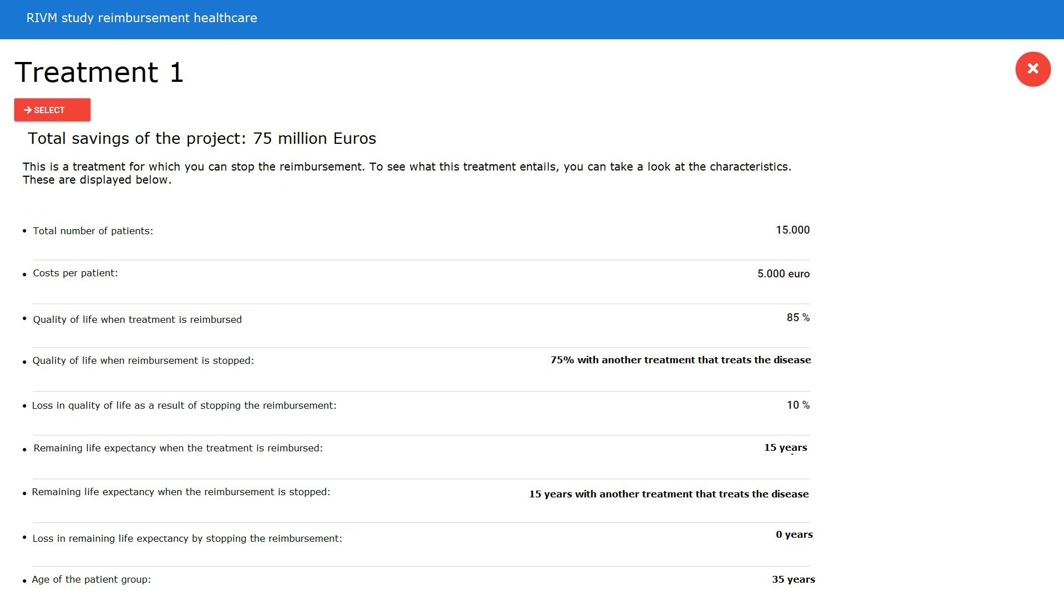
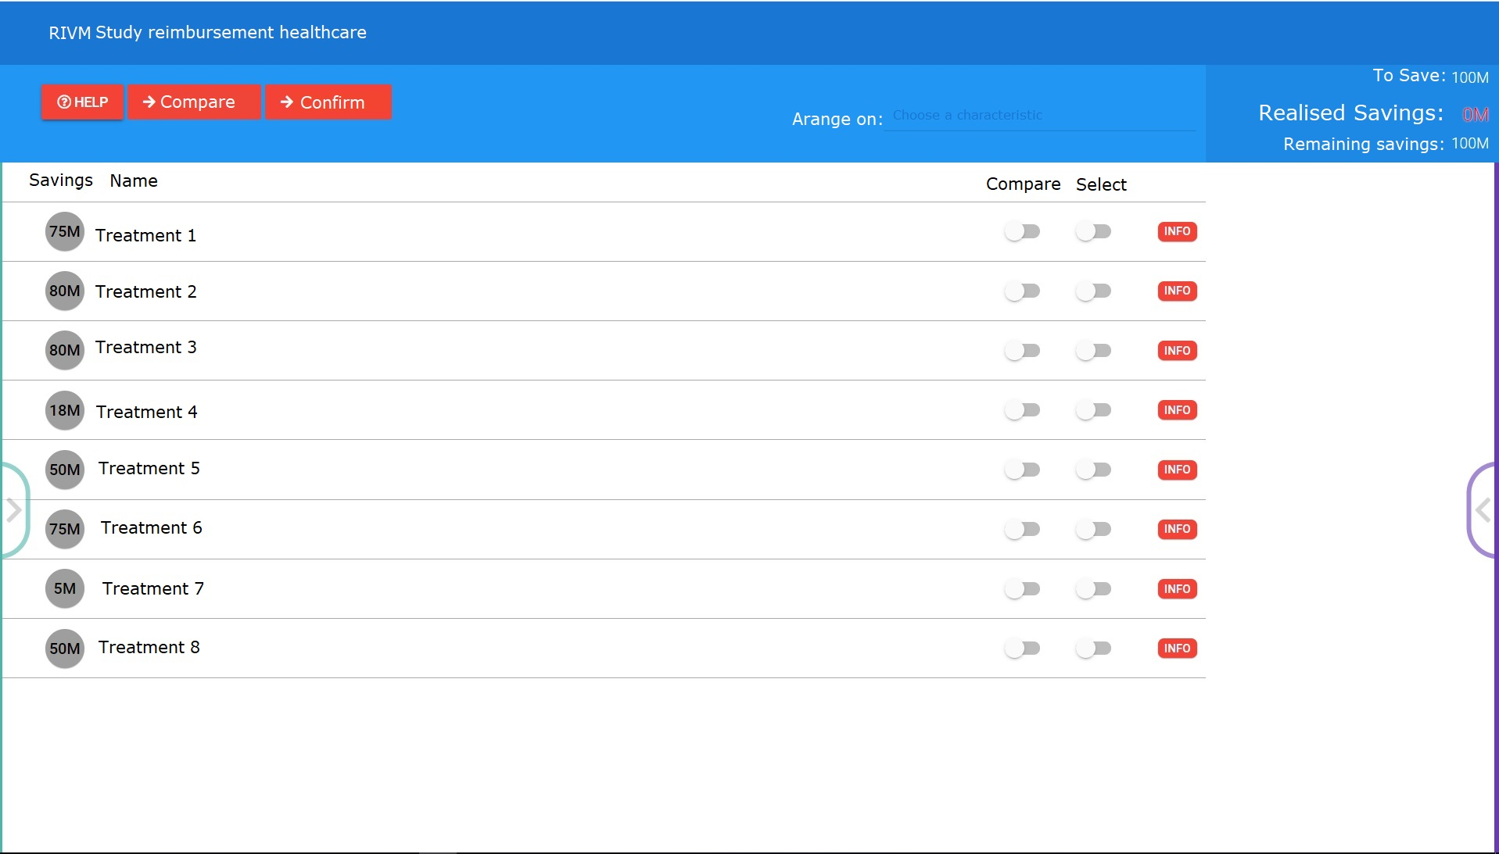

Appendix C: Attribute level selection
The levels for the ‘availability of alternative treatment’ attribute were obtained from Bourke et al. 2018 (Bourke et al., 2018). The levels for ‘average age of the patient group’ were adapted from van de Wetering et al. 2016 (E. J. van de Wetering et al., 2016) for the purpose of this study. The levels for the health effect attributes were determined based on the authors’ knowledge of previous reimbursement decisions in the Netherlands combined with input from the literature.
The budget-impact levels were restricted between 1 and 90 million Euros and calculated by multiplying levels of ‘number of patients’ and ‘costs per patient’. 90 Million Euros was chosen as an upper bound to force participants to select at least 2 treatments for disinvestment (note that the minimum budget to be saved was 100 million Euros). The lower bound of 1 million Euros was based on a trade-off between impact of the budget-impact on the total budget to be saved, and feasibility for the levels of the underlying attributes. The levels for ‘number of patients’ and ‘costs per patient’ were determined based on the following considerations: 1) a maximum of six levels for each attribute, 2) including a broad range, from cheap treatments for many people to expensive treatments for just a few patients, 3) the possibility to make combinations between the ‘number of patients’ and the ‘costs per patient’, resulting in levels of the budget-impact within the restrictions posed, 4) the possibility to combine each level of ‘number of patients’ with at least 2 levels of ‘costs per patient’ and vice versa, 5) sufficient overlap between the combinations of the levels of ‘number of patients’ and ‘costs per patient’. Considerations 1, 4 and 5 were included to ensure efficiency of the design. Consideration 2 was included to keep the design realistic.

Appendix D: Experience participants with PVE task
Question | Answer (N(%))
 | Completely agree | Agree | Don’t agree, don’t disagree | Disagree | Completely disagree | Missing
I had enough information to make a choice | 103 (9) | 460 (40) | 254 (22) | 134 (12) | 44 (4) | 148 (13)
The costs of the different treatments were decisive in making my choice | 93 (8) | 345 (30) | 298 (26) | 189 (17) | 68 (6) | 150 (13)
I am convinced of my choice | 90 (8) | 389 (34) | 349 (34) | 119 (10) | 44 (4) | 152 (13)
I consider this to be a realistic study | 75 (7) | 330 (29) | 340 (30) | 176 (15) | 68 (6) | 154 (13)
I found it difficult to understand the task | 39 (3) | 138 (12) | 218 (19) | 354 (31) | 240 (21) | 154 (13)
I found it difficult to make a choice | 181 (16) | 365 (32) | 209 (18) | 176 (15) | 59 (5) | 153 (13)
By participating in this experiment, I learned more about the choices the government needs to make regarding the reimbursement of healthcare | 110 (10) | 479 (42) | 259 (23) | 103 (9) | 45 (4) | 147 (13)
By participating in this experiment, I learned more about the choices the government needs to make to keep healthcare affordable | 97 (8) | 503 (44) | 257 (22) | 97 (8) | 39 (3) | 150 (13)
This is a good method to involve citizens in reimbursement decisions | 150 (13) | 428 (37) | 233 (20) | 113 (10) | 69 (6) | 150 (13)
The government should use this method more often to involve citizens in government policy | 168 (15) | 416 (36) | 233 (20) | 108 (9) | 69 (6) | 149 (13)
Because of the involvement of citizens in decision, the final government decision is more acceptable to me | 123 (11) | 414 (36) | 263 (23) | 122 (11) | 62 (5) | 159 (14)

We also consulted a number of scientists who are expert in the field of the reimbursement of healthcare. How much value should the government attach to the advice of citizens compared to the advice of experts | Government should follow the advice of (N(%)):
 | Citizens | Citizens and experts, with more weight to citizens | Citizens and experts, with equal weight | Experts and citizens, with more weight to experts | Experts | No Answer
 | 47 (4) | 85 (7) | 255 (22) | 441 (39) | 77 (7) | 238 (21)

Appendix E: Relative utility lost by disinvesting three different portfolios of treatments
Portfolio 1 |  |  |  | Portfolio 2 |  |  |  | Portfolio 3
Chosen treatments | Attributes | Attribute levels | Utility | Chosen treatments | Attributes | Attribute levels | Utility | Chosen treatments | Attributes | Attribute levels | Utility
Treatment 4 | Costs | 20M |  | Treatment 1 | Costs | 80M |  | Treatment 1 | Costs | 80M
 | Gain in quality of life | 5% | 0.1070 |  | Gain in quality of life | 45% | 0.9630 |  | Gain in quality of life | 45% | 0.9630
 | Gain in life expectancy | 1 year | 0.0615 |  | Gain in life expectancy | 5 years | 0.3075 |  | Gain in life expectancy | 5 years | 0.3075
 | Age | 35 years | 0.0149 |  | Age | 10 years | 0.0310 |  | Age | 10 years | 0.0310
 | Alternative treatment | Yes, treats symptoms | 0.0272 |  | Alternative treatment | Yes, treats disease | -0.0678 |  | Alternative treatment | Yes, treats disease | -0.0678
 | Total |  | 0.2106 |  | Total |  | 1.2337 |  | Total |  | 1.2337
Treatment 5 | Costs | 20M |  | Treatment 3 | Costs | 1M |  | Treatment 2 | Costs | 10M
 | Gain in quality of life | 5% | 0.1070 |  | Gain in quality of life | 25% | 0.5350 |  | Gain in quality of life | 25% | 0.5350
 | Gain in life expectancy | 0 years | 0 |  | Gain in life expectancy | 5 years | 0.3075 |  | Gain in life expectancy | 10 years | 0.6150
 | Age | 10 years | 0.0310 |  | Age | 55 years | -0.0943 |  | Age | 55 years | -0.0943
 | Alternative treatment | Yes, treats disease | -0.0678 |  | Alternative treatment | Yes, treats disease | -0.0678 |  | Alternative treatment | Yes, treats symptoms | 0.0272
 | Total |  | 0.0702 |  | Total |  | 0.6804 |  | Total |  | 1.0829
Treatment 6 | Costs | 40M |  | Treatment 4 | Costs | 20M |  | Treatment 8 | Costs | 20M
 | Gain in quality of life | 0% | 0 |  | Gain in quality of life | 5% | 0.1070 |  | Gain in quality of life | 5% | 0.1070
 | Gain in life expectancy | 0.5 years | 0.0308 |  | Gain in life expectancy | 1 year | 0.0615 |  | Gain in life expectancy | 5 years | 0.3075
 | Age | 55 years | -0.0943 |  | Age | 35 years | 0.0149 |  | Age | 75 years | -0.2891
 | Alternative treatment | No | 0 |  | Alternative treatment | Yes, treats symptoms | 0.0272 |  | Alternative treatment | No | 0
 | Total |  | -0.0636 |  | Total |  | 0.2106 |  | Total |  | 0.1254
Treatment 8 | Costs | 20M |  | Treatment 7 | Costs | 2M
 | Gain in quality of life | 5% | 0.1070 |  | Gain in quality of life | 5% | 0.1070
 | Gain in life expectancy | 5 years | 0.3075 |  | Gain in life expectancy | 15 years | 0.9225
 | Age | 75 years | -0.2891 |  | Age | 35 years | 0.0149
 | Alternative treatment | No | 0 |  | Alternative treatment | Yes, treats symptoms
 | Total |  | 0.1254 |  | Total |  | 1.0716
Subtotal utility lost |  |  | 0.3426 | Subtotal utility lost |  |  | 3.1962 | Subtotal utility lost |  |  | 2.4420
Additional savings (in addition to the 100M) |  | 0 | 0 | Additional savings (in addition to the 100M) |  | 3M | -0.0312 | Additional savings (in addition to the 100M) |  | 10M | -0.1040
Total utility lost by disinvesting portfolioª |  |  | 0.3426 | Total utility lost by disinvesting portfolioª |  |  | 3.2274 | Total utility lost by disinvesting portfolioª |  |  | 2.5460
ªThe total utility lost by choosing the portfolio for disinvestment: $U_{n\overline{p}}=\sum_{j=1}^{J}{\left(1-y_{nj}\right)⋅U_{nj}}-α\left(\sum_{j=1}^{J}{\left(1-y_{nj}\right)⋅c_{nj}}-B\right)+ε_{np}$

Appendix F: Relative utility lost by disinvesting three different portfolios based on the additional analysis including interactions between gain in health and health status before and after treatment
Table H1: Relative utility lost by disinvesting three different portfolios of treatments based on the portfolio model including the health status before treatment
Portfolio 1 |  |  |  | Portfolio 2 |  |  |  | Portfolio 3
Chosen treatments | Attributes | Attribute level | Utility | Chosen treatments | Attributes | Attribute level | Utility | Chosen treatments | Attributes | Attribute level | Utility
Treatment 4 | Costs | 20M |  | Treatment 1 | Costs | 80M |  | Treatment 1 | Costs | 80M
 | Gain in quality of life | 5% | 0.0750 |  | Gain in quality of life | 45% | 0.8270 |  | Gain in quality of life | 45% | 0.8270
 | Quality of life before | 75% |  |  | Quality of life before | 35% |  |  | Quality of life before | 35%
 | Gain in life expectancy | 1 year | 0.1354 |  | Gain in life expectancy | 5 years | 0.3770 |  | Gain in life expectancy | 5 years | 0.3770
 | Life expectancy before | 5 years |  |  | Life expectancy before | 25 years |  |  | Life expectancy before | 25 years
 | Age | 35 years | -0.0677 |  | Age | 10 years | -0.0001 |  | Age | 10 years | -0.0001
 | Alternative treatment | Yes, treats symptoms | 0.0216 |  | Alternative treatment | Yes, treats disease | -0.0833 |  | Alternative treatment | Yes, treats disease | -0.0833
 | Total |  | 0.1643 |  | Total |  | 1.1206 |  | Total utility |  | 1.1206
Treatment 5 | Costs | 20M |  | Treatment 3 | Costs | 1M |  | Treatment 2 | Costs | 10M
 | Gain in quality of life | 5% | 0.0750 |  | Gain in quality of life | 25% | 0.5310 |  | Gain in quality of life | 25% | 0.5310
 | Quality of life before | 75% |  |  | Quality of life before | 55% |  |  | Quality of life before | 55%
 | Gain in life expectancy | 0 years | 0.1575 |  | Gain in life expectancy | 5 years | 0.3770 |  | Gain in life expectancy | 10 years | 0.8815
 | Life expectancy before | 15 years |  |  | Life expectancy before | 25 years |  |  | Life expectancy before | 5 years
 | Age of the patient group | 10 years | -0.0001 |  | Age of the patient group | 55 years | -0.1911 |  | Age of the patient group | 55 years | -0.1911
 | Alternative treatment | Yes, treats disease | -0.0833 |  | Alternative treatment | Yes, treats disease | -0.0833 |  | Alternative treatment | Yes, treats symptoms | 0.0216
 | Total |  | 0.1491 |  | Total |  | 0.6336 |  | Total |  | 1.2430
Treatment 6 | Costs | 40M |  | Treatment 4 | Costs | 20M |  | Treatment 8 | Costs | 20M
 | Gain in quality of life | 0% | -0.0440 |  | Gain in quality of life | 5% | 0.0750 |  | Gain in quality of life | 5% | 0.0750
 | Quality of life before | 55% |  |  | Quality of life before | 75% |  |  | Quality of life before | 75%
 | Gain in life expectancy | 0.5 years | 0.0580 |  | Gain in life expectancy | 1 years | 0.1354 |  | Gain in life expectancy | 5 years | 0.4850
 | Life expectancy before | 1 years |  |  | Life expectancy before | 5 years |  |  | Life expectancy before | 1 year
 | Age of the patient group | 55 years | -0.19113 |  | Age of the patient group | 35 years | -0.0677 |  | Age of the patient group | 75 years | -0.3761
 | Alternative treatment | No | 0 |  | Alternative treatment | Yes, treats symptoms | 0.0216 |  | Alternative treatment | No | 0
 | Total |  | -0.1771 |  | Total |  | 0.1643 |  | Total |  | 0.1839
Treatment 8 | Costs | 20M |  | Treatment 7 | Costs | 2M
 | Gain in quality of life | 5% | 0.0750 |  | Gain in quality of life | 5% | 0.0750
 | Quality of life before | 75% |  |  | Quality of life before | 75%
 | Gain in life expectancy | 5 years | 0.4850 |  | Gain in life expectancy | 15 years | 0.9510
 | Life expectancy before | 1 year |  |  | Life expectancy before | 15 years
 | Age of the patient group | 75 years | -0.3761 |  | Age of the patient group | 35 years | -0.0677
 | Alternative treatment | No | 0 |  | Alternative treatment | Yes, treats symptoms | 0.0216
 | Total |  | 0.1839 |  | Total |  | 0.9799
Additional savings (in addition to the 100M) |  | 0 | 0 | Additional savings (in addition to the 100M) |  | 3M | -0.0297 | Additional savings (in addition to the 100M) |  | 10M | -0.0990
Total utility lost by disinvesting portfolio |  |  | 0.3201 | Total utility lost by disinvesting portfolio |  |  | 2.9280 | Total utility lost by disinvesting portfolio |  |  | 2.6465

Table H2: Relative utility lost by disinvesting three different portfolios of treatments based on the portfolio model including the health status after treatment
Portfolio 1 |  |  |  | Portfolio 2 |  |  |  | Portfolio 3
Chosen treatments | Attributes | Attribute level | Utility | Chosen treatments | Attributes | Attribute level | Utility | Chosen treatments | Attributes | Attribute level | Utility
Treatment 4 | Total costs | 20M |  | Treatment 1 | Total costs | 80M |  | Treatment 1 | Total costs | 80M
 | Gain in quality of life | 5% | 0.2705 |  | Gain in quality of life | 45% | 0.9625 |  | Gain in quality of life | 45% | 0.9625
 | Quality of life after | 80% |  |  | Quality of life after | 80% |  |  | Quality of life after | 80%
 | Gain in life expectancy | 1 year | 0.1162 |  | Gain in life expectancy | 5 years | 0.3650 |  | Gain in life expectancy | 5 years | 0.3650
 | Life expectancy after | 6 years |  |  | Life expectancy after | 30 years |  |  | Life expectancy after | 30 years
 | Age of the patient group | 35 years | -0.1628 |  | Age of the patient group | 10 years | -0.0375 |  | Age of the patient group | 10 years | -0.0375
 | Alternative treatment | Yes, treats symptoms | -0.0284 |  | Alternative treatment | Yes, treats disease | -0.1112 |  | Alternative treatment | Yes, treats disease | -0.1112
 | Total utility treatment |  | 0.1956 |  | Total utility |  | 1.1788 |  | Total utility |  | 1.1788
Treatment 5 | Total costs | 20M |  | Treatment 3 | Total costs | 1M |  | Treatment 2 | Total costs | 10M
 | Gain in quality of life | 5% | 0.2705 |  | Gain in quality of life | 25% | 0.6165 |  | Gain in quality of life | 25% | 0.6165
 | Quality of life after | 80% |  |  | Quality of life after | 80% |  |  | Quality of life after | 80%
 | Gain in life expectancy | 0 years | 0.0600 |  | Gain in life expectancy | 5 years | 0.3650 |  | Gain in life expectancy | 10 years | 0.8200
 | Life expectancy after | 15 years |  |  | Life expectancy after | 30 years |  |  | Life expectancy after | 15 years
 | Age of the patient group | 10 years | -0.0375 |  | Age of the patient group | 55 years | -0.2954 |  | Age of the patient group | 55 years | -0.2954
 | Alternative treatment | Yes, treats disease | -0.1112 |  | Alternative treatment | Yes, treats disease | -0.1112 |  | Alternative treatment | Yes, treats symptoms | -0.0284
 | Total utility treatment |  | 0.1818 |  | Total utility |  | 0.5750 |  | Total utility |  | 1.1128
Treatment 6 | Total costs | 40M |  | Treatment 4 | Total costs | 20M |  | Treatment 8 | Total costs | 20M
 | Gain in quality of life | 0% | 0.1265 |  | Gain in quality of life | 5% | 0.2705 |  | Gain in quality of life | 5% | 0.2705
 | Quality of life after | 55% |  |  | Quality of life after | 80% |  |  | Quality of life after | 80%
 | Gain in life expectancy | 0.5 years | 0.0562 |  | Gain in life expectancy | 1 year | 0.1162 |  | Gain in life expectancy | 5 years | 0.4850
 | Life expectancy after | 1.5 years |  |  | Life expectancy after | 6 years |  |  | Life expectancy after | 6 years
 | Age of the patient group | 55 years | -0.2954 |  | Age of the patient group | 35 years | -0.1628 |  | Age of the patient group | 75 years | -0.4568
 | Alternative treatment | No | 0 |  | Alternative treatment | Yes, treats symptoms | -0.0284 |  | Alternative treatment | No | 0
 | Total utility treatment |  | -0.1127 |  | Total utility |  | 0.1956 |  | Total utility |  | 0.2988
Treatment 8 | Total costs | 20M |  | Treatment 7 | Total costs | 2M
 | Gain in quality of life | 5% | 0.2705 |  | Gain in quality of life | 5% | 0.2705
 | Quality of life after | 80% |  |  | Quality of life after | 80%
 | Gain in life expectancy | 5 years | 0.4850 |  | Gain in life expectancy | 15 years | 0.8550
 | Life expectancy after | 6 years |  |  | Life expectancy after | 30 years
 | Age of the patient group | 75 years | -0.4568 |  | Age of the patient group | 35 years | -0.1628
 | Alternative treatment | No | 0 |  | Alternative treatment | Yes, treats symptoms | -0.0284
 | Total utility treatment |  | 0.2988 |  | Total utility |  | 0.9344
Additional savings (in addition to the 100M) |  | 0M | 0 | Additional savings (in addition to the 100M) |  | 3M | -0.0288 | Additional savings (in addition to the 100M) |  | 10M | -0.0960
Total utility lost by disinvesting portfolio |  |  | 0.5634 | Total utility lost by disinvesting portfolio |  |  | 2.9125 | Total utility lost by disinvesting portfolio |  |  | 2.6863

