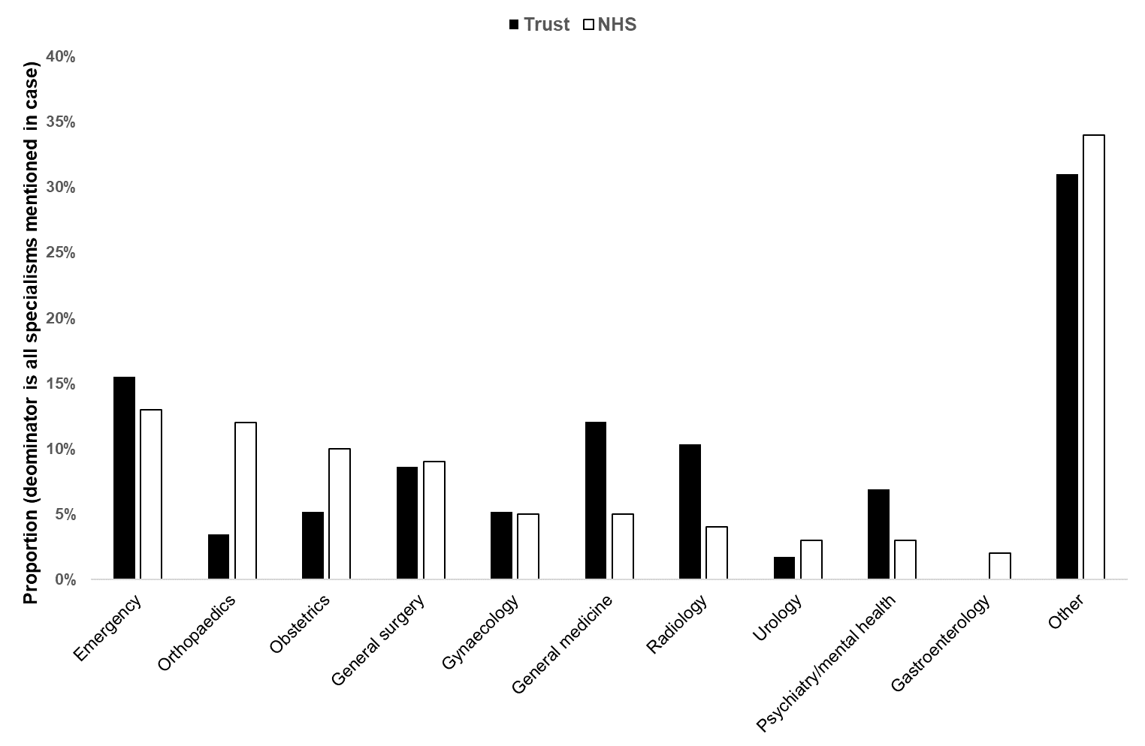
Supplement one. Proportion, by specialty, of all cases that NHS Resolution handled in 2018/19 (white bars) and the equivalent proportions from the study sample (n = 15) from one large NHS Trust (black bars).

