Appendix
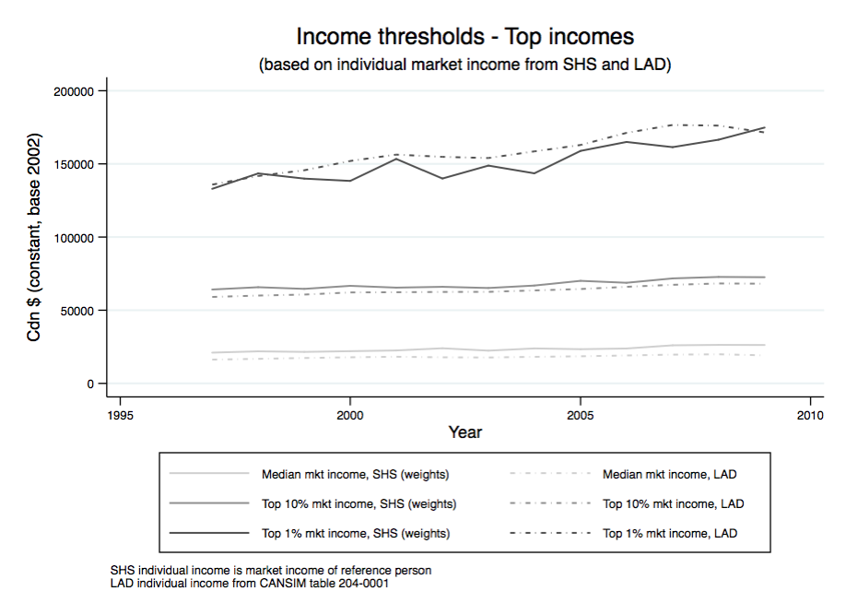
Figure A1 : Evolution income fractiles thresholds based on the distribution of individual market income

Figure A2 : Evolution of thresholds determining household income fractiles, and of the average household income per fractile

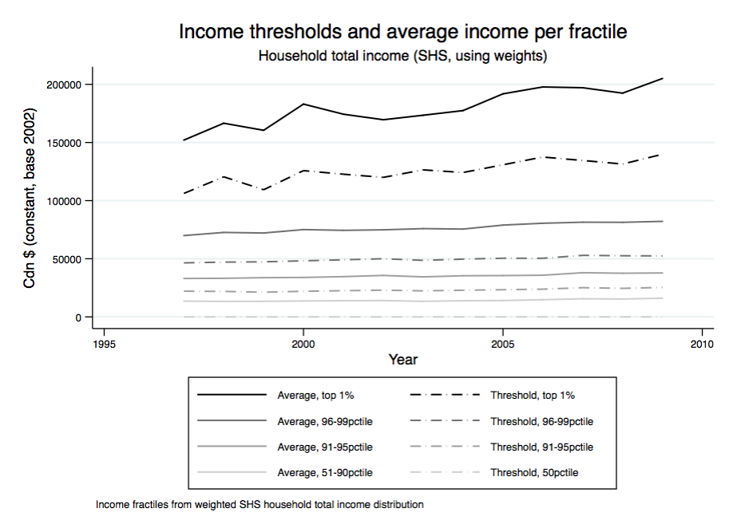

Figure A3 : Evolution of total premiums for private health insurance plans in Canada
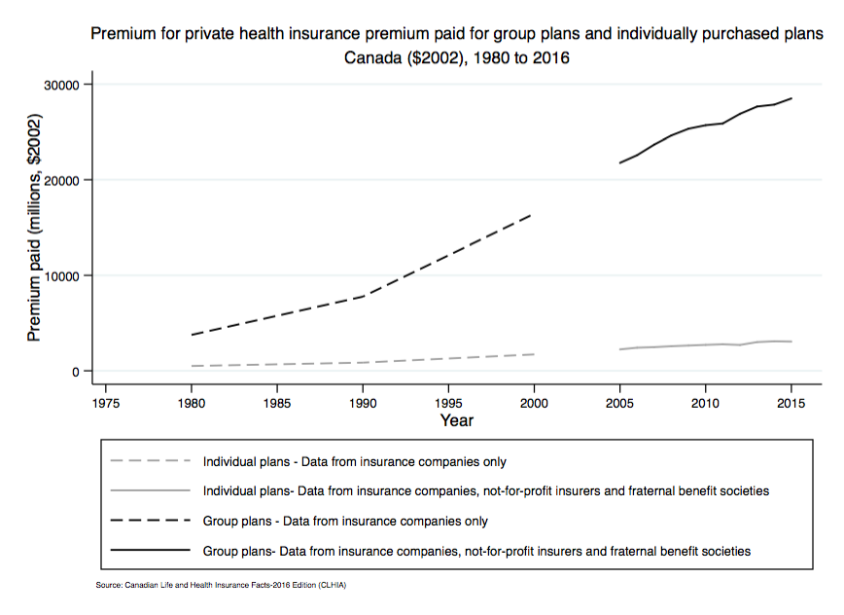

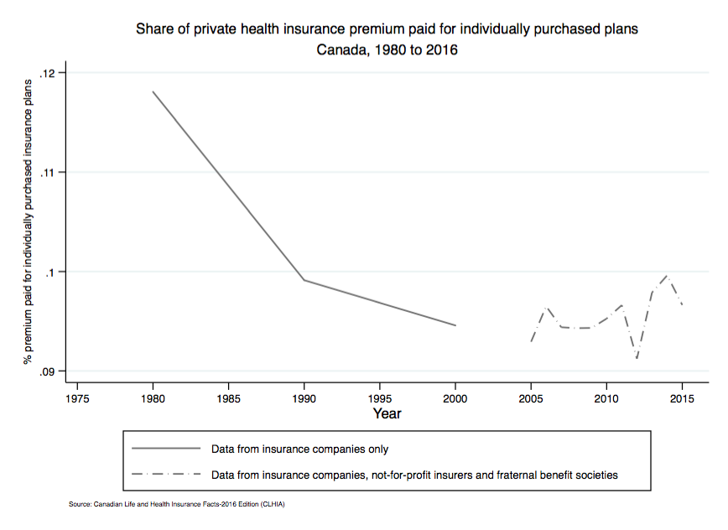
Figure A4 : Evolution of the share of private health insurance premium attributed to individually purchased plans

Table A1 : Ln inequality on Ln private health expenditure (controlling for total health expenditure)

 | Full sample |  |  | Restricted sample
 | (1) | (2) | (3) | (4) | (5) | (6)
 | top 1% [t] | top 1% [t-1] | top 1% [t-2] | top 1% [t] | top 1% [t-1] | top 1% [t-2]
Panel A: Top 1% income share
Top 1% income share | 0.538*** | 0.300* | 0.336** | 0.640** | 0.481 | 0.183
 | (0.149) | (0.155) | (0.145) | (0.269) | (0.327) | (0.182)
Ln All health expenditure | 0.880*** | 1.191*** | 1.095*** | 0.945*** | 1.124*** | 1.264***
 | (0.186) | (0.204) | (0.192) | (0.276) | (0.275) | (0.353)
Ln GDP | -0.638** | -0.874*** | -0.700** | -1.150 | -0.800 | 0.147
 | (0.305) | (0.327) | (0.323) | (0.785) | (0.968) | (0.921)
Ln Government expenditure | 0.346 | 0.284 | 0.430* | 0.351 | 0.349 | -0.128
 | (0.239) | (0.277) | (0.260) | (0.658) | (0.793) | (0.491)
Ln Population (/100k) | -0.054 | -0.040 | -0.302 | 1.361 | 0.401 | 0.317
 | (0.320) | (0.475) | (0.441) | (0.892) | (1.073) | (1.268)
Ln Population aged > 65 | -1.081*** | -1.157*** | -1.093*** | -0.679 | -0.357 | -0.266
 | (0.196) | (0.239) | (0.240) | (0.440) | (0.503) | (0.422)
Ln Employment rate | 0.380 | 0.436 | 0.221 | 0.308 | -0.857 | -0.974*
 | (0.315) | (0.341) | (0.290) | (0.693) | (0.618) | (0.539)
Ln Average income (tax unit) | 0.460** | 0.351* | 0.348* | 0.425 | 1.013** | 0.539
 | (0.189) | (0.202) | (0.200) | (0.412) | (0.418) | (0.452)
Observations | 453 | 418 | 405 | 143 | 128 | 110
Panel B: Gini coefficient
Ln Gini coefficient | 1.077** | 0.986* | 0.750 | 0.944** | 0.954* | 0.739*
 | (0.483) | (0.577) | (0.462) | (0.419) | (0.479) | (0.380)
Ln All health expenditure | 0.827*** | 0.907*** | 0.808*** | 1.194*** | 1.331*** | 1.265***
 | (0.257) | (0.248) | (0.228) | (0.286) | (0.304) | (0.316)
Ln GDP | -1.075 | -0.769 | -0.375 | -0.784 | -0.642 | 0.117
 | (0.676) | (0.743) | (0.782) | (0.666) | (0.822) | (0.854)
Ln Government expenditure | 0.450 | 0.404 | 0.033 | 0.290 | 0.427 | 0.063
 | (0.603) | (0.712) | (0.462) | (0.666) | (0.786) | (0.492)
Ln Population (/100k) | 0.983 | -0.065 | 0.250 | 0.752 | 0.264 | 0.532
 | (0.992) | (0.830) | (1.289) | (0.954) | (1.071) | (1.180)
Ln Population aged > 65 | -0.186 | 0.271 | 0.267 | -0.639 | -0.466 | -0.368
 | (0.422) | (0.444) | (0.422) | (0.482) | (0.566) | (0.447)
Ln Employment rate | 0.020 | -1.252** | -1.088** | 0.387 | -0.688 | -0.856
 | (0.694) | (0.515) | (0.521) | (0.763) | (0.580) | (0.528)
Ln Average income (per tax unit) | 0.621 | 1.326*** | 0.959*** | 0.080 | 0.705* | 0.372
 | (0.426) | (0.365) | (0.291) | (0.426) | (0.417) | (0.432)
Observations | 195 | 183 | 168 | 143 | 128 | 110
Panel C: Skew
Ln Income ratio 90th/50th | -0.498 | -0.075 | -0.359 | -0.498 | -0.113 | -0.122
 | (0.487) | (0.413) | (0.334) | (0.487) | (0.449) | (0.383)
Ln Income ratio 50th/10th | 0.257 | 0.535 | 0.528 | 0.257 | 0.521 | 0.568
 | (0.392) | (0.478) | (0.397) | (0.392) | (0.465) | (0.397)
Ln All health expenditure | 1.322*** | 1.344*** | 1.318*** | 1.322*** | 1.363*** | 1.333***
 | (0.305) | (0.320) | (0.325) | (0.305) | (0.327) | (0.330)
Ln GDP | -0.922 | -0.489 | -0.137 | -0.922 | -0.599 | 0.004
 | (0.695) | (0.752) | (0.784) | (0.695) | (0.826) | (0.837)
Ln Government expenditure | 0.128 | 0.362 | 0.100 | 0.128 | 0.346 | 0.112
 | (0.638) | (0.768) | (0.539) | (0.638) | (0.781) | (0.535)
Ln Population (/100k) | 0.838 | -0.008 | 0.664 | 0.838 | 0.240 | 0.674
 | (1.021) | (0.775) | (1.221) | (1.021) | (1.197) | (1.214)
Ln Population aged > 65 | -0.716 | -0.625 | -0.610 | -0.716 | -0.614 | -0.615
 | (0.499) | (0.682) | (0.527) | (0.499) | (0.623) | (0.516)
Ln Employment rate | 0.222 | -0.764 | -0.696 | 0.222 | -0.789 | -0.828
 | (0.788) | (0.601) | (0.501) | (0.788) | (0.556) | (0.525)
Ln Average income (tax unit) | 0.059 | 0.658 | 0.184 | 0.059 | 0.697 | 0.269
 | (0.439) | (0.436) | (0.443) | (0.439) | (0.445) | (0.452)
Observations | 143 | 133 | 117 | 143 | 128 | 110
Notes: Robust standard errors in parentheses. All regressions include country and year fixed effects. Income shares from the World Wealth and Income Database (Alvaredo et al, 2016). GDP, government expenditure, private and total health expenditure, population and employment rate from the OECD (OECD, 2016). All values in 2010 $US. Unbalanced panel, data available from 1982 to 2015.

*** p<0.01, ** p<0.05, * p<0.1
Table A2 : Ln inequality on Ln private health expenditure (controlling for Ln public health expenditure)
 | Full sample |  |  | Restricted sample
 | (1) | (2) | (3) | (4) | (5) | (6)
 | top 1% [t] | top 1% [t-1] | top 1% [t-2] | top 1% [t] | top 1% [t-1] | top 1% [t-2]
Panel A: Top 1% income share
Top 1% income share | 0.778*** | 0.650*** | 0.613*** | 0.890*** | 0.743* | 0.498*
 | (0.142) | (0.155) | (0.143) | (0.288) | (0.387) | (0.254)
Ln Public health expenditure | -0.551*** | -0.489*** | -0.486*** | -0.203 | -0.031 | 0.004
 | (0.129) | (0.161) | (0.141) | (0.287) | (0.338) | (0.313)
Ln GDP | 0.856*** | 0.762** | 0.840** | -0.800 | -0.506 | 0.735
 | (0.304) | (0.386) | (0.370) | (0.877) | (1.036) | (1.061)
Ln Government expenditure | 0.883*** | 0.917*** | 1.024*** | 0.895 | 0.789 | 0.164
 | (0.230) | (0.276) | (0.269) | (0.702) | (0.888) | (0.601)
Ln Population (/100k) | -0.566 | -0.723 | -0.980 | 1.610 | 1.049 | 1.077
 | (0.456) | (0.676) | (0.650) | (1.015) | (1.363) | (1.609)
Ln Population aged > 65 | -0.838*** | -0.858*** | -0.820*** | -0.956** | -0.478 | -0.316
 | (0.190) | (0.235) | (0.239) | (0.449) | (0.573) | (0.516)
Ln Employment rate | 0.186 | 0.234 | 0.000 | 0.654 | -0.754 | -0.982
 | (0.344) | (0.399) | (0.354) | (0.698) | (0.766) | (0.738)
Ln Average income (tax unit) | 0.434** | 0.400* | 0.349* | 0.449 | 1.076** | 0.660
 | (0.183) | (0.204) | (0.204) | (0.386) | (0.466) | (0.529)
Observations | 453 | 434 | 418 | 143 | 131 | 113
Panel B: Gini coefficient
Ln Gini coefficient | 1.416** | 1.248* | 1.269** | 1.237** | 1.122* | 1.139*
 | (0.578) | (0.697) | (0.592) | (0.598) | (0.670) | (0.607)
Ln Public health expenditure | -0.255 | -0.147 | -0.261 | -0.006 | 0.239 | 0.180
 | (0.193) | (0.236) | (0.195) | (0.294) | (0.299) | (0.307)
Ln GDP | -0.212 | 0.226 | 0.531 | -0.243 | -0.174 | 0.794
 | (0.642) | (0.647) | (0.747) | (0.793) | (0.934) | (0.931)
Ln Government expenditure | 0.925 | 0.804 | 0.466 | 0.831 | 0.790 | 0.377
 | (0.665) | (0.814) | (0.554) | (0.776) | (0.935) | (0.634)
Ln Population (/100k) | 1.704* | 0.861 | 1.415 | 0.924 | 0.609 | 0.972
 | (0.901) | (0.739) | (1.114) | (1.228) | (1.526) | (1.525)
Ln Population aged > 65 | -0.492 | 0.050 | -0.007 | -0.939 | -0.583 | -0.488
 | (0.455) | (0.522) | (0.457) | (0.565) | (0.705) | (0.601)
Ln Employment rate | 0.321 | -1.338** | -1.081* | 0.821 | -0.675 | -0.904
 | (0.710) | (0.624) | (0.623) | (0.870) | (0.754) | (0.755)
Ln Average income (per tax unit) | 0.380 | 1.165*** | 0.785** | -0.004 | 0.752 | 0.380
 | (0.384) | (0.382) | (0.350) | (0.427) | (0.482) | (0.529)
Observations | 195 | 183 | 168 | 143 | 128 | 110
Panel C: Skew
Ln Skew | -0.094 | -0.147 | -0.310 | -0.094 | -0.295 | -0.079
 | (0.593) | (0.511) | (0.379) | (0.593) | (0.547) | (0.452)
Ln Income ratio 90th/10th | 0.543 | 0.507 | 0.767 | 0.543 | 0.519 | 0.819
 | (0.522) | (0.616) | (0.626) | (0.522) | (0.602) | (0.623)
Ln Public health expenditure | 0.036 | 0.216 | 0.232 | 0.036 | 0.244 | 0.249
 | (0.313) | (0.296) | (0.291) | (0.313) | (0.302) | (0.314)
Ln GDP | -0.242 | 0.136 | 0.519 | -0.242 | -0.117 | 0.701
 | (0.918) | (0.777) | (0.871) | (0.918) | (1.013) | (0.941)
Ln Government expenditure | 0.643 | 0.722 | 0.404 | 0.643 | 0.686 | 0.416
 | (0.766) | (0.904) | (0.716) | (0.766) | (0.941) | (0.719)
Ln Population (/100k) | 0.745 | -0.067 | 0.805 | 0.745 | 0.465 | 0.784
 | (1.313) | (1.042) | (1.580) | (1.313) | (1.720) | (1.608)
Ln Population aged > 65 | -1.051* | -0.684 | -0.800 | -1.051* | -0.746 | -0.821
 | (0.627) | (0.804) | (0.728) | (0.627) | (0.770) | (0.724)
Ln Employment rate | 0.739 | -0.986 | -0.793 | 0.739 | -0.831 | -0.903
 | (0.962) | (0.783) | (0.750) | (0.962) | (0.748) | (0.788)
Ln Average income (tax unit) | 0.039 | 0.790 | 0.224 | 0.039 | 0.734 | 0.285
 | (0.461) | (0.500) | (0.549) | (0.461) | (0.503) | (0.558)
Observations | 143 | 133 | 117 | 143 | 128 | 110
Notes: Robust standard errors in parentheses. All regressions include country and year fixed effects. Income shares from the World Wealth and Income Database (Alvaredo et al, 2016). GDP, government expenditure, private and public health expenditure, population and employment rate from the OECD (OECD, 2016). All values in 2010 $US. Unbalanced panel, data available from 1982 to 2015.

*** p<0.01, ** p<0.05, * p<0.1
Table A3 : Ln inequality on Ln population with private health insurance (controlling for Ln total health expenditure)

 | Full sample |  |  | Restricted sample
 | (1) | (2) | (3) | (4) | (5) | (6)
 | top 1% [t] | top 1% [t-1] | top 1% [t-2] | top 1% [t] | top 1% [t-1] | top 1% [t-2]
Panel A: Top 1% income share
Top 1% income share | 0.861** | 0.679** | 0.930*** | 1.202* | -1.159 | 0.337
 | (0.339) | (0.320) | (0.313) | (0.681) | (1.282) | (0.687)
Ln Health expenditure | -0.956 | -1.202* | -1.167 | 0.048 | -3.252 | -4.847*
 | (0.686) | (0.707) | (0.708) | (0.523) | (2.366) | (2.472)
Ln GDP | -2.631** | -2.524* | -2.379 | -2.410 | -6.958 | -2.766
 | (1.247) | (1.424) | (1.457) | (1.506) | (5.377) | (2.726)
Ln Government expenditure | 1.596** | 1.557* | 1.508* | 1.200 | 1.963 | 0.038
 | (0.765) | (0.850) | (0.804) | (0.909) | (2.224) | (2.197)
Ln Population aged > 65 | 2.228* | 3.040** | 3.481*** | 2.633 | 7.297 | 11.655**
 | (1.250) | (1.217) | (1.239) | (1.614) | (4.622) | (4.420)
Ln Employment rate | 1.251 | 0.754 | 0.843 | 2.854* | -1.351 | -2.429
 | (0.908) | (1.010) | (0.961) | (1.444) | (3.364) | (2.522)
Ln Average income (tax unit) | 0.036 | 0.140 | 0.116 | -0.139 | 2.064 | 0.684
 | (0.788) | (0.855) | (0.832) | (0.915) | (2.182) | (1.952)
Observations | 135 | 131 | 130 | 65 | 60 | 53
Panel B: Gini coefficient
Ln Gini coefficient | 2.213* | 2.278 | 1.001 | 2.686 | 2.391 | 2.093
 | (1.222) | (1.911) | (3.751) | (1.645) | (4.094) | (3.860)
Ln Health expenditure | -0.045 | -0.905 | -1.500 | 0.642 | -2.364 | -3.671
 | (0.572) | (1.159) | (1.919) | (0.779) | (3.093) | (3.262)
Ln GDP | -1.866 | -6.027 | -4.872 | -2.782 | -7.688 | -3.926
 | (1.183) | (3.991) | (3.159) | (1.811) | (5.792) | (2.617)
Ln Government expenditure | 1.251 | 2.309 | 1.426 | 1.034 | 2.361 | 0.574
 | (0.893) | (1.451) | (1.730) | (1.141) | (2.581) | (2.185)
Ln Population aged > 65 | 4.088*** | 0.901 | 1.704 | 4.053*** | 6.941 | 11.476**
 | (0.933) | (2.920) | (2.823) | (1.320) | (4.392) | (4.404)
Ln Employment rate | 3.142** | 3.110 | 2.155 | 3.946* | -2.522 | -2.055
 | (1.323) | (2.324) | (2.709) | (2.012) | (4.035) | (2.121)
Ln Average income (per tax unit) | -0.601 | -0.175 | 0.446 | -0.098 | 2.687 | 0.616
 | (0.704) | (1.439) | (1.788) | (0.909) | (2.531) | (1.741)
Observations | 87 | 84 | 78 | 65 | 60 | 53
Panel C: Skew
Ln Skew | 1.248 | -0.540 | 3.230 | 1.248 | -0.846 | 2.310
 | (1.197) | (1.959) | (2.820) | (1.197) | (2.124) | (2.251)
Ln Income ratio 90th/10th | 1.637 | 0.288 | -0.330 | 1.637 | 0.431 | -0.798
 | (1.066) | (2.587) | (2.541) | (1.066) | (3.250) | (3.090)
Ln Health expenditure | -0.047 | -2.989 | -5.058 | -0.047 | -3.249 | -5.616*
 | (0.654) | (2.394) | (3.127) | (0.654) | (2.746) | (2.818)
Ln GDP | -2.852 | -5.919 | -0.734 | -2.852 | -7.212 | -1.642
 | (1.847) | (4.868) | (2.356) | (1.847) | (5.405) | (2.466)
Ln Government expenditure | 0.617 | 2.195 | 0.663 | 0.617 | 2.285 | -0.066
 | (1.126) | (2.430) | (2.035) | (1.126) | (2.619) | (2.153)
Ln Population aged > 65 | 3.999*** | 3.345 | 7.462** | 3.999*** | 6.315 | 11.812**
 | (1.392) | (3.333) | (2.685) | (1.392) | (5.137) | (4.396)
Ln Employment rate | 3.635* | -3.477 | -3.164 | 3.635* | -2.877 | -2.512
 | (1.985) | (5.038) | (3.664) | (1.985) | (4.594) | (2.167)
Ln Average income (tax unit) | 0.652 | 2.670 | 1.539 | 0.652 | 2.382 | 0.951
 | (1.016) | (2.988) | (2.365) | (1.016) | (2.647) | (1.856)
Observations | 65 | 62 | 55 | 65 | 60 | 53
Notes: Robust standard errors in parentheses. All regressions include country and year fixed effects. Income shares from the World Wealth and Income Database (Alvaredo et al, 2016). GDP, government expenditure, private health insurance, population and employment rate from the OECD (OECD, 2016). All values in 2010 $US. Unbalanced panel, data available from 1995 to 2015.

*** p<0.01, ** p<0.05, * p<0.1
Table A4 : Ln inequality on Ln out-of-pocket health expenditure (controlling for Ln total health expenditure)

 | Full sample |  |  | Restricted sample
 | (1) | (2) | (3) | (4) | (5) | (6)
 | top 1% [t] | top 1% [t-1] | top 1% [t-2] | top 1% [t] | top 1% [t-1] | top 1% [t-2]
Panel A: Top 1% income share
Top 1% income share | 0.194* | 0.148* | 0.157** | 0.168 | 0.073 | 0.038
 | (0.105) | (0.085) | (0.084) | (0.121) | (0.102) | (0.100)
Ln Health expenditure | -0.126 | 0.033 | 0.116 | -0.010 | 0.135 | 0.121
 | (0.127) | (0.127) | (0.121) | (0.251) | (0.135) | (0.148)
Ln GDP | 0.627** | 0.510** | 0.460* | 0.711 | 0.229 | 0.634*
 | (0.256) | (0.253) | (0.249) | (0.566) | (0.383) | (0.370)
Ln Government expenditure | 0.541*** | 0.469*** | 0.385** | 0.510 | 0.038 | -0.234
 | (0.179) | (0.174) | (0.173) | (0.377) | (0.248) | (0.269)
Ln Population (/100k) | -0.558 | -0.385 | -0.177 | -1.257 | -0.296 | 0.014
 | (0.529) | (0.494) | (0.489) | (0.928) | (0.733) | (0.842)
Ln Population aged > 65 | -0.011 | 0.018 | 0.090 | 0.227 | 0.890*** | 0.858***
 | (0.169) | (0.170) | (0.169) | (0.434) | (0.316) | (0.278)
Ln Employment rate | -0.439** | -0.487*** | -0.473*** | -1.153** | -1.638*** | -1.119**
 | (0.194) | (0.179) | (0.179) | (0.524) | (0.423) | (0.446)
Ln Average income (tax unit) | 0.451*** | 0.560*** | 0.553*** | 0.774** | 1.355*** | 1.008***
 | (0.147) | (0.143) | (0.141) | (0.315) | (0.248) | (0.239)
Observations | 265 | 258 | 255 | 112 | 100 | 84
Panel B: Gini coefficient
Ln Gini coefficient | 0.405 | 0.271 | 0.396** | 0.245 | 0.175 | 0.361
 | (0.248) | (0.197) | (0.186) | (0.275) | (0.205) | (0.224)
Ln Health expenditure | -0.129 | -0.046 | -0.050 | 0.006 | 0.155 | 0.113
 | (0.210) | (0.136) | (0.147) | (0.252) | (0.130) | (0.158)
Ln GDP | 0.783* | 0.139 | 0.426 | 0.808 | 0.216 | 0.528
 | (0.439) | (0.364) | (0.302) | (0.507) | (0.358) | (0.337)
Ln Government expenditure | 0.388 | 0.145 | -0.074 | 0.497 | 0.063 | -0.114
 | (0.300) | (0.241) | (0.244) | (0.395) | (0.262) | (0.288)
Ln Population (/100k) | -0.750 | -0.153 | -0.020 | -1.347 | -0.273 | 0.233
 | (0.708) | (0.599) | (0.592) | (0.916) | (0.649) | (0.719)
Ln Population aged > 65 | 0.520 | 0.952*** | 1.060*** | 0.338 | 0.928*** | 0.872***
 | (0.331) | (0.242) | (0.245) | (0.420) | (0.305) | (0.266)
Ln Employment rate | -0.891* | -0.785* | -0.610 | -1.106** | -1.604*** | -1.061**
 | (0.466) | (0.426) | (0.411) | (0.535) | (0.441) | (0.450)
Ln Average income (per tax unit) | 0.702** | 0.973*** | 0.857*** | 0.731** | 1.334*** | 0.966***
 | (0.270) | (0.216) | (0.182) | (0.329) | (0.247) | (0.227)
Observations | 142 | 133 | 120 | 112 | 100 | 84
Panel C: Skew
Ln Skew | -0.333 | -0.075 | -0.002 | -0.333 | 0.042 | 0.047
 | (0.445) | (0.319) | (0.302) | (0.445) | (0.306) | (0.265)
Ln Income ratio 90th/10th | 0.168 | 0.160 | 0.183 | 0.168 | 0.119 | 0.204
 | (0.288) | (0.280) | (0.282) | (0.288) | (0.257) | (0.265)
Ln Health expenditure | 0.085 | 0.048 | 0.078 | 0.085 | 0.156 | 0.136
 | (0.224) | (0.160) | (0.178) | (0.224) | (0.132) | (0.149)
Ln GDP | 0.577 | 0.108 | 0.516 | 0.577 | 0.265 | 0.602*
 | (0.435) | (0.380) | (0.358) | (0.435) | (0.353) | (0.347)
Ln Government expenditure | 0.468 | 0.126 | -0.164 | 0.468 | 0.063 | -0.129
 | (0.379) | (0.338) | (0.362) | (0.379) | (0.285) | (0.329)
Ln Population (/100k) | -1.070 | -0.293 | -0.101 | -1.070 | -0.399 | -0.007
 | (0.936) | (0.750) | (0.794) | (0.936) | (0.678) | (0.736)
Ln Population aged > 65 | 0.273 | 0.878** | 0.907** | 0.273 | 0.895*** | 0.787**
 | (0.418) | (0.345) | (0.356) | (0.418) | (0.335) | (0.312)
Ln Employment rate | -1.038* | -1.189** | -0.867 | -1.038* | -1.626*** | -1.103**
 | (0.530) | (0.525) | (0.545) | (0.530) | (0.448) | (0.456)
Ln Average income (tax unit) | 0.684** | 1.172*** | 0.932*** | 0.684** | 1.335*** | 0.961***
 | (0.333) | (0.290) | (0.251) | (0.333) | (0.275) | (0.247)
Observations | 112 | 102 | 86 | 112 | 100 | 84
Notes: Robust standard errors in parentheses. All regressions include country and year fixed effects. Income shares from the World Wealth and Income Database (Alvaredo et al, 2016). GDP, government expenditure, total health expenditure, population and employment rate from the OECD (OECD, 2016). Out-of-pocket health spending from the World Bank (WORLD BANK, 2016). All values in 2010 $US. Unbalanced panel, data available from 1995 to 2014.
*** p<0.01, ** p<0.05, * p<0.1.

Table A5 : Categories of health expenditures from the Survey of Household Spending

 | Definition
Hospital and other residential facilities | Charges paid on hospital/nursing homes/ residential health care facilities bills (including phone charges, television charges, etc.)
Physician care | Payments for physician care (general practitioners, family practitioners, and specialists)
Other health professionals (non physicians) care | Expenditures on services from health care professionals such as nurses, attendant care, therapists, chiropractors, podiatrists, homeopaths, naturopaths, osteopaths, physiotherapists, etc. either received at home or in a clinic
Other health care and medical services | Expenditures on services such as weight loss plans, smoking cessation plans, ambulance transportation, rental of medical equipment, laboratory services, etc.
Prescription drugs | Expenditures on medicines, drugs and pharmaceutical products prescribed by a physician
Other medicinal or pharmaceutical products | Expenditures for non-prescribed pharmaceutical products, drugs, over-the-counter medicines, supplements, vitamins, herbal and homeopathic remedies, etc.
Private health insurance | Premiums for private health insurance plans, supplementary coverage to public health insurance plans (including for upgrades in amenities in inpatient facilities), extended health benefit packages, drug plans, out-of-country benefits, dental plans and accident/disability insurance plans. Includes contributions automatically deducted from salaries through private plans offered in share employee-employer financed plans
Public hospital, medical and drug plans | Premiums for insurance plans administered by provincial or territorial governments for hospital services, medical services and drug coverage (excluding contributions made through general taxation)
Health care supplies | Expenditures on goods such as first aid supplies, hearing aids, thermometers, bathroom scales, wheelchairs and other appliances, elastic hoisery, etc.
Eye care | Expenditures on prescription and non-prescription eye glasses, contact lenses, eye care supplies, eye care services (examinations, laser correction, eye surgeries performed outside of a hospital, etc.)
Dental care | Expenditures on dental services (examinations, cleanings, fillings, extractions, root canals, etc.) , orthodontic and peridontal procedures, including the x-rays and the prescription and fitting of dentures
Direct health expenditure | All health care related expenditures listed above, excluding expenditures on health insurance plans and premiums
Total health expenditure | All health care related expenditures listed above, including expenditures on health insurance plans and premiums

