Web appendix
Figure W1. Co-citation of academic disciplines
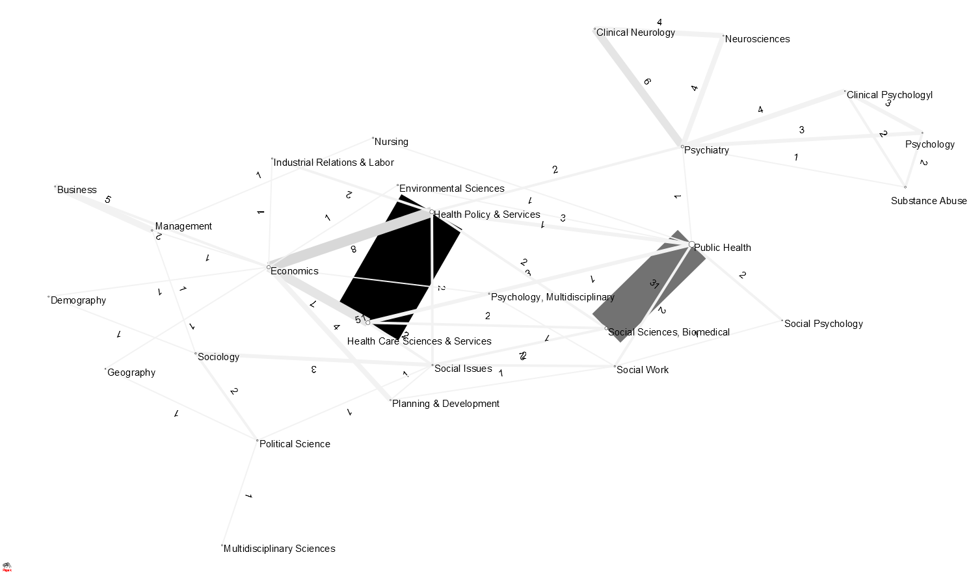
Shaded lines correspond to the co-citation score for a pair of disciplines, listed in the numbers on each line. The dark black and gray shaded boxes show, respectively, the strongest co-citation links for classifications ‘health policy & services’ and ‘health care sciences & services’ (co-citation = 51), followed by ‘public health’ and ‘social sciences, biomedical’ (co-citation = 31).
Figure W2. Co-citation of journals
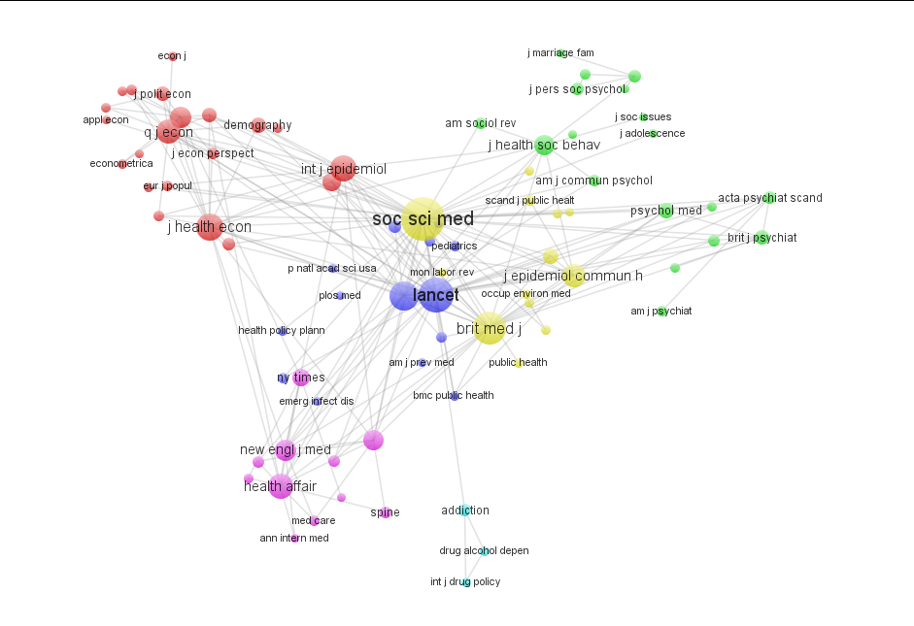
Notes: Bubble sizes correspond to the relative magnitude of each journal’s citations in cited documents with greater than 3 citations (n= 338 documents). Colours reflect communities identified by VOS clustering.

Figure W3. Four generations of scholarship on the health effects of recessions

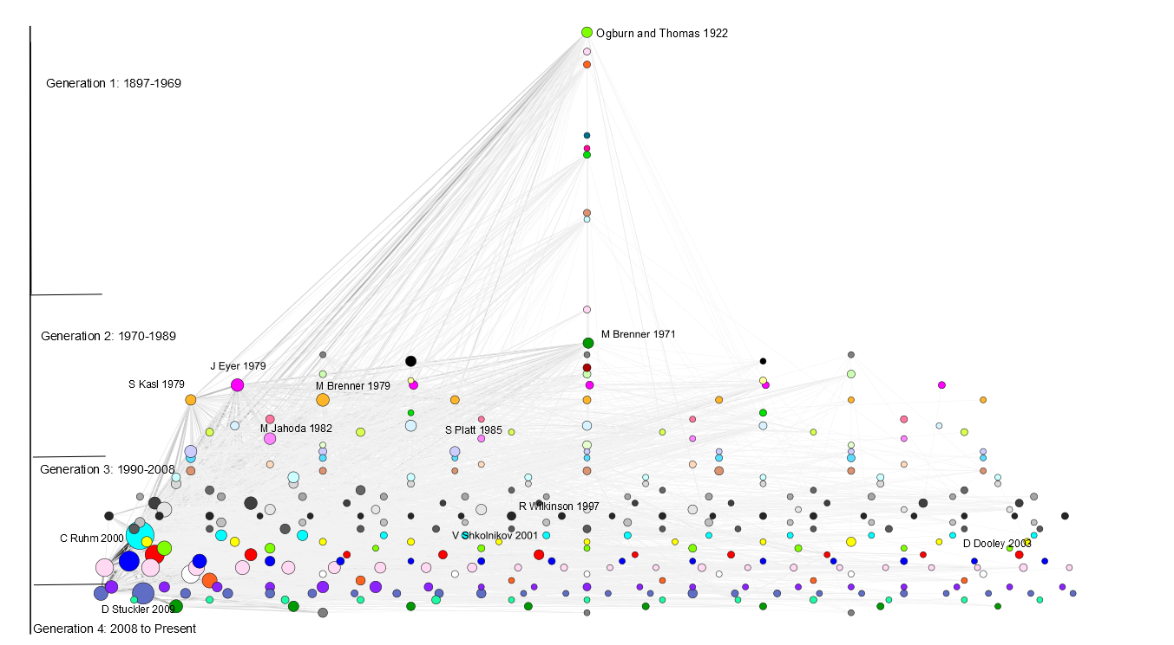
Notes: Bubble sizes correspond to the magnitude of citation for documents with greater than three citations (n= 338). Shaded lines denote co-citation strength. Colours reflect communities identified by VOS clustering as in Figure 3. The documents are spatially arranged so to minimise the geometric distance between the citation connection strength lines so the various communities cluster along the x axis but no meaning should be attributed to their position on it.

