Appendix 1. Figures.

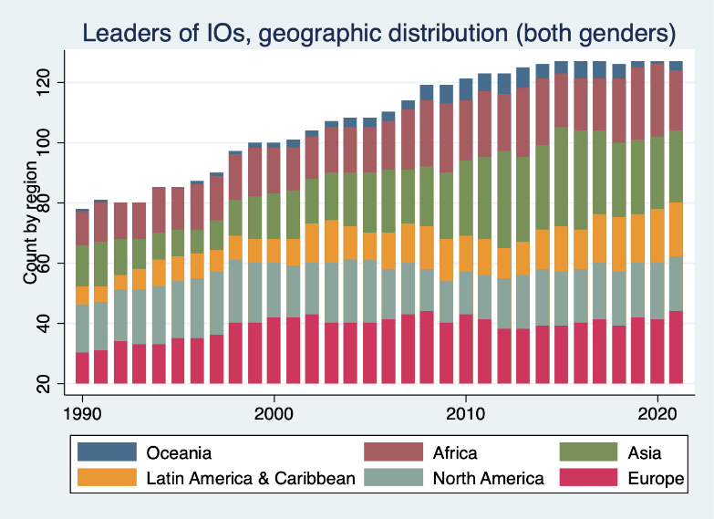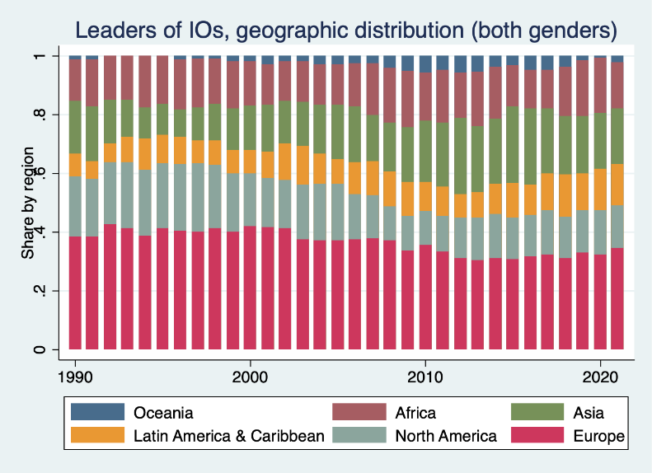

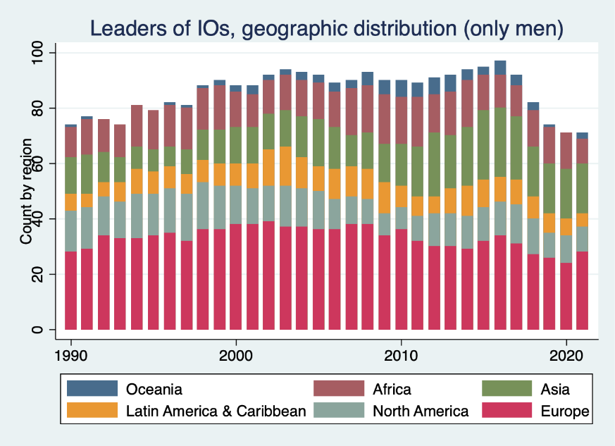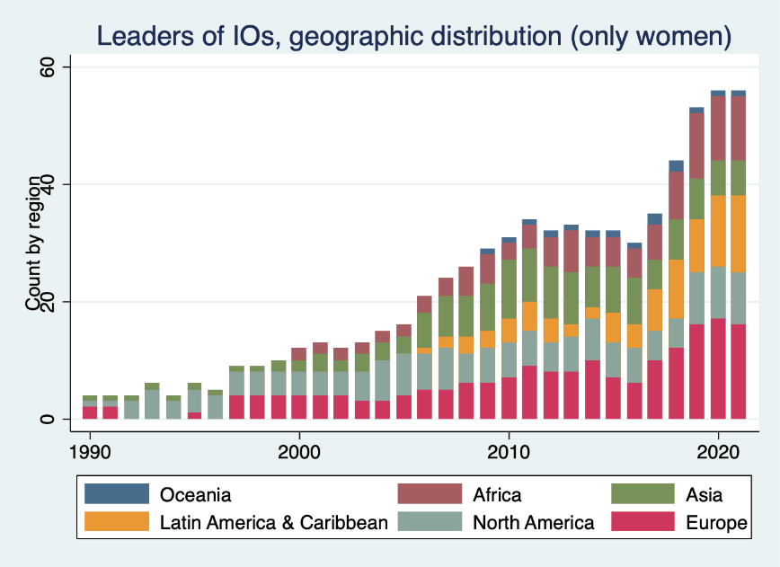
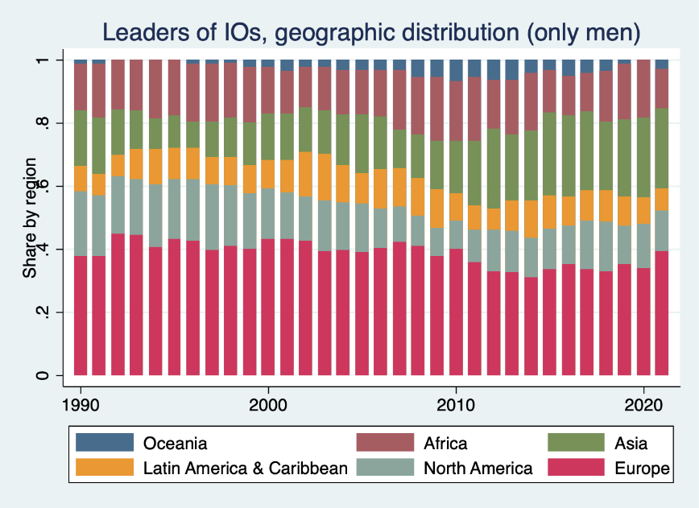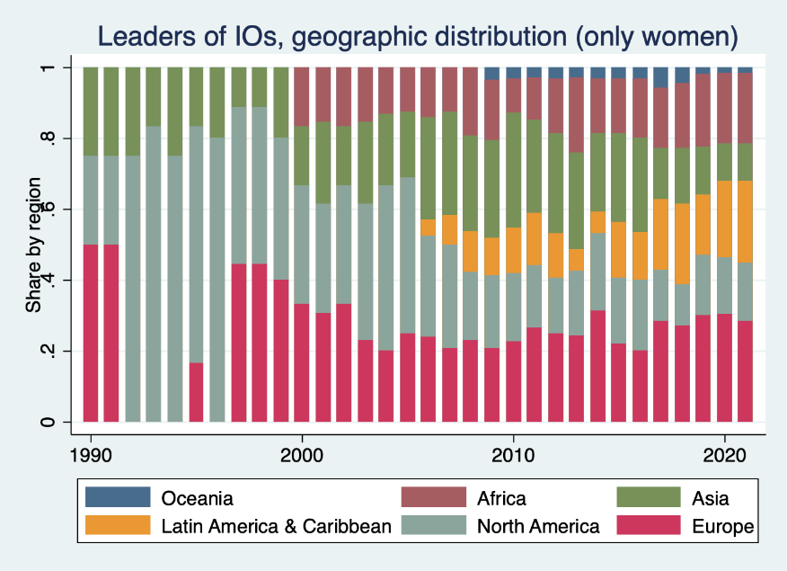

Appendix 2. Estimation results.

Only appointments (years of “having” a woman leader don’t count)

 | (1) | (2) | (3) | (4) | (5) | (6) | (7) | (8)
 | xtreg | xtlogit re | xtlogit fe | xtlogit pa | xtlogit re | xtlogit re | xtlogit fe | xtlogit pa
VARIABLES
Prior_w_leader | 0.11** | 1.41*** | 1.56* | 1.11*** | 0.13** | 1.36*** | 1.74* | 1.28***
 | (0.05) | (0.15) | (0.42) | (0.13) | (0.06) | (0.23) | (0.50) | (0.22)
leader_region
Asia |  |  |  |  | -0.08 | -0.33 | 0.57 | -0.34
 |  |  |  |  | (0.07) | (0.36) | (0.26) | (0.34)
Europe |  |  |  |  | -0.04 | -0.40 | 0.77 | -0.39
 |  |  |  |  | (0.07) | (0.35) | (0.33) | (0.33)
LatAm&Caribbean |  |  |  |  | -0.06 | -0.24 | 0.69 | -0.24
 |  |  |  |  | (0.10) | (0.49) | (0.35) | (0.46)
North America |  |  |  |  | 0.15* | 0.41 | 2.40* | 0.41
 |  |  |  |  | (0.08) | (0.35) | (1.24) | (0.33)
Oceania |  |  |  |  | -0.08 | -0.64 | 0.58 | -0.61
 |  |  |  |  | (0.13) | (0.76) | (0.47) | (0.73)
Appointment_Type
Internal executive |  |  |  |  |  | -0.68* |  | -0.67*
 |  |  |  |  |  | (0.38) |  | (0.38)
Member states |  |  |  |  |  | -2.05*** |  | -1.96***
 |  |  |  |  |  | (0.71) |  | (0.70)
UNGA |  |  |  |  |  | -1.68* |  | -1.47*
 |  |  |  |  |  | (0.98) |  | (0.78)
UNSG |  |  |  |  |  | -0.04 |  | -0.03
 |  |  |  |  |  | (0.33) |  | (0.32)
Observations | 595 | 595 | 385 | 595 | 592 | 592 | 383 | 592
R-squared | 0.01 |  |  |  | 0.04
Number of d_inst | 118 | 118 | 70 | 118 | 118 | 118 | 70 | 118
Country | RE | RE | FE | PA | RE | RE | FE | PA
Year | FE | FE | FE | PA | FE | FE | FE | PA
Pseudo R-squared |  |  | 0.00938 |  |  |  | 0.0481
AIC |  | 607.86 | 295.56 |  |  | 581.97 | 291.27
BIC |  | 621.02 | 299.52 |  |  | 634.57 | 314.96
Standard errors in parentheses. *** p<0.01, ** p<0.05, * p<0.1

Appendix 3. List of 129 institutions included in the data set.

 | 1 | 2 | 3 | 4 | 5
 | All institutions | Institutions with information on vice leaders | Institutions with public candidate pool | Years for which candidate observations available | Institutions with data on staff composition
1 | ActionAid
2 | African development bank (AfDB) | x | x | 2015, 2005
3 | African Union (AU) | x | x | 2016
4 | AIESEC |  | x | 2020, 2019, 2018, 2017
5 | Amnesty International | x
6 | Asian Development Bank | x | x | 2019, 2016, 2013
7 | Bank for International Settlements (BIS) | x
8 | BIPM
9 | BRAC
10 | CARE International | x
11 | Catholic Agency for Overseas Development (CAFOD)
12 | Danish Refugee Council
13 | Department for General Assembly and Conference Management (DGACM) | x | x | 2020, 2018, 2016
14 | Department of Economic and Social Affairs (DESA) | x
15 | Department of Field Support (DFS) | x
16 | Department of Management (DM) | x
17 | Department of Peacekeeping Operations (DPKO) | x
18 | Department of Political Affairs (DPA) | x
19 | Department of Safety and Security (DSS) | x
20 | Department Public Information (DPI) or Department of Global Communications | x
21 | European Bank of Reconstruction and Development (EBRD) | x | x | 2020, 2016, 2012
22 | European Central Bank (ECB) | x | x | 2019
23 | European Commission (EC) | x | x | 2019, 2014
24 | Executive Office of the Secretary-General (EOSG) | x
25 | Food and Agriculture Organization of the United Nations (FAO) | x | x | 2019, 2015, 2011, 2005, 1999 | x
26 | General Assembly of the United Nations |  | x | 2020, 2019, 2018, 2012
27 | Global Alliance for Vaccines and Immunisation (GAVI) | x
28 | Global Fund |  | x | 2017, 2012, 2008
29 | Inter-American development bank | x | x | 2020, 2005
30 | International Association of Students in Economic and Commercial Sciences (AIESEC)
31 | International Atomic Energy Agency (IAEA) | x |  |  | x
32 | International Bank for Reconstruction and Development (IBRD) |  | x | 2019, 2012
33 | International Centre for Settlement of Investment Disputes (ICSID) | x
34 | International Civil Aviation Organization (ICAO) |  |  |  | x
35 | International Civil Service Commission (ICSC) | x |  |  | x
36 | International Committee of the Red Cross (ICRC) | x
37 | International Court of Justice (ICJ) | x |  |  | x
38 | International Criminal Court (ICC) | x
39 | International Development Association (IDA) |  | x | 2019, 2012
40 | International Finance Corporation (IFC) | x | x | 2019, 2012
41 | International Fund for Agricultural Development (IFAD) | x | x | 2017, 2001 | x
42 | International Labour Organization (ILO) | x | x | 2012, 1998 | x
43 | International Maritime Organization (IMO) | x | x | 2011, 2015 | x
44 | International Monetary Fund (IMF) | x | x | 2019, 2011, 2007, 2004
45 | International organization for migration (IOM) | x
46 | International Rescue Committee
47 | International Seabed Authority (ISA) |  | x | 2016, 2004
48 | International Space Agency
49 | International Standards Organization (ISO) | x
50 | International Telecommunication Union (ITU) | x | x | 2014, 2006, 1998 | x
51 | International Trade Centre (ITC) | x |  |  | x
52 | International Tribunal for the Law of the Sea (ITLOS) | x
53 | Joint United Nations Programme on HIV/AIDS (UNAIDS) | x | x | 2019 | x
54 | Koyamada International Foundation | x
55 | Medecins Sans Frontieres (MSF)
56 | MERCOSUR | x
57 | MERCOSUR Secretariat
58 | Mercy Corps | x
59 | Multilateral Investment Guarantee Agency (MIGA) | x
60 | North Atlantic Treaty Organization (NATO) | x | x | 2014, 2009
61 | Office for the Coordination of Humanitarian Affairs (OCHA) | x
62 | Office of Internal Oversight Services (OIOS) | x
63 | Office of Legal Affairs (OLA) | x
64 | Office of the High Representative for the Least Developed Countries, Landlocked Developing Countries and Small Island Developing States (UN-OHRLLS)
65 | Office of the Special Adviser on Africa (OSAA)
66 | Office of the Special Representative of the Secretary-General for Children and Armed Conflict (SRSG/CAAC)
67 | Office of the Special Representative of the Secretary-General on Sexual Violence in Conflict (SRSG/SVC)
68 | Office of the United Nations High Commissioner for Human Rights (OHCHR) | x | x | 2008
69 | Organization for Economic Cooperation and Development (OECD) | x | x | 2020, 2015, 2010, 2006
70 | Organization for the Prohibition of Chemical Weapons (OPCW) | x | x | 2017, 2009
71 | Oxfam
72 | Peacebuilding Support Office (PBSO)
73 | Preparatory Commission for the Comprehensive Nuclear-Test-Ban Treaty Organization (CTBTO Preparatory Commission) |  | x | 2020, 2012
74 | Save the Children | x
75 | SOS Children's Villages | x
76 | Statistical Office of the European Union (EUROSTAT) | x
77 | The Adventist Development and Relief Agency International (ADRA) | x
78 | The Association of Southeast Asian Nations (ASEAN) | x
79 | The International Road Transport Union (IRU) | x
80 | UN International Computing Centre (UNICC) | x
81 | UNFCC | x
82 | UNICEF | x |  |  | x
83 | United National Human Rights Commission (UNHCR) | x |  |  | x
84 | United Nations Capital Development Fund (UNCDF) | x
85 | United Nations Conference on Trade and Development (UNCTAD) | x
86 | United Nations Development Programme (UNDP) | x |  |  | x
87 | United Nations Economic and Social Commission for Asia and the Pacific (UNESCAP) | x
88 | United Nations Economic and Social Commission for Western Asia (UNESCWA) | x
89 | United Nations Economic Commission for Africa (UNECA) | x
90 | United Nations Economic Commission for Europe (UNECE) | x
91 | United Nations Economic Commission for Latin America and the Caribbean (UNECLAC) | x
92 | United Nations Educational, Scientific and Cultural Organization (UNESCO) | x | x | 2017, 2009 | x
93 | United Nations Entity for Gender Equality and Women Empowerment (UN-Women) | x
94 | United Nations Environment Programme (UNEP) | x | x | 2006
95 | United Nations Group of Experts on Geographical Names (UNGEGN) | x
96 | United Nations Human Settlements Programme (UN-Habitat) | x
97 | United Nations Industrial Development Organization (UNIDO) |  | x | 2020, 2013 | x
98 | United Nations Institute for Disarmament Research (UNIDIR) | x
99 | United Nations Institute for Training and Research (UNITAR) |  |  |  | x
100 | United Nations Interregional Crime and Justice Research Initiative (UNICRI)
101 | United Nations Joint Staff Pension Fund (UNJSPF) | x |  |  | x
102 | United Nations Office at Geneva (UNOG)
103 | United Nations Office at Nairobi (UNON)
104 | United Nations Office at Vienna (UNOV) | x
105 | United Nations Office for Disarmament Affairs (UNODA) | x
106 | United Nations Office for Disaster Risk Reduction (UNISDR)
107 | United Nations Office for Outer Space Affairs (UNOOSA)
108 | United Nations Office for Partnerships (UNOP)
109 | United Nations Office for Project Services (UNOPS) | x |  |  | x
110 | United Nations Office on Drugs and Crime (UNODC)
111 | United Nations Population Fund (UNFPA) | x |  |  | x
112 | United Nations Relief and Works Agency for Palestine Refugees in the Near East (UNRWA) | x |  |  | x
113 | United Nations Research Initiative for Social Development (UNRISD) | x
114 | United Nations Statistics Division (UNSD)
115 | United Nations System Staff College (UNSSC)
116 | United Nations University (UNU) | x |  |  | x
117 | United Nations Volunteers (UNV) | x
118 | Universal Postal Union (UPU) | x | x | 2012, 2008, 2004 | x
119 | Ushahidi | x
120 | WFP – World Food Program | x | x | 2017 | x
121 | White Helmets | x
122 | WIPO World Intellectual Property Organization | x | x | 2020, 2008 | x
123 | World Bank (WB) | x | x | 2019, 2016, 2012
124 | World Economic Forum (WEF) | x
125 | World Health Organization (WHO) | x | x | 2016, 2012, 2006 | x
126 | World Meteorological Organization (WMO) | x |  |  | x
127 | World Tourism Organization (UNWTO) | x | x | 2017 | x
128 | World Trade Organization (WTO) | x | x | 2020, 2017, 2013
129 | World Vision International | x

