**Online Appendix for “Uninspired by Old White Guys: The Mobilizing Factor of Younger, More Diverse Candidates for Gen Z Women”**

**S1. SURVEY INSTRUMENT**

**2019 Qualtrics Survey Design**

Pre-Treatment Questions

How important is being a [man/woman] to you?

a. Extremely important

b. Very important

c. Not very important

d. Not important at all

When talking about [men/women] how often do you use “we” instead of “they”?

a. All of the time

b. Most of the time

c. Some of the time

d. Rarely

e. Never

Treatments

Introduction:

Now we would like to get your opinion about a candidate running for State Legislature running outside of your state. Please read excerpt that follows from a newspaper article describing the announcement of [his/her] candidacy and then tell us what you think.

Treatment – 22-Woman-Black

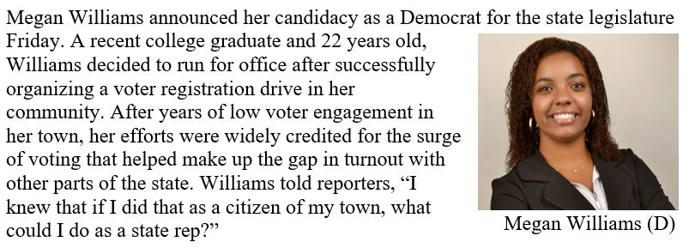

Treatment – 22-Woman-White

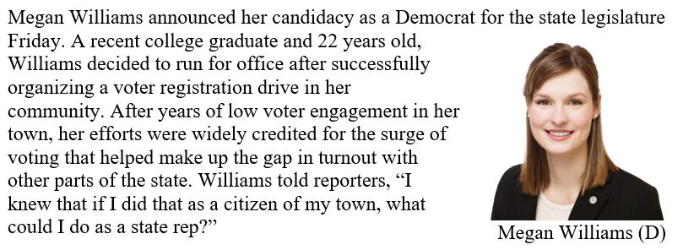

Q38c. Treatment – 22-Man-Black

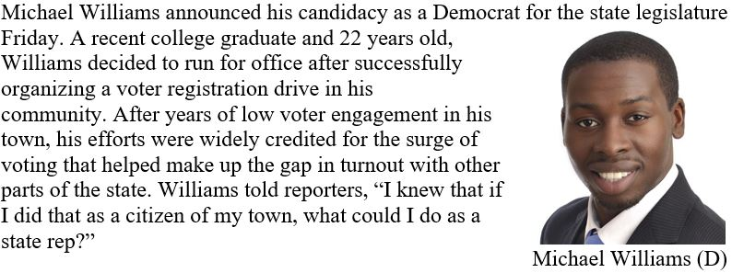

Q38d. Treatment – 22-Man-White

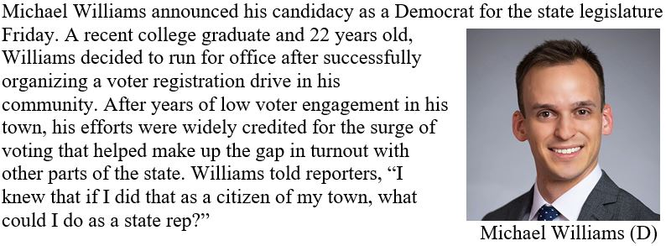

Q38e. Treatment – 68-Woman-Black

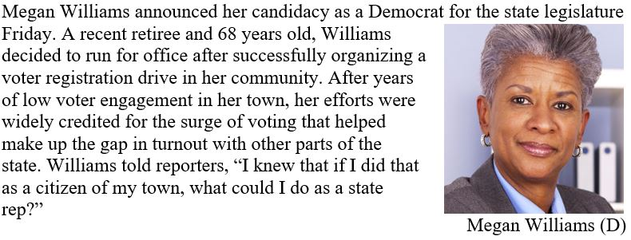

Q38f. Treatment – 68-Woman-White

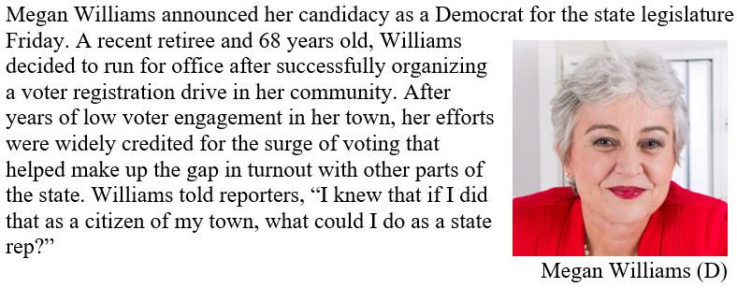

Q38g. Treatment – 68-Man-Black

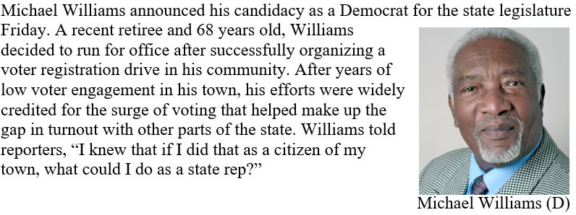

Q38h. Treatment – 68-Man-White

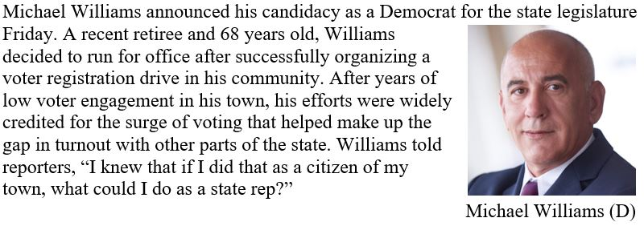

Post-Treatment Questions

In the next year, how likely are you to engage in the following political or civic actions?

Very Likely Somewhat Likely A little likely Not at all likely

a. Volunteer for a political campaign

b. Participate in a Protest or Rally

c. Encourage people to vote

d. Discuss public affairs with friends and family

e. Follow political news

f. Run for political office

g. Attend a local public or community meeting

h. Use social media to bring attention to an issue in my community

**S2. ADDITIONAL ANALYSES**

**Table A1: OLS Regression – Replication of Results Using Latent Measure of Future Political Activity Generated via Factor Analysis**

|  |  |  |
| --- | --- | --- |
|  | Model 1  Men | Model 2  Women |
| Variable | b/se | b/se |
| Non-White-Man-68 Treatment | -0.093  (0.132) | -0.090  (0.122) |
| High Gender Identity | 0.308+  (0.174) | -0.026  (0.151) |
| Treatment X Gender Identity | -0.100  (0.185) | 0.375*  (0.162) |
| Constant | -0.090  (0.124) | -0.048  (0.114) |
| Prob>F | 0.001 | 0.000 |
| N | 966 | 1,108 |

+Statistically significant at p<0.1, two-tailed test

*Statistically significant at p<0.05, two-tailed test

**Statistically significant at p<0.01, two-tailed test

**Table A2: OLS Regression – Replication of Results Using Continuous Measure of Gender Identity[1]**

|  |  |  |
| --- | --- | --- |
|  | Model 1  Men | Model 2  Women |
| Variable | b/se | b/se |
| Non-White-Man-68 Treatment | 0.000  (0.748) | -0.113  (0.074) |
| High Gender Identity | 0.190*  (0.094) | 0.038  (0.089) |
| Treatment X Gender Identity | 0.057  (0.101) | 0.189*  (0.095) |
| Constant | 0.422**  (0.027) | 0.487**  (0.069) |
| Prob>F | 0.000 | 0.000 |
| N | 974 | 1,109 |

+Statistically significant at p<0.1, two-tailed test

*Statistically significant at p<0.05, two-tailed test

**Statistically significant at p<0.01, two-tailed test

**Table A3: Regression Coefficients-Treatment and Partisanship on Future Political Activity**

|  |  |  |
| --- | --- | --- |
|  | Model 1  Men | Model 2  Women |
| Variable | b/se | b/se |
| Non-White-Man-68 Treatment | -0.033  (0.046) | -0.008  (0.039) |
| Partisanship (7-point) | -0.007*  (0.010) | -0.028**  (0.009) |
| Treatment X Partisanship | -0.001  (0.011) | 0.012  (0.010) |
| Constant | 0.578**  (0.043) | 0.608**  (0.036) |
| Prob>F | 0.048 | 0.000 |
| N | 982 | 1,116 |

+Statistically significant at p<0.1, two-tailed test

*Statistically significant at p<0.05, two-tailed test

**Statistically significant at p<0.01, two-tailed test

**Table A4: Regression Coefficients-Treatment and Gender Identity on Future Political Activity with Control for Partisanship**

|  |  |  |
| --- | --- | --- |
|  | Model 1  Men | Model 2  Women |
| Variable | b/se | b/se |
| Non-White-Man-68 Treatment | -0.028  (0.031) | -0.010  (0.028) |
| High Gender Identity | 0.073+  (0.041) | -0.003  (0.035) |
| Partisanship (7-point) | -0.009*  (0.003) | -0.015**  (0.003) |
| Treatment X Gender Identity | -0.019  (0.044) | 0.077**  (0.037) |
| Constant | 0.549**  (0.032) | 0.566**  (0.028) |
| Prob>F | 0.000 | 0.000 |
| N | 982 | 1,116 |

+Statistically significant at p<0.1, two-tailed test

*Statistically significant at p<0.05, two-tailed test

**Statistically significant at p<0.01, two-tailed test

**Table A5: Gender Identity by Partisanship**

|  |  |  |
| --- | --- | --- |
|  | Men | Women |
|  | % High in Gender Identity | |
| Democrats  (N=1,042) | 49.9% | 64.2% |
| Independents  (N=583) | 43.5% | 52.0% |
| Republicans  (N=583) | 56.6% | 54.7% |
| **Total** | **50.2%** | **58.6%** |
|  |  |  |

**Table A6: Heterogeneous Treatment Effects on Mobilization by Partisanship and Gender Identity (Standard Errors in Parentheses)**

|  |  |  |  |
| --- | --- | --- | --- |
|  |  | High Gender ID | Low Gender ID |
| **Women** | Democrat | 0.044  (0.032) | -0.010  (0.038) |
| Republican | 0.157**  (0.051) | -0.009  (0.055) |
| **Men** | Democrat | -0.076  (0.048) | -0.018  (0.040) |
| Republican | -0.065  (0.052) | 0.028  (0.067) |

+Statistically significant at p<0.1, two-tailed test

*Statistically significant at p<0.05, two-tailed test

**Statistically significant at p<0.01, two-tailed test

**Table A7: OLS Regression – Effect of Treatment on Future Political Activity by Racial Group (White and Non-White)**

|  |  |
| --- | --- |
|  | Model 1  Whites |
| Variable | b/se |
| Non-White-Man-68 Treatment | 0.035+  (0.020) |
| Race (White) | 0.025  (0.026) |
|  |  |
| Treatment X White | -0.072**  (0.028) |
| Constant | 0.518**  (0.019) |
| Prob>F | 0.000 |
| N | 2,205 |

+Statistically significant at p<0.1, two-tailed test

*Statistically significant at p<0.05, two-tailed test

**Statistically significant at p<0.01, two-tailed test

NOTE: Additional tests were run looking at non-white groups, though the effects were all very similar.

**Table A8a: OLS Regression – Placebo Interaction Predicting Future Political Activity as a Function of Ideology, Treatment, and Interaction of Ideology and Treatment**

|  |  |  |
| --- | --- | --- |
|  | Model 1 | Model 2 |
|  | Men | Women |
| Variable | b/se | b/se |
| Non-White-Man-68 Treatment | -0.023  (0.064) | 0.082  (0.056) |
| Ideology (1=Liberal, 7=Conservative) | 0.009  (0.014) | 0.008  (0.012) |
| Treatment X Ideology | -0.003 | -0.012 |
|  | (0.015) | (0.013) |
| Constant | 0.514**  (0.060) | 0.482**  (0.013) |
| Prob>F | 0.233 | 0.221 |
| N | 958 | 1,090 |

+Statistically significant at p<0.1, two-tailed test

*Statistically significant at p<0.05, two-tailed test

**Statistically significant at p<0.01, two-tailed test

**Table A8b: OLS Regression – Placebo Interaction Predicting Future Political Activity as a Function of Partisanship, Treatment and Interaction of Partisanship and Treatment**

|  |  |  |
| --- | --- | --- |
|  | Model 1 | Model 2 |
|  | Men | Women |
| Variable | b/se | b/se |
| Non-White-Man-68 Treatment | -0.033  (0.046) | -0.008  (0.039) |
| Partisanship (1=Democrat, 7=Republican) | -0.007  (0.010) | -0.028**  (0.009) |
| Treatment X Partisanship | -0.001 | 0.012 |
|  | (0.011) | (0.010) |
| Constant | 0.578**  (0.043) | 0.608**  (0.036) |
| Prob>F | 0.047 | 0.000 |
| N | 982 | 1,116 |

+Statistically significant at p<0.1, two-tailed test

*Statistically significant at p<0.05, two-tailed test

**Statistically significant at p<0.01, two-tailed test

**Table A8c: OLS Regression – Placebo Interaction Predicting Future Political Activity as a Function of Educational Goals, Treatment and Interaction of Educational Goals and Treatment**

|  |  |  |
| --- | --- | --- |
|  | Model 1 | Model 2 |
|  | Men | Women |
| Variable | b/se | b/se |
| Non-White-Man-68 Treatment | 0.004  (0.057) | 0.072  (0.051) |
| Education Goals (1=High School, 4=Graduate Degree) | 0.011  (0.017) | 0.019  (0.015) |
| Treatment X Educational Goals | -0.015 | -0.016 |
|  | (0.018) | (0.016) |
| Constant | 0.525**  (0.054) | 0.465**  (0.048) |
| Prob>F | 0.292 | 0.318 |
| N | 930 | 1,085 |

+Statistically significant at p<0.1, two-tailed test

*Statistically significant at p<0.05, two-tailed test

**Statistically significant at p<0.01, two-tailed test

**Table A8d: OLS Regression – Placebo Interaction Predicting Future Political Activity as a Function of Religiosity, Treatment and Interaction of Religiosity and Treatment**

|  |  |  |
| --- | --- | --- |
|  | Model 1 | Model 2 |
|  | Men | Women |
| Variable | b/se | b/se |
| Non-White-Man-68 Treatment | -0.081  (0.059) | 0.022  (0.059) |
| Freq. of Religious Services (1=Weekly or more, 4=Rarely/Never) | -0.078**  (0.024) | -0.045+  (0.023) |
| Treatment X Religious Attendance | 0.019 | 0.001 |
|  | (0.026) | (0.024) |
| Constant | 0.721**  (0.056) | 0.619**  (0.056) |
| Prob>F | 0.000 | 0.000 |
| N | 978 | 1,117 |

+Statistically significant at p<0.1, two-tailed test

*Statistically significant at p<0.05, two-tailed test

**Statistically significant at p<0.01, two-tailed test

**Table A9: OLS Regression – Predicting Future Political Activity as a Function of Male Treatments, Race Treatments, and Age Treatments, and Gender Identity**

|  |  |  |
| --- | --- | --- |
|  | Model 1 | Model 2 |
|  | Men | Women |
| Variable | b/se | b/se |
| Treatment: Candidate Age=22 | -0.015 | 0.017 |
|  | (0.020) | (0.020) |
|  |  |  |
| Treatment: Candidate Gender=Woman | -0.009 | -0.022 |
|  | (0.020) | (0.019) |
|  |  |  |
| Treatment: Candidate Race=Black | -0.013 | -0.022 |
|  | (0.020) | (0.020) |
|  |  |  |
| High Gender Identity | 0.056+ | 0.020 |
|  | (0.029) | (0.025) |
|  |  |  |
| Age Treatment X Gender ID | -0.020 | 0.019 |
|  | (0.029) | (0.025) |
|  |  |  |
| Woman Treatment X Gender ID | 0.001 | 0.050+ |
|  | (0.029) | (0.025) |
|  |  |  |
| Black Treatment X Gender ID | 0.015 | 0.036 |
|  | (0.029) | (0.025) |
|  |  |  |
| Constant | 0.512** | 0.511** |
|  | (0.021) | (0.019) |
|  |  |  |
| Prob>F | 0.009 | 0.000 |
| N | 982 | 1,118 |

+Statistically significant at p<0.1, two-tailed test

*Statistically significant at p<0.05, two-tailed test

**Statistically significant at p<0.01, two-tailed test

**Table A10: Randomization Check – Multinomial Logit Predicting Assignment to Condition using Demographic Variables (White-Man-22 as omitted category)**

|  |  |  |  |  |  |  |  |
| --- | --- | --- | --- | --- | --- | --- | --- |
|  | Black-  Woman-22 | White-  Woman-22 | Black-  Man-22 | Black-  Woman-68 | White-  Woman-68 | Black-  Man-68 | White-  Man-68 |
| Variable | b/se | b/se | b/se | b/se | b/se | b/se | b/se |
| Race (white) | -0.142  (0.173) | -0.081  (0.175) | 0.001  (0.177) | -0.145  (0.178) | -0.193  (0.174) | -0.149  (0.172) | 0.094  (0.174) |
| Gender (male) | -0.193  (0.171) | 0.065  (0.172) | 0.017  (0.174) | 0.117  (0.175) | -0.182  (0.172) | 0.154  (0.169) | -0.042  (0.172) |
| Family Income | 0.006  (0.029) | -0.045  (0.029) | -0.002  (0.029) | 0.005  (0.029) | -0.013  (0.029) | 0.001  (0.028) | 0.006  (0.029) |
| Party ID (7-pt) | 0.011  (0.044) | 0.012  (0.044) | 0.014  (0.044) | 0.056  (0.044) | 0.042  (0.044) | 0.025  (0.043) | 0.015  (0.044) |
| Constant | 0.050  (0.239) | 0.106  (0.242) | -0.169  (0.246) | -0.348  (0.248) | 0.040  (0.240) | -0.103  (0.239) | -0.172  (0.243) |
| Prob>Chi2 | 0.901 |  |  |  |  |  |  |
| R2 | 0.002 |  |  |  |  |  |  |
| N | 2,137 |  |  |  |  |  |  |

+Statistically significant at p<0.1, two-tailed test

*Statistically significant at p<0.05, two-tailed test

**Statistically significant at p<0.01, two-tailed test

**S3. NOTES ON 2020 PARTIAL REPLICATION**

In Spring 2020, we sought to replicate the results from the 2019 experiment. Due to budget considerations and the need to maintain a baseline condition (which, for us, was the 68-year-old white man condition), we opted to include only 4 conditions. Because the effect of Gen Z treatments was minimal in the 2019 study, we made the decision to eliminate the 4 conditions involving a candidate who was 22-years-old.

Data collection was administered in an identical fashion to the 2019 study by the survey firm Qualtrics on a sample of 1,049 respondents from May 22-29. Respondents were spread across conditions as shown in Table A11.

**Table A11: OLS Regression Coefficients-Treatment and Gender Identity on Future Political Activity**

|  |  |
| --- | --- |
| Treatment Group | N |
| Black-Woman-68 | 264 |
| White-Woman-68 | 258 |
| Black-Man-68 | 268 |
| White-Man-68 | 259 |

When seeking the replicate the main findings, we focused initially on women, hypothesizing that women who identified strongly with their gender would prefer candidates who were not older, white men. Yet we found few differences between these groups (Figure A12). Why did we find inconsistent results? We suspected this was ultimately due to a surge in political activism around Black Lives Matter in the wake of the deaths of George Floyd and Breonna Taylor (George Floyd’s murder occurred during the administration of the survey, while Breonna Taylor’s occurred just weeks prior). Those who might have been activated via a role model in our survey were likely pre-treated as a wave of political activism took over the nation.

**Figure A12. 2020 Replication: Effect of Treatment among Women by Gender Identity**



NOTE: Error bars represent 95% confidence intervals.

The results among men also seemed to indicate that race, not gender was more important (Figure A13). Men low in gender identity disproportionately identified as Democrats (47% compared to 35% among high identifiers) and appear more motivated to engage in the Black candidate conditions, but do not appear particularly motivated by the white woman condition. Thus, while there is evidence that gender identity interacts with the attributes of the candidates, it is more consistent with a story of race than gender. Because the 2019 survey is a cleaner test of the theory advanced here with all eight conditions, and because of the mitigating factors surrounding the replication, we opted to focus on that study. Yet the findings from the replication suggest the need for caution, as the role model effect appears highly sensitive to context. The 2019 survey was done shortly after the success of many women candidates in the 2018 midterms and in the wake of the “Me Too” movement, which may have contributed to the findings.

**Figure A13. 2020 Replication Effect of Treatment among Men by Gender Identity**



NOTE: Error bars represent 95% confidence intervals.

1. To eliminate undue influence of outliers, observations more than 3 standard deviations from the mean on gender identity were omitted from the analysis (N=18).