Online Appendix – The Gendered Religious Response to State Action on the Coronavirus Pandemic

Table of Contents
Pages | Contents
1 | Variable Coding
2 | Table A1 – Model Behind Figure 3
3 | Table A2 – Models Behind Figure 4
4 | Figure A1 – Conditional Effect of Literalism on the Gender Gap in Support for Women as Clergy, by Worship Attendance.
5 | Figure A2 – Conditional Effect of Literalism on the Gender Gap in Political Participation, by Worship Attendance.

Variable Coding
Dependent Variables
Defy the Government – If the government tells us to stop gathering in person for worship, I would want my congregation to defy the order. Originally coded 5=strongly disagree to 1=strongly agree. Dichotomous in the model 1 = agree/strongly agree.

Independent Variables
Partisanship – “Generally, which of these party labels bests describes you?” Collapsed to Democrat = Strong Democrat, Democrat, or Independent but lean Democrat; Independent = Independent (no leaners); Republican=Strong Republican, Republican, or Independent but lean Republican.
White – Identifies as White=1, 0=otherwise.
Age – In years (18 or over)
Gender – 1=Women, 0=Men.
Education – “What is the highest level of education that you have completed?” 1= Less than High School, 2=High School or GED, 3=Some college or trade school, 4=4-year college graduate, 5=Graduate education (toward a master's or doctoral degree)
Religious tradition – Follows the Steensland et al. (2000) approach to differentiate evangelicals from mainline Protestants. All other groups were defined by their response to “What is your present religion, if any?” Small groups were combined into “Other religion.” Atheists, agnostics, and ‘nothing in particular’s were combined into religious nones.
Worship attendance – Aside from weddings and funerals, how often do you typically attend religious services before the corona virus reached the US? 5=More than once a week or Once a week, 4=A few times a month, 3=A few times a year, 2=Seldom, 1=Never.
Prosperity Gospel – An average index (collapsed to a 0-1 scale) composed of responses to three statements: God will reward the faithful with health and wealth; Our efforts and our sacrifices to God will be richly rewarded in this life; God will give you the material things you seek if you give to Him and have faith. Each was originally coded 1=strongly disagree to 5=strongly agree.
Income – scaled 1 (less than $25,000) through 8 (more than $200k) in increments of $25k.
Gendered Nationalism – The US is becoming too feminized and weak. Originally coded 5=strongly disagree to 1=strongly agree
Church Open or Closed – In-person worship has been cancelled for now because of the corona virus. Coded Yes of No.

Table A1 – OLS Estimates Behind Figure 3 Showing Support for Defying State Orders
 | B (p)
(Intercept) | 0.40 (0.47)
Worship Attendance | 0.33 (0.01)
Women | 0.26 (0.71)
Literalism | -0.61 (0.01)
Party ID | -0.01 (0.68)
White | -0.36 (0.00)
Age | -0.02 (0.00)
Education | -0.14 (0.01)
Mainline | 0.06 (0.77)
Black Prot. | 0.18 (0.60)
Catholic | 0.34 (0.03)
Jewish | 1.34 (0.00)
Other Faith | 0.90 (0.00)
No Religion | 0.27 (0.20)
Unclassified | 0.07 (0.76)
Income | 0.03 (0.27)
Attendance * Women | -0.30 (0.09)
Attendance * Literalism | -0.02 (0.73)
Women * Literalism | -0.32 (0.31)
Attendance * Women * Literalism | 0.13 (0.15)
N | 2755
AIC | 2397.27
BIC | 2515.69
Pseudo R² | 0.24
Source: 2020 Religion and C19 Survey.

Table A2 – OLS Estimates Behind Figure 4.
 | Gender  Interaction | Closed Church  Interaction
 | B (p) | B (p)
(Intercept) | -1.39 (0.00) | -0.79 (0.22)
Women | -0.28 (0.34) | -0.26 (0.06)
Gendered nationalism | 0.58 (0.00) | 0.30 (0.03)
Women * gendered nationalism | -0.03 (0.77) | —
Church is closed | — | -1.34 (0.01)
Gendered nationalism * closed church | — | 0.37 (0.01)
Worship attendance | 0.23 (0.00) | 0.32 (0.00)
Partisanship | -0.09 (0.00) | -0.11 (0.00)
White | -0.31 (0.02) | -0.17 (0.27)
Age | -0.02 (0.00) | -0.03 (0.00)
Education | -0.06 (0.30) | -0.05 (0.43)
Mainline | 0.21 (0.33) | 0.31 (0.20)
Black Prot. | 0.38 (0.28) | 0.62 (0.10)
Catholic | 0.44 (0.01) | 0.47 (0.01)
Jewish | 1.40 (0.00) | 1.44 (0.00)
Other Faith | 1.00 (0.00) | 0.98 (0.00)
No Religion | 0.38 (0.09) | 0.32 (0.28)
Unclassified | 0.22 (0.34) | 0.28 (0.28)
Income | 0.02 (0.57) | 0.02 (0.49)
N | 2752 | 1840
AIC | 2217.11 | 1636.72
BIC | 2323.67 | 1741.56
Pseudo R² | 0.32 | 0.34
Source: 2020 Religion and C19 Survey.

Figure A1 – Conditional Effect of Literalism on the Gender Gap in Support for Women as Clergy, by Worship Attendance.

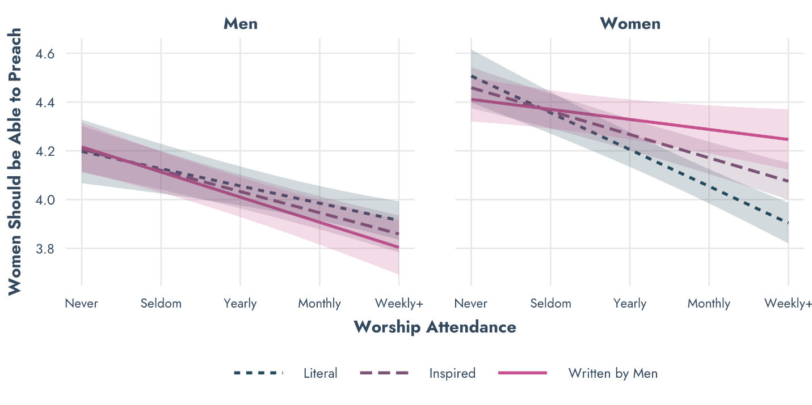
Source: 2020 Religion and C19 Survey.
Figure A2 – Conditional Effect of Literalism on the Gender Gap in Political Participation, by Worship Attendance.
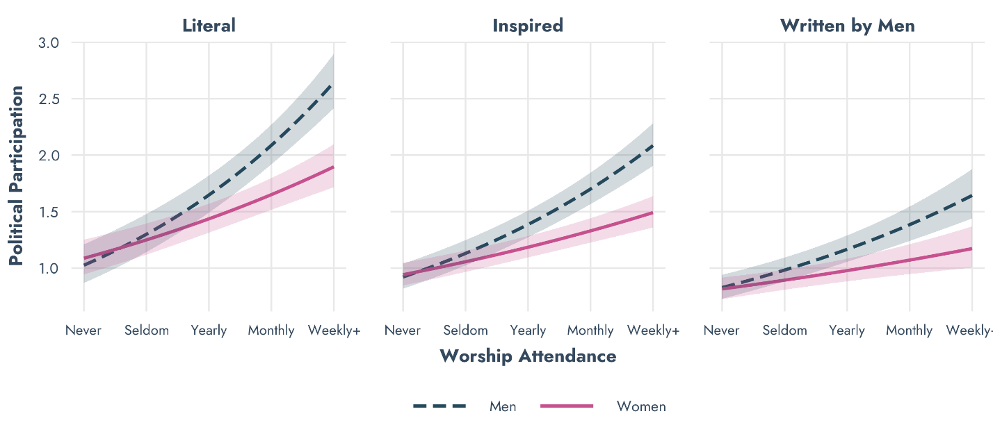
Source: 2020 Religion and C19 Survey.

