Supplementary Material
Table 5: Model Specification Survey of Negative Campaigning and Voter Gender
 | Publication | Model controls for voter gender | Model specifies voter gender  conditional relationship | Publication offers voter gender conditional hypothesis
1 | Ansolabehere et al. 1994 | 1 | 0 | 0
2 | Ansolabehere and Iyengar 1995 | 1 | 0 | 0
3 | Ansolabehere, Iyengar, and Simon 1999 | 1 | 1 | 0
4 | Arceneaux and Nickerson 2010 | 1 | 0 | 0
5 | Banda 2014 | 0 | 0 | 0
6 | Banda and Windett 2016 | 0 | 0 | 0
7 | Bartels and Vavreck 2000 | 1 | 0 | 0
8 | Bartels 2014 | 0 | 0 | 0
9 | Barton, Castillo, and Petrie 2016 | 1 | 0 | 0
10 | Basil, Schooler, and Reeves 1991 | 0 | 0 | 0
11 | Blackwell 2013 | 0 | 0 | 0
12 | Box-Steffensmeier, Darmofal, and Farrell 2009 | 0 | 0 | 0
13 | Brader 2005 | 0 | 0 | 0
14 | Brader 2006 | 1 | 0 | 0
15 | Brians and Wattenberg 1996 | 1 | 0 | 0
16 | Brooks 2006 | 0 | 0 | 0
17 | Brooks and Geer 2007 | 0 | 0 | 0
18 | Brooks 2010 | 1 | 1 | 1
19 | Brooks and Murov 2012 | 0 | 0 | 0
20 | Capella and Taylor 1992 | 0 | 0 | 0
21 | Carraro and Castelli 2010 | 0 | 0 | 0
22 | Cassese and Holman 2018 | 1 | 0 | 0
23 | Chang 2001 | 0 | 0 | 0
24 | Chang 2003 | 0 | 0 | 0
25 | Cheng and Riffe 2008 | 1 | 0 | 0
26 | Cho 2013 | 1 | 0 | 0
27 | Clinton and Lapinski 2004 | 1 | 1 | 0
28 | Cohen and Davis 1991 | 0 | 0 | 0
29 | Craig, Kane, and Gainous 2005 | 1 | 0 | 0
30 | Craig, Rippere, and Grayson 2014 | 0 | 0 | 0
31 | Craig and Rippere 2014 | 1 | 1 | 0
32 | Craig and Rippere 2016 | 1 | 1 | 1
33 | Crigler, Just, and Belt 2006 | 1 | 0 | 0
34 | Dardis, Shen, and Edwards 2008 | 0 | 0 | 0
35 | Dermody and Scullion 2000 | 0 | 0 | 0
36 | Djupe and Peterson 2002 | 0 | 0 | 0
37 | Dowling and Wichowsky 2013 | 1 | 0 | 0
38 | Dowling and Wichowsky 2015 | 0 | 0 | 0
39 | Fernandes 2013 | 1 | 0 | 0
40 | Finkel and Geer 1998 | 1 | 0 | 0
41 | Freedman and Goldstein 1999 | 1 | 0 | 0
42 | Freedman, Wood, and Lawton 1999 | 0 | 0 | 0
43 | Fridkin and Kenney 2004 | 0 | 0 | 0
44 | Fridkin and Kenney 2008 | 1 | 1 | 0
45 | Fridkin, Kenney, and Woodall 2009 | 1 | 1 | 0
46 | Fridkin and Kenney 2011 | 1 | 1 | 1
47 | Fridkin and Kenney 2019 | 1 | 1 | 1
48 | Garramone 1984 | 1 | 1 | 0
49 | Garramone and Smith 1984 | 0 | 0 | 0
50 | Garramone 1985 | 0 | 0 | 0
51 | Garramone et al. 1990 | 0 | 0 | 0
52 | Geer and Geer 2003 | 0 | 0 | 0
53 | Geer 2006 | 0 | 0 | 0
54 | Geer and Lau 2006 | 0 | 0 | 0
55 | Goldstein and Freedman 2002 | 1 | 1 | 0
56 | Groenendyk and Valentino 2002 | 0 | 0 | 0
57 | Haddock and Zanna 1997 | 0 | 0 | 0
58 | Hassell and Oeltjenbruns 2016 | 0 | 0 | 0
59 | Henderson and Theodoridis 2018 | 0 | 0 | 0
60 | Hill 1989 | 0 | 0 | 0
61 | Hill, Capella, and Cho 2015 | 0 | 0 | 0
62 | Hitchon and Chang 1995 | 0 | 0 | 0
63 | Hitchon, Chang, and Harris 1997 | 0 | 0 | 0
64 | Houston, Doan, and Roskos-Ewoldsen 1999 | 0 | 0 | 0
65 | Houston and Doan 1999 | 0 | 0 | 0
66 | Jackson and Sides 2006 | 0 | 0 | 0
67 | Jackson and Carsey 2007 | 1 | 0 | 0
68 | Jackson, Mondak, and Huckfeldt 2009 | 1 | 0 | 0
69 | Jasperson and Fan 2002 | 0 | 0 | 0
70 | Johnson, Dunaway, and Weber 2011 | 1 | 0 | 0
71 | Just and Crigler 1990 | 0 | 0 | 0
72 | Kahn and Geer 1994 | 1 | 0 | 0
73 | Kahn and Kenney 1999 | 0 | 0 | 0
74 | Kahn and Kenney 2004 | 1 | 1 | 0
75 | Kaid and Boydston 1987 | 0 | 0 | 0
76 | Kaid, Chanslor, and Hovind 1992 | 0 | 0 | 0
77 | Kaid, Leland, and Whitney 1992 | 0 | 0 | 0
78 | Kaid 1997 | 1 | 0 | 0
79 | Kaid, Fernandes, and Painter 2011 | 1 | 0 | 0
80 | Kern and Just 1997 | 1 | 1 | 1
81 | King and McConnell 2003 | 1 | 1 | 1
82 | Krasno and Green 2008 | 0 | 0 | 0
83 | Krupnikov 2012 | 1 | 0 | 0
84 | Krupnikov 2014 | 1 | 0 | 0
85 | Krupnikov and Bauer 2014 | 1 | 1 | 0
86 | Krupnikov and Piston 2015 | 1 | 0 | 0
87 | Lang 1991 | 0 | 0 | 0
88 | Lau and Pomper 2002 | 1 | 0 | 0
89 | Lau and Pomper 2004 | 1 | 0 | 0
90 | Lariscy and Tinkham 1999 | 0 | 0 | 0
91 | Lemert, Wanta, and Lee 1999 | 0 | 0 | 0
92 | Leshner and Thorson 2000 | 0 | 0 | 0
93 | Lipsitz and Geer 2017 | 0 | 0 | 0
94 | Llaudet 2018 | 1 | 0 | 0
95 | Lovejoy, Riffe, and Cheng 2012 | 1 | 0 | 0
96 | Ma et al. 2018 | 0 | 0 | 0
97 | Malloy and Pearson-Merkowitz 2016 | 0 | 0 | 0
98 | Martin 2004 | 1 | 0 | 0
99 | Mattes and Redlawsk 2014 | 1 | 1 | 0
100 | Matthews and Dietz-Uhler 1998 | 0 | 0 | 0
101 | Meirick 2002 | 0 | 0 | 0
102 | Meirick 2005 | 1 | 1 | 0
103 | Meirick and Nisbett 2011 | 0 | 0 | 0
104 | Meirick et al. 2011 | 0 | 0 | 0
105 | Merritt 1984 | 0 | 0 | 0
106 | Min 2004 | 0 | 0 | 0
107 | Morey 2017 | 1 | 0 | 0
108 | Newhagen and Reeves 1991 | 0 | 0 | 0
109 | Niven 2006 | 1 | 0 | 0
110 | Peng and Hackley 2009 | 0 | 0 | 0
111 | Pfau and Burgoon 1989 | 0 | 0 | 0
112 | Pinkleton 1997 | 0 | 0 | 0
113 | Pinkleton 1998 | 0 | 0 | 0
114 | Pinkleton 2002 | 0 | 0 | 0
115 | Rahn and Hirshorn 1999 | 0 | 0 | 0
116 | Ridout and Franz 2011 | 0 | 0 | 0
117 | Ridout, Franz, and Fowler 2015 | 0 | 0 | 0
118 | Ridout et al. 2018 | 1 | 0 | 0
119 | Roberts 1995 | 0 | 0 | 0
120 | Roddy and Garramone 1988 | 0 | 0 | 0
121 | Sanders, Norris, and Cambridge 2002 | 1 | 0 | 0
122 | Schultz and Pancer 1997 | 0 | 0 | 0
123 | Scullion and Dermody 2000 | 0 | 0 | 0
124 | Searles et al. 2017 | 1 | 1 | 0
125 | Shapiro and Rieger 1992 | 0 | 0 | 0
126 | Shen and Wu 2002 | 0 | 0 | 0
127 | Shen, Dardis, and Edwards 2011 | 0 | 0 | 0
128 | Sides, Lipsitz, and Grossmann 2010 | 1 | 0 | 0
129 | Sonner 1998 | 0 | 0 | 0
130 | Stevens et al. 2008 | 1 | 0 | 0
131 | Stevens 2008 | 0 | 0 | 0
132 | Stevens 2009 | 1 | 0 | 0
133 | Stevens 2012 | 1 | 0 | 0
134 | Stevens et al. 2015 | 1 | 0 | 0
135 | Stone et al. 2013 | 1 | 1 | 0
136 | Strach et al. 2015 | 1 | 0 | 0
137 | Thorson, Christ, and Caywood 1991b | 0 | 0 | 0
138 | Thorson, Christ, and Caywood 1991a | 0 | 0 | 0
139 | Thorson et al. 2000 | 1 | 0 | 0
140 | Tinkham and Weaver-Lariscy 1990 | 0 | 0 | 0
141 | Tinkham and Weaver-Lariscy 1991 | 0 | 0 | 0
142 | Tinkham and Weaver-Lariscy 1993 | 0 | 0 | 0
143 | Wadsworth et al. 1987 | 0 | 0 | 0
144 | Wanta, Lemert, and Lee 1998 | 0 | 0 | 0
145 | Wattenberg and Brians 1999 | 1 | 0 | 0
146 | Weaver-Lariscy and Tinkham 1996 | 0 | 0 | 0
147 | Weber 2012 | 1 | 0 | 0
148 | Weber, Dunaway, and Johnson 2012 | 1 | 0 | 0

Table 6: Coding Tabulation Data
Candidate | Positive  Total | Negative  Total | Attack Rate | Negative Dem | Negative Rep
Obama | 125 | 21 | 14.39 | - | 21
Romney | 245 | 72 | 22.93 | 72 | -
Clinton | 194 | 118 | 37.82 | - | 118
Trump | 140 | 82 | 36.94 | 82 | -
Clinton (Primary) | 2693 | 370 | 12.08 | 18 | 353
Sanders (Primary) | 1596 | 175 | 9.88 | 111 | 84
Cruz (Primary) | 2266 | 304 | 11.83 | 86 | 241
Kasich (Primary) | 1358 | 157 | 10.36 | 71 | 109
Rubio (Primary) | 1228 | 123 | 9.10 | 92 | 34
Trump (Primary) | 1764 | 568 | 24.36 | 313 | 267

Table 7: Analysis of Deviance Logistic Model Fit Diagnostics
Variable | Df | Deviance | Resid. Df | Resid. Dev | p value
Null |  |  | 38380604 | 56236976
Voter Gender | 1 | 2830178 | 38380603 | 53406798 | 0.000
Candidate Rate of Negativity | 1 | 404445 | 38380602 | 53002354 | 0.000
Voter Gender * Candidate Rate of Negativity | 1 | 918090 | 38380601 | 52084264 | 0.000
Incumbent Candidate | 1 | 5272 | 38380600 | 52078992 | 0.000
General Election | 1 | 252 | 38380599 | 52078740 | 0.000

Figure 2: Obama General Election Total Reactions for Negative vs. Positive Posts over Time
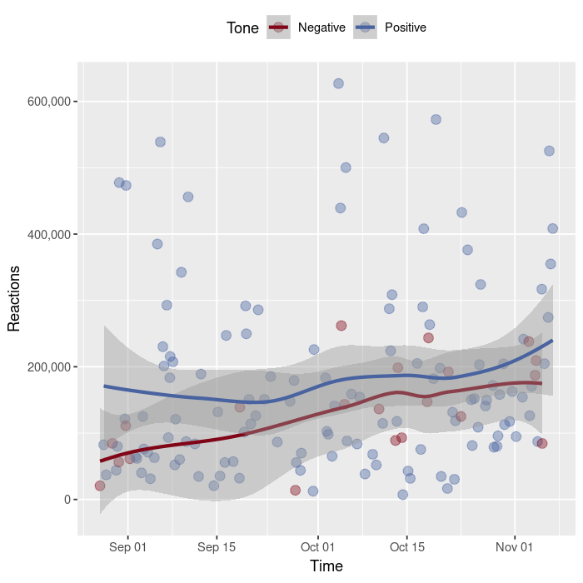
Figure 3: Romney General Election Total Reactions for Negative vs. Positive Posts over Time
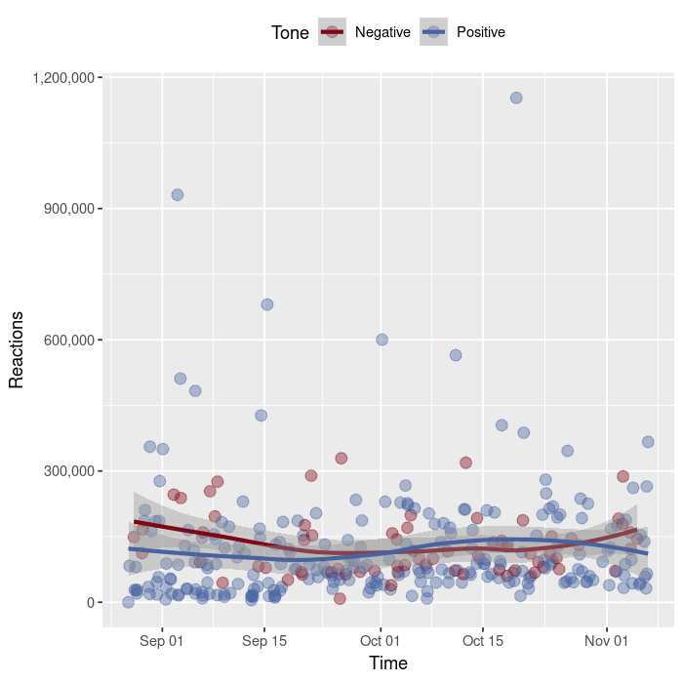
Figure 4: Clinton General Election Total Reactions for Negative vs. Positive Posts over Time 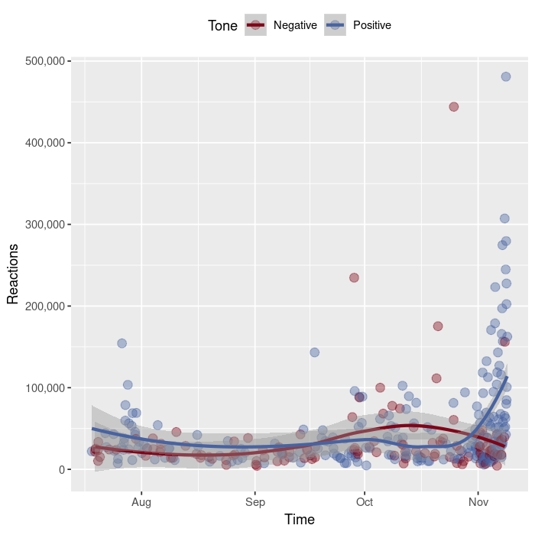
Figure 5: Trump General Election Total Reactions for Negative vs. Positive Posts over Time 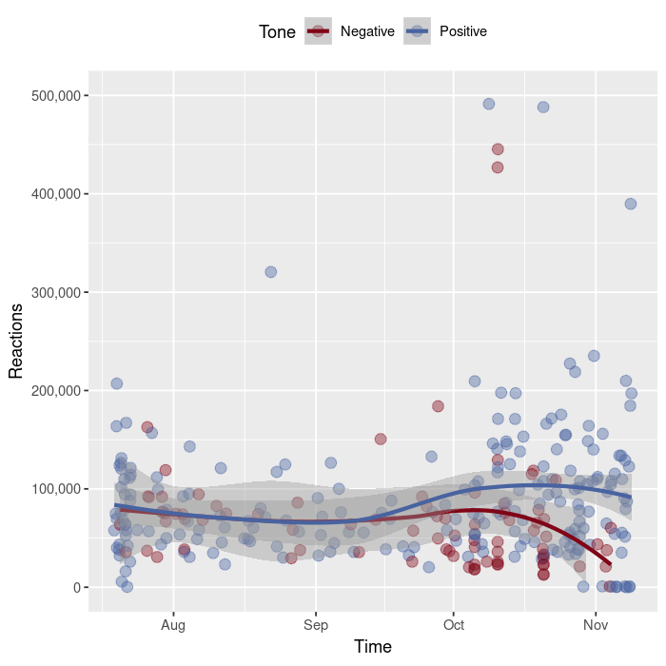

Figure 6: Clinton 2016 Primaries Total Reactions for Negative vs. Positive Posts over Time
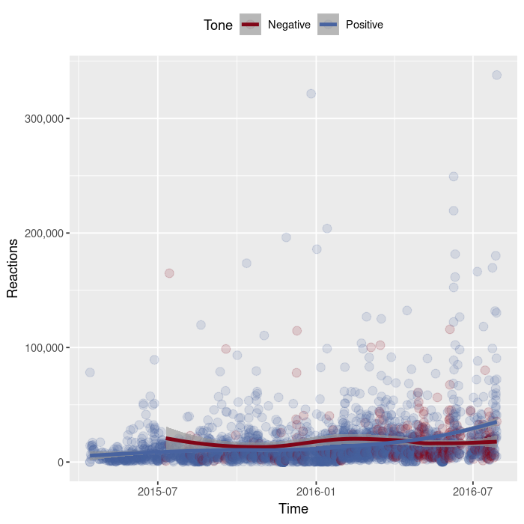
Figure 7: Sanders 2016 Primaries Total Reactions for Negative vs. Positive Posts over Time
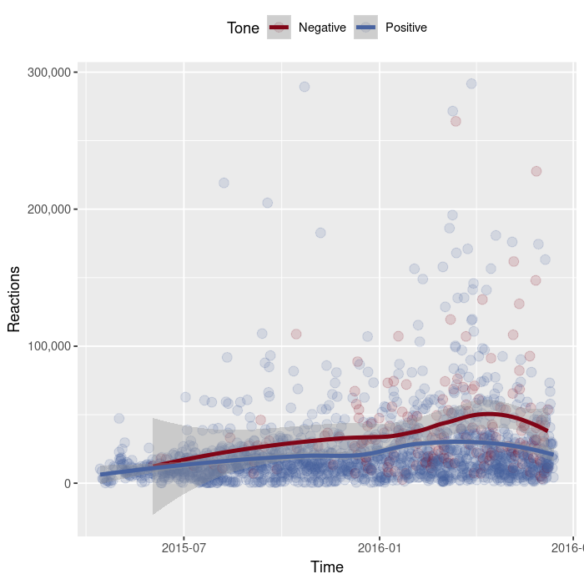
Figure 8: Cruz 2016 Primaries Total Reactions for Negative vs. Positive Posts over Time
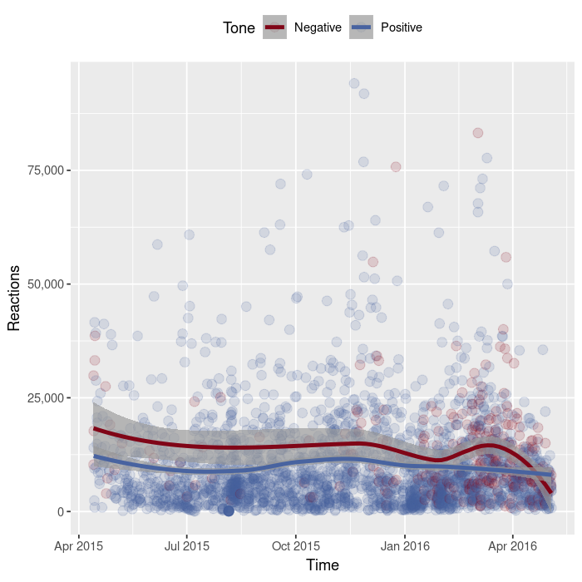
Figure 9: Kasich 2016 Primaries Total Reactions for Negative vs. Positive Posts over Time
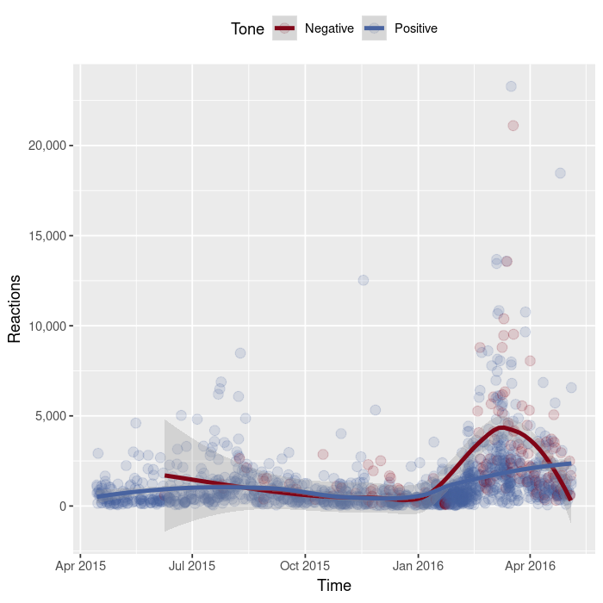
Figure 10: Rubio 2016 Primaries Total Reactions for Negative vs. Positive Posts over Time
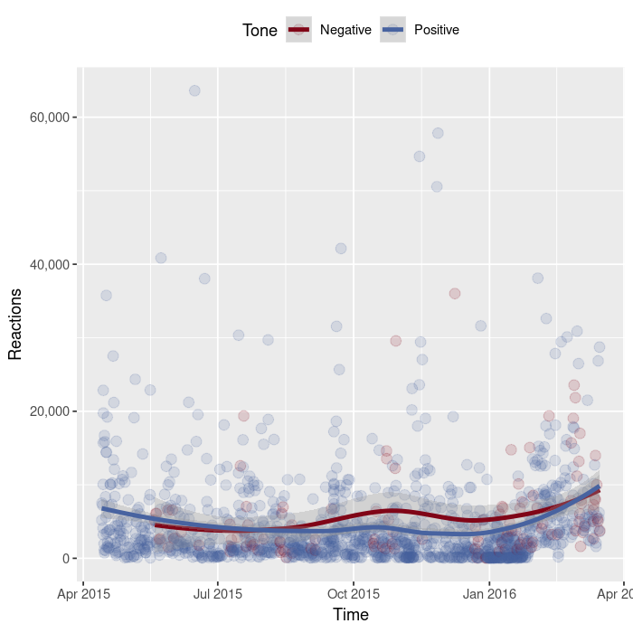
Figure 11: Trump 2016 Primaries Total Reactions for Negative vs. Positive Posts over Time
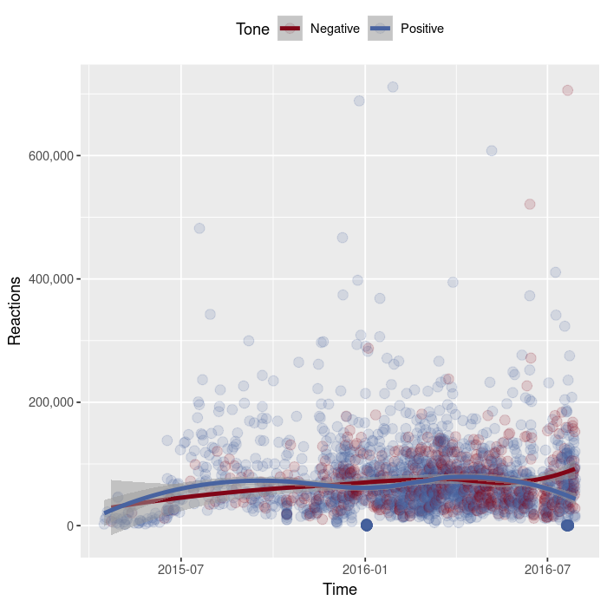
Figure 12: Logistic Regression Model Marginal Effects Plots
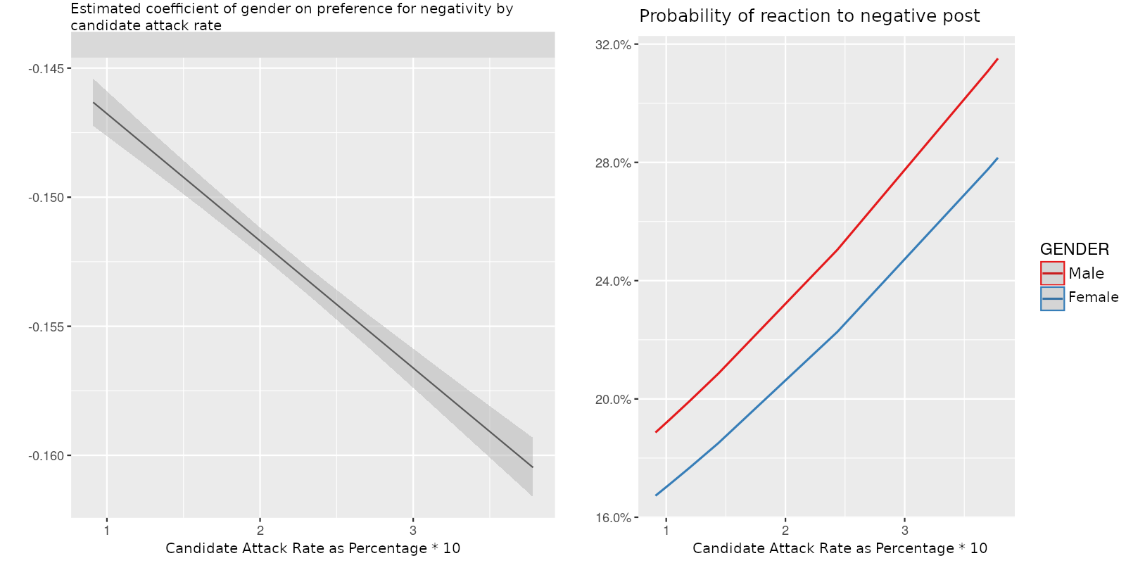

Figure 13: Box Plot Example of Obama’s (GE) Negative Post Reactions and Positive Post Reactions
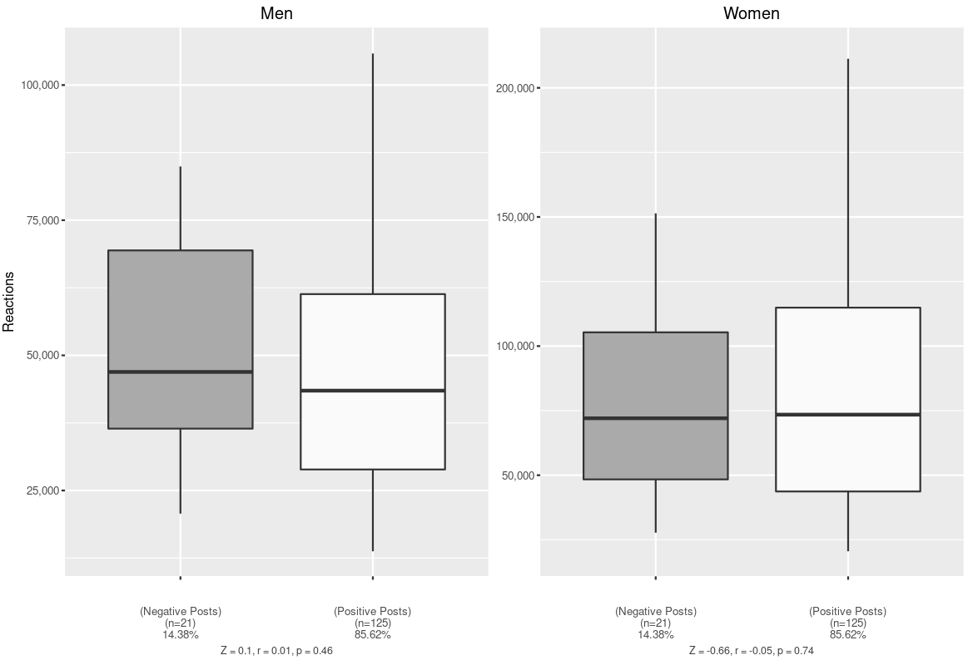

Figure 14: Box Plot Example of Romney’s (GE) Negative Post Reactions and Positive Post Reactions
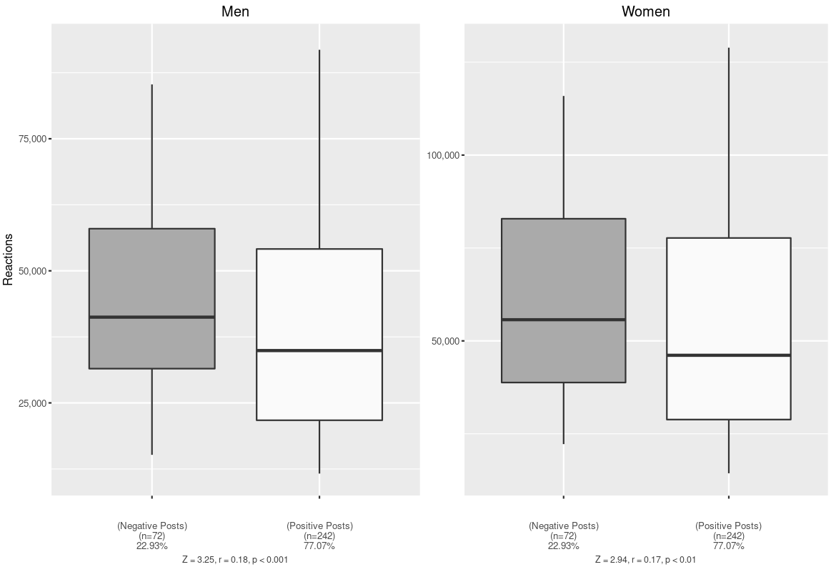 Figure 15: Box Plot Example of Clinton’s (GE) Negative Post Reactions and Positive Post Reactions
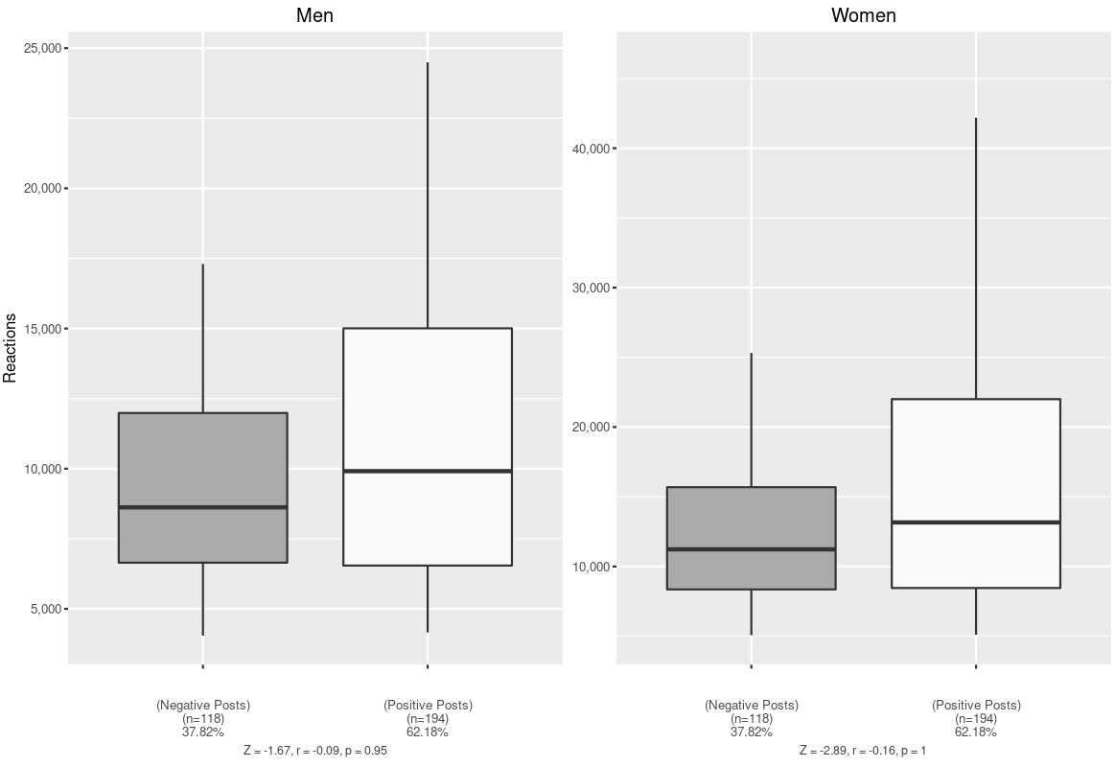
Figure 16: Box Plot Example of Trump’s (GE) Negative Post Reactions and Positive Post Reactions
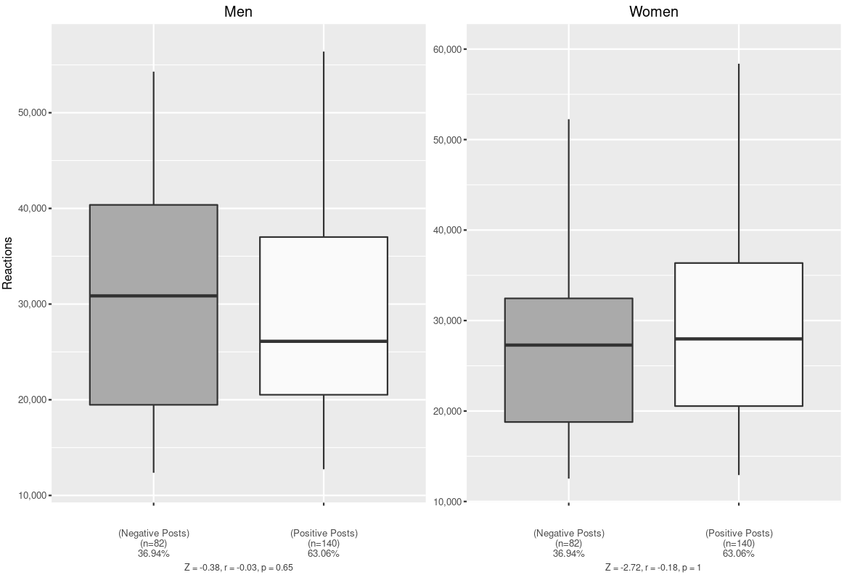
Figure 17: Box Plot Example of Clinton’s (Primary) Negative Post Reactions and Positive Post Reactions
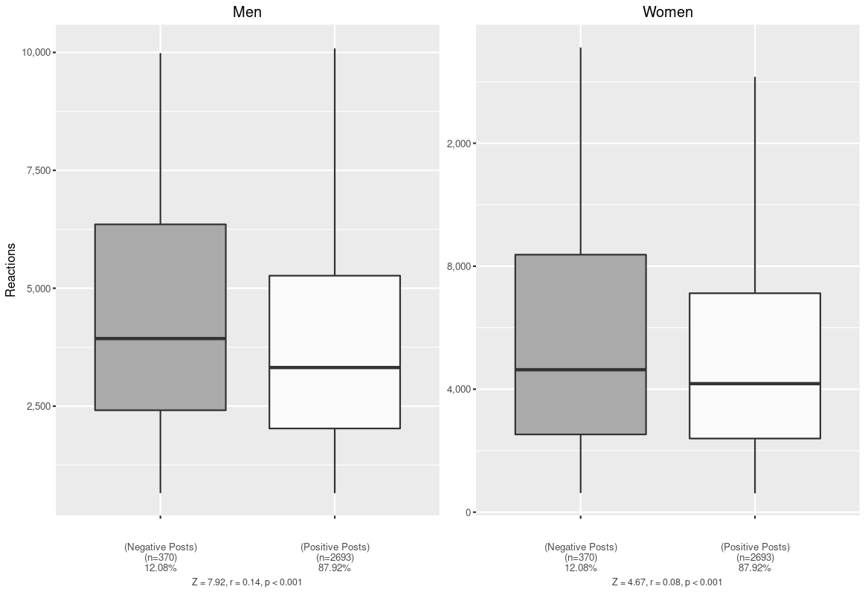
Figure 18: Box Plot Example of Kasich’s Negative Post Reactions and Positive Post Reactions
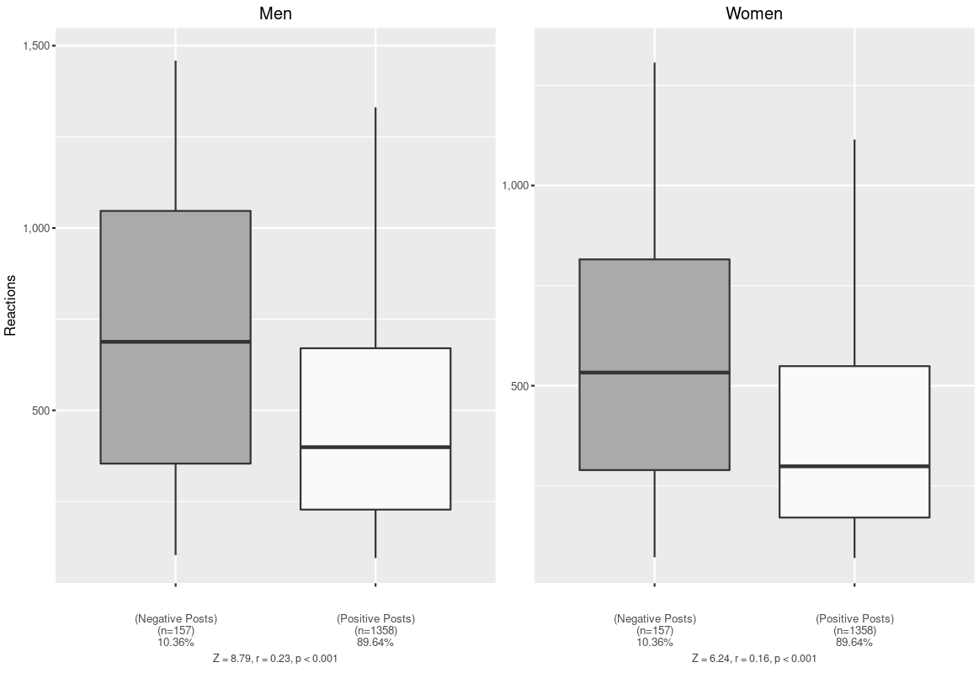
Figure 19: Box Plot Example of Rubio’s Negative Post Reactions and Positive Post Reactions
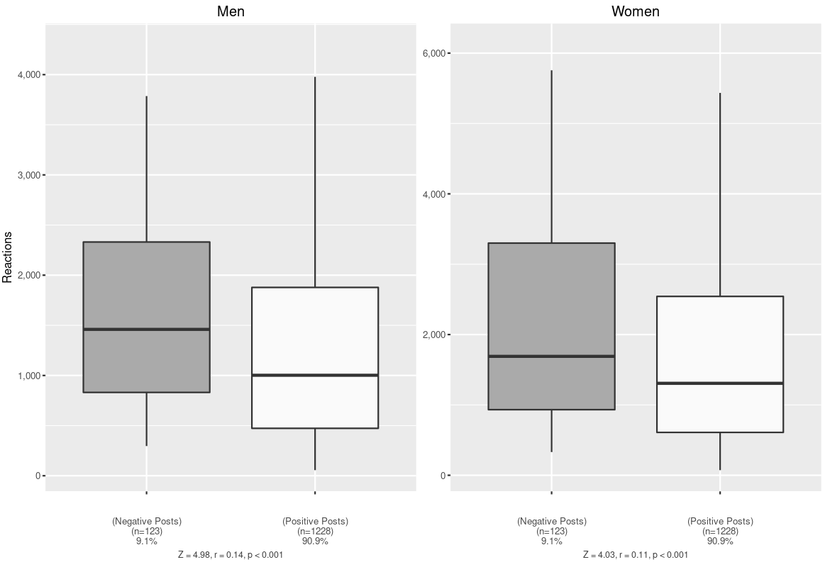
Figure 20: Box Plot Example of Sanders’ Negative Post Reactions and Positive Post Reactions
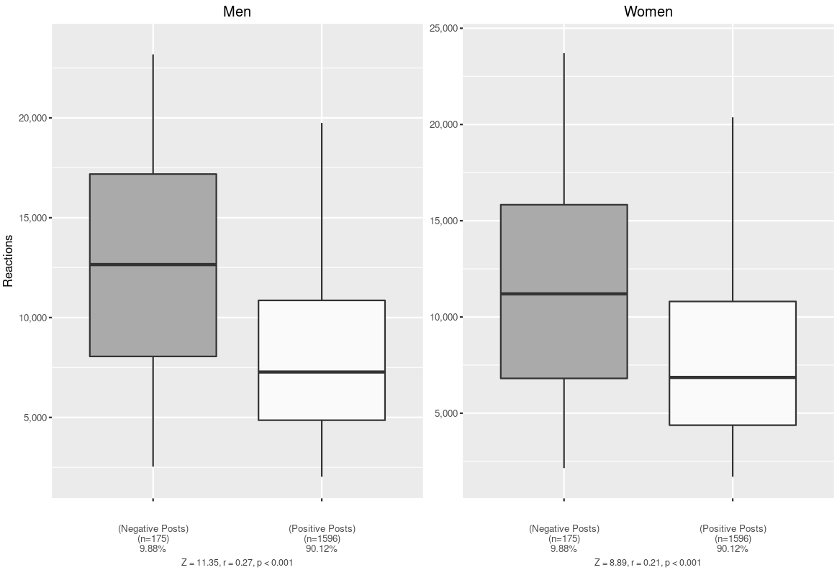
Figure 21: Box Plot Example of Trump’s (Primary) Negative Post Reactions and Positive Post Reactions 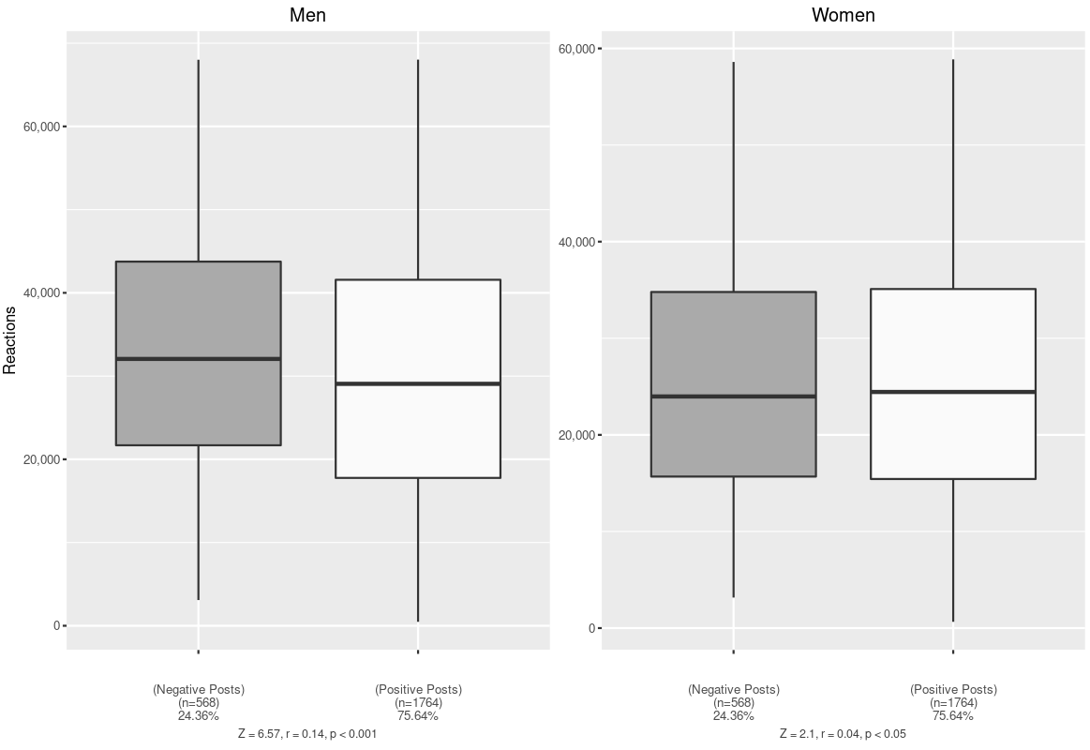

References for Supplementary Material
Ansolabehere, Stephen, and Shanto Iyengar. 1995. Going Negative. New York: The Free Press.
Ansolabehere, Stephen, Shanto Iyengar, and Adam Simon. 1999. “Replication Experiments Using Aggregate and Survey Data: The Case of Negative Advertising and Turnout.” American Political Science Review 93 (4): 901–909.
Ansolabehere, Stephen, Shanto Iyengar, Adam Simon, and Nicholas Valentino. 1994. “Does Attack Advertising Demobilize the Electorate?” American Political Science Review 88 (4): 829–838. https://doi.org/10.2307/2082710.
Arceneaux, Kevin, and David W. Nickerson. 2010. “Comparing Negative and Positive Campaign Messages: Evidence From Two Field Experiments.” American Politics Research 38 (1): 54–83. https://doi.org/10.1177/1532673X09331613.
Banda, K. K. 2014. “Issue-Based Negativity and Candidate Assessment.” Public Opinion Quarterly 78 (3): 707–20. https://doi.org/10.1093/poq/nfu038.
Banda, Kevin K., and Jason H. Windett. 2016. “Negative Advertising and the Dynamics of Candidate Support.” Political Behavior 38 (3): 747–66. https://doi.org/10.1007/s11109-016-9336-x.
Bartels, Larry M. 2014. “Remembering to Forget: A Note on the Duration of Campaign Advertising Effects.” Political Communication 31 (4): 532–544. https://doi.org/10.1080/10584609.2014.956198.
Bartels, Larry M., and Lynn Vavreck. 2000. “Campaign Quality: Standards for Evaluation, Benchmarks for Reform.” In Campaign Reform: Insights and Evidence. Ann Arbor: University of Michigan Press.
Barton, Jared, Marco Castillo, and Ragan Petrie. 2016. “Negative Campaigning, Fundraising, and Voter Turnout: A Field Experiment.” Journal of Economic Behavior & Organization 121 (January): 99–113. https://doi.org/10.1016/j.jebo.2015.10.007.
Basil, Michael, Caroline Schooler, and Byron Reeves. 1991. “Positive and Negative Political Advertising: Effectiveness of Ads and Perceptions of Candidates.” In Television and Political Advertising, edited by Frank Biocca. Vol. 1. Hillsdale, NJ: Lawrence Erlbaum.
Blackwell, Matthew. 2013. “A Framework for Dynamic Causal Inference in Political Science.” American Journal of Political Science 57 (2): 504–520. https://doi.org/10.1111/j.1540-5907.2012.00626.x.
Box-Steffensmeier, Janet M., David Darmofal, and Christian A. Farrell. 2009. “The Aggregate Dynamics of Campaigns.” The Journal of Politics 71 (1): 309–23. https://doi.org/10.1017/S0022381608090208.
Brader, Ted. 2005. “Striking a Responsive Chord:How Political Ads Motivate and Persuade Voters by Appealing to Emotions.” American Journal of Political Science 49 (2): 388–405.
———. 2006. Campaigning for Hearts and Minds: How Emotional Appeals in Political Ads Work. Chicago: University of Chicago Press.
Brians, Craig Leonard, and Martin P. Wattenberg. 1996. “Campaign Issue Knowledge and Salience: Comparing Reception from TV Commercials, TV News and Newspapers.” American Journal of Political Science 40 (1): 172. https://doi.org/10.2307/2111699.
Brooks, Deborah Jordan, and Michael Murov. 2012. “Assessing Accountability in a Post-Citizens United Era: The Effects of Attack Ad Sponsorship by Unknown Independent Groups.” American Politics Research 40 (3): 383–418. https://doi.org/10.1177/1532673X11414791.
Brooks, Deborah Jordan. 2006. “The Resilient Voter: Moving Toward Closure in the Debate over Negative Campaigning and Turnout.” Journal of Politics 68 (3): 684–696. https://doi.org/10.1111/j.1468-2508.2006.00454.x.
———. 2010. “A Negativity Gap? Voter Gender, Attack Politics, and Participation in American Elections.” Politics & Gender 6 (3): 319–41. https://doi.org/10.1017/S1743923X10000218.
Brooks, Deborah Jordan, and John G. Geer. 2007. “Beyond Negativity: The Effects of Incivility on the Electorate.” American Journal of Political Science 51 (1): 1–16.
Capella, Louis, and Ronald D. Taylor. 1992. “An Analysis of the Effectiveness of Negative Political Campaigning.” Business and Public Affairs 18 (2): 10–17.
Carraro, Luciana, and Luigi Castelli. 2010. “The Implicit and Explicit Effects of Negative Political Campaigns: Is the Source Really Blamed?: Negative Campaigns.” Political Psychology 31 (4): 617–45. https://doi.org/10.1111/j.1467-9221.2010.00771.x.
Cassese, Erin C., and Mirya R. Holman. 2018. “Party and Gender Stereotypes in Campaign Attacks.” Political Behavior 40 (3): 785–807. https://doi.org/10.1007/s11109-017-9423-7.
Chang, Chingching. 2001. “The Impacts of Emotion Elicited By Print Political Advertising on Candidate Evaluation.” Media Psychology 3 (2): 91–118. https://doi.org/10.1207/S1532785XMEP0302_01.
———. 2003. “Party Bias in Political-Advertising Processing–Results from an Experiment Involving the 1998 Taipei Mayoral Election.” Journal of Advertising 32 (February 2015): 55–67. https://doi.org/10.1080/00913367.2003.10639129.
Cheng, Hong, and Daniel Riffe. 2008. “Attention, Perception, and Perceived Effects: Negative Political Advertising in a Battleground State of the 2004 Presidential Election.” Mass Communication and Society 11 (2): 177–96. https://doi.org/10.1080/15205430701592859.
Cho, Jaeho. 2013. “Campaign Tone, Political Affect, and Communicative Engagement: Campaign Tone and Political Discussion.” Journal of Communication 63 (6): 1130–52. https://doi.org/10.1111/jcom.12064.
Clinton, Joshua D., and John S. Lapinski. 2004. “An Experimental Study of Political Advertising Effects in the 2000 Presidential Election.” Journal of Politics 66 (1): 67–96.
Cohen, Jeremy, and Robert G. Davis. 1991. “Third-Person Effects and the Differential Impact in Negative Political Advertising.” Journalism & Mass Communication 68 (4): 680–688.
Craig, Stephen C., James G. Kane, and Jason Gainous. 2005. “Issue-Related Learning in a Gubernatorial Campaign: A Panel Study.” Political Communication 22 (4): 483–503. https://doi.org/10.1080/10584600500311501.
Craig, Stephen C., and Paulina S. Rippere. 2014. “Political Trust and Negative Campaigns: Two Tests of the Figure-Ground Hypothesis: Political Trust and Negative Campaigns.” Politics & Policy 42 (5): 693–743. https://doi.org/10.1111/polp.12091.
———. 2016. “He Said, She Said: The Impact of Candidate Gender in Negative Campaigns.” Politics & Gender 12 (2): 391–414. https://doi.org/10.1017/S1743923X15000550.
Craig, Stephen C, Paulina S Rippere, and Marissa Silber Grayson. 2014. “Attack and Response in Political Campaigns: An Experimental Study in Two Parts.” Political Communication 31 (4). https://doi.org/10.1080/10584609.2013.879362.
Crigler, Ann, Marion Just, and Todd Belt. 2006. “The Three Faces of Negative Campaigning: The Democratic Implications of Attack Ads, Cynical News, and Fear-Arousing Messages.” In Feeling Politics, 135–63. Springer.
Dardis, Frank E., Fuyuan Shen, and Heidi Hatfield Edwards. 2008. “Effects of Negative Political Advertising on Individuals’ Cynicism and Self-Efficacy: The Impact of Ad Type and Message Exposures.” Mass Communication and Society 11 (1): 24–42. https://doi.org/10.1080/15205430701582512.
Dermody, Janine, and Richard Scullion. 2000. “Perceptions of Negative Political Advertising: Meaningful or Menacing? An Empirical Study of the 1997 British General Election Campaign.” International Journal of Advertising 19 (2): 201–23. https://doi.org/10.1080/02650487.2000.11104795.
Djupe, Paul A., and David A. M. Peterson. 2002. “The Impact of Negative Campaigning: Evidence from the 1998 Senatorial Primaries.” Political Research Quarterly 55 (4): 845–860. https://doi.org/10.1177/106591290205500406.
Dowling, Conor M., and Amber Wichowsky. 2013. “Does It Matter Who’s Behind the Curtain? Anonymity in Political Advertising and the Effects of Campaign Finance Disclosure.” American Politics Research 41 (6): 965–996. https://doi.org/10.1177/1532673X13480828.
———. 2015. “Attacks without Consequence? Candidates, Parties, Groups, and the Changing Face of Negative Advertising.” American Journal of Political Science 59 (1): 1–18. https://doi.org/10.1111/ajps.12094.
Fernandes, Juliana. 2013. “Effects of Negative Political Advertising and Message Repetition on Candidate Evaluation.” Mass Communication and Society 16 (2): 268–91. https://doi.org/10.1080/15205436.2012.672615.
Finkel, Steven E., and John G. Geer. 1998. “A Spot Check: Casting Doubt on the Demobilizing Effect of Attack Advertising.” American Journal of Political Science 42 (2): 573-595. https://doi.org/10.2307/2991771.
Freedman, Paul, and Ken Goldstein. 1999. “Measuring Media Exposure and the Effects of Negative Campaign Ads.” American Journal of Political Science 43 (4): 1189. https://doi.org/10.2307/2991823.
Freedman, Paul, William Wood, and Dale Lawton. 1999. “Do’s and Dont’s of Negative Ads: What Voters Say.” Campaigns & Elections 20 (9): 20–24.
Fridkin, Kim, and Patrick Kenney. 2004. “Do Negative Messages Work? The Impact of Negativity on Citizens’ Evaluations of Candidates.” American Politics Research 32 (5): 570–605. https://doi.org/10.1177/1532673X03260834.
———. 2011. “Variability in Citizens’ Reactions to Different Types of Negative Campaigns.” American Journal of Political Science 55 (2): 307–325. https://doi.org/10.1111/j.1540-5907.2010.00494.x.
———. 2019. Taking Aim at Attack Advertising: Understanding the Impact of Negative Campaigning in U. S. Senate Races. Oxford University Press.
Fridkin, Kim L., and Patrick J. Kenney. 2008. “The Dimensions of Negative Messages.” American Politics Research 36 (5): 694–723. https://doi.org/10.1177/1532673X08316448.
Fridkin, Kim L., Patrick J. Kenney, and Gina Serignese Woodall. 2009. “Bad for Men, Better for Women: The Impact of Stereotypes During Negative Campaigns.” Political Behavior 31 (1): 53–77. https://doi.org/10.1007/s11109-008-9065-x.
Garramone, Gina M. 1984. “Voter Responses to Negative Political Ads.” Journalism & Mass Communication Quarterly 61: 250–259. https://doi.org/10.1177/107769908406100202.
———. 1985. “Effects of Negative Political Advertising: The Roles of Sponsor and Rebuttal.” Journal of Broadcasting & Electronic Media 29 (2): 147–159. https://doi.org/10.1080/08838158509386573.
Garramone, Gina M., Charles K. Atkin, Bruce E. Pinkleton, and Richard T. Cole. 1990. “Effects of Negative Political Advertising on the Political Process.” Journal of Broadcasting & Electronic Media 34 (3): 299–311. https://doi.org/10.1080/08838159009386744.
Garramone, Gina M., and Sandra J. Smith. 1984. “Reactions to Political Advertising: Clarifying Sponsor Effects.” Journalism & Mass Communication Quarterly 61 (4).
Geer, John G., and James H. Geer. 2003. “REMEMBERING ATTACK ADS: An Experimental Investigation of Radio.” Political Behavior 25 (1): 69–95.
Geer, John Gray. 2006. In Defense of Negativity: Attack Ads in Presidential Campaigns. Chicago: University of Chicago Press.
Geer, John, and Richard R. Lau. 2006. “Filling in the Blanks: A New Method for Estimating Campaign Effects.” British Journal of Political Science 36 (2): 269. https://doi.org/10.1017/S0007123406000159.
Goldstein, Ken, and Paul Freedman. 2002. “Campaign Advertising and Voter Turnout: New Evidence for a Stimulation Effect.” Journal of Politics 64 (3): 721–740.
Groenendyk, Eric W., and Nicholas A. Valentino. 2002. “Of Dark Clouds and Silver Linings: Effects of Exposure to Issue versus Candidate Advertising on Persuasion, Information Retention, and Issue Salience.” Communication Research 29 (3): 295–319.
Haddock, Geoffrey, and Mark P. Zanna. 1997. “Impact of Negative Advertising on Evaluations of Political Candidates: The 1993 Canadian Federal Election.” Basic and Applied Social Psychology 79 (2): 205–223.
Hassell, Hans J. G., and Kelly R. Oeltjenbruns. 2016. “When to Attack: The Trajectory of Congressional Campaign Negativity.” American Politics Research 44 (2): 222–46. https://doi.org/10.1177/1532673X15589613.
Henderson, John A., and Alexander G. Theodoridis. 2018. “Seeing Spots: Partisanship, Negativity and the Conditional Receipt of Campaign Advertisements.” Political Behavior 40 (4): 965–87. https://doi.org/10.1007/s11109-017-9432-6.
Hill, Ronald Paul. 1989. “An Exploration of Voter Responses to Political Advertising.” Journal of Advertising 18 (4): 14–22.
Hill, Ronald Paul, Michael Capella, and Yoon-Na Cho. 2015. “Incivility in Political Advertisements: A Look at the 2012 US Presidential Election.” International Journal of Advertising 34 (5): 812–29. https://doi.org/10.1080/02650487.2015.1024386.
Hitchon, Jacqueline C., and Chingching Chang. 1995. “Effects of Gender Schematic Processing on the Reception of Political Commercials for Men and Women Candidates.” Communication Research 22 (4): 430–458.
Hitchon, Jacqueline C., Chingching Chang, and Rhonda Harris. 1997. “Should Women Emote? Perceptual Bias and Opinion Change in Response to Political Ads for Candidates of Different Genders.” Political Communication 14 (1S): 49–69. https://doi.org/10.1080/105846097199533.
Houston, David A., and Kelly Doan. 1999. “Can You Back That Up?” Media Psychology 1 (3): 191–206. https://doi.org/10.1207/s1532785xmep0103_1.
Houston, David A., Kelly Doan, and David Roskos-Ewoldsen. 1999. “Negative Political Advertising and Choice Conflict.” Journal of Experimental Psychology: Applied 5 (1): 3–16. https://doi.org/10.1037/1076-898X.5.1.3.
Jackson, Robert A., and Thomas M. Carsey. 2007. “US Senate Campaigns, Negative Advertising, and Voter Mobilization in the 1998 Midterm Election.” Electoral Studies 26 (1): 180–95. https://doi.org/10.1016/j.electstud.2006.06.010.
Jackson, Robert A., Jeffery J. Mondak, and Robert Huckfeldt. 2009. “Examining the Possible Corrosive Impact of Negative Advertising on Citizens’ Attitudes toward Politics.” Political Research Quarterly 62 (1): 55–69. https://doi.org/10.1177/1065912908317031.
Jackson, Robert A., and Jason C. Sides. 2006. “Revisiting the Influence of Campaign Tone on Turnout in Senate Elections.” Political Analysis 14: 206–218. https://doi.org/10.1093/pan/mpj003.
Jasperson, Amy E., and David P. Fan. 2002. “An Aggregate Examination of the Backlash Effect in Political Advertising: The Case of the 1996 U.S. Senate Race in Minnesota.” Journal of Advertising 31 (1): 1–12. https://doi.org/10.1080/00913367.2002.10673656.
Johnson, Tyler, Johanna Dunaway, and Christopher R. Weber. 2011. “Consider the Source: Variations in the Effects of Negative Campaign Messages.” Journal of Integrated Social Sciences 2 (1): 98–127.
Just, Marion, Ann Crigler, and Lori Wallach. 1990. “Thirty Seconds or Thirty Minutes: What Viewers Learn from Spot Advertisements and Candidate Debates.” Journal of Communication 40 (3): 120. https://doi.org/10.1111/j.1460-2466.1990.tb02274.x.
Kahn, Kim Fridkin, and John G. Geer. 1994. “Creating Impressions: An Experimental Investigation of Political Advertising on Television.” Political Behavior 16 (1): 93–116. https://doi.org/10.1007/BF01541644.
Kahn, Kim Fridkin, and Patrick J Kenney. 1999. “Do Negative Campaigns Mobilize or Suppress Turnout? Clarifying the Relationship between Negativity and Participation.” The American Political Science Review 93 (4): 877–889. https://doi.org/10.2307/2586118.
Kahn, Kim Fridkin, and Patrick J. Kenney. 2004. No Holds Barred: Negativity in U.S. Senate Campaign. Upper Saddle River, NJ: Pearson Education.
Kaid, Lynda Lee. 1997. “Effects of the Television Spots on Images of Dole and Clinton.” American Behavioral Scientist 40 (8): 1085–1094.
Kaid, Lynda Lee, and John Boydston. 1987. “An Experimental Study of the Effectiveness of Negative Political Advertisements.” Communication Quarterly 35 (February 1987): 193–201. https://doi.org/10.1080/01463378709369680.
Kaid, Lynda Lee, Mike Chanslor, and Mark Hovind. 1992. “The Influence of Program and Commercial Type on Political Advertising Effectiveness.” Journal of Broadcasting & Electronic Media 36 (3): 303–20. https://doi.org/10.1080/08838159209364179.
Kaid, Lynda Lee, J. Fernandes, and D. Painter. 2011. “Effects of Political Advertising in the 2008 Presidential Campaign.” American Behavioral Scientist 55 (4): 437–456. https://doi.org/10.1177/0002764211398071.
Kaid, Lynda Lee, Chris M. Leland, and Susan Whitney. 1992. “The Impact of Televised Political Ads: Evoking Viewer Responses in the 1988 Presidential Campaign.” Southern Communication Journal 57 (4): 285–95. https://doi.org/10.1080/10417949209372875.
Kern, Montague, and Marion Just. 1997. “A Gender Gap Among Viewers?” In Women, Media, and Politics, edited by Pippa Norris. New York: Oxford University Press 1997.
King, James D., and Jason B. McConnell. 2003. “The Effect of Negative Campaign Advertising on Vote Choice: The Mediating Influence of Gender.” Social Science Quarterly 84 (4): 843–857. https://doi.org/10.1046/j.0038-4941.2003.08404012.x.
Krasno, Jonathan S., and Donald P. Green. 2008. “Do Televised Presidential Ads Increase Voter Turnout? Evidence from a Natural Experiment.” The Journal of Politics 70 (1): 245–61. https://doi.org/10.1017/S0022381607080176.
Krupnikov, Yanna. 2012. “Negative Advertising and Voter Choice: The Role of Ads in Candidate Selection.” Political Communication 29 (4): 387–413. https://doi.org/10.1080/10584609.2012.721868.
———. 2014. “How Negativity Can Increase and Decrease Voter Turnout: The Effect of Timing.” Political Communication 31 (3): 446–66. https://doi.org/10.1080/10584609.2013.828141.
Krupnikov, Yanna, and Nichole M. Bauer. 2014. “The Relationship Between Campaign Negativity, Gender and Campaign Context.” Political Behavior 36 (1): 167–88. https://doi.org/10.1007/s11109-013-9221-9.
Krupnikov, Yanna, and Spencer Piston. 2015. “Accentuating the Negative: Candidate Race and Campaign Strategy.” Political Communication 32 (1): 152–73. https://doi.org/10.1080/10584609.2014.914612.
Lang, Annie. 1991. “Emotion, Formal Features, and Memory for Televised Political Advertisements.” In Television and Political Advertising, Vol. 1, edited by Frank Biocca, 221–43. New York, NY: Routledge.
Lariscy, Ruth Ann Weaver, and Spencer F. Tinkham. 1999. “The Sleeper Effect and Negative Political Advertising.” Journal of Advertising 28 (4): 13–30. https://doi.org/10.1080/00913367.1999.10673593.
Lau, Richard R., and Gerald M. Pomper. 2002. “Effectiveness of Negative Campaigning in U.S. Senate Elections.” American Journal of Political Science 46 (1): 47. https://doi.org/10.2307/3088414.
Lau, Richard R, and Gerald M Pomper. 2004. Negative Campaigning: An Analysis of U.S. Senate Elections. Lanham, MD: Rowman & Littlefield 2004.
Lemert, James B., Wayne Wanta, and Tien-Tsung Lee. 1999. “Party Identification and Negative Advertising in a U.S. Senate Election.” Journal of Communication 49 (2): 123–34. https://doi.org/10.1111/j.1460-2466.1999.tb02797.x.
Leshner, Glenn, and Esther Thorson. 2000. “Overreporting Voting: Campaign Media, Public Mood, and the Vote.” Political Communication 17 (February 2015): 263–278. https://doi.org/10.1080/105846000414278.
Lipsitz, Keena, and John G. Geer. 2017. “Rethinking the Concept of Negativity: An Empirical Approach.” Political Research Quarterly 70 (3).
Llaudet, Elena. 2018. “The Mobilizing and Demobilizing Effects of Political TV Ads: A Midterm Election Study.” Electoral Studies 54 (August): 226–36. https://doi.org/10.1016/j.electstud.2018.06.002.
Lovejoy, Jennette, Daniel Riffe, and Hong Cheng. 2012. “Campaign Interest and Issue Knowledge: Did the Media—and Negative Political Advertising—Matter in ‘Battleground Ohio’?” Atlantic Journal of Communication 20 (4): 201–20. https://doi.org/10.1080/15456870.2012.711148.
Ma, Jennifer, David Atkin, Leslie Snyder, and Arthur Van Lear. 2018. “Negative Advertising Effects on Presidential Support Ratings During the 2012 Election: A Hierarchical Linear Modeling and Serial Dependency Study.” Mass Communication and Society 22 (2): 196-221. https://doi.org/10.1080/15205436.2018.1536997.
Malloy, Liam C, and Shanna Pearson-Merkowitz. 2016. “Going Positive: The Effects of Negative and Positive Advertising on Candidate Success and Voter Turnout.” Research & Politics 3 (1).
Martin, Paul S. 2004. “Inside the Black Box of Negative Campaign Effects: Three Reasons Why Negative Campaigns Mobilize.” Political Psychology 25 (4): 545–62. https://doi.org/10.1111/j.1467-9221.2004.00386.x.
Mattes, Kyle, and David P. Redlawsk. 2014. The Positive Case for Negative Campaigning. London: The University of Chicago Press.
Matthews, Douglas, and Beth Dietz-Uhler. 1998. “The Black-Sheep Effect: How Positive and Negative Advertisements Affect Voters’ Perceptions of the Sponsor of the Advertisement.” Journal of Applied Social Psychology 28: 1903–1915. https://doi.org/10.1111/j.1559-1816.1998.tb01352.x.
Meirick, P. 2002. “Cognitive Responses to Negative and Comparative Political Advertising.” Journal of Advertising 31 (1): 49–62. https://doi.org/10.1080/00913367.2002.10673660.
Meirick, Patrick C. 2005. “Political Knowledge and Sponsorship in Backlash from Party‐ and Candidate‐sponsored Attacks.” Communication Reports 18 (1–2): 75–84. https://doi.org/10.1080/08934210500309967.
Meirick, Patrick C., and Gwendelyn S. Nisbett. 2011. “I Approve This Message: Effects of Sponsorship, Ad Tone, and Reactance in 2008 Presidential Advertising.” Mass Communication and Society 14 (5): 666–89. https://doi.org/10.1080/15205436.2010.530381.
Meirick, Patrick C., Gwendelyn S. Nisbett, Matthew D. Jefferson, and Michael W. Pfau. 2011. “The Influence of Tone, Target, and Issue Ownership on Political Advertising Effects in Primary Versus General Elections.” Journal of Political Marketing 10 (3): 275–96. https://doi.org/10.1080/15377857.2011.588111.
Merritt, Sharyne. 1984. “Negative Political Advertising: Some Empirical Findings Author(s):” Journal of Advertising 13 (3): 27–38.
Min, Young. 2004. “News Coverage of Negative Political Campaigns: An Experiment of Negative Campaign Effects on Turnout and Candidate Preference.” Harvard International Journal of Press/Politics 9 (4): 95–111. https://doi.org/10.1177/1081180X04271861.
Morey, Alyssa C. 2017. “Memory for Positive and Negative Political TV Ads: The Role of Partisanship and Gamma Power.” Political Communication 34 (3): 404–23. https://doi.org/10.1080/10584609.2016.1266534.
Newhagen, John E., and Byron Reeves. 1991. “Emotion and Memory Responses for Negative Political Advertising: A Study of Television Commercials Used in the 1988 Presidential Election.” In Television and Political Advertising, edited by Frank Biocca, 197–220. New York, NY: Routledge.
Niven, David. 2006. “A Field Experiment on the Effects of Negative Campaign Mail on Voter Turnout in a Municipal Election.” Political Research Quarterly 59 (2): 203–210. https://doi.org/10.1177/106591290605900203.
Peng, Norman, and Chris Hackley. 2009. “Are Voters, Consumers? A Qualitative Exploration of the Voter-Consumer Analogy in Political Marketing.” Qualitative Market Research : An International Journal 12 (2): 171–186.
Pfau, Michael, and Michael Burgoon. 1989. “The Efficacy of Issue and Character Attack Message Strategies in Political Campaign Communication.” Communication Reports 2 (2): 53–61. https://doi.org/10.1080/08934218909367484.
Pinkleton, Bruce. 1997. “The Effects of Negative Comparative Political Advertising on Candidate Evaluations and Advertising Evaluations : An Exploration.” Journal of Advertising 26 (1): 19–29.
Pinkleton, Bruce E. 1998. “Effects of Print Comparative Political Advertising on Political Decision-Making and Participation,” 24–36.
Pinkleton, Bruce E. 2002. “An Exploration of the Effects of Negative Political Advertising on Political Decision Making.” Journal of Advertising 31 (1): 13–25.
Rahn, Wendy M., and Rebecca M Hirshorn. 1999. “Political Advertising and Public Mood: A Study of Children’s Political Orientations.” Political Communication 16 (4): 387–407. https://doi.org/10.1080/105846099198550.
Ridout, Travis N., Erika Franklin Fowler, Michael M. Franz, and Kenneth Goldstein. 2018. “The Long-Term and Geographically Constrained Effects of Campaign Advertising on Political Polarization and Sorting.” American Politics Research 46 (1): 3–25. https://doi.org/10.1177/1532673X17721479.
Ridout, Travis N., and Michael M. Franz. 2011. “How Negativity and Emotional Appeals in Ads Matter.” In The Persuasive Power of Campaign Advertising, 79–102. Philadelphia: Temple University Press.
Ridout, Travis N., Michael M. Franz, and Erika Franklin Fowler. 2015. “Sponsorship, Disclosure, and Donors: Limiting the Impact of Outside Group Ads.” Political Research Quarterly 68 (1): 154–66. https://doi.org/10.1177/1065912914563545.
Roberts, Marilyn S. 1995. “Political Advertising: Strategies for Influence.” In Presidential Campaign Discourse: Strategic Communication Problems, edited by Kathleen E. Kendall. SUNY Press.
Roddy, Brian L., and Gina M. Garramone. 1988. “Appeals and Strategies of Negative Political Advertising.” Journal of Broadcasting & Electronic Media 32 (4): 415–27. https://doi.org/10.1080/08838158809386713.
Sanders, David, and Pippa Norris. 2002. “Advocacy versus Attack: The Impact of Political Advertising in the 2001 UK General Election.” ECPR Joint Sessions, Turin.
Schultz, Cindy, and S. Mark Pancer. 1997. “Character Attacks and Their Effects on Perceptions of Male and Female Political Candidates.” Political Psychology 18 (1): 93–102. https://doi.org/10.1111/0162-895X.00046.
Scullion, Richard, and Janine Dermody. 2000. “Perceptions of Negative Political Advertising. Meaningful or Menacing? An Empirical Study of the 1997 British General Election Campaign.” International Journal of Advertising 19: 201–223.
Searles, Kathleen, Erika Franklin Fowler, Travis N. Ridout, Patricia Strach, and Katherine Zuber. 2017. “The Effects of Men’s and Women’s Voices in Political Advertising.” Journal of Political Marketing. https://doi.org/10.1080/15377857.2017.1330723.
Shapiro, Michael A., and Robert H. Rieger. 1992. “Comparing Positive and Negative Political Advertising on Radio.” Journalism Quarterly 69 (1): 135–45.
Shen, Fuyuan, Frank E. Dardis, and Heidi Hatfield Edwards. 2011. “Advertising Exposure and Message Type: Exploring the Perceived Effects of Soft-Money Television Political Ads.” Journal of Political Marketing 10 (3): 215–229. https://doi.org/10.1080/15377857.2011.588097.
Shen, Fuyuan, and H. Denis Wu. 2002. “Effects of Soft-Money Issue Advertisements on Candidate Evaluation and Voting Preference: An Exploration.” Mass Communication and Society 5 (4): 395–410.
Sides, John, Keena Lipsitz, and Matthew Grossmann. 2010. “Do Voters Perceive Negative Campaigns as Informative Campaigns?” American Politics Research 38 (3): 502–530. https://doi.org/10.1177/1532673X09336832.
Sonner, Brenda S. 1998. “The Effectiveness of Negative Political Advertising: A Case Study.” Journal of Advertising Research 38 (6): 37–38.
Stevens, Daniel. 2008. “Measuring Exposure to Political Advertising in Surveys.” Political Behavior 30 (1): 47–72.
———. 2009. “Elements of Negativity: Volume and Proportion in Exposure to Negative Advertising.” Political Behavior 31 (3): 429–454. https://doi.org/10.1007/s11109-008-9082-9.
———. 2012. “Tone Versus Information: Explaining the Impact of Negative Political Advertising.” Journal of Political Marketing 11 (4): 322–352. https://doi.org/10.1080/15377857.2012.723988.
Stevens, Daniel, Barbara Allen, John Sullivan, and Eric Lawrence. 2015. “Fair’s Fair? Principles, Partisanship, and Perceptions of the Fairness of Campaign Rhetoric.” British Journal of Political Science 45 (1): 195–213. https://doi.org/10.1017/S0007123413000045.
Stevens, Daniel, John Sullivan, Barbara Allen, and Dean Alger. 2008. “What’s Good for the Goose Is Bad for the Gander: Negative Political Advertising, Partisanship, and Turnout.” The Journal of Politics 70 (2): 527–41. https://doi.org/10.1017/S0022381608080481.
Stone, George W., Jeffrey G. Blodgett, Japhet Nkonge, and Kathryn T. Cort. 2013. “The Moderating Influence of Political Involvement on Voters’ Attitudes toward Attack Ads.” Journal of Marketing Theory and Practice 21 (1): 91–102. https://doi.org/10.2753/MTP1069-6679210106.
Strach, Patricia, Katherine Zuber, Erika Franklin Fowler, Travis N. Ridout, and Kathleen Searles. 2015. “In a Different Voice? Explaining the Use of Men and Women As Voice-Over Announcers in Political Advertising.” Political Communication, no. February: 1–23. https://doi.org/10.1080/10584609.2014.914614.
Thorson, Esther, William G. Christ, and Clarke Caywood. 1991a. “Effects of Issue-Image Strategies, Attack and Support Appeals, Music, and Visual Content in Political Commercials.” Journal of Broadcasting & Electronic Media 35 (4): 465–486. https://doi.org/10.1080/08838159109364141.
———. 1991b. “Selling Candidates Like Tubes of Toothpaste: Is the Comparison Apt?” In Television and Political Advertising, edited by Frank Biocca. Vol. 1. Hillsdale, NJ: Lawrence Erlbaum.
Thorson, Esther, Ekaterina Ognianova, James Coyle, and Frank Denton. 2000. “Negative Political Ads and Negative Citizen Orientations toward Politics.” Journal of Current Issues & Research in Advertising 22 (1): 13–40. https://doi.org/10.1080/10641734.2000.10505099.
Tinkham, Spencer F., and Ruth Ann Weaver-Lariscy. 1990. “Advertising Message Strategy in U.S. Congressional Campaigns: Its Impact on Election Outcome.” Current Issues & Research in Advertising 13 (1): 207–226.
———. 1991. “Advertising Message Strategy in US Congressional Campaigns: Its Impact on Election Outcome.” Current Issues and Research in Advertising 13 (1–2): 207–26.
———. 1993. “A Diagnostic Approach to Assessing the Impact of Negative Political Television Commercials.” Journal of Broadcasting & Electronic Media 37 (4): 24.
Wadsworth, Anne Johnston, Philip Patterson, Lynda Lee Kaid, Ginger Cullers, Drew Malcomb, and Linda Lamirand. 1987. “‘Masculine’ vs. ‘Feminine’ Strategies in Political ADS: Implications for Female Candidates.” Journal of Applied Communication Research 15 (1–2): 77–94. https://doi.org/10.1080/00909888709365261.
Wanta, Wane, James B. Lemert, and Tien-tsung Lee. 1998. “Consequences of Negative Political Advertising Exposure.” In Engaging the Public: How Government and the Media Can Reinvigorate American Democracy, edited by Thomas J. Johnson, Carol E. Hays, and Scott P. Hays. Rowman & Littlefield.
Wattenberg, Martin P, and Craig Leonard Brians. 1999. “Negative Campaign Advertising: Demobilizer or Mobilizer?” The American Political Science Reveiw 93 (4): 891–899. https://doi.org/10.2307/2586119.
Weaver-Lariscy, Ruth Ann, and Spencer F. Tinkham. 1996. “Advertising Message Strategies in US Congressional Campaigns: 1982, 1990.” Journal of Current Issues & Research in Advertising 18 (1): 53–66.
Weber, Christopher. 2012. “Emotions, Campaigns, and Political Participation.” Political Research Quarterly 66 (2): 414–428. https://doi.org/10.1177/1065912912449697.
Weber, Christopher, Johanna Dunaway, and Tyler Johnson. 2012. “It’s All in the Name: Source Cue Ambiguity and the Persuasive Appeal of Campaign Ads.” Political Behavior 34: 561–584. https://doi.org/10.1007/s11109-011-9172-y.

