**Descriptive Representation and the Political Engagement of Women**

Supplemental appendix

*Conditional effects by party*

3 Table A1: Descriptive Representation and Partisan Knowledge, Controlling for Shared Partisanship

4 Table A2: Descriptive Representation and Partisan Knowledge, Conditional on Party of Politician

5 Figure A1: Marginal Effects of the Gender of the Elected Official, by Respondent Gender and Party of Elected Official

6 Table A3: Descriptive Representation and Partisan Knowledge, Conditional on Shared Partisanship

7 Figure A2: Marginal Effects of the Gender of the Elected Official, by Respondent Gender and Shared Partisanship

*Conditional effects by competitiveness of election*

8 Table A4: Descriptive Representation and Partisan Knowledge, Conditional on Campaign Competitiveness

9 Figure A3: Marginal Effects of the Gender of the Elected Official, by Respondent Gender and Campaign Competitiveness

*Conditional effects based on district type*

10 Table A5: Descriptive Representation and Women-Friendliness of the District, Officeholder Knowledge

11 Figure A4: Marginal Effects of the Gender of the Elected Official, by Respondent Gender and Women-Friendliness of the District

12 Table A6: Descriptive Representation and Women-Friendliness of the District, State Legislative Knowledge

13 Figure A5: Marginal Effects of the Percent Female State Legislators, by Respondent Gender and Women-Friendliness of the District

14 Table A7: Descriptive Representation and District Women-Friendliness, Political Engagement

15 Figure A6: Marginal Effects of the Count of Female Politicians, by Respondent Gender and the Women-Friendliness of the District

*Alternate measures of women’s representation*

16 Table A8: Women Candidates and Officeholders Indices and Campaign Engagement

17 Table A9: Women Candidates and Officeholders and Campaign Engagement

*Results by survey year*

18 Table A10: Correct Identification of Representative's Partisanship, by Year

20 Table A11: Correct Identification of First Senator’s Partisanship, by Year

21 Table A12: Correct Identification of Second Senator’s Partisanship, by Year

22 Table A13: Correct Identification of Governor’s Partisanship, by Year

23 Table A14: Descriptive Representation and Knowledge of Party Control of State House, by Year

24 Table A15: Descriptive Representation and Knowledge of Party Control of State Senate, by Year

25 Table A16: Descriptive Representation and Following Politics, by Year

26 Table A17: Descriptive Representation and Voter Turnout, by Year

27 Table A18: Descriptive Representation and Campaign Participation, by Year

|  |  |  |  |  |
| --- | --- | --- | --- | --- |
| **Table A1: Descriptive Representation and Partisan Knowledge, Controlling for Shared Partisanship** | | | | |
|  | Knowledge, party of MC | Knowledge, party of Senator 1 | Knowledge, party of Senator 2 | Knowledge, party of governor |
| Female respondent | -0.634* | -0.906* | -0.818* | -0.782* |
|  | (0.020) | (0.046) | (0.035) | (0.035) |
| Elected official is female | 0.326* | 0.320* | 0.356* | 0.325* |
|  | (0.057) | (0.119) | (0.109) | (0.123) |
| Female × Female elected official | 0.067 | 0.098 | 0.161* | 0.026 |
|  | (0.053) | (0.088) | (0.080) | (0.091) |
| Elected official is of own party | 0.317* | 0.030 | 0.102* | 0.151* |
|  | (0.019) | (0.027) | (0.030) | (0.031) |
| Education | 1.402* | 1.578* | 1.575* | 1.702* |
|  | (0.034) | (0.046) | (0.040) | (0.049) |
| Strength of partisanship | 0.249* | 0.307* | 0.279* | 0.338* |
|  | (0.009) | (0.012) | (0.011) | (0.014) |
| Household income | 1.151* | 1.265* | 1.220* | 1.377* |
|  | (0.033) | (0.045) | (0.041) | (0.054) |
| Nonwhite | -0.277* | -0.337* | -0.307* | -0.297* |
|  | (0.023) | (0.023) | (0.027) | (0.028) |
| Age | 0.038* | 0.039* | 0.038* | 0.036* |
|  | (0.001) | (0.001) | (0.001) | (0.001) |
| Elected official’s tenure in office | 0.007* | 0.020* | 0.010 | 0.045* |
|  | (0.002) | (0.004) | (0.007) | (0.019) |
| Competitiveness of election | 0.049 | 0.589* | 0.615* | 0.127 |
|  | (0.056) | (0.109) | (0.100) | (0.086) |
| Women-friendliness of district | -0.465* | 1.061* | 1.059* | 0.735* |
|  | (0.175) | (0.189) | (0.225) | (0.246) |
| Constant | -2.375* | -2.504* | -2.338* | -1.986* |
|  | (0.071) | (0.099) | (0.088) | (0.104) |
| *Variance components* |  |  |  |  |
| Variance, intercept | 0.596* | 0.487* | 0.370* | 0.356* |
|  | (0.026) | (0.122) | (0.048) | (0.049) |
| Variance, gender | 0.427* | 0.162* | 0.125* | 0.157* |
|  | (0.024) | (0.033) | (0.023) | (0.025) |
| Covariance, gender and constant | -0.325* | -0.161* | -0.093* | -0.108* |
|  | (0.021) | (0.053) | (0.031) | (0.030) |
|  |  |  |  |  |
| Deviance | 215,701 | 198,007 | 202,330 | 172,608 |
| N  (number of district-years) | 198,576 (2165) | 199,882  (250) | 199,918  (250) | 200,013  (250) |
| Multilevel logit estimates. Standard errors in parentheses. * p<0.05 | | | | |

|  |  |  |  |  |
| --- | --- | --- | --- | --- |
| **Table A2: Descriptive Representation and Partisan Knowledge, Conditional on Party of Politician** | | | | |
|  | Knowledge, party of MC | Knowledge, party of Senator 1 | Knowledge, party of Senator 2 | Knowledge, party of governor |
| Female respondent | -0.648* | -0.893* | -0.819* | -0.746* |
|  | (0.026) | (0.077) | (0.038) | (0.054) |
| Elected official is female | 0.543* | 0.467* | 0.301 | 0.186 |
|  | (0.103) | (0.212) | (0.227) | (0.150) |
| Female × Female elected official | -0.148 | 0.020 | 0.108 | 0.153 |
|  | (0.086) | (0.119) | (0.192) | (0.116) |
| Democratic elected official | 0.152* | -0.140 | 0.079 | -0.281* |
|  | (0.043) | (0.117) | (0.101) | (0.090) |
| Female × Democratic elected official | 0.031 | -0.019 | 0.033 | -0.085 |
|  | (0.040) | (0.091) | (0.057) | (0.069) |
| Female leg. × Democratic elected official | -0.334* | -0.162 | 0.027 | 0.319 |
|  | (0.124) | (0.256) | (0.266) | (0.236) |
| Female × Female leg. × Dem. elected official | 0.314* | 0.102 | 0.043 | -0.135 |
|  | (0.109) | (0.150) | (0.210) | (0.169) |
| Education | 1.403* | 1.579* | 1.577* | 1.705* |
|  | (0.034) | (0.046) | (0.040) | (0.049) |
| Strength of partisanship | 0.294* | 0.311* | 0.292* | 0.357* |
|  | (0.008) | (0.011) | (0.010) | (0.012) |
| Household income | 1.162* | 1.265* | 1.223* | 1.381* |
|  | (0.034) | (0.045) | (0.042) | (0.054) |
| Nonwhite | -0.286* | -0.337* | -0.315* | -0.307* |
|  | (0.024) | (0.023) | (0.027) | (0.030) |
| Age | 0.038* | 0.039* | 0.037* | 0.036* |
|  | (0.001) | (0.001) | (0.001) | (0.001) |
| Elected official’s tenure in office | 0.007* | 0.020* | 0.016* | 0.021 |
|  | (0.002) | (0.004) | (0.004) | (0.017) |
| Competitiveness of election | 0.026 | 0.590* | 0.587* | 0.241* |
|  | (0.056) | (0.107) | (0.096) | (0.076) |
| Women-friendliness of district | -0.585* | 1.084* | 1.064* | 0.742* |
|  | (0.199) | (0.190) | (0.221) | (0.237) |
| Constant | -2.336* | -2.432* | -2.386* | -1.803* |
|  | (0.070) | (0.112) | (0.086) | (0.105) |
| *Variance components* |  |  |  |  |
| Variance, intercept | 0.583* | 0.470* | 0.384* | 0.329* |
|  | (0.026) | (0.135) | (0.046) | (0.047) |
| Variance, gender | 0.421* | 0.166* | 0.125* | 0.159* |
|  | (0.024) | (0.040) | (0.021) | (0.024) |
| Covariance, gender and constant | -0.317* | -0.152* | -0.101* | -0.114* |
|  | (0.021) | (0.061) | (0.029) | (0.029) |
|  |  |  |  |  |
| N (number of district-years) | 198576 (2165) | 199,882 (250) | 199,918 (250) | 200,189 (250) |
| Multilevel logit estimates. Standard errors in parentheses. * p<0.05 | | | | |

**Figure A1: Marginal Effects of the Gender of the Elected Official, by Respondent Gender and Party of Elected Official**

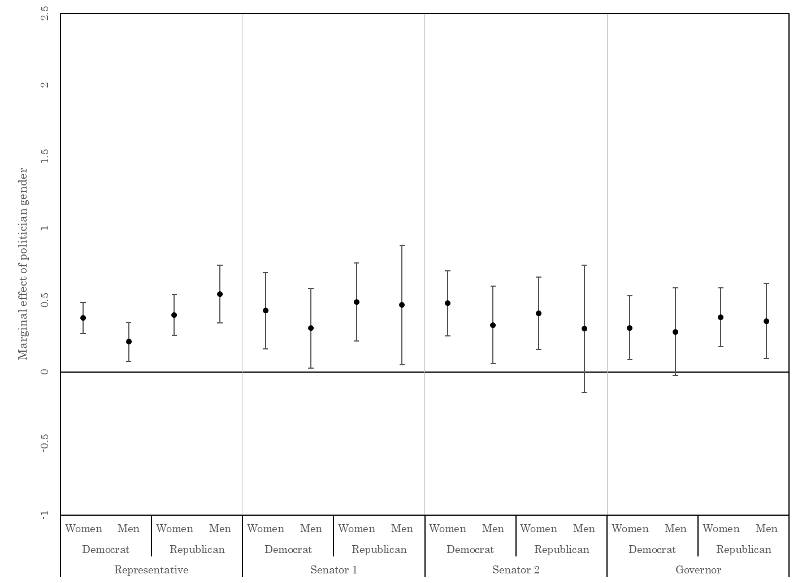

Marginal effects are based on the models reported in Table A2.

|  |  |  |  |  |
| --- | --- | --- | --- | --- |
| **Table A3: Descriptive Representation and Partisan Knowledge, Conditional on Shared Partisanship** | | | | |
|  | Knowledge, party of MC | Knowledge, party of Senator 1 | Knowledge, party of Senator 2 | Knowledge, party of governor |
| Female respondent | -0.661* | -0.943* | -0.810* | -0.772* |
|  | (0.027) | (0.054) | (0.042) | (0.042) |
| Elected official is female | 0.404* | 0.295* | 0.500* | 0.354* |
|  | (0.069) | (0.125) | (0.117) | (0.134) |
| Female × Female elected official | 0.012 | 0.129 | 0.126 | 0.026 |
|  | (0.072) | (0.097) | (0.088) | (0.111) |
| Own-party elected official | 0.300* | -0.021 | 0.155* | 0.168* |
|  | (0.032) | (0.048) | (0.047) | (0.047) |
| Female × Own-party elected official | 0.058 | 0.082 | -0.030 | -0.017 |
|  | (0.038) | (0.051) | (0.047) | (0.046) |
| Female off. × Own-party elected official | -0.158* | 0.057 | -0.256* | -0.074 |
|  | (0.075) | (0.088) | (0.088) | (0.148) |
| Female × Female off. × Own-party official | 0.109 | -0.071 | 0.156 | 0.000 |
|  | (0.094) | (0.084) | (0.081) | (0.138) |
| Education | 1.402* | 1.578* | 1.575* | 1.702* |
|  | (0.034) | (0.046) | (0.040) | (0.049) |
| Strength of partisanship | 0.250* | 0.307* | 0.279* | 0.338* |
|  | (0.009) | (0.012) | (0.011) | (0.014) |
| Household income | 1.150* | 1.266* | 1.217* | 1.377* |
|  | (0.033) | (0.045) | (0.041) | (0.054) |
| Nonwhite | -0.276* | -0.337* | -0.302* | -0.296* |
|  | (0.023) | (0.023) | (0.027) | (0.028) |
| Age | 0.038* | 0.039* | 0.037* | 0.036* |
|  | (0.001) | (0.001) | (0.001) | (0.001) |
| Elected official's tenure in office | 0.007* | 0.020* | 0.011 | 0.044* |
|  | (0.002) | (0.004) | (0.007) | (0.019) |
| Competitiveness of election | 0.050 | 0.589* | 0.608* | 0.124 |
|  | (0.056) | (0.110) | (0.100) | (0.088) |
| Women-friendliness of district | -0.469* | 1.059* | 1.096* | 0.736* |
|  | (0.175) | (0.189) | (0.225) | (0.246) |
| Constant | -2.368* | -2.483* | -2.368* | -1.990* |
|  | (0.072) | (0.101) | (0.089) | (0.104) |
| *Variance components* |  |  |  |  |
| Variance, intercept | 0.594* | 0.485* | 0.365* | 0.355* |
|  | (0.026) | (0.122) | (0.046) | (0.050) |
| Variance, gender | 0.425* | 0.161* | 0.126* | 0.157* |
|  | (0.024) | (0.033) | (0.022) | (0.026) |
| Covariance, gender and constant | -0.322* | -0.159* | -0.088* | -0.109* |
|  | (0.021) | (0.053) | (0.032) | (0.030) |
|  |  |  |  |  |
| N (number of district-years) | 198,576 (2165) | 199,882 (250) | 199,918 (250) | 200,013 (250) |
| Multilevel logit estimates. Standard errors in parentheses. * p<0.05 | | | | |

**Figure A2: Marginal Effects of the Gender of the Elected Official, by Respondent Gender and Shared Partisanship**

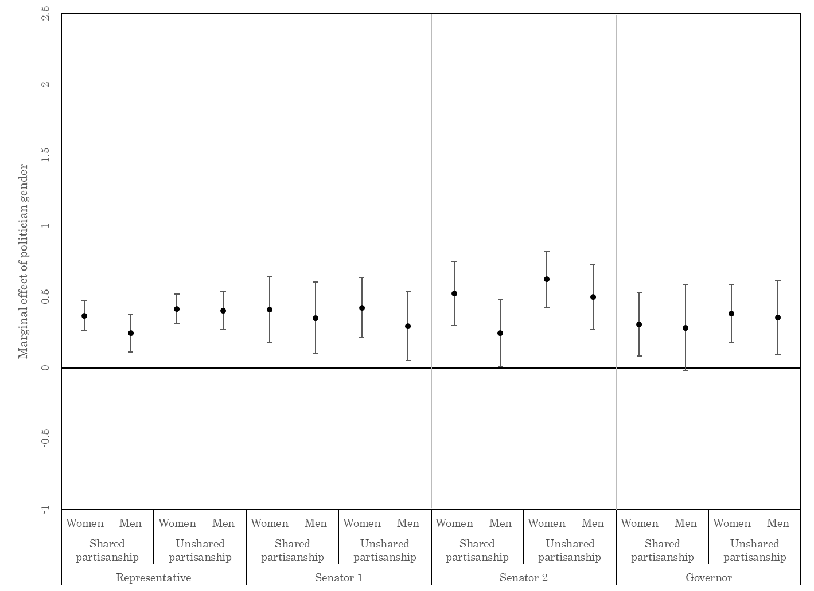

Marginal effects are based on the models reported in Table A3.

|  |  |  |  |  |
| --- | --- | --- | --- | --- |
| **Table A4: Descriptive Representation and Partisan Knowledge, Conditional on Campaign Competitiveness** | | | | |
|  | Knowledge, party of MC | Knowledge, party of Senator 1 | Knowledge, party of Senator 2 | Knowledge, party of governor |
| Female respondent | -0.653* | -0.922* | -0.832* | -0.698* |
|  | (0.063) | (0.052) | (0.040) | (0.056) |
| Female elected official | 0.071 | 0.262 | 0.331* | 0.478* |
|  | (0.156) | (0.138) | (0.126) | (0.168) |
| Female × Female elected official | 0.364* | 0.153 | 0.205* | -0.051 |
|  | (0.173) | (0.133) | (0.092) | (0.106) |
| Competitiveness of campaign | -0.004 | 0.502* | 0.568* | 0.328* |
|  | (0.087) | (0.129) | (0.126) | (0.101) |
| Female × campaign competitiveness | 0.023 | 0.089 | 0.071 | -0.169* |
|  | (0.076) | (0.103) | (0.079) | (0.076) |
| Female off. × campaign comp. | 0.332 | 0.000 | 0.220 | -0.302 |
|  | (0.194) | (0.272) | (0.240) | (0.247) |
| Female × female off. × campaign comp. | -0.366 | -0.184 | -0.150 | 0.165 |
|  | (0.208) | (0.185) | (0.159) | (0.173) |
| Education | 1.403* | 1.579* | 1.577* | 1.705* |
|  | (0.034) | (0.046) | (0.040) | (0.049) |
| Strength of partisanship | 0.294* | 0.311* | 0.292* | 0.358* |
|  | (0.008) | (0.011) | (0.010) | (0.012) |
| Household income | 1.161* | 1.265* | 1.225* | 1.382* |
|  | (0.034) | (0.045) | (0.042) | (0.054) |
| Nonwhite | -0.284* | -0.337* | -0.314* | -0.306* |
|  | (0.024) | (0.023) | (0.027) | (0.030) |
| Age | 0.038* | 0.039* | 0.037* | 0.036* |
|  | (0.001) | (0.001) | (0.001) | (0.001) |
| Elected official's tenure in office | 0.007* | 0.020* | 0.010 | 0.039* |
|  | (0.002) | (0.004) | (0.007) | (0.018) |
| Women-friendliness of district | -0.299 | 1.075* | 1.076* | 0.751* |
|  | (0.178) | (0.189) | (0.221) | (0.239) |
| Constant | -2.291* | -2.482* | -2.311* | -2.037* |
|  | (0.088) | (0.102) | (0.089) | (0.101) |
| *Variance components* |  |  |  |  |
| Variance, intercept | 0.591* | 0.481* | 0.365* | 0.352* |
|  | (0.026) | (0.122) | (0.048) | (0.049) |
| Variance, gender | 0.422* | 0.159* | 0.126* | 0.154* |
|  | (0.024) | (0.034) | (0.023) | (0.025) |
| Covariance, gender and constant | -0.318* | -0.157* | -0.088* | -0.106* |
|  | (0.021) | (0.054) | (0.033) | (0.029) |
|  |  |  |  |  |
| N (number of district-years) | 198,576 (2165) | 199,882 (250) | 199,918 (250) | 200,189 (250) |
| Multilevel logit estimates. Standard errors in parentheses. * p<0.05 | | | | |

**Figure A3: Marginal Effects of the Gender of the Elected Official, by Respondent Gender and Campaign Competitiveness**

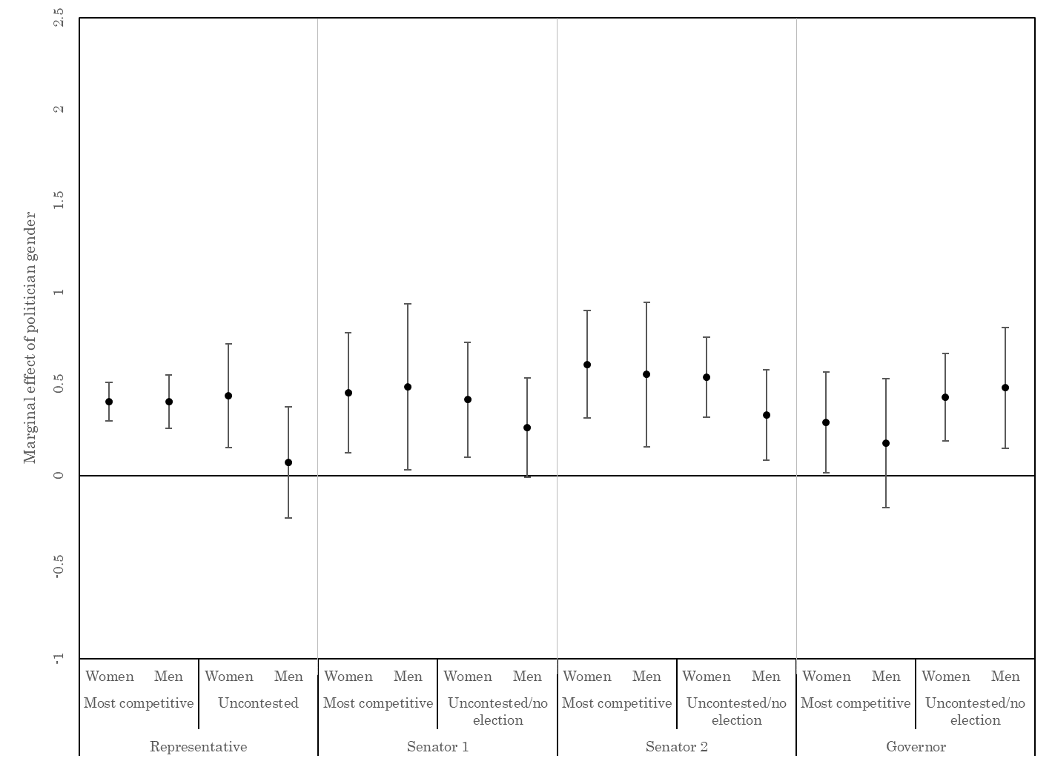

Marginal effects based on the models reported in Table A4. The moderator is set at the minimum and maximum levels of campaign competitiveness.

|  |  |  |  |  |
| --- | --- | --- | --- | --- |
| **Table A5: Descriptive Representation and Women-Friendliness of the District, Officeholder Knowledge** | | | | |
|  | Knowledge, party of rep. | Knowledge, party of Senator 1 | Knowledge, party of Senator 2 | Knowledge, party of governor |
| Female respondent | -0.765* | -1.041* | -0.983* | -0.997* |
|  | (0.037) | (0.055) | (0.051) | (0.052) |
| Female elected official | 0.560* | 0.323* | 0.527* | 0.047 |
|  | (0.118) | (0.123) | (0.120) | (0.156) |
| Female × Female elected official | -0.144 | 0.150 | 0.146 | 0.093 |
|  | (0.099) | (0.122) | (0.113) | (0.146) |
| Women-friendliness of district | -0.801* | 0.530 | 0.681* | -0.269 |
|  | (0.238) | (0.298) | (0.298) | (0.329) |
| Female × women-friendliness of district | 0.908* | 1.022* | 1.263* | 1.607* |
|  | (0.230) | (0.279) | (0.290) | (0.317) |
| Female off. × women-friendliness of district | -0.907 | -0.001 | -0.727 | 2.106* |
|  | (0.518) | (0.477) | (0.501) | (0.819) |
| Female × female off. × women-friendliness | 0.751 | -0.149 | -0.081 | -0.142 |
|  | (0.465) | (0.549) | (0.487) | (0.800) |
| Education | 1.401* | 1.578* | 1.575* | 1.703* |
|  | (0.034) | (0.047) | (0.040) | (0.049) |
| Strength of partisanship | 0.294* | 0.311* | 0.292* | 0.358* |
|  | (0.008) | (0.011) | (0.010) | (0.012) |
| Household income | 1.160* | 1.264* | 1.222* | 1.378* |
|  | (0.034) | (0.045) | (0.042) | (0.054) |
| Nonwhite | -0.285* | -0.339* | -0.319* | -0.309* |
|  | (0.024) | (0.023) | (0.027) | (0.030) |
| Age | 0.038* | 0.004* | 0.037* | 0.036* |
|  | (0.001) | (0.001) | (0.001) | (0.001) |
| Elected official's tenure in office | 0.007* | 0.021* | 0.012 | 0.035 |
|  | (0.002) | (0.004) | (0.007) | (0.018) |
| Competitiveness of campaign | 0.02 | 0.619* | 0.652* | 0.135 |
|  | (0.056) | (0.104) | (0.091) | (0.081) |
| Constant | -2.235* | -2.454* | -2.291* | -1.792* |
|  | (0.073) | (0.118) | (0.089) | (0.108) |
| *Variance components* |  |  |  |  |
| Variance, intercept | 0.586* | 0.468* | 0.384* | 0.350* |
|  | (0.026) | (0.136) | (0.047) | (0.045) |
| Variance, gender | 0.411* | 0.154* | 0.109* | 0.148* |
|  | (0.023) | (0.035) | (0.022) | (0.023) |
| Covariance, gender and constant | -0.311* | -0.148* | -0.092* | -0.105* |
|  | (0.020) | (0.059) | (0.029) | (0.029) |
|  |  |  |  |  |
| N (number of district-years) | 198,576 (2165) | 199,882 (250) | 199,918 (250) | 200,189 (250) |
| Multilevel logit estimates. Standard errors in parentheses. * p<0.05 | | | | |

**Figure A4: Marginal Effects of the Gender of the Elected Official, by Respondent Gender and Women-Friendliness of the District**

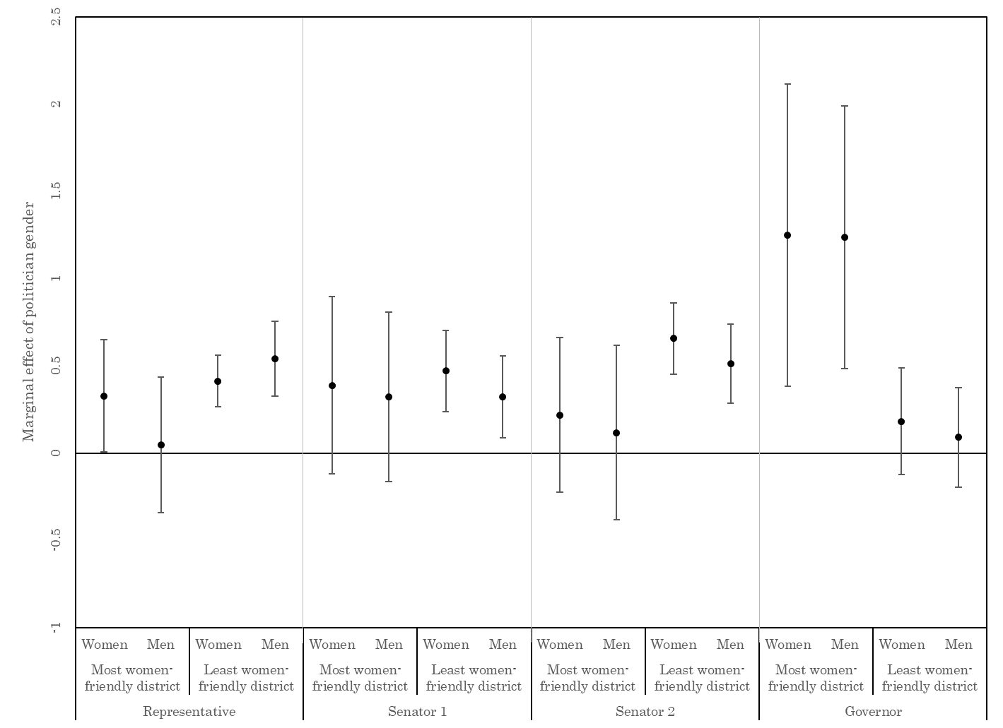

Marginal effects are based on the models reported in Table A5. The moderator is set at the minimum and maximum levels of district women-friendliness.

|  |  |  |
| --- | --- | --- |
| **Table A6: Descriptive Representation and Women-Friendliness of the District, State Legislative Knowledge** | | |
|  | Knowledge, partisan control of statehouse | Knowledge, partisan control of state senate |
| Female respondent | -0.808* | -0.571* |
|  | (0.155) | (0.154) |
| Percent female state legislature | 0.485 | 2.235* |
|  | (0.844) | (1.076) |
| Female × Percent female state leg. | -0.212 | -0.901 |
|  | (0.672) | (0.661) |
| Women-friendliness of district | -1.311 | -0.020 |
|  | (0.967) | (1.024) |
| Female × women-friendliness of district | 1.313 | -0.525 |
|  | (1.016) | (1.026) |
| Pct. female st. leg. × women-friendliness of district | 4.048 | -0.785 |
|  | (3.577) | (3.788) |
| Female × % female st. leg. × women-friendliness | -2.653 | 4.083 |
|  | (4.132) | (4.087) |
| Education | 1.234* | 1.192* |
|  | (0.041) | (0.048) |
| Strength of partisanship | 0.204* | 0.200* |
|  | (0.008) | (0.009) |
| Household income | 0.967* | 0.979* |
|  | (0.036) | (0.035) |
| Nonwhite | -0.231* | -0.161* |
|  | (0.025) | (0.027) |
| Age | 0.014* | 0.016* |
|  | (0.001) | (0.001) |
| Competitiveness of campaign | 0.320* | 0.316* |
|  | (0.093) | (0.113) |
| Constant | -1.892* | -2.383* |
|  | (0.211) | (0.295) |
| *Variance components* |  |  |
| Variance, intercept | 0.389* | 0.398* |
|  | (0.049) | (0.053) |
| Variance, gender | 0.041* | 0.051* |
|  | (0.010) | (0.011) |
| Covariance, gender and constant | -0.032 | 0.028 |
|  | (0.019) | (0.068) |
|  |  |  |
| N  (number of district-years) | 167,929 (196) | 168,111  (196) |
| Multilevel logit estimates. Standard errors in parentheses. * p<0.05 | | |

**Figure A5:** **Marginal Effects of the Percent Female State Legislators, by Respondent Gender and Women-Friendliness of the District**

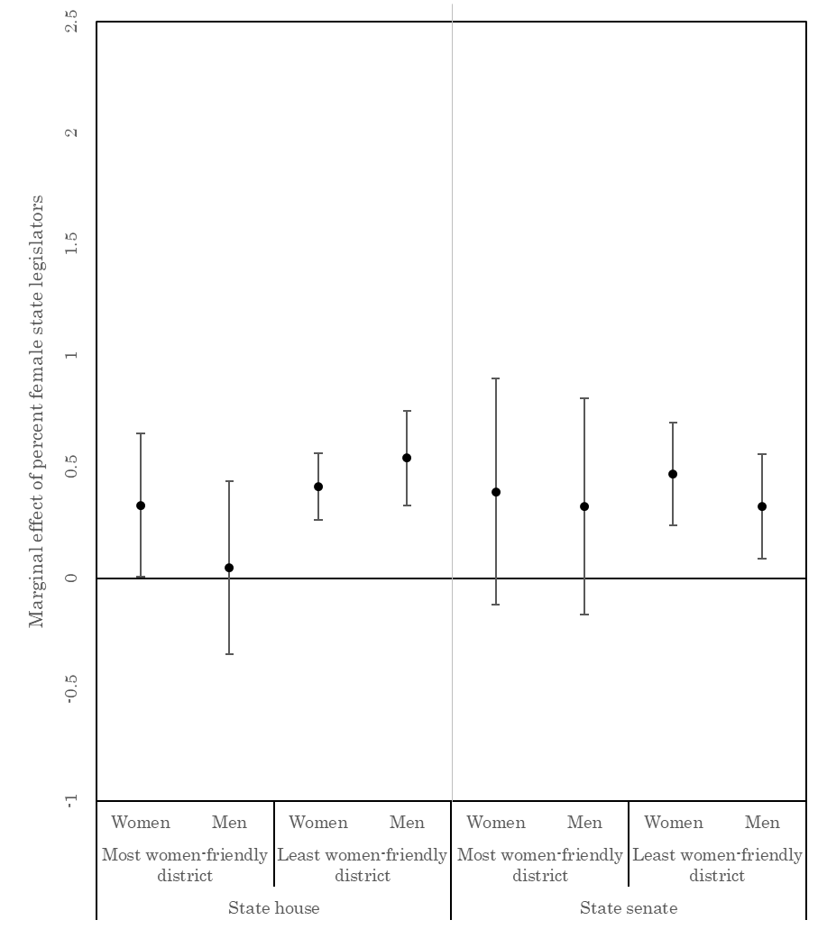

Marginal effects based on estimates reported in Table A6. The moderator is set at the minimum and maximum levels of district women-friendliness.

|  |  |  |  |
| --- | --- | --- | --- |
| **Table A7: Descriptive Representation and District Women-Friendliness, Political Engagement** | | | |
|  | Attention to politics | Voter turnout | Campaign participation | |
| Female respondent | -0.847* | -0.367* | -0.279* | |
|  | (0.052) | (0.058) | (0.033) | |
| Index of women's representation | -0.012 | 0.093* | 0.001 | |
|  | (0.020) | (0.036) | (0.013) | |
| Female × Index of women's representation | 0.039 | 0.000 | 0.007 | |
|  | (0.024) | (0.027) | (0.015) | |
| Women-friendliness of district | -0.784* | 0.348 | -0.671* | |
|  | (0.260) | (0.455) | (0.171) | |
| Female × women-friendliness of district | 0.701* | 0.908* | 0.107 | |
|  | (0.305) | (0.365) | (0.201) | |
| Index of women's rep. × women-friendliness of district | 0.156 | -0.149 | 0.045 | |
|  | (0.092) | (0.156) | (0.057) | |
| Female × index of women's rep. × women-friendliness | -0.191 | -0.033 | 0.001 | |
|  | (0.115) | (0.134) | (0.069) | |
| Education | 1.395* | 1.177* | 0.848* | |
|  | (0.032) | (0.039) | (0.023) | |
| Strength of partisanship | 0.296* | 0.336* | 0.207* | |
|  | (0.008) | (0.010) | (0.006) | |
| Household income | 0.976* | 1.046* | 0.840* | |
|  | (0.033) | (0.041) | (0.024) | |
| Nonwhite | -0.391* | -0.345* | 0.021 | |
|  | (0.021) | (0.026) | (0.016) | |
| Age | 0.037* | 0.038* | 0.012* | |
|  | (0.001) | (0.001) | (0.000) | |
| Competitiveness of House race | -0.100* | 0.165* | 0.007 | |
|  | (0.033) | (0.084) | (0.029) | |
| Competitiveness of Senate race | -0.011 | -0.045 | 0.009 | |
|  | (0.019) | (0.047) | (0.019) | |
| Competitiveness of gubernatorial race | -0.004 | -0.370* | -0.188* | |
|  | (0.018) | (0.048) | (0.017) | |
| Constant | --- | -2.426* | -2.056* | |
|  |  | (0.114) | (0.052) | |
| Cutpoint 1 | -0.508* |  | --- | |
|  | (0.070) |  |  | |
| Cutpoint 2 | 0.927* | --- | --- | |
|  | (0.070) |  |  | |
| Cutpoint 3 | 2.579* | --- | --- | |
|  | (0.071) |  |  | |
| *Variance components* |  |  |  | |
| Variance, intercept | 0.264* | 1.279* | 0.124* | |
|  | (0.014) | (0.100) | (0.006) | |
| Variance, gender | 0.328* | 0.523* | 0.110* | |
|  | (0.019) | (0.032) | (0.008) | |
| Covariance, gender and constant | -0.243* | -0.391* | -0.064* | |
|  | (0.015) | (0.034) | (0.006) | |
|  |  |  |  | |
| N (number of districts) | 167,329 (1740) | 159,835 (2164) | 143,997 (1740) | |
| First column, multilevel ordered logit, second column, multilevel logit, third column, multilevel negative binomial estimates. Standard errors in parentheses. * p<0.05 | | | |

**Figure A6: Marginal Effects of the Count of Female Politicians, by Respondent Gender and the Women-Friendliness of the District**

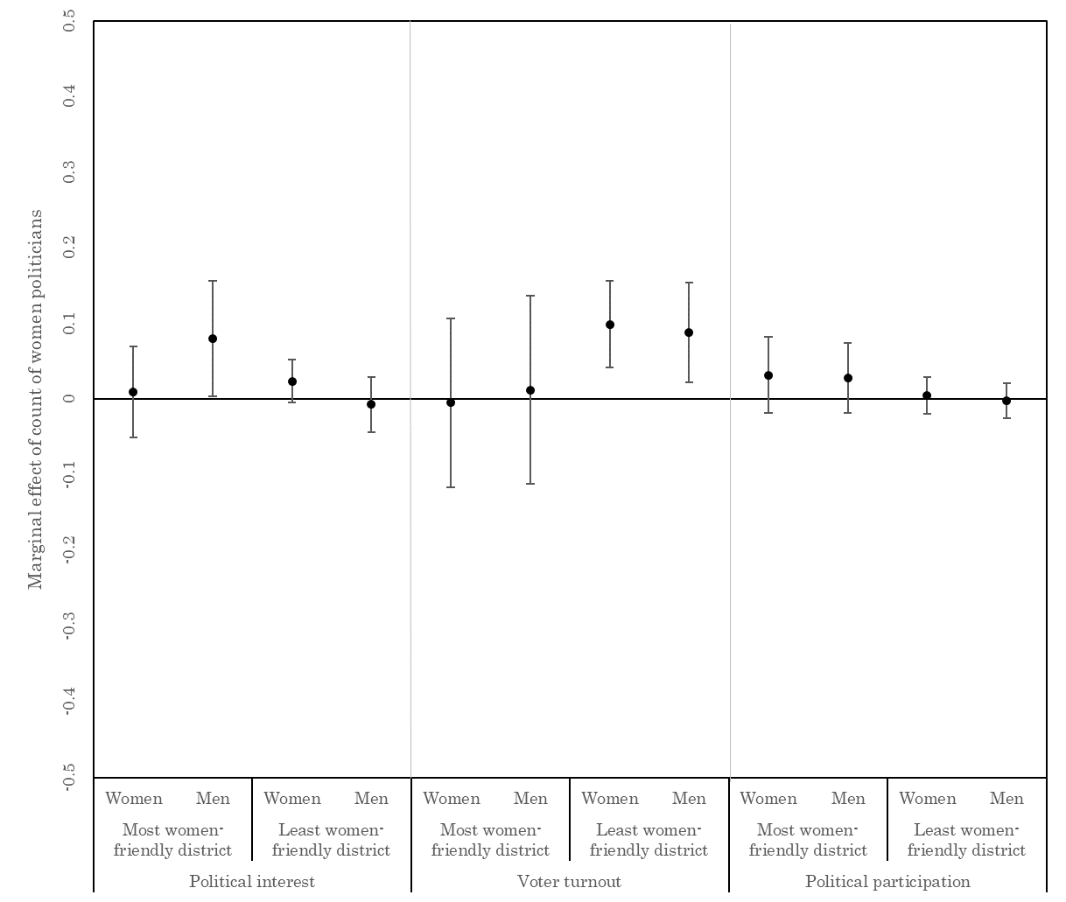

Marginal effects based on the models reported in Table A7. The moderator is set at the minimum and maximum levels of district women-friendliness.

|  |  |  |  |
| --- | --- | --- | --- |
| **Table A8: Women Candidates and Officeholders Indices and Campaign Engagement** | | | |
|  | Attention to politics | Voter turnout | Campaign participation | |
| Female respondent | -0.743* | -0.254* | -0.266* | |
|  | (0.025) | (0.030) | (0.017) | |
| Number of women candidates | -0.013 | 0.066 | -0.010 | |
|  | (0.020) | (0.039) | (0.013) | |
| Female × Number of women candidates | 0.022 | -0.009 | 0.003 | |
|  | (0.022) | (0.028) | (0.015) | |
| Number of women officeholders | 0.044* | 0.043 | 0.029* | |
|  | (0.018) | (0.032) | (0.013) | |
| Female × Number of women officeholders | -0.008 | 0.029 | 0.015 | |
|  | (0.021) | (0.027) | (0.014) | |
| Education | 1.395* | 1.178* | 0.848* | |
|  | (0.032) | (0.039) | (0.023) | |
| Strength of partisanship | 0.296* | 0.336* | 0.207* | |
|  | (0.008) | (0.010) | (0.006) | |
| Household income | 0.976* | 1.046* | 0.839* | |
|  | (0.033) | (0.041) | (0.024) | |
| Nonwhite | -0.391* | -0.344* | 0.021 | |
|  | (0.021) | (0.026) | (0.016) | |
| Age | 0.037* | 0.038* | 0.012* | |
|  | (0.001) | (0.001) | 0.000 | |
| Competitiveness of House race | -0.098* | 0.169* | 0.009 | |
|  | (0.033) | (0.084) | (0.028) | |
| Competitiveness of Senate race | 0.002 | -0.044 | 0.025 | |
|  | (0.021) | (0.050) | (0.020) | |
| Competitiveness of gubernatorial race | -0.001 | -0.366* | -0.185* | |
|  | (0.018) | (0.049) | (0.017) | |
| Women-friendliness of district | -0.278* | 0.566* | -0.539* | |
|  | (0.110) | (0.267) | (0.095) | |
| Constant | --- | -2.450* | -2.090* | |
|  |  | (0.103) | (0.047) | |
| Cutpoint 1 | -0.418* | --- | --- | |
|  | (0.057) |  |  | |
| Cutpoint 2 | 1.017* | --- | --- | |
|  | (0.057) |  |  | |
| Cutpoint 3 | 2.669* | --- | --- | |
|  | (0.058) |  |  | |
| *Variance components* |  |  |  | |
| Variance, intercept | 0.263* | 1.283* | 0.123* | |
|  | (0.014) | (0.100) | (0.006) | |
| Variance, gender | 0.329* | 0.532* | 0.110* | |
|  | (0.019) | (0.032) | (0.008) | |
| Covariance, gender and constant | -0.244* | -0.396* | -0.064* | |
|  | (0.015) | (0.035) | (0.006) | |
|  |  |  |  | |
| N (number of district-years) | 167,329  (1740) | 159,835 (2164) | 143,997  (1740) | |
| First column, multilevel ordered logit, second column, multilevel logit, third column, multilevel negative binomial estimates. Standard errors in parentheses. * p<0.05 | | | | |

|  |  |  |  |
| --- | --- | --- | --- |
| **Table A9: Women Candidates and Officeholders and Campaign Engagement** | | | |
|  | Follows politics | Voter turnout | Campaign participation |
| Female respondent | -0.866* | -0.370* | -0.355* |
|  | (0.074) | (0.086) | (0.049) |
| Female representative | 0.062 | -0.029 | 0.090* |
|  | (0.046) | (0.083) | (0.031) |
| Female × female representative | -0.033 | 0.088 | -0.037 |
|  | (0.053) | (0.064) | (0.035) |
| Number of female Senators | 0.060* | 0.041 | 0.029 |
|  | (0.023) | (0.039) | (0.015) |
| Female × female Senators | -0.022 | 0.010 | 0.006 |
|  | (0.026) | (0.032) | (0.017) |
| Number of female House and Senate candidates | -0.041 | 0.061 | -0.049* |
|  | (0.026) | (0.048) | (0.016) |
| Female × female House and Senate candidates | 0.030 | 0.022 | 0.016 |
|  | (0.028) | (0.034) | (0.018) |
| Female governor | 0.034 | -0.041 | -0.005 |
|  | (0.051) | (0.092) | (0.034) |
| Female × female governor | 0.010 | -0.113 | 0.046 |
|  | (0.062) | (0.068) | (0.038) |
| Number of female gubernatorial candidates | 0.110* | 0.123 | 0.136* |
|  | (0.044) | (0.092) | (0.031) |
| Female × number of female gub. candidates | -0.005 | -0.193* | -0.022 |
|  | (0.051) | (0.058) | (0.033) |
| Percent female state legislators | -0.318 | 1.819* | 0.204 |
|  | (0.274) | (0.485) | (0.195) |
| Female × percent female state legislators | 0.554 | 0.575 | 0.391 |
|  | (0.308) | (0.370) | (0.205) |
| Education | 1.395* | 1.177* | 0.848* |
|  | (0.032) | (0.039) | (0.023) |
| Strength of partisanship | 0.296* | 0.337* | 0.207* |
|  | (0.008) | (0.010) | (0.006) |
| Household income | 0.975* | 1.045* | 0.838* |
|  | (0.033) | (0.041) | (0.024) |
| Nonwhite | -0.391* | -0.344* | 0.021 |
|  | (0.022) | (0.026) | (0.016) |
| Age | 0.037* | 0.038* | 0.012* |
|  | (0.001) | (0.001) | (0.000) |
| Competitiveness of House race | -0.086* | 0.126 | 0.015 |
|  | (0.034) | (0.085) | (0.029) |
| Competitiveness of Senate race | 0.002 | -0.051 | 0.026 |
|  | (0.021) | (0.051) | (0.020) |
| Competitiveness of gubernatorial race | -0.031 | -0.375* | -0.228* |
|  | (0.020) | (0.051) | (0.019) |
| Women-friendliness of district | -0.237* | 0.170 | -0.561* |
|  | (0.120) | (0.284) | (0.101) |
| Constant | --- | -2.758* | -2.120* |
|  |  | (0.132) | (0.062) |
| Cutpoint 1 | -0.485* | --- | --- |
|  | (0.080) |  |  |
| Cutpoint 2 | 0.950* | --- | --- |
|  | (0.080) |  |  |
| Cutpoint 3 | 2.602* | --- | --- |
|  | (0.081) |  |  |
| *Variance components* |  |  |  |
| Variance, intercept | 0.262* | 1.267* | 0.121* |
|  | (0.014) | (0.099) | (0.006) |
| Variance, gender | 0.328* | 0.521* | 0.109* |
|  | (0.019) | (0.032) | (0.008) |
| Covariance, gender and constant | -0.243* | -0.391* | -0.065* |
|  | (0.015) | (0.034) | (0.006) |
|  |  |  |  |
| N  (number of district-years) | 167,329 (1740) | 159,835 (2164) | 143,997 (1740) |
| First column, multilevel ordered logit, second column, multilevel logit, third column, multilevel negative binomial estimates. Standard errors in parentheses. * p<0.05 | | | |

|  |  |  |  |  |  |
| --- | --- | --- | --- | --- | --- |
| **Table A10: Correct Identification of Representative's Partisanship, by Year** | | | | |  |
|  | 2006 | 2008 | 2010 | 2012 | 2014 |
| Female respondent | -0.826* | -0.773* | -0.789* | -0.326* | -0.513* |
|  | (0.036) | (0.044) | (0.049) | (0.045) | (0.039) |
| Female representative | 0.401* | 0.255* | 0.118 | 0.435* | 0.351* |
|  | (0.123) | (0.124) | (0.137) | (0.134) | (0.098) |
| Female × Female representative | 0.057 | 0.067 | 0.273* | -0.037 | 0.021 |
|  | (0.103) | (0.111) | (0.122) | (0.133) | (0.102) |
| Education | 1.430* | 1.363* | 1.385* | 1.453* | 1.400* |
|  | (0.071) | (0.074) | (0.076) | (0.077) | (0.067) |
| Strength of partisanship | 0.314* | 0.334* | 0.311* | 0.301* | 0.235* |
|  | (0.016) | (0.018) | (0.019) | (0.020) | (0.017) |
| Household income | 1.082* | 1.161* | 1.265* | 1.210* | 1.017* |
|  | (0.072) | (0.074) | (0.074) | (0.076) | (0.070) |
| Nonwhite | -0.310* | -0.250* | -0.408* | -0.288* | -0.175* |
|  | (0.047) | (0.054) | (0.051) | (0.051) | (0.053) |
| Age | 0.037* | 0.033* | 0.045* | 0.033* | 0.040* |
|  | (0.001) | (0.001) | (0.002) | (0.001) | (0.001) |
| Member's tenure in office | 0.008* | 0.004 | 0.005 | 0.009* | 0.010* |
|  | (0.003) | (0.003) | (0.003) | (0.003) | (0.003) |
| Competitiveness of congressional race | 0.201* | 0.056 | 0.289* | -0.098 | 0.077 |
|  | (0.094) | (0.103) | (0.113) | (0.114) | (0.079) |
| Women-friendliness of district | 0.366 | 0.147 | 0.747* | -0.760* | -0.46 |
|  | (0.345) | (0.394) | (0.380) | (0.364) | (0.329) |
| Constant | -2.140* | -2.210* | -2.855* | -2.353* | -2.413* |
|  | (0.136) | (0.141) | (0.143) | (0.153) | (0.119) |
| *Variance components* |  |  |  |  |  |
| Variance, intercept | 0.396* | 0.515* | 0.703* | 0.573* | 0.468* |
|  | (0.054) | (0.057) | (0.067) | (0.052) | (0.045) |
| Variance, gender | 0.111* | 0.306* | 0.589* | 0.512* | 0.331* |
|  | (0.035) | (0.055) | (0.063) | (0.059) | (0.040) |
| Covariance, gender and constant | -0.126* | -0.238* | -0.453* | -0.320* | -0.226* |
|  | (0.034) | (0.045) | (0.056) | (0.045) | (0.036) |
|  |  |  |  |  |  |
| N | 30,715 | 29,582 | 46,651 | 44,936 | 46,692 |
| Multilevel logit estimates. Standard errors in parentheses. * p<0.05 | | | | | |

|  |  |  |  |  |  |
| --- | --- | --- | --- | --- | --- |
| **Table A11: Correct Identification of First Senator's Partisanship, by Year** | | | | | |
|  | 2006 | 2008 | 2010 | 2012 | 2014 |
| Female respondent | -1.235* | -1.044* | -0.837* | -0.596* | -0.609* |
|  | (0.038) | (0.069) | (0.068) | (0.060) | (0.057) |
| Senator is female | 0.399* | 0.303 | 0.347 | 0.227 | 0.476* |
|  | (0.171) | (0.223) | (0.309) | (0.150) | (0.176) |
| Female × Female senator | 0.171 | 0.285* | -0.062 | 0.202 | 0.177 |
|  | (0.100) | (0.121) | (0.166) | (0.153) | (0.113) |
| Education | 1.937* | 1.515* | 1.461* | 1.592* | 1.548* |
|  | (0.117) | (0.097) | (0.134) | (0.070) | (0.079) |
| Strength of partisanship | 0.373* | 0.358* | 0.312* | 0.330* | 0.234* |
|  | (0.024) | (0.025) | (0.029) | (0.021) | (0.016) |
| Household income | 1.379* | 1.485* | 1.286* | 1.238* | 1.086* |
|  | (0.085) | (0.115) | (0.108) | (0.096) | (0.074) |
| Nonwhite | -0.433* | -0.209* | -0.441* | -0.353* | -0.286* |
|  | (0.068) | (0.060) | (0.044) | (0.039) | (0.043) |
| Age | 0.043* | 0.041* | 0.038* | 0.034* | 0.041* |
|  | (0.001) | (0.001) | (0.002) | (0.002) | (0.002) |
| Senator's tenure in office | 0.016* | 0.025* | 0.014 | 0.019* | 0.016* |
|  | (0.005) | (0.010) | (0.014) | (0.008) | (0.008) |
| Competitiveness of Senate race | 0.628* | 0.680* | 0.642 | 0.549* | 0.660* |
|  | (0.178) | (0.202) | (0.454) | (0.169) | (0.174) |
| Women-friendliness of district | 2.133* | 1.186* | 1.371* | 0.840* | 0.631* |
|  | (0.406) | (0.333) | (0.472) | (0.326) | (0.306) |
| Constant | -2.455* | -2.785* | -2.395* | -2.754* | -2.450* |
|  | (0.130) | (0.279) | (0.220) | (0.179) | (0.185) |
| *Variance components* |  |  |  |  |  |
| Variance, intercept | 0.163* | 0.470* | 0.915* | 0.234* | 0.257* |
|  | (0.047) | (0.208) | (0.461) | (0.051) | (0.052) |
| Variance, gender | 0.000 | -0.087 | -0.212 | -0.056 | -0.015 |
|  | (0.000) | (0.062) | (0.147) | (0.033) | (0.034) |
| Covariance, gender and constant | 0.000 | 0.048 | 0.101 | 0.103* | 0.052* |
|  | (0.000) | (0.027) | (0.054) | (0.037) | (0.017) |
|  |  |  |  |  |  |
| N | 30,728 | 29,740 | 46,866 | 45,472 | 47,076 |
| Multilevel logit estimates. Standard errors in parentheses. * p<0.05 | | | | | |

|  |  |  |  |  |  |
| --- | --- | --- | --- | --- | --- |
| **Table A12: Correct Identification of Second Senator's Partisanship, by Year** | | | | | |
|  | 2006 | 2008 | 2010 | 2012 | 2014 |
| Female respondent | -1.092* | -0.890* | -0.958* | -0.488* | -0.660* |
|  | (0.057) | (0.056) | (0.083) | (0.052) | (0.054) |
| Senator is female | 0.437* | 0.640* | 0.134 | -0.032 | 0.474* |
|  | (0.202) | (0.249) | (0.185) | (0.132) | (0.158) |
| Female × Female senator | 0.059 | 0.121 | 0.211 | 0.227* | 0.057 |
|  | (0.113) | (0.105) | (0.180) | (0.109) | (0.109) |
| Education | 2.003* | 1.457* | 1.566* | 1.549* | 1.546* |
|  | (0.116) | (0.083) | (0.117) | (0.066) | (0.067) |
| Strength of partisanship | 0.372* | 0.327* | 0.314* | 0.289* | 0.218* |
|  | (0.030) | (0.021) | (0.018) | (0.021) | (0.017) |
| Household income | 1.283* | 1.382* | 1.323* | 1.188* | 1.029* |
|  | (0.091) | (0.068) | (0.093) | (0.090) | (0.086) |
| Nonwhite | -0.403* | -0.267* | -0.417* | -0.304* | -0.254* |
|  | (0.057) | (0.047) | (0.065) | (0.050) | (0.052) |
| Age | 0.039* | 0.033* | 0.046* | 0.031* | 0.038* |
|  | (0.002) | (0.002) | (0.002) | (0.002) | (0.002) |
| Senator's tenure in office | 0.004 | 0.009 | 0.006 | 0.032* | 0.007 |
|  | (0.018) | (0.014) | (0.011) | (0.007) | (0.006) |
| Competitiveness of Senate race | 0.760* | 0.633* | 0.421* | 0.839* | 0.595* |
|  | (0.287) | (0.234) | (0.172) | (0.236) | (0.188) |
| Women-friendliness of district | 2.655* | 1.023* | 1.661* | 0.700 | 0.539 |
|  | (0.450) | (0.273) | (0.405) | (0.451) | (0.352) |
| Constant | -2.275* | -2.202* | -2.748* | -2.507* | -2.256* |
|  | (0.163) | (0.159) | (0.232) | (0.155) | (0.152) |
| *Variance components* |  |  |  |  |  |
| Variance, intercept | 0.382 | 0.373* | 0.285* | 0.220* | 0.239* |
|  | (0.205) | (0.116) | (0.127) | (0.056) | (0.069) |
| Variance, gender | 0.057 | 0.031 | 0.114 | 0.068* | 0.044 |
|  | (0.041) | (0.020) | (0.059) | (0.031) | (0.022) |
| Covariance, gender and constant | -0.059 | 0.019 | -0.093 | -0.041 | -0.035 |
|  | (0.098) | (0.044) | (0.080) | (0.034) | (0.037) |
|  |  |  |  |  |  |
| N | 30,745 | 29,737 | 46,873 | 45,477 | 47,086 |
| Multilevel logit estimates. Standard errors in parentheses. * p<0.05 | | | | | |

|  |  |  |  |  |  |
| --- | --- | --- | --- | --- | --- |
| **Table A13: Correct Identification of Governor’s Partisanship, by Year** | | | | | |
|  | 2006 | 2008 | 2010 | 2012 | 2014 |
| Female respondent | -1.174* | -0.979* | -0.757* | -0.426* | -0.561* |
|  | (0.060) | (0.070) | (0.078) | (0.060) | (0.045) |
| Female governor | 0.117 | 0.418 | -0.039 | 0.452* | 0.232 |
|  | (0.211) | (0.329) | (0.165) | (0.134) | (0.182) |
| Female × Female governor | 0.074 | -0.015 | 0.111 | -0.039 | -0.061 |
|  | (0.157) | (0.114) | (0.182) | (0.092) | (0.126) |
| Education | 2.260* | 1.695* | 1.706* | 1.591* | 1.671* |
|  | (0.111) | (0.084) | (0.131) | (0.085) | (0.089) |
| Strength of partisanship | 0.467* | 0.400* | 0.351* | 0.336* | 0.311* |
|  | (0.027) | (0.022) | (0.039) | (0.021) | (0.018) |
| Household income | 1.540* | 1.620* | 1.428* | 1.460* | 1.002* |
|  | (0.080) | (0.093) | (0.116) | (0.108) | (0.088) |
| Nonwhite | -0.492* | -0.163* | -0.338* | -0.288* | -0.352* |
|  | (0.066) | (0.067) | (0.071) | (0.067) | (0.044) |
| Age | 0.033* | 0.033* | 0.038* | 0.030* | 0.041* |
|  | (0.002) | (0.002) | (0.002) | (0.002) | (0.002) |
| Governor's tenure in office | -0.060* | -0.007 | 0.057 | 0.070* | 0.048 |
|  | (0.025) | (0.042) | (0.030) | (0.012) | (0.029) |
| Competitiveness of gubernatorial race | 0.446* | 0.163 | 0.159 | -0.219 | 0.539* |
|  | (0.147) | (0.241) | (0.172) | (0.137) | (0.176) |
| Women-friendliness of district | 1.762* | 0.985* | 1.572* | 0.583 | -0.133 |
|  | (0.419) | (0.378) | (0.389) | (0.410) | (0.416) |
| Constant | -1.529* | -1.775* | -2.389* | -2.029* | -2.293* |
|  | (0.159) | (0.215) | (0.238) | (0.149) | (0.168) |
| *Variance components* |  |  |  |  |  |
| Variance, intercept | 0.116* | 0.406* | 0.320* | 0.160* | 0.253 |
|  | (0.037) | (0.109) | (0.071) | (0.038) | (0.135) |
| Variance, gender | 0.051* | 0.06 | 0.161* | 0.105* | 0.044* |
|  | (0.022) | (0.038) | (0.044) | (0.033) | (0.015) |
| Covariance, gender and constant | 0.006 | -0.094 | -0.124* | 0.006 | 0.017 |
|  | (0.026) | (0.063) | (0.043) | (0.021) | (0.032) |
|  |  |  |  |  |  |
| N | 30.758 | 29.764 | 46.970 | 45.528 | 47.169 |
| Multilevel logit estimates. Standard errors in parentheses. * p<0.05 | | | | | |

|  |  |  |  |  |
| --- | --- | --- | --- | --- |
| **Table A14: Descriptive Representation and Knowledge of Party Control of State House, by Year** | | | | |
|  | 2008 | 2010 | 2012 | 2014 |
| Female respondent | -0.636* | -0.748* | -0.501* | -0.924* |
|  | (0.181) | (0.174) | (0.193) | (0.123) |
| Percent female state legislators | 2.870* | 2.351 | -0.609 | -1.253 |
|  | (1.284) | (1.489) | (1.463) | (0.995) |
| Female × Percent female state legislators | -1.118 | -0.207 | -0.595 | 0.811 |
|  | (0.675) | (0.671) | (0.706) | (0.505) |
| Education | 1.159* | 1.100* | 1.307* | 1.337* |
|  | (0.082) | (0.065) | (0.066) | (0.094) |
| Strength of partisanship | 0.179* | 0.235* | 0.209* | 0.183* |
|  | (0.016) | (0.017) | (0.015) | (0.014) |
| Household income | 0.926* | 1.072* | 0.899* | 0.962* |
|  | (0.062) | (0.065) | (0.068) | (0.074) |
| Nonwhite | -0.154* | -0.304* | -0.170* | -0.265* |
|  | (0.044) | (0.045) | (0.048) | (0.047) |
| Age | 0.014* | 0.017* | 0.012* | 0.013* |
|  | (0.001) | (0.002) | (0.002) | (0.002) |
| Competitiveness of gubernatorial race | -0.331 | 0.594* | 0.14 | 0.295 |
|  | (0.292) | (0.203) | (0.170) | (0.179) |
| Women-friendliness of district | 0.247 | 0.069 | -0.158 | 0.034 |
|  | (0.183) | (0.314) | (0.228) | (0.321) |
| Constant | -2.367* | -2.794* | -1.589* | -1.288* |
|  | (0.340) | (0.391) | (0.351) | (0.290) |
| *Variance components* |  |  |  |  |
| Variance, intercept | 0.494* | 0.352* | 0.344* | 0.267* |
|  | (0.146) | (0.094) | (0.091) | (0.054) |
| Variance, gender | 0.013 | 0.032* | 0.040* | 0.030* |
|  | (0.015) | (0.014) | (0.020) | (0.013) |
| Covariance, gender and constant | -0.064 | -0.063 | -0.009 | -0.005 |
|  | (0.047) | (0.034) | (0.026) | (0.022) |
|  |  |  |  |  |
| N | 29.340 | 46.763 | 45.023 | 46.803 |
| Multilevel logit estimates. Standard errors in parentheses. * p<0.05 | | | | |

|  |  |  |  |  |
| --- | --- | --- | --- | --- |
| **Table A15: Descriptive Representation and Knowledge of Party Control of State Senate, by Year** | | | | |
|  | 2008 | 2010 | 2012 | 2014 |
| Female respondent | -0.665* | -0.682* | -0.488* | -0.921* |
|  | (0.179) | (0.177) | (0.146) | (0.157) |
| Percent female state legislators | 4.399* | 2.878 | 0.386 | -0.235 |
|  | (1.632) | (1.504) | (1.360) | (1.354) |
| Female × Percent female state legislators | -0.827 | -0.293 | -0.418 | 0.895 |
|  | (0.691) | (0.679) | (0.575) | (0.529) |
| Education | 1.096* | 1.097* | 1.304* | 1.227* |
|  | (0.092) | (0.065) | (0.063) | (0.134) |
| Strength of partisanship | 0.190* | 0.227* | 0.206* | 0.175* |
|  | (0.016) | (0.019) | (0.017) | (0.014) |
| Household income | 0.955* | 1.079* | 0.936* | 0.949* |
|  | (0.057) | (0.055) | (0.070) | (0.077) |
| Nonwhite | -0.089 | -0.278* | -0.081 | -0.170* |
|  | (0.046) | (0.044) | (0.044) | (0.062) |
| Age | 0.016* | 0.018* | 0.014* | 0.016* |
|  | (0.002) | (0.002) | (0.001) | (0.002) |
| Competitiveness of gubernatorial race | -0.045 | 0.393 | 0.163 | 0.188 |
|  | (0.255) | (0.422) | (0.212) | (0.226) |
| Women-friendliness of district | 0.013 | 0.129 | -0.106 | 0.063 |
|  | (0.188) | (0.310) | (0.342) | (0.259) |
| Constant | -2.799* | -2.686* | -1.912* | -1.599* |
|  | (0.436) | (0.420) | (0.335) | (0.386) |
| *Variance components* |  |  |  |  |
| Variance, intercept | 0.676* | 0.394* | 0.318* | 0.361* |
|  | (0.173) | (0.120) | (0.066) | (0.087) |
| Variance, gender | 0.034 | 0.038 | 0.028* | 0.044* |
|  | (0.023) | (0.035) | (0.012) | (0.021) |
| Covariance, gender and constant | -0.119 | 0.036 | 0.007 | -0.044 |
|  | (0.063) | (0.065) | (0.029) | (0.047) |
|  |  |  |  |  |
| N | 29.363 | 46.807 | 45.045 | 46.896 |
| Multilevel logit estimates. Standard errors in parentheses. * p<0.05 | | | | |

|  |  |  |  |  |
| --- | --- | --- | --- | --- |
| **Table A16: Descriptive Representation and Following Politics, by Year** | | | | |
|  | 2008 | 2010 | 2012 | 2014 |
| Female respondent | -0.953* | -0.794* | -0.406* | -0.816* |
|  | (0.045) | (0.049) | (0.050) | (0.050) |
| Index of women's representation | 0.003 | 0.008 | 0.035 | 0.044* |
|  | (0.022) | (0.015) | (0.021) | (0.018) |
| Female × index of women's representation | 0.020 | 0.035 | -0.048* | -0.010 |
|  | (0.024) | (0.019) | (0.023) | (0.025) |
| Education | 1.190* | 1.249* | 1.562* | 1.569* |
|  | (0.066) | (0.063) | (0.064) | (0.056) |
| Strength of partisanship | 0.337* | 0.300* | 0.330* | 0.223* |
|  | (0.016) | (0.017) | (0.017) | (0.014) |
| Household income | 1.191* | 1.228* | 0.780* | 0.777* |
|  | (0.068) | (0.069) | (0.065) | (0.056) |
| Nonwhite | -0.251* | -0.559* | -0.320* | -0.394* |
|  | (0.046) | (0.042) | (0.043) | (0.036) |
| Age | 0.030* | 0.050* | 0.026* | 0.040* |
|  | (0.001) | (0.001) | (0.001) | (0.001) |
| Competitiveness of House race | -0.031 | -0.051 | -0.087 | -0.098* |
|  | (0.059) | (0.062) | (0.074) | (0.044) |
| Competitiveness of Senate race | 0.011 | 0.111* | 0.005 | 0.066 |
|  | (0.038) | (0.041) | (0.041) | (0.035) |
| Competitiveness of gubernatorial race | 0.151* | 0.054 | 0.059 | 0.001 |
|  | (0.065) | (0.044) | (0.055) | (0.039) |
| Women-friendliness of district | 0.127 | 0.041 | -0.430 | -0.162 |
|  | (0.231) | (0.206) | (0.243) | (0.169) |
| Cutpoint 1 | -0.822* | 0.429* | -0.516* | -0.406* |
|  | (0.109) | (0.105) | (0.122) | (0.101) |
| Cutpoint 2 | 0.645* | 1.921* | 0.968* | 0.921* |
|  | (0.103) | (0.106) | (0.123) | (0.101) |
| Cutpoint 3 | 2.391* | 3.528* | 2.468* | 2.769* |
|  | (0.104) | (0.109) | (0.126) | (0.104) |
| *Variance components* |  |  |  |  |
| Variance, intercept | 0.171* | 0.236* | 0.262* | 0.182* |
|  | (0.023) | (0.024) | (0.028) | (0.020) |
| Variance, gender | 0.158* | 0.337* | 0.356* | 0.275* |
|  | (0.030) | (0.036) | (0.041) | (0.030) |
| Covariance, gender and constant | -0.135* | -0.238* | -0.249* | -0.182* |
|  | (0.023) | (0.027) | (0.032) | (0.021) |
|  |  |  |  |  |
| N | 29.573 | 46.476 | 44.902 | 46.378 |
| Multilevel ordered logit. Standard errors in parentheses. * p<0.05 | | | | |

|  |  |  |  |  |  |
| --- | --- | --- | --- | --- | --- |
| **Table A17: Descriptive Representation and Voter Turnout, by Year** | | | | | |
|  | 2006 | 2008 | 2010 | 2012 | 2014 |
| Female respondent | -0.255* | 0.087 | -0.654* | -0.045 | -0.369* |
|  | (0.076) | (0.058) | (0.054) | (0.069) | (0.076) |
| Index of women's representation | 0.137 | 0.058 | 0.036 | 0.014 | 0.007 |
|  | (0.074) | (0.040) | (0.019) | (0.028) | (0.032) |
| Female × index of women's representation | 0.003 | -0.034 | 0.037 | 0.028 | 0.039 |
|  | (0.031) | (0.034) | (0.021) | (0.032) | (0.037) |
| Education | 1.234* | 1.172* | 1.173* | 1.186* | 1.351* |
|  | (0.107) | (0.086) | (0.070) | (0.094) | (0.088) |
| Strength of partisanship | 0.282* | 0.411* | 0.352* | 0.348* | 0.261* |
|  | (0.023) | (0.019) | (0.020) | (0.022) | (0.019) |
| Household income | 0.979* | 0.985* | 1.321* | 0.886* | 0.913* |
|  | (0.093) | (0.088) | (0.079) | (0.097) | (0.084) |
| Nonwhite | -0.470* | -0.039 | -0.450* | -0.189* | -0.576* |
|  | (0.062) | (0.055) | (0.047) | (0.064) | (0.055) |
| Age | 0.044* | 0.023* | 0.052* | 0.022* | 0.047* |
|  | (0.002) | (0.001) | (0.001) | (0.002) | (0.002) |
| Competitiveness of House race | 0.858* | 0.059 | 0.065 | 0.142 | 0.297* |
|  | (0.352) | (0.163) | (0.090) | (0.107) | (0.079) |
| Competitiveness of Senate race | -0.255 | -0.158 | 0.450* | 0.091 | 0.266* |
|  | (0.255) | (0.090) | (0.054) | (0.071) | (0.055) |
| Competitiveness of gubernatorial race | 0.449 | 0.178 | 0.353* | 0.214* | 0.478* |
|  | (0.265) | (0.104) | (0.066) | (0.088) | (0.062) |
| Women-friendliness of district | 2.724* | 0.027 | -0.035 | -0.391 | -0.27 |
|  | (1.018) | (0.626) | (0.273) | (0.378) | (0.276) |
| Constant | -4.552* | -1.782* | -4.112* | -1.441* | -3.113* |
|  | (0.436) | (0.202) | (0.144) | (0.164) | (0.155) |
| *Variance components* |  |  |  |  |  |
| Variance, intercept | 5.377* | 0.994* | 0.346* | 0.467* | 0.503* |
|  | (0.670) | (0.217) | (0.040) | (0.046) | (0.049) |
| Variance, gender | 0.429* | 0.296* | 0.357* | 0.608* | 0.617* |
|  | (0.088) | (0.053) | (0.050) | (0.070) | (0.073) |
| Covariance, gender and constant | -1.009* | -0.276* | -0.283* | -0.355* | -0.448* |
|  | (0.201) | (0.063) | (0.041) | (0.048) | (0.053) |
|  |  |  |  |  |  |
| N | 21,323 | 26,863 | 41,460 | 38,376 | 31,813 |
| Multilevel logit. Standard errors in parentheses. * p<0.05 | | | | | |

|  |  |  |  |  |
| --- | --- | --- | --- | --- |
| **Table A18: Descriptive Representation and Campaign Participation, by Year** | | | | |
|  | 2008 | 2010 | 2012 | 2014 |
| Female respondent | -0.206* | -0.295* | -0.170* | -0.359* |
|  | (0.026) | (0.033) | (0.033) | (0.040) |
| Index of women's representation | -0.009 | 0.007 | -0.011 | 0.008 |
|  | (0.011) | (0.010) | (0.012) | (0.014) |
| Female × index of women's representation | 0.004 | 0.016 | -0.002 | 0.008 |
|  | (0.013) | (0.012) | (0.014) | (0.020) |
| Education | 0.699* | 0.832* | 0.978* | 0.928* |
|  | (0.040) | (0.042) | (0.045) | (0.049) |
| Strength of partisanship | 0.197* | 0.194* | 0.231* | 0.190* |
|  | (0.010) | (0.011) | (0.012) | (0.014) |
| Household income | 0.850* | 0.902* | 0.768* | 0.760* |
|  | (0.042) | (0.045) | (0.048) | (0.052) |
| Nonwhite | 0.067* | -0.089* | 0.023 | 0.084* |
|  | (0.028) | (0.032) | (0.033) | (0.035) |
| Age | 0.004* | 0.021* | 0.013* | 0.008* |
|  | (0.001) | (0.001) | (0.001) | (0.001) |
| Competitiveness of House race | 0.043 | 0.031 | -0.007 | -0.005 |
|  | (0.040) | (0.046) | (0.050) | (0.044) |
| Competitiveness of Senate race | 0.008 | 0.039 | 0.062 | 0.054 |
|  | (0.025) | (0.031) | (0.036) | (0.031) |
| Competitiveness of gubernatorial race | 0.105* | 0.003 | 0.160* | 0.065 |
|  | (0.035) | (0.032) | (0.048) | (0.035) |
| Women-friendliness of district | 0.094 | -0.273 | -0.100 | -0.344* |
|  | (0.152) | (0.157) | (0.170) | (0.161) |
| Constant | -1.505* | -2.707* | -2.427* | -2.286* |
|  | (0.061) | (0.085) | (0.091) | (0.094) |
| *Variance components* |  |  |  |  |
| Variance, intercept | 0.038* | 0.085* | 0.102* | 0.109* |
|  | (0.006) | (0.010) | (0.011) | (0.014) |
| Variance, gender | 0.030* | 0.113* | 0.120* | 0.158* |
|  | (0.009) | (0.015) | (0.016) | (0.020) |
| Covariance, gender and constant | -0.020* | -0.074* | -0.077* | -0.093* |
|  | (0.006) | (0.010) | (0.012) | (0.014) |
|  |  |  |  |  |
| N | 24.784 | 39.846 | 37.816 | 41.551 |
| Multilevel negative binomial estimates. Standard errors in parentheses. * p<0.05 | | | | |