Online Appendix Materials for “She Who Shall Not Be Named: The Women that Women’s Organizations Do (and Do Not) Represent in the Rulemaking Process”

Appendix 1: Count Model Fit Analysis
 | Sexual Orientation Model | Gender Identity  Model | Race, Ethnicity, Nationality Model | Socioeconomic Status Model
Number of Zeros | 849 | 869 | 870 | 758
Poisson
BIC | 26.96 | -3,290.65 | 439.53 | -3,819.57
AIC | 6.91 | 3.66 | 7.31 | 3.14
Negative Binomial
BIC | -4,957.79 | -5,512.19 | -5,333.35 | -5,011.79
AIC | 2.02 | 1.48 | 1.65 | 1.97
LR Test | 4,991.67*** | 2,228.47*** | 5,779.81*** | 1,199.15***
Zero-Inflated Poisson
BIC | -3,231.98 | -4,086.87 | -3,609.96 | -4,606.42
AIC | 3.67 | 2.83 | 3.30 | 2.32
Zero-Inflated Negative Binomial
BIC | -5,081.11 | NA | -5,279.48 | -5,000.59
AIC | 1.85 | NA | 1.66 | 1.93
LR Test | 1,856.06*** | NA | 1,676.44*** | 401.10***
Selection | Zero-Inflated Negative Binomial | Negative Binomial | Negative Binomial | Negative  Binomial
Notes: ***p≤0.01, **p≤0.05, *p≤0.10

Appendix 2: Comparison of Socioeconomic Status Models
 | Socioeconomic Status  (Negative Binomial) | Socioeconomic Status  (Zero-Inflated Negative Binomial)
Count Stage
Commenter Characteristics
Intersectional Constituency | 1.31***  (0.21) | 1.26***  (0.24)
Conservative Organization | -2.12***  (0.79) | -2.27***  (0.76)
Coalition | -0.78***  (0.19) | 0.14  (0.25)
Policymaking Context
Intersectional Target Population | 1.39***  (0.22) | 0.55**  (0.24)
Received Media Coverage | 0.60***  (0.18) | 0.19  (0.23)
Moral Policy Rule | 0.64***  (0.20) | 0.38  (0.24)
Controls
Obama | -0.29  (0.22) | -0.91***  (0.28)
Divided Government | 0.36*  (0.22) | -0.40  (0.27)
Word Count | 0.0002***  (0.00003) | 0.0002***  (0.00003)
Constant | -1.95***  (0.34) | -0.08  (0.50)
Inflate Stage
Commenter Characteristics
Intersectional Constituency | NA | 0.33  (0.56)
Conservative Organization | NA | -17.06  (2,443.48)
Coalition | NA | 2.93***  (0.56)
Policymaking Context
Intersectional Target Population | NA | -16.19  (588.75)
Received Media Coverage | NA | -1.12**  (0.49)
Moral Policy Rule | NA | -0.47  (0.69)
Controls
Obama | NA | -2.03***  (0.73)
Divided Government | NA | -2.02***  (0.61)
Word Count | NA | -0.00004***  (0.00005)
Constant | NA | 2.39***  (0.85)
/ln alpha | 1.29 | 0.79***
alpha | 3.65 | 2.22
Log Likelihood | -993.02 | -963.97
LR Chi² (9) | 182.45*** | 96.29***
N | 1,021 | 1,021
N_{Non-Zero,} N_{Zero} | 263, 758 | 263, 758
Notes: ***p≤0.01, **p≤0.05, *p≤0.10

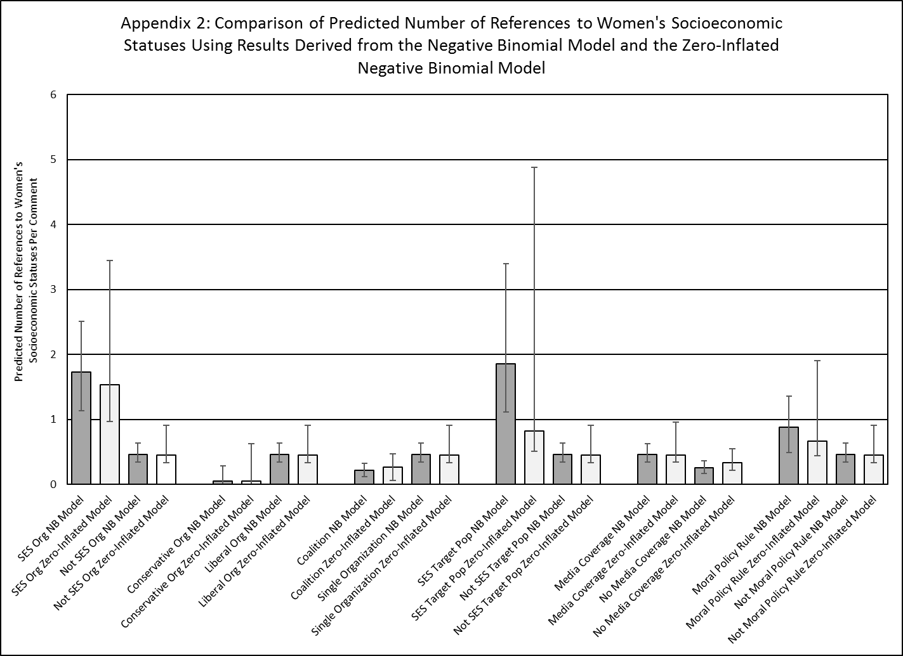
Appendix 3: Comparison of Socioeconomic Status Models with Affordable Care Act Reproductive Rights Rules Removed
 | Socioeconomic Status without ACA Reproductive Rights Rules  (Negative Binomial) | Socioeconomic Status with ACA Reproductive Rights Rules  (Negative Binomial)
Count Stage
Commenter Characteristics
Intersectional Constituency | 1.39***  (0.22) | 1.31***  (0.21)
Conservative Organization | -3.60***  (1.28) | -2.12***  (0.79)
Coalition | -0.91***  (0.21) | -0.78***  (0.19)
Policymaking Context
Intersectional Target Population | 1.40***  (0.24). | 1.39***  (0.22)
Received Media Coverage | 0.61***  (0.19) | 0.60***  (0.18)
Moral Policy Rule | 0.76***  (0.25) | 0.64***  (0.20)
Controls
Obama | -0.27  (0.23) | -0.29  (0.22)
Divided Government | 0.40  (0.24) | 0.36*  (0.22)
Word Count | 0.0002***  (0.00003) | 0.0002***  (0.00003)
Constant | -1.99***  (0.37) | -1.95***  (0.34)
/ln alpha | 1.36 | 0.79***
alpha | 3.90 | 2.22
Log Likelihood | -887.54 | -963.97
LR Chi² (9) | 166.11*** | 96.29***
N | 928 | 1,021
Notes: ***p≤0.01, **p≤0.05, *p≤0.10

Appendix 4: Comparison of Sexual Orientation and Gender Identity Models with Biasing Rules Removed
 | Full  Sexual Orientation Model (Zero-Inflated Negative Binomial) | Revised Sexual Orientation Model  (Negative Binomial) | Full  Gender Identity Model  (Negative Binomial) | Revised Gender Identity Model  (Negative Binomial)
Count Stage
Commenter Characteristics
Intersectional Constituency | 1.71***  (0.21) | 4.37***  (0.47) | 3.89***  (0.27) | 4.06***  (0.28)
Conservative Organization | -0.92  (1.19) | -18.68  (5,292.78) | -27.65  (27,848.33) | -23.98  (108,031.3)
Coalition | -0.004  (0.21) | 0.11  (0.29) | -0.11  (0.22) | -0.43*  (0.24)
Policymaking Context
Intersectional Target Population | 0.62**  (0.29) | 0.97***  (0.38) | 1.66***  (0.27) | 1.64***  (0.28)
Received Media Coverage | -0.84***  (0.21) | -0.74***  (0.28) | -0.68***  (0.22) | -0.53  (0.25)
Moral Policy Rule | -0.17  (0.44) | -0.32  (0.44) | 1.04***  (0.29) | 0.74**  (0.34)
Controls
Obama | 0.86*  (0.51) | 3.45***  (0.57) | 1.68***  (0.39) | 1.69***  (0.43)
Divided Government | -0.49  (0.48) | 1.58***  (0.38) | 0.78***  (0.31) | 0.89***  (0.35)
Word Count | 0.00003  (0.00002) | 0.0002***  (0.00005) | 0.0002***  (0.00003) | 0.0002***  (0.00003)
Constant | 1.62**  (0.80) | -5.46***  (0.75) | -4.60***  (0.53) | -4.67***  (0.58)
Inflate Stage
Commenter Characteristics
Intersectional Constituency | -3.97***  (0.43) | NA | NA | NA
Conservative Organization | 4.32  (3.96) | NA | NA | NA
Coalition | 0.03  (0.27) | NA | NA | NA
Policymaking Context
Intersectional Target Population | -0.69**  (0.35) | NA | NA | NA
Received Media Coverage | 0.24  (0.28) | NA | NA | NA
Moral Policy Rule | -1.39***  (0.42) | NA | NA | NA
Controls
Obama | -1.97***  (0.58) | NA | NA | NA
Divided Government | -1.15***  (0.38) | NA | NA | NA
Word Count | -0.0003***  (0.00006) | NA | NA | NA
Constant | 5.62***  (0.77) | NA | NA | NA
/ln alpha | 0.43*** | 2.36 | 1.50 | 1.49
alpha | 1.54 | 10.55 | 4.46 | 4.44
Log Likelihood | -923.72 | -837.22 | -742.82 | -650.64
LR Chi² (9) | 82.02*** | 195.29*** | 368.65*** | 323.07***
N | 1,021 | 914 | 1,021 | 914
N_{Non-Zero,} N_{Zero} | 172, 849 | 139, 775 | 152, 869 | 130, 784
Notes: ***p≤0.01, **p≤0.05, *p≤0.10

