Online Appendix B: Experimental Manipulations

Candidate Biographies: Female Republican Incumbent

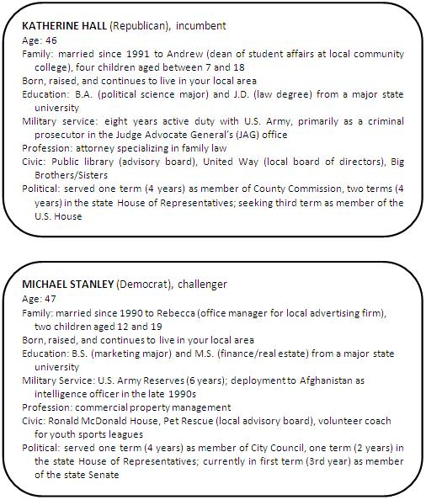
Candidate Biographies: Male Republican Incumbent

Imagine that it is the fall of 2012, and the general election campaign is under way. One of the races on your ballot is for U.S. House of Representatives, where incumbent Michael Stanley (R) is being challenged by state senator Katherine Hall (D). Please read the following short biographical sketches of these candidates, and then answer the questions that immediately follow.

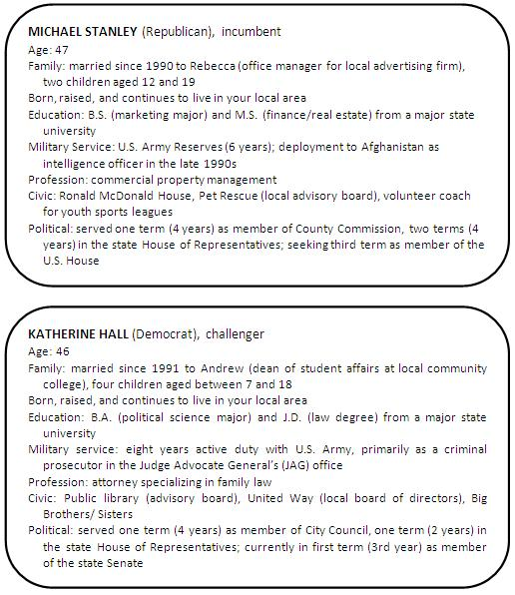
Attack (Taking Advantage): Female Republican Incumbent

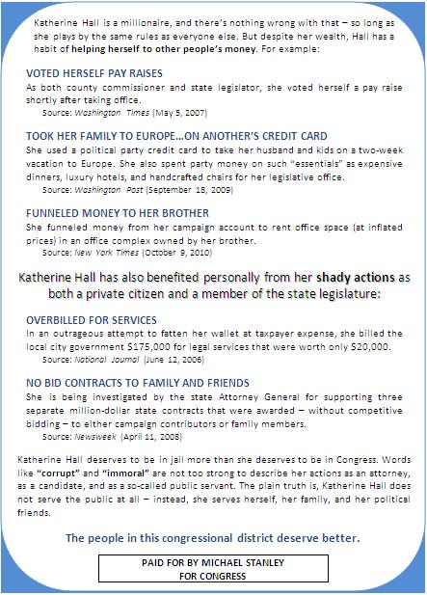
Response (Denial): Female Republican Incumbent

Response (Counterattack): Female Republican Incumbent

Response (Counterimaging): Female Republican Incumbent

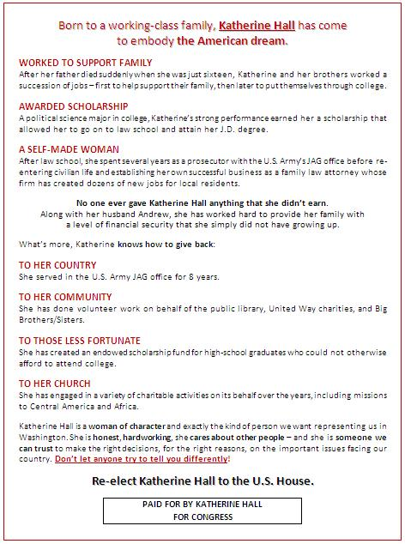
Response (Justification): Female Republican Incumbent

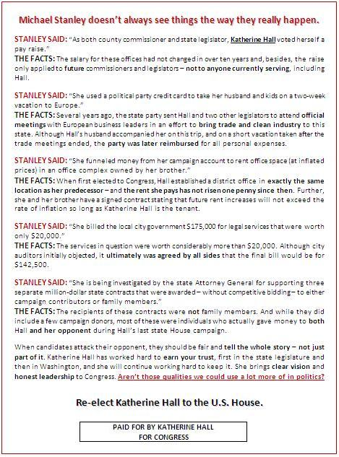
Response (Mudslinging): Female Republican Incumbent

Attack (Taking Advantage): Male Republican Incumbent

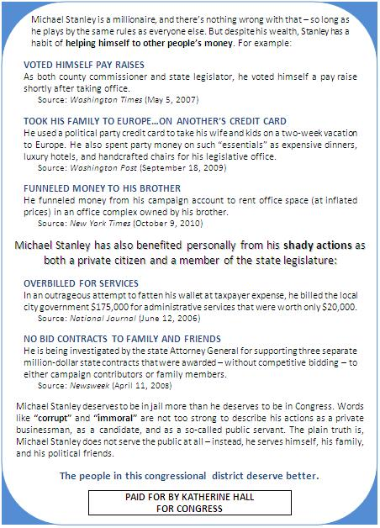
Response (Denial): Male Republican Incumbent

Response (Counterattack): Male Republican Incumbent

Response (Counterimaging): Male Republican Incumbent

Response (Justification): Male Republican Incumbent

Response (Mudslinging): Male Republican Incumbent

